Lowell High School AP CS Principles
Dell Optiplex 320 Computer Disassembly and Reassembly

In this lab you'll take apart a computer and put it back together. Before you start, you should familiarize yourself with the IT Essentials Virtual Desktop.

IMPORTANT SAFETY NOTICE: Unplug the power cord of the computer prior to dis-assembly! Once unplugged, press the power switch to discharge the computer.
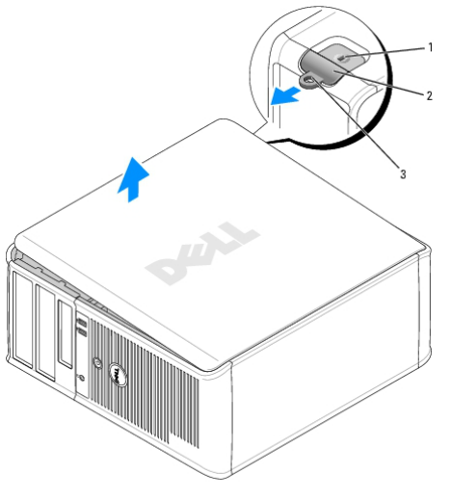
Step 1--Open the Case:
Lay the computer on its side, slide the cover release latch back and lift the cover off.

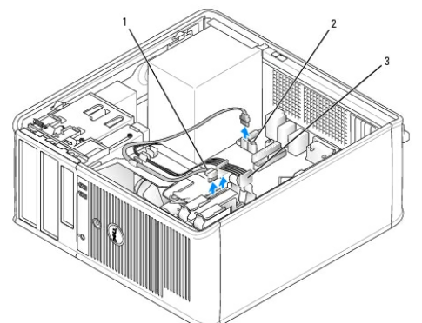
Step 2--Remove the hard drive:

The hard drive is in a light blue tray near the bottom front corner of the case. Remove the SATA data cable (labeled #1) and the SATA power cable (#3). Pinch the two blue tabs together to slide the hard drive out. Remove the hard drive from the tray by gently bending the tray.

Step 3--Remove the drive panel:
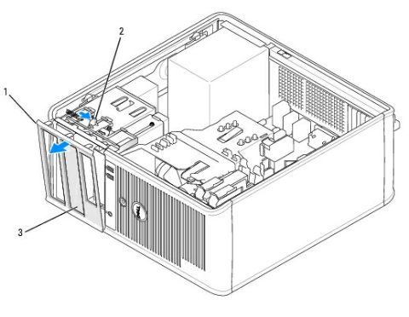
The drive panel covers the optical and floppy drives. Remove the drive panel (#1) by sliding the drive release latch (#2) downward to open the panel. Then, remove the drive panel from the hinges.

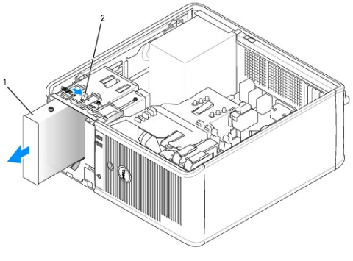
Step 4--Remove the optical and floppy drives:
Remove the power and data cables from the optical drive. Slide the drive release latch and pull the optical drive out. Remove the rear screw on the floppy drive. Remove the power and data cables from the floppy drive. Slide the drive release latch and remove the floppy drive.

Step 5--Remove the RAM:

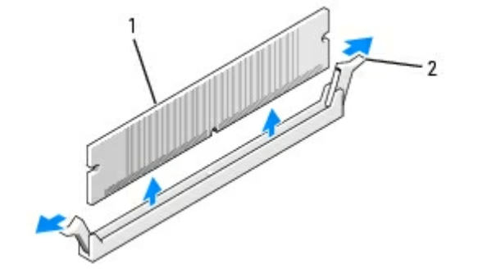
The DDR2 RAM (#1) sits in two slots between the power supply and heat sink. Press the white clips (#2) on the ends of each stick of RAM down. Firmly pull the RAM stick straight up to remove it.

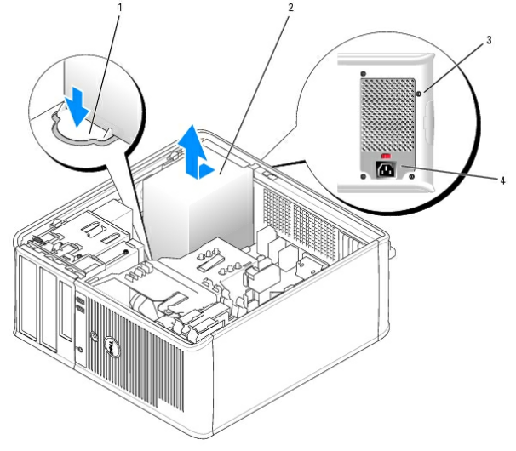
Step 6--Remove the power supply:

Press the release tabs on the 24 pin and 4 pin power connectors from motherboard and disconnect them. Remove the wires for the SATA hard-drive from the blue and black clips. Unsnap the blue clip that holds the PATA data cable from the bottom of the power supply. Unscrew the 4 black screws (#3) from the power supply. Press the blue release button (#1) slide the power supply about an inch toward the front of the computer. You can now lift the power supply out of the computer.

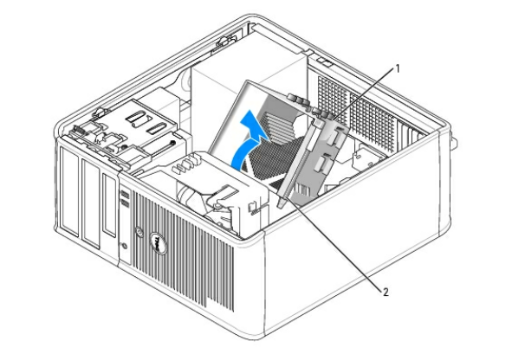
Step 7--Remove the heat sink assembly:

Loosen the captive screw (#2) on each side of the heat sink assembly(#1). Remove the floppy drive data cable from the black clip on the top of the assembly. Rotate the heat sink assembly upward, and remove it from the computer.

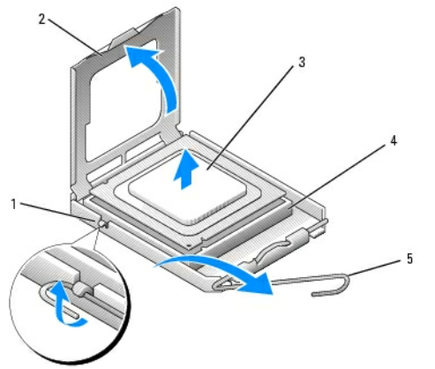
Step 8--Remove the CPU

Open the processor cover by sliding the release lever (#1) from under the center cover latch on the socket. Then, pull the lever back to release the CPU (#3). Try to avoid touching the thermal paste when you remove the CPU.

Step 9—Label the following parts: Hard Drive, Optical Drive, Power Supply, RAM, Heat sink, CPU

Step 10—Notify the instructor or a TA that you've disassembled the computer and then reassemble it in reverse order.

Step 11— Test your computer to make sure it boots after reassembly.

