Logic Gates in Logic.ly
AP Computer Science Principles Name__KEY____
Go to https://logic.ly/demo/ to complete this assignment.

- Build the circuit shown in the following sample AP Computer Science Principles question. Take a screen shot of your circuit and paste it below. Then use your circuit to answer the question.

The figure below shows a circuit composed of two logic gates. The outuput of the circuit is true. Which of the following is a true statement about input A?
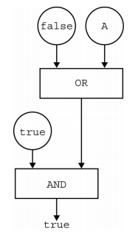
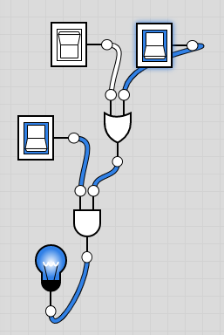

- Input A must be true
- Input A must be false
- Input A can be either true or false
- There is no possible value of Input A that will cause the circuit to have the output true
2. Build the circuit shown in the following sample AP Computer Science Principles question. Take a screen shot of your circuit and paste it below. Then use your circuit to answer the question.

The figure below is shows a circuit composed of three logic gates. The output of the circuit is true

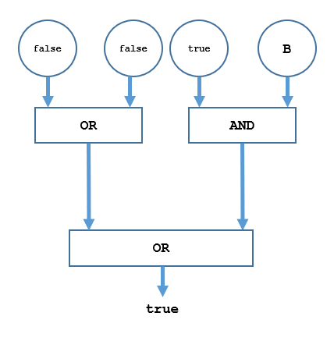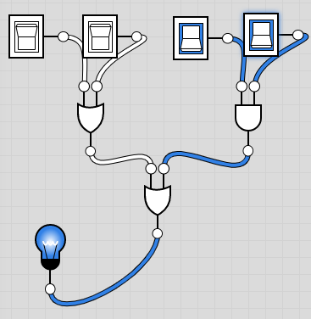
Which of the following is a true statement about input B?
- Input B must be true
- Input B must be false
- Input B can be either true or false
- There is no possible value of Input A that will cause the circuit to have the output true

3. Build the following Binary to Hex converter, then use it to fill in the table with the appropriate binary or hex values

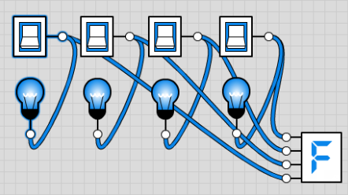

Binary | Hex
1010 | A
1001 | 9
1000 | 8
1110 | E
0010 | 2
1100 | 10

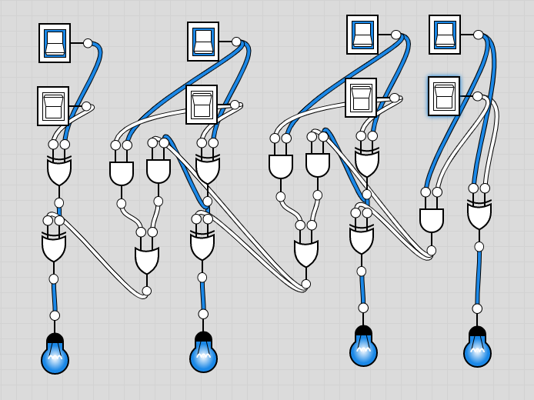
4. Build a 4 bit adder. One way is shown at the right. It uses five components:
- Toggle Switch
- AND gate
- XOR gate
- OR gate
- Light Bulb

Take a screen shot of your 4 bit adder and paste it here.

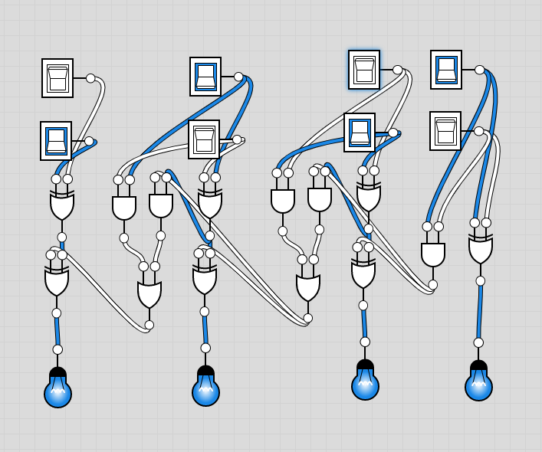
For each of the following binary addition problems, answer the question and include a screen shot that shows your adder solving the problem.
5. 0101
+1010
1111

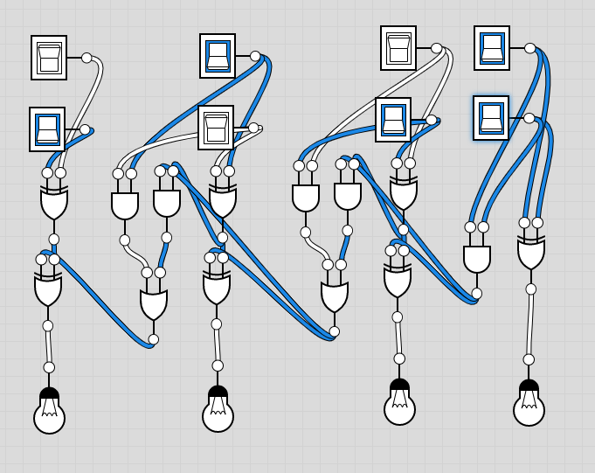
6. 0101
+1011
0000

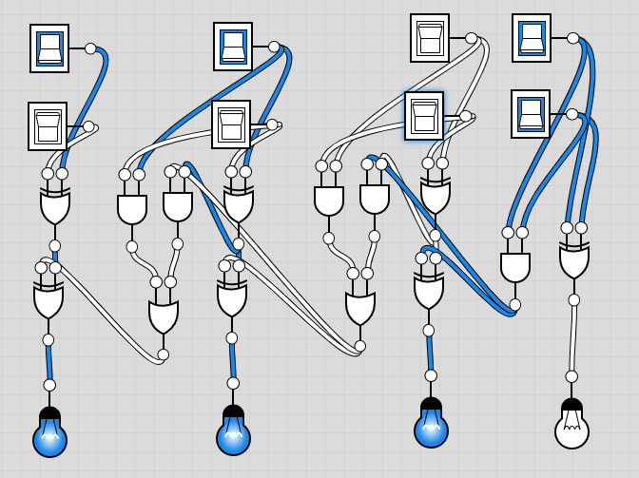
7. 1101
+0001
1110

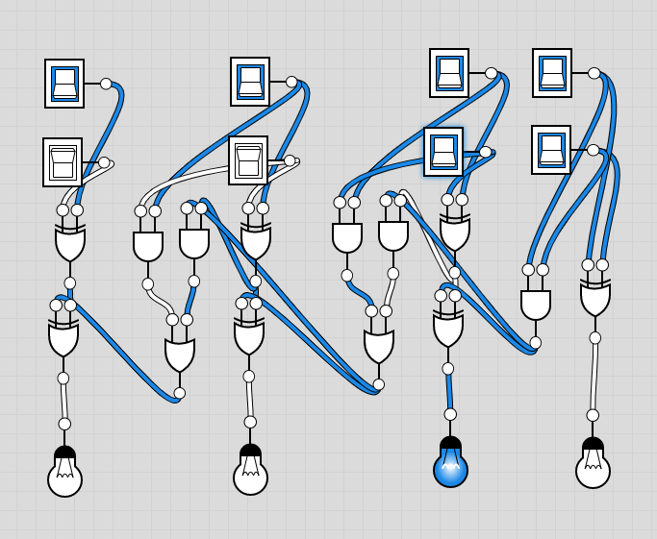

8. 1111
+0011
0010

9. Which problems of #5-8 result in overflow? 6 & 8

