QT_HMI

Unit Test Instruction

Version 1.0.0

Revision History

|  |  |  |  |
| --- | --- | --- | --- |
| **Date** | **Version** | **Description** | **Author** |
| Apr/03/2018 | 1.0.0 | Unit Test Structure and build |  |
|  |  |  |  |
|  |  |  |  |
|  |  |  |  |

Table of Contents

1. Introduction 4

1.1 Overview 4

1.2 Scope 4

2. Test Tool Configuration 4

2.1 Add Test Tool 4

2.2 Cmake Configuration 4

2.3 Modify README.md Document 4

2.4 Cmake Install Structure 5

2.4.1 bin directory 5

2.4.2 googletest directory 5

3. Test Environment Configuration 6

3.1 Install Test Tool 6

3.2 Configure The Qt Project 6

4. Qt Project Test Structure 7

4.1 Add Test Module For every Module 7

4.1.1 Test Class Header File 9

4.1.2 Test Source Files 10

4.2 Add Test Module For Main Directory 10

4.2.1 Configure The Mock Class 12

# Introduction

## Overview

This article describes the test environment architecture, involves the code structure and test tool path planning and specification .

Using Google Mock and Google Test testing tools, the version uses googletest-release-1.8.0.

## Scope

Code-level interface tests, check problems at the code.

Improve program stability.

# Test Tool Configuration

Using Google Mock and Google Test testing tools,the version uses googletest-release-1.8.0

## Add Test Tool

In the tools directory，as follow：

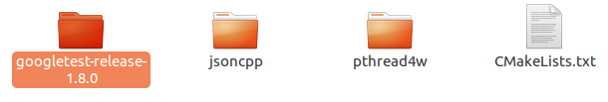

## Cmake Configuration

Modify CmakeList.txt in the tools directory，and add configuration for googletest-release-1.8.0，as follow：

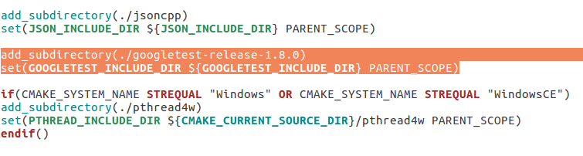

## Modify README.md Document

Add INSTALL Description in the README.md Document ,as follow:

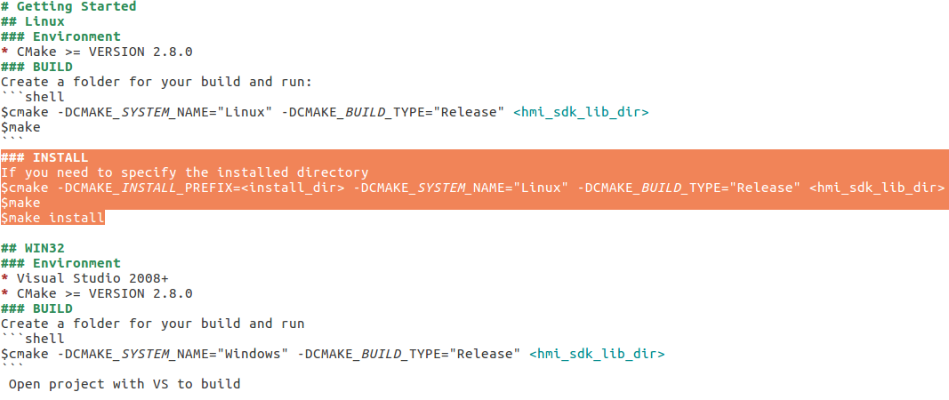

## Cmake Install Structure

Specify the installation directory as ”googletest” and the make & make install results are as follows:

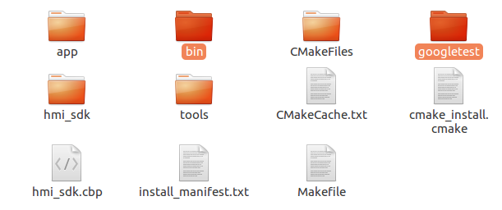

There are two newly generated directories bin directory and googletest directory.

### bin directory

The content is as follows：

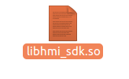

### googletest directory

1. The content of googletest directory is as follow：



1. The content of lib directory is as follow：

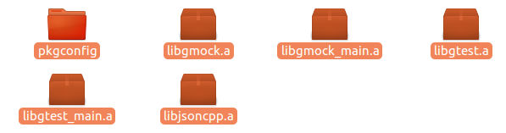

# Test Environment Configuration

## Install Test Tool

1. Specify the install directory as googletest
2. Put the generated bin directory under googletest directory



1. Deploy test tools

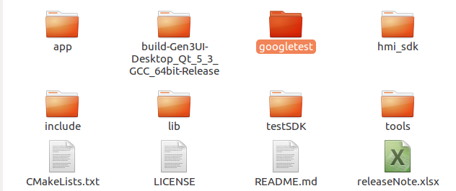

Put the googletest directory under HMI_SDK_LIB directory . Same level as hmi_sdk directory.

## Configure The Qt Project

Add the test module in the pro file as follows:

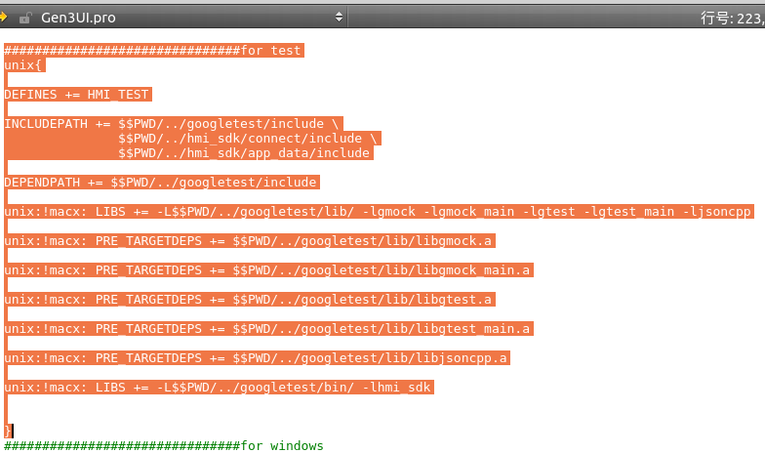

Defines: HM_TEST

Header dependencies: googletest, hmi_sdk

Library dependencies: libgmock.a, libgmock_main.a, libgtest.a, libgtest_main.a, hmi_sdk.so, jsoncpp.a

# Qt Project Test Structure

## Add Test Module For every Module

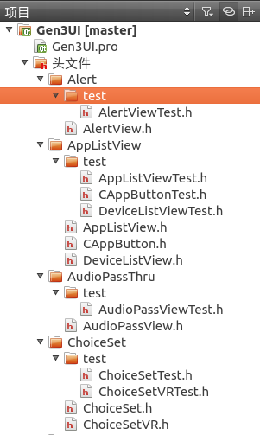

Add the test directory under each module and add the Test file under the test directory.

### Test Class Header File

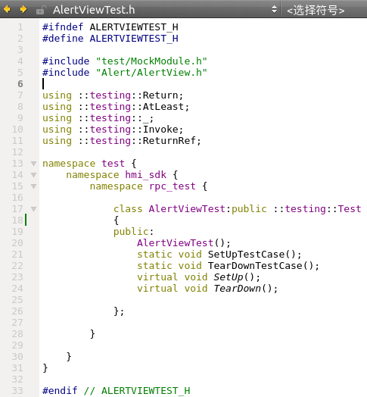

### Test Source Files

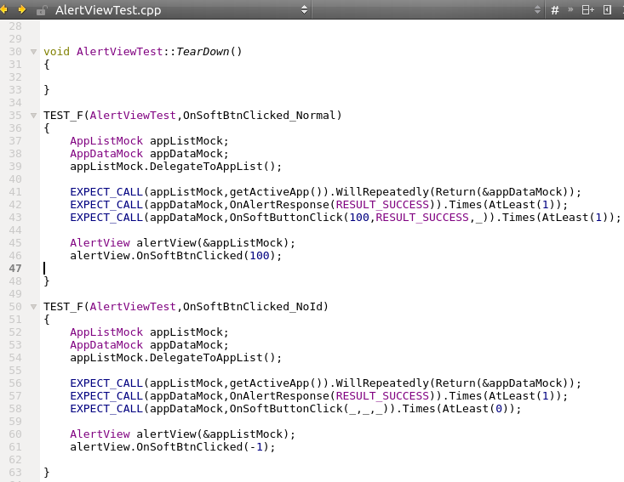

## Add Test Module For Main Directory

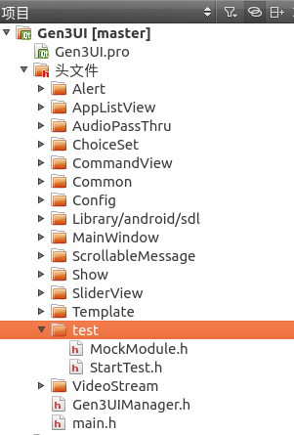

### Configure The Mock Class

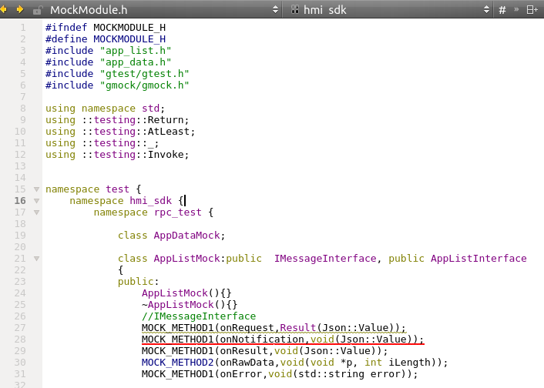

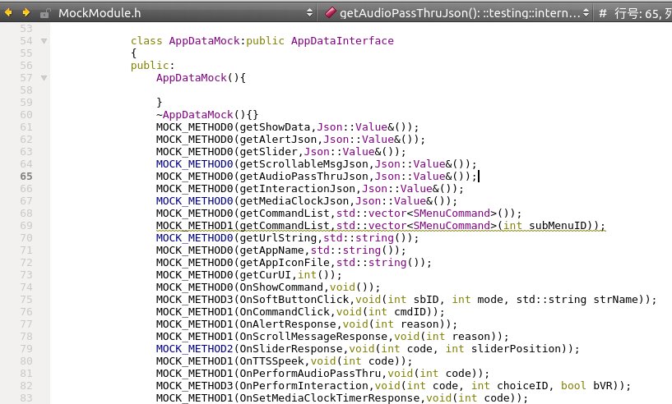

Add the mock class int the MockModule.h .