SmartDeivceLink2.0概要说明

# 简介

SmartDeviceLink（简称SDL）由两个不同的软件部份组成；一个是车载内核部件，它包括车载服务包和整合车载HMI，另一个是移动代理，它通过API访问和使用汽车首单元的服务。车载内核包括以下部分：

1.管理物理终端发现和连接到移动设备应用的逻辑传输。

2.支持白色标签（服务提供商），多功能非单应用的情况，以及单应用单功能的情况。

3.提供统一的接口，此接口使应用程序了解车载首单元的功能。

4.管理和维护连接的移动应用程序状态，和通知适应的状态变化的应用。

5.把车载服务，如按钮，显示，语音，菜单系统，音频控件和其他普通车辆的输入和输出打包到一个共同的消息格式和API。

6.可扩展到允许特定的OEM、或首单元制造商API、或消息。

7.创建一个模板和元UI，此UI创建一致的开发经验，而不管实际的HMI表现。

移动代理部件包括以下部份：

1.提供一个通用、抽象的接口到车载信息娱乐系统，整合到SmartDeviceLink功能的移动应用程序。

2.对于Android和IPhone应用程序是可用的。

3.支持TCP、蓝牙和苹果特定的传输协议的实现，并且能扩展到其它传输协议。

4.简化传输的发现、连接和协议的使用。

5.可扩展到允许特定的OEM、或首单元制造商API、或消息。

# 结构分析

## 网络拓扑图

### 目前的网络拓扑图

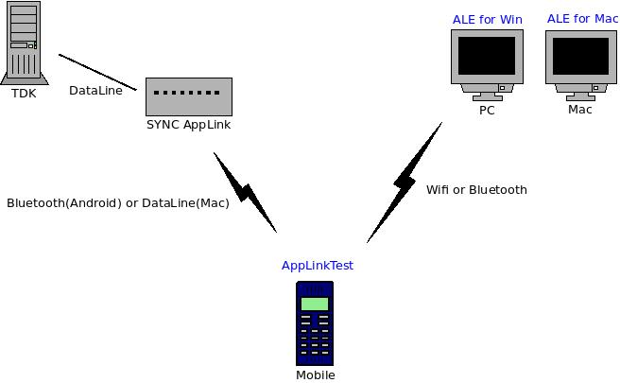

### 将要实现的网络拓扑图

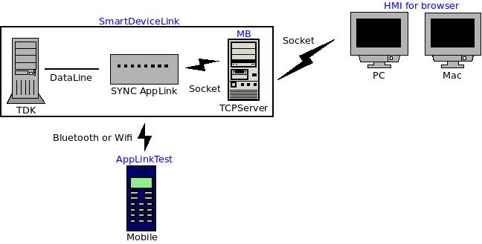

## 包图

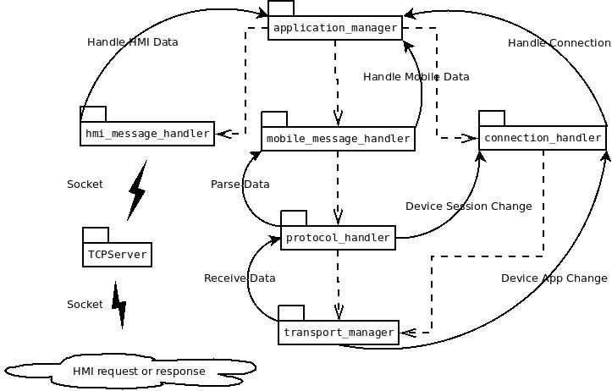

## 类图

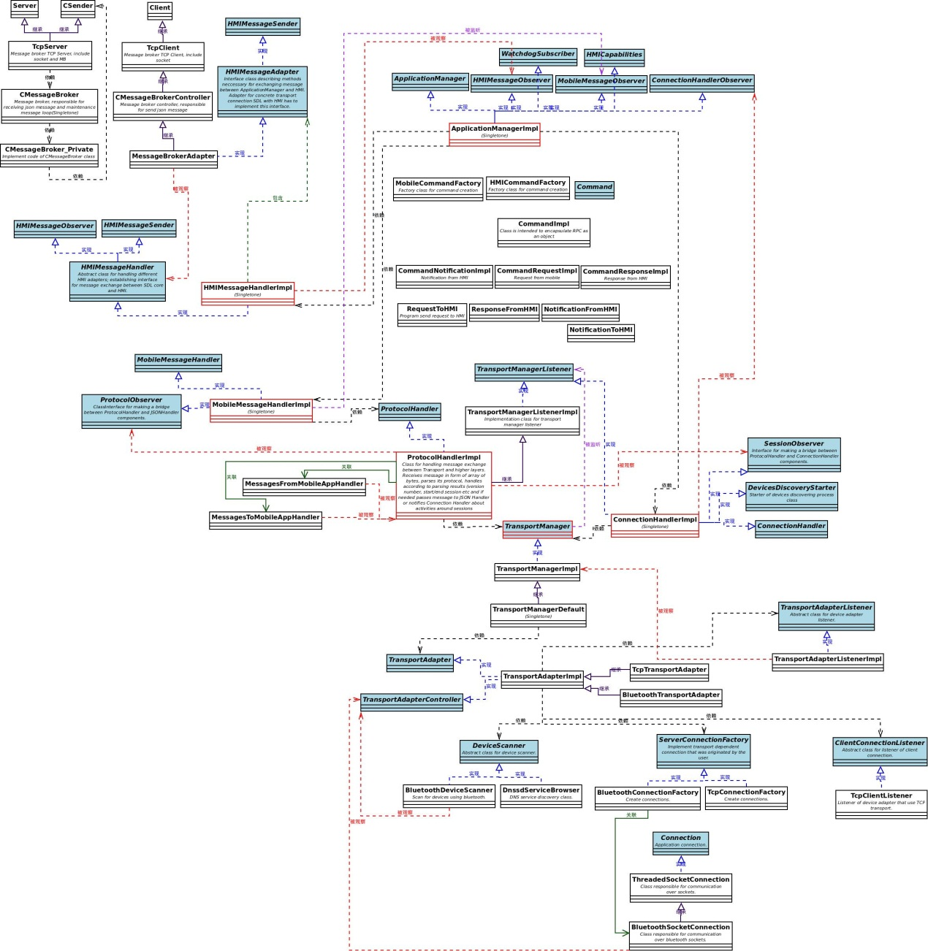

# 流程分析

## 总体序列图

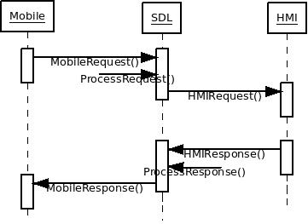

## Mobile命令流程

### Show

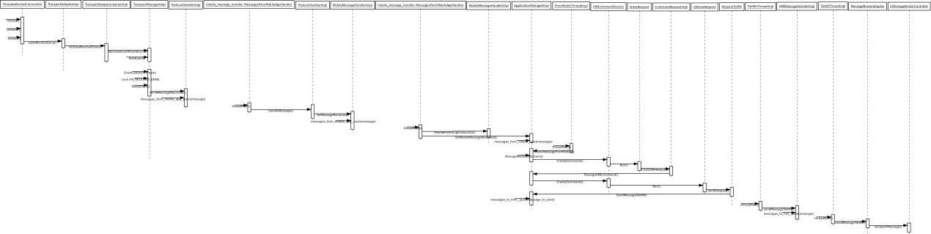

## HMI命令流程

### Up Button

以按钮“UP”为例描述整个过程:

1、运行./smartDeviceLinkCore。

启动HMI页面index.html，路径为/home/patrick/projects/SmartDeviceLink/git_repo/src/components/HM/index.html。

2、点击Home的“UP”按钮。

代码过程如下：

2.1 HMI发送

index.html

Path:/home/patrick/projects/SmartDeviceLink/git_repo/src/components/HM/index.html

Line:131

Code:

<script type="text/javascript" src="app/view/home/controlButtons.js"></script>

controlButtons.js

Path:/home/patrick/projects/SmartDeviceLink/git_repo/src/components/HMI/app/view/home/controlButtons.js

Line:394

Code:

/** Up button */

UpBtn: SDL.Button.create( SDL.PresetEvents, {

elementId: 'TUNEUP',

classNames: 'UpBtn',

time: 0,

presetName: 'TUNEUP'

} ),

PresetEvents.js

Path:/home/patrick/projects/SmartDeviceLink/git_repo/src/components/HMI/app/mixins/PresetEvents.js

Line:37

Code:

SDL.PresetEvents = Ember.Mixin.create( {

actionDown: function() {

this._super();

SDL.SDLController.onSoftButtonActionDown( this );

},

actionUp: function() {

this._super();

SDL.SDLController.onSoftButtonActionUp( this );

}

} );

Controller.js

Path:/home/patrick/projects/SmartDeviceLink/git_repo/src/components/HMI/app/controller/sdl/Controller.js

Line:453

Code:

onSoftButtonActionDown: function( element ) {

FFW.Buttons.buttonEvent( element.presetName, "BUTTONDOWN" );

element.time = 0;

element.timer = setTimeout( function() {

FFW.Buttons.buttonPressed( element.presetName, "LONG" );

element.time++;

}, 2000 );

},

ButtonRPC.js

Path:/home/patrick/projects/SmartDeviceLink/git_repo/src/components/HMI/ffw/ButtonsRPC.js

Line:252

Code:

buttonEvent: function( id, type ) {

Em.Logger.log( "FFW.Buttons.buttonEvent " + type );

var JSONMessage = {

"jsonrpc": "2.0",

"method": "Buttons.OnButtonEvent",

"params": {

"name": id,

"mode": type

}

};

this.client.send( JSONMessage );

},

# 协议分析

## Mobile协议分析

### 协议类型定义

namespace FunctionID {

/**

* @brief Enumeration FunctionID.

*

* Enumeration linking function names with function IDs in AppLink protocol.

* Assumes enumeration starts at value 0.

*/

enum eType {

/**

* @brief INVALID_ENUM.

*/

INVALID_ENUM = -1,

/**

* @brief RESERVED.

*/

RESERVED = 0,

/**

* @brief RegisterAppInterfaceID.

*/

RegisterAppInterfaceID = 1,

/**

* @brief UnregisterAppInterfaceID.

*/

UnregisterAppInterfaceID = 2,

/**

* @brief SetGlobalPropertiesID.

*/

SetGlobalPropertiesID = 3,

/**

* @brief ResetGlobalPropertiesID.

*/

ResetGlobalPropertiesID = 4,

/**

* @brief AddCommandID.

*/

AddCommandID = 5,

/**

* @brief DeleteCommandID.

*/

DeleteCommandID = 6,

/**

* @brief AddSubMenuID.

*/

AddSubMenuID = 7,

/**

* @brief DeleteSubMenuID.

*/

DeleteSubMenuID = 8,

/**

* @brief CreateInteractionChoiceSetID.

*/

CreateInteractionChoiceSetID = 9,

/**

* @brief PerformInteractionID.

*/

PerformInteractionID = 10,

/**

* @brief DeleteInteractionChoiceSetID.

*/

DeleteInteractionChoiceSetID = 11,

/**

* @brief AlertID.

*/

AlertID = 12,

/**

* @brief ShowID.

*/

ShowID = 13,

/**

* @brief SpeakID.

*/

SpeakID = 14,

/**

* @brief SetMediaClockTimerID.

*/

SetMediaClockTimerID = 15,

/**

* @brief PerformAudioPassThruID.

*/

PerformAudioPassThruID = 16,

/**

* @brief EndAudioPassThruID.

*/

EndAudioPassThruID = 17,

/**

* @brief SubscribeButtonID.

*/

SubscribeButtonID = 18,

/**

* @brief UnsubscribeButtonID.

*/

UnsubscribeButtonID = 19,

/**

* @brief SubscribeVehicleDataID.

*/

SubscribeVehicleDataID = 20,

/**

* @brief UnsubscribeVehicleDataID.

*/

UnsubscribeVehicleDataID = 21,

/**

* @brief GetVehicleDataID.

*/

GetVehicleDataID = 22,

/**

* @brief ReadDIDID.

*/

ReadDIDID = 23,

/**

* @brief GetDTCsID.

*/

GetDTCsID = 24,

/**

* @brief ScrollableMessageID.

*/

ScrollableMessageID = 25,

/**

* @brief SliderID.

*/

SliderID = 26,

/**

* @brief ShowConstantTBTID.

*/

ShowConstantTBTID = 27,

/**

* @brief AlertManeuverID.

*/

AlertManeuverID = 28,

/**

* @brief UpdateTurnListID.

*/

UpdateTurnListID = 29,

/**

* @brief ChangeRegistrationID.

*/

ChangeRegistrationID = 30,

/**

* @brief GenericResponseID.

*/

GenericResponseID = 31,

/**

* @brief PutFileID.

*/

PutFileID = 32,

/**

* @brief DeleteFileID.

*/

DeleteFileID = 33,

/**

* @brief ListFilesID.

*/

ListFilesID = 34,

/**

* @brief SetAppIconID.

*/

SetAppIconID = 35,

/**

* @brief SetDisplayLayoutID.

*/

SetDisplayLayoutID = 36,

/**

* @brief OnHMIStatusID.

*/

OnHMIStatusID = 32768,

/**

* @brief OnAppInterfaceUnregisteredID.

*/

OnAppInterfaceUnregisteredID = 32769,

/**

* @brief OnButtonEventID.

*/

OnButtonEventID = 32770,

/**

* @brief OnButtonPressID.

*/

OnButtonPressID = 32771,

/**

* @brief OnVehicleDataID.

*/

OnVehicleDataID = 32772,

/**

* @brief OnCommandID.

*/

OnCommandID = 32773,

/**

* @brief OnTBTClientStateID.

*/

OnTBTClientStateID = 32774,

/**

* @brief OnDriverDistractionID.

*/

OnDriverDistractionID = 32775,

/**

* @brief OnPermissionsChangeID.

*/

OnPermissionsChangeID = 32776,

/**

* @brief OnAudioPassThruID.

*/

OnAudioPassThruID = 32777,

/**

* @brief OnLanguageChangeID.

*/

OnLanguageChangeID = 32778,

/**

* @brief EncodedSyncPDataID.

*/

EncodedSyncPDataID = 65536,

/**

* @brief SyncPDataID.

*/

SyncPDataID = 65537,

/**

* @brief OnEncodedSyncPDataID.

*/

OnEncodedSyncPDataID = 98304,

/**

* @brief OnSyncPDataID.

*/

OnSyncPDataID = 98305

};

} // FunctionID

## HMI协议分析

### 协议类型定义

namespace FunctionID {

/**

* @brief Enumeration FunctionID.

*/

enum eType {

/**

* @brief INVALID_ENUM.

*/

INVALID_ENUM = -1,

/**

* @brief Buttons_GetCapabilities.

*/

Buttons_GetCapabilities,

/**

* @brief Buttons_OnButtonEvent.

*/

Buttons_OnButtonEvent,

/**

* @brief Buttons_OnButtonPress.

*/

Buttons_OnButtonPress,

/**

* @brief BasicCommunication_OnReady.

*/

BasicCommunication_OnReady,

/**

* @brief BasicCommunication_OnStartDeviceDiscovery.

*/

BasicCommunication_OnStartDeviceDiscovery,

/**

* @brief BasicCommunication_UpdateDeviceList.

*/

BasicCommunication_UpdateDeviceList,

/**

* @brief BasicCommunication_OnUpdateDeviceList.

*/

BasicCommunication_OnUpdateDeviceList,

/**

* @brief BasicCommunication_AllowDeviceToConnect.

*/

BasicCommunication_AllowDeviceToConnect,

/**

* @brief BasicCommunication_OnDeviceChosen.

*/

BasicCommunication_OnDeviceChosen,

/**

* @brief BasicCommunication_OnFindApplications.

*/

BasicCommunication_OnFindApplications,

/**

* @brief BasicCommunication_UpdateAppList.

*/

BasicCommunication_UpdateAppList,

/**

* @brief BasicCommunication_OnAppActivated.

*/

BasicCommunication_OnAppActivated,

/**

* @brief BasicCommunication_OnAppDeactivated.

*/

BasicCommunication_OnAppDeactivated,

/**

* @brief BasicCommunication_OnAppRegistered.

*/

BasicCommunication_OnAppRegistered,

/**

* @brief BasicCommunication_OnAppUnregistered.

*/

BasicCommunication_OnAppUnregistered,

/**

* @brief BasicCommunication_OnExitApplication.

*/

BasicCommunication_OnExitApplication,

/**

* @brief BasicCommunication_OnExitAllApplications.

*/

BasicCommunication_OnExitAllApplications,

/**

* @brief BasicCommunication_MixingAudioSupported.

*/

BasicCommunication_MixingAudioSupported,

/**

* @brief BasicCommunication_PlayTone.

*/

BasicCommunication_PlayTone,

/**

* @brief BasicCommunication_AllowAllApps.

*/

BasicCommunication_AllowAllApps,

/**

* @brief BasicCommunication_AllowApp.

*/

BasicCommunication_AllowApp,

/**

* @brief VR_IsReady.

*/

VR_IsReady,

/**

* @brief VR_Started.

*/

VR_Started,

/**

* @brief VR_Stopped.

*/

VR_Stopped,

/**

* @brief VR_AddCommand.

*/

VR_AddCommand,

/**

* @brief VR_DeleteCommand.

*/

VR_DeleteCommand,

/**

* @brief VR_OnCommand.

*/

VR_OnCommand,

/**

* @brief VR_ChangeRegistration.

*/

VR_ChangeRegistration,

/**

* @brief VR_OnLanguageChange.

*/

VR_OnLanguageChange,

/**

* @brief VR_GetSupportedLanguages.

*/

VR_GetSupportedLanguages,

/**

* @brief VR_GetLanguage.

*/

VR_GetLanguage,

/**

* @brief TTS_IsReady.

*/

TTS_IsReady,

/**

* @brief TTS_Speak.

*/

TTS_Speak,

/**

* @brief TTS_StopSpeaking.

*/

TTS_StopSpeaking,

/**

* @brief TTS_ChangeRegistration.

*/

TTS_ChangeRegistration,

/**

* @brief TTS_OnLanguageChange.

*/

TTS_OnLanguageChange,

/**

* @brief TTS_GetSupportedLanguages.

*/

TTS_GetSupportedLanguages,

/**

* @brief TTS_GetLanguage.

*/

TTS_GetLanguage,

/**

* @brief TTS_SetGlobalProperties.

*/

TTS_SetGlobalProperties,

/**

* @brief UI_Alert.

*/

UI_Alert,

/**

* @brief UI_ShowNotification.

*/

UI_ShowNotification,

/**

* @brief UI_Show.

*/

UI_Show,

/**

* @brief UI_AddCommand.

*/

UI_AddCommand,

/**

* @brief UI_DeleteCommand.

*/

UI_DeleteCommand,

/**

* @brief UI_AddSubMenu.

*/

UI_AddSubMenu,

/**

* @brief UI_DeleteSubMenu.

*/

UI_DeleteSubMenu,

/**

* @brief UI_PerformInteraction.

*/

UI_PerformInteraction,

/**

* @brief UI_SetMediaClockTimer.

*/

UI_SetMediaClockTimer,

/**

* @brief UI_SetGlobalProperties.

*/

UI_SetGlobalProperties,

/**

* @brief UI_ShowVrHelp.

*/

UI_ShowVrHelp,

/**

* @brief UI_OnCommand.

*/

UI_OnCommand,

/**

* @brief UI_OnSystemContext.

*/

UI_OnSystemContext,

/**

* @brief UI_GetCapabilities.

*/

UI_GetCapabilities,

/**

* @brief UI_ChangeRegistration.

*/

UI_ChangeRegistration,

/**

* @brief UI_OnLanguageChange.

*/

UI_OnLanguageChange,

/**

* @brief UI_GetSupportedLanguages.

*/

UI_GetSupportedLanguages,

/**

* @brief UI_GetLanguage.

*/

UI_GetLanguage,

/**

* @brief UI_OnDriverDistraction.

*/

UI_OnDriverDistraction,

/**

* @brief UI_SetAppIcon.

*/

UI_SetAppIcon,

/**

* @brief UI_Slider.

*/

UI_Slider,

/**

* @brief UI_ScrollableMessage.

*/

UI_ScrollableMessage,

/**

* @brief UI_PerformAudioPassThru.

*/

UI_PerformAudioPassThru,

/**

* @brief UI_EndAudioPassThru.

*/

UI_EndAudioPassThru,

/**

* @brief UI_IsReady.

*/

UI_IsReady,

/**

* @brief UI_ClosePopUp.

*/

UI_ClosePopUp,

/**

* @brief Navigation_IsReady.

*/

Navigation_IsReady,

/**

* @brief Navigation_ShowConstantTBT.

*/

Navigation_ShowConstantTBT,

/**

* @brief Navigation_AlertManeuver.

*/

Navigation_AlertManeuver,

/**

* @brief Navigation_UpdateTurnList.

*/

Navigation_UpdateTurnList,

/**

* @brief Navigation_OnTBTClientState.

*/

Navigation_OnTBTClientState,

/**

* @brief VehicleInfo_IsReady.

*/

VehicleInfo_IsReady,

/**

* @brief VehicleInfo_GetVehicleType.

*/

VehicleInfo_GetVehicleType,

/**

* @brief VehicleInfo_ReadDID.

*/

VehicleInfo_ReadDID,

/**

* @brief VehicleInfo_GetDTCs.

*/

VehicleInfo_GetDTCs,

/**

* @brief VehicleInfo_GetVehicleData.

*/

VehicleInfo_GetVehicleData,

/**

* @brief VehicleInfo_OnVehicleData.

*/

VehicleInfo_OnVehicleData

};

} // FunctionID