Initialization-

* A variable you pass as an OUT parameter doesn't need to be initialized.
* A variable you pass as a REF parameter needs to be initialized.

Default Value:

* A REF or OUT parameter cannot have a Default Value.

Assignment:

* A function must assign the OUT parameter. It’s not allowed to leave it unassigned otherwise we’ll receive a compile time error.
* A function doesn’t have to assign the REF parameter.

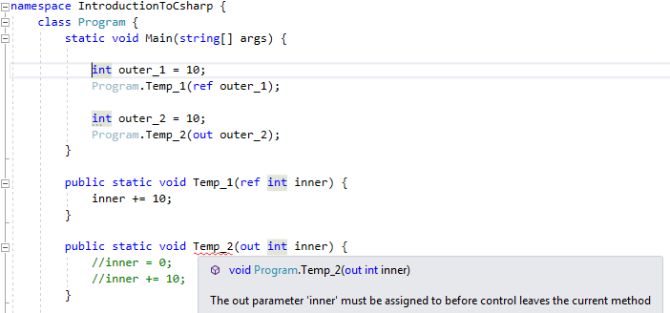

Usefulness:

* Passing a parameter value by REF is useful when the called method is also needed to modify the passed parameter.
* Declaring a parameter to an OUT is useful when multiple values need to be returned from a function or a method.

A Property or Indexer may not be passed as an OUT or REF parameter.