**Method Overriding: -** When a Base Class Reference Variable pointing to a Derived Class Object then the Overridden method from the Derived Class will be invoked. The Virtual method must be overridden in the Derived Class. When a virtual method is called on an object, then the most derived version of the method is invoked. Hence even though we are dealing with Employee as a Base Class then functionality defined in FullTimeEmployee Class is invoked. Please see the below screenshot for reference:

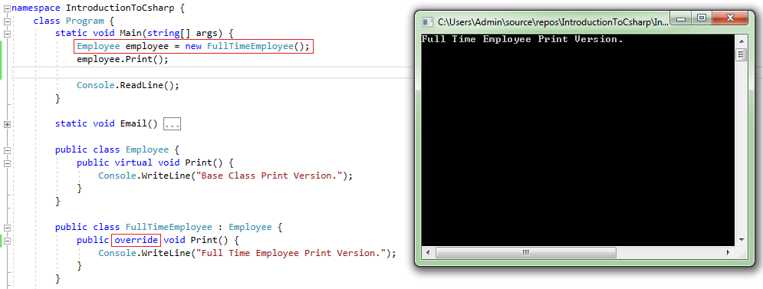

**Method Hiding: -** Method Hiding means that we have a completely different method. When a Base Class Reference Variable pointing to a Derived Class Object then the Base Class version of the method will be invoked. Please see the below screenshot for reference:

