**Method Overloading** allows a Class to have multiple methods with the same name but with a different signature. The signature of a method consists of the Method Name & the Type, Kind (Value, REF, OUT) and the number of its formal parameters. The signature of a method does not include the return type and the Params modifier. In C#, methods can be overloaded based on the Type, Kind and the number of parameters.

* It is not possible to Overload a method just based on the return type.

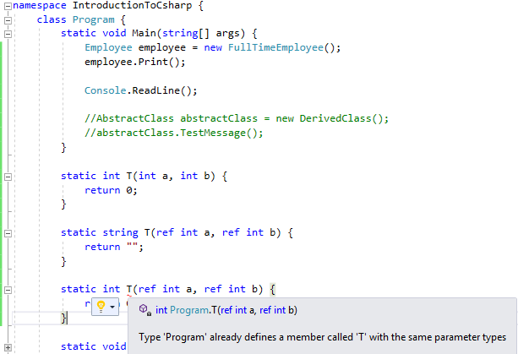

* We are trying to overload a method having different return types but with no parameters then we’ll receive a Compile Time error.