**Reflection:**

* It is the ability to inspect an assembly’s metadata at runtime.
* It enables us to use the code that is not available at compile time.
* Late Binding can be achieved by using reflection. We can use reflection to dynamically create an instance of a type, about which we don’t have any information at compile time.

Reflection is useful in the following situations:

* When you have to access attributes in your program's metadata.
* For examining and instantiating types in an assembly.
* For building new types at runtime. Use classes in System.Reflection.Emit.
* For performing late binding, accessing methods on types created at run time.

e.g.

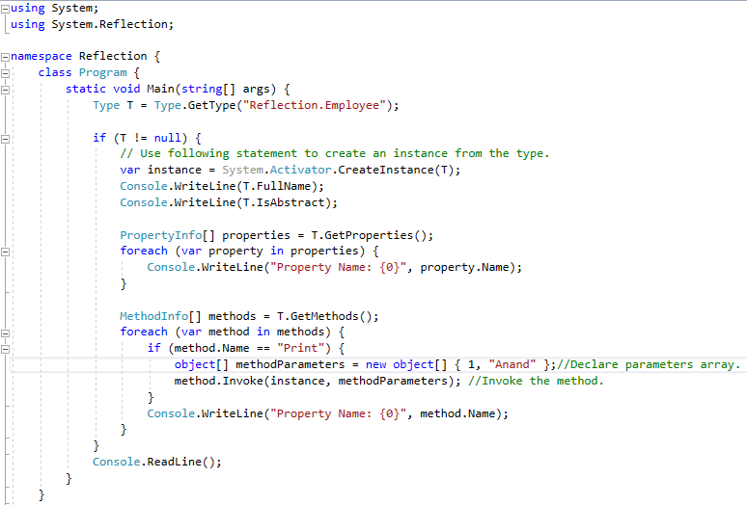

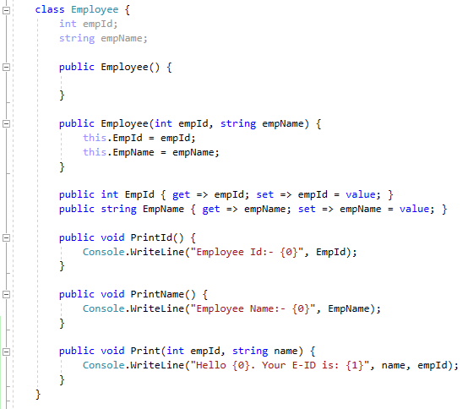

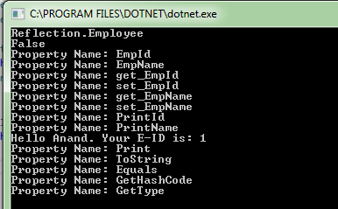

Useful links:

<https://stackoverflow.com/questions/723328/c-can-someone-explain-the-practicalities-of-reflection>

<https://stackoverflow.com/questions/429962/when-do-you-use-reflection-patterns-anti-patterns>