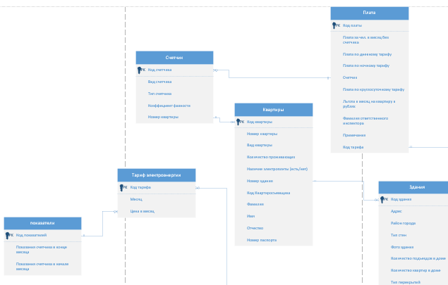



Листинг кода по созданию базы данных:

CREATE DATABASE УП_ПМ01_ИСПП_5_Буйлов_МА

ON PRIMARY (

NAME= ИСПП_5_Буйлов_МА,

FILENAME='\\sql\c$\Program Files\Microsoft SQL Server\MSSQL15.MSSQLSERVER\MSSQL\DATA\ УП_ПМ01_ИСПП_5_Буйлов_МА.mdf',

SIZE=100MB,

MAXSIZE=200,

FILEGROWTH=20)

LOG ON (

NAME= УП_ПМ01_ИСПП_5_Буйлов_МАLog ,

FILENAME='\\sql\c$\Program Files\Microsoft SQL Server\MSSQL15.MSSQLSERVER\MSSQL\DATA\ УП_ПМ01_ИСПП_5_Буйлов_МА.ldf',

SIZE=100MB,

MAXSIZE=200,

FILEGROWTH=20)

Листинг кода по созданию таблиц базы данных:

Create table Apartments(

Apartment_code int identity(1,1),

constraint PK1 primary key(Apartment_code),

Flat numeric (3),

FlatType numeric (1),

People numeric (2),

EStove bit,

Building_number int,

constraint FK1 foreign key(Building_number)

references Building (Building_Code),

Tenant_code int,

Lastname Varchar(20),

ForstName Varchar(20),

Patronymic Varchar(20),

Passport Varchar(20),

)

Create table Building (

Building_code int identity(1,1),

constraint PK4 primary key(Building_code),

Address Varchar(60),

District Varchar(15),

Material Varchar(15),

Picture image,

Doorway numeric (2),

Flats numeric (3),

Floor Varchar(15),

Owner Varchar(15),

)

Create table Indicators(

Indicator_code int identity(1,1),

constraint PK5 primary key(Indicator_code),

BeginMonth real,

EndMonth real,

)

Create table Electricity_tariff(

Tariff_code int identity(1,1),

constraint PK6 primary key(Tariff_code),

Month date,

Price_per_month money,

)

Create table Pay (

Pay_code int identity(1,1),

constraint PK3 primary key(Pay_code),

Counter int,

constraint FK2 foreign key(Counter)

references Counter (Counter_Code),

Tariff real,

Day real,

Night real,

hour24 real,

Privilege money,

Surname Varchar(20),

Comment Varchar not null,

Tariff_code int,

constraint FK3 foreign key(Tariff_code)

references Electricity_tariff (Tariff_code),

Indicators int,

constraint FK4 foreign key(Indicators)

references Indicators (Indicator_code),

)

Create table Counter (

Counter_code int identity(1,1),

constraint PK2 primary key(Counter_code),

Type Varchar(15),

Factor real,

Flat int,

constraint FK5 foreign key(Flat)

references Apartments (Apartment_code),

)

if (textBox1.Text == "1" && textBox2.Text == "1")

{

Form2 check = new Form2();

check.Show();

Hide();

}

if (textBox1.Text == "2" && textBox2.Text == "2")

{

Form3 check = new Form3();

check.Show();

Hide();

}

else

{

MessageBox.Show("Неверный пароль или логин!");

}

Create table Пользователи1 (

Код_пользователя int identity(1,1),

constraint PK7 primary key(Код_пользователя),

Логин Varchar(15),

Пароль Varchar(15),

Права_доступа Varchar(15),

)

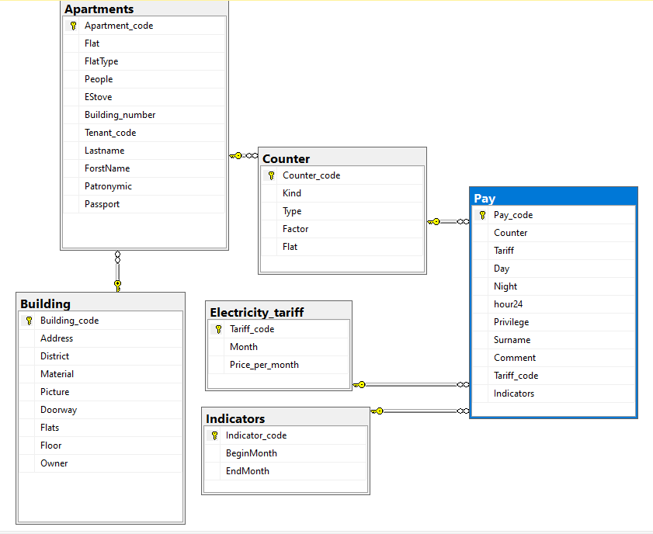

using System;

using System.Collections.Generic;

using System.ComponentModel;

using System.Data;

using System.Drawing;

using System.Linq;

using System.Text;

using System.Threading.Tasks;

using System.Windows.Forms;

using System.Data.SqlClient;

namespace Практика_sql

{

public partial class Form5 : Form

{

public Form5()

{

InitializeComponent();

}

int k = 0;

private void button1_Click(object sender, EventArgs e)

{

SqlConnection sqlConnect = new SqlConnection("Data Source=sql;Initial Catalog =уП_ПМ01_ИСПП_5_Буйлов_МА; Integrated Security = True");

sqlConnect.Open();

SqlDataAdapter da = new SqlDataAdapter($"INSERT INTO Пользователи(Логин, Пароль,Права_Доступа)VALUES('{textBox1.Text}','{textBox2.Text}','Квартиросъемщик')", sqlConnect);

DataTable dt = new DataTable();

da.Fill(dt);

Boolean flag = false;

for (int i = 0; i < dt.Rows.Count; i++)

if ((dt.Rows[i]["Логин"].ToString() == textBox1.Text) &&

(dt.Rows[i]["Пароль"].ToString() == textBox2.Text)) { flag = true; k = i; }

if (flag == true)

{

switch (dt.Rows[k]["Права_Доступа"].ToString())

{

case "Админ":

this.Hide();

Form2 UsrFrm = new Form2();

UsrFrm.Show(); break;

default: MessageBox.Show("Неверный пароль или логин!"); break;

}

}

}

private void button2_Click(object sender, EventArgs e)

{

Form1 check = new Form1();

check.Show();

Hide();

}

}

}

using System;

using System.Collections.Generic;

using System.ComponentModel;

using System.Data;

using System.Drawing;

using System.Linq;

using System.Text;

using System.Threading.Tasks;

using System.Windows.Forms;

using System.Data.SqlClient;

namespace Практика_sql

{

public partial class Form1 : Form

{

public Form1()

{

InitializeComponent();

}

int k = 0;

private void button1_Click(object sender, EventArgs e)

{

SqlConnection sqlConnect = new SqlConnection("Data Source=sql;Initial Catalog =уП_ПМ01_ИСПП_5_Буйлов_МА; Integrated Security = True");

sqlConnect.Open();

SqlDataAdapter da = new SqlDataAdapter("select * from Пользователи",sqlConnect);

DataTable dt = new DataTable();

da.Fill(dt);

Boolean flag = false;

for (int i = 0; i < dt.Rows.Count; i++)

if ((dt.Rows[i]["Логин"].ToString() == textBox1.Text) &&

(dt.Rows[i]["Пароль"].ToString() == textBox2.Text)) {flag = true;k = i; }

if (flag == true)

{switch (dt.Rows[k]["Права_Доступа"].ToString())

{

case "Админ":this.Hide();

Form2 UsrFrm = new Form2();

UsrFrm.Show(); break;

default: MessageBox.Show("Неверный пароль или логин!"); break;

case "Квартиросъемщик":

this.Hide();

Form3 form3 = new Form3();

form3.Show(); break;

case "Инспектор":

this.Hide();

Form4 form4 = new Form4();

form4.Show(); break;

}

}else MessageBox.Show("Неверный пароль или логин!");

}

private void button2_Click(object sender, EventArgs e)

{

Application.Exit();

}

private void button3_Click(object sender, EventArgs e)

{

Form5 check = new Form5();

check.Show();

Hide();

}

}

}