SentinelAI: System Architecture & Technical Approach

Soumyadip Chakrabarti

23BAI1265

System Architecture Diagram
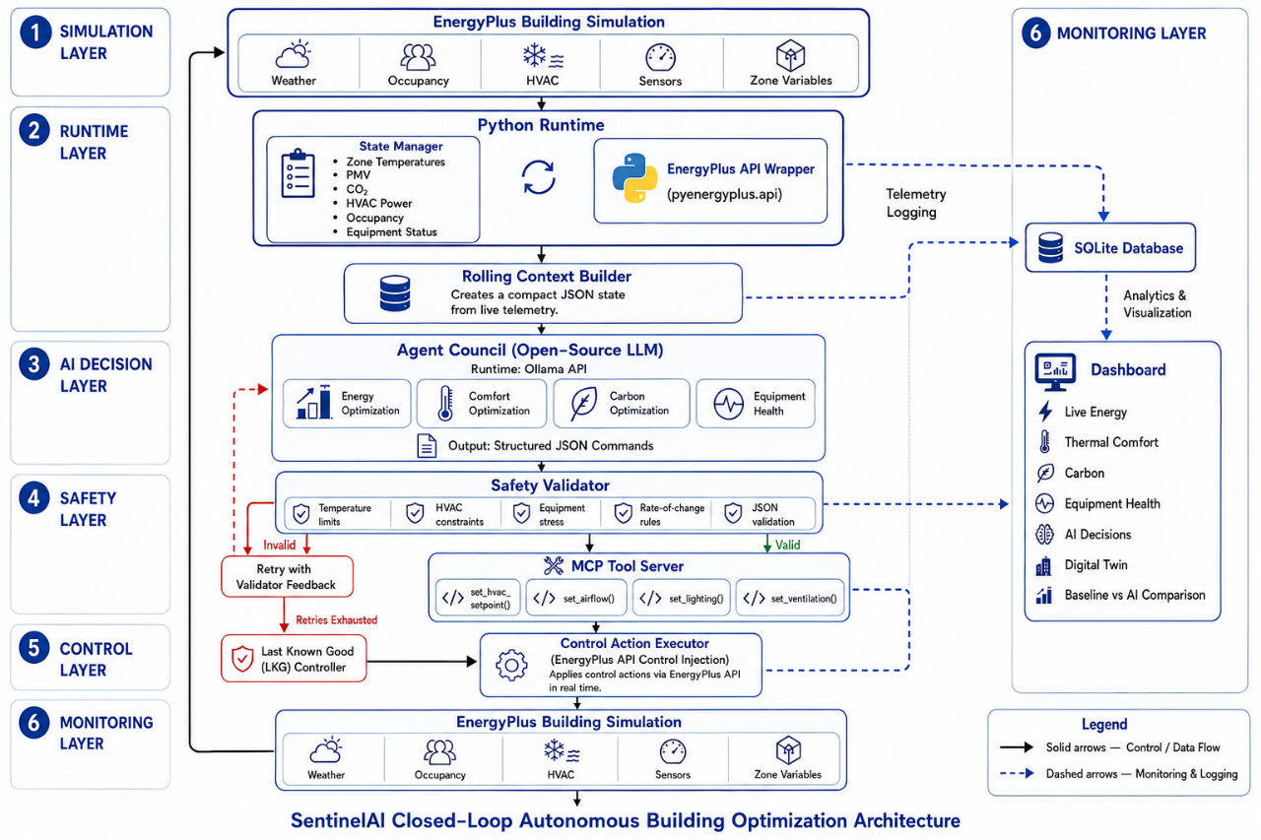

1. Tool-Calling Architecture & Agent Orchestration
SentinelAI employs a deterministic Model Context Protocol (MCP) architecture to bridge the gap between probabilistic Large Language Models (LLMs) and the strict physical constraints of the EnergyPlus physics engine.

- Agent Council Orchestrator: Instead of using raw unstructured generation, the LLM is prompted as a multi-objective "Agent Council". It outputs a strict JSON payload mapping directly to MCP tool signatures (e.g., set_hvac_setpoint, set_airflow).
- Safety Validator Interceptor: Before any LLM output touches the building, a 9-rule Safety Validator intercepts the proposed JSON. It checks physical bounds (e.g., setpoints between 18-26°C), rate limits (max 1.5°C delta per hour), and equipment stress bounds. If a rule is violated, it intercepts the tool call and forces the LLM to self-correct using targeted error feedback.
- EnergyPlus C-API Bridge: Once validated, the JSON payloads are converted into memory-address pointers and injected directly into the EnergyPlus C engine via pyenergyplus.api at every 15-minute zone timestep.

2. Prompt Engineering Strategies
To maintain consistent reasoning across multiple optimization objectives while minimizing hallucinations, SentinelAI uses a unified structured prompting strategy.

Rather than deploying four separate agent prompts (which multiplies latency and token costs), the prompt forces the LLM to write distinct reasoning chains for each objective before emitting the final actuator tool calls. The prompt instructs the model to explicitly evaluate energy efficiency, thermal comfort, carbon impact, and equipment health before producing a structured JSON action. This encourages consistent multi-objective reasoning while keeping the output deterministic.

3. Prompt Latency Management
In a live HVAC control system, latency is a critical safety parameter. We manage latency through three layers:
1. Streaming Response Processing: The system supports chunked streaming from the LLM. Instead of waiting for the full response, a custom regex parser aggregates the stream and extracts the JSON tool call block in real-time.
2. Context Minimization: We strictly forbid sending raw simulation logs to the LLM. The prompt consists only of a highly-dense JSON State object (occupancy, PMV, temps) and a short list of safety rule violations if it is in a retry state.
3. Deterministic Fallback (LKG): If the LLM times out (e.g., >10 seconds), experiences API failure, or fails safety validation 3 times in a row, the system instantly halts the LLM pipeline and falls back to a deterministic Last-Known-Good (LKG) rule-based engine, ensuring zero downtime in physical building operations.

4. Handling Lengthy Simulation Logs
EnergyPlus generates massive, verbose text logs (.eso, .err, .audit) that easily exceed million-token context windows if fed natively to an LLM.

- C-API Polling (Zero-Log Execution): SentinelAI completely bypasses text-log parsing. We use the EnergyPlus Python API to read variables directly from C memory pointers at runtime.
- Rolling Context Builder: Raw telemetry (e.g., fan power watts, room temperatures) is fed into a ContextBuilder which summarizes the data into a 10-step rolling average summary.
- SQLite Decoupling: The full, lengthy simulation logs are written atomically to a structured SQLite database (sentinel_ai.db). The LLM never sees this database. Instead, the Live Dashboard queries SQLite for quantitative plotting, isolating the LLM entirely from "Big Data" bloat.

Conclusion
SentinelAI demonstrates a complete closed-loop autonomous building management workflow by combining EnergyPlus, an LLM-based Agent Council, MCP tool execution, safety validation, and real-time telemetry. The architecture prioritizes deterministic tool execution, low-latency inference, and robust operation while maintaining occupant comfort and reducing energy consumption.

