**Childhood Diarrhoea Module**

Background 2

The Thanzi La Onse (TLO) Model 2

General approach to decisions on modelling causal influences and effects of interventions 2

Demographic and social characteristics modelled 2

Placing diarrhoea within TLO model 2

Approach to modelling diarrhoea: rationale for model structure and choice of parameter values 4

Disease definition and classifications 4

Conceptualisation of diarrhoea model structure 4

Limitations in the design of diarrhoea model concept 9

Properties and parameters of diarrhoea model 10

Disability Adjusted Life Year 13

Integrating Diarrhoea with the Health System 14

Health care seeking 14

Delivery of interventions at the health system 14

Next steps 19

Literature review 19

Code in Python program 19

Things to consider adding to the model: 19

Model outputs 20

Preliminary model outputs – without health systems input 20

References 22

# Background

## The Thanzi La Onse (TLO) Model

The Thanzi La Onse program is a multi-disciplinary research with the core objective to improve population health and reduce health inequities through data-informed prioritization of resource allocation in Malawi, Uganda, Southern and East Africa. As the basis of the analysis of the TLO program, the Epidemiology and Modelling stream is developing a model that aims to capture the health experiences of the population of Malawi and the consequent interactions with the health care system. The model will be used to inform prioritisation of health resources for Malawi’s next Health Sector Strategic Plan III (2022-2027). The model is an individual based model – which means we explicitly simulate the individual life and health experiences of a representative proportion of population of Malawi. The simulation initiates on 1 Jan 2010 and we attempt to simulate the attributes of the population at that point. We can run the model forward to any specified future time point. Each potential intervention and its associated diseases are being modelled. This is being divided into separate disease/intervention modules. This document describes the childhood diarrhoea module.

## General approach to decisions on modelling causal influences and effects of interventions

This module was designed in the context of an overall approach to modelling causal effects in general and causal effects of interventions in particular. The overall intent is to adopt as simple a structure as can be conceived, whilst still capturing the essential elements of a disease and the interventions used to prevent or treatment. We include a causal link between a “variable” (by which we mean a characteristic or property of an individual, whether that be demographic, social or biologic), and risk of disease or another variable if there is strong evidence from an overall body of studies that such a causal link exists and is at least moderately strong. In informing such decisions, we place particular value on RCTs or studies with a quasi-experimental design such as analyses based on an instrumental variable. There is no expectation that such studies will be from Malawi or even from Africa. If there are such local studies and in the unlikely event that they provide strong evidence to suggest that the causal link is substantively different in Malawi then the intent is that this is taken into account and the Malawi-specific link included.

In the special case of a potential causal variable which relates to whether an individual has experienced or is experiencing an intervention the intent is to only include interventions if there is substantial RCT evidence of their beneficial effect, based on trials with objectively ascertained clinical endpoints with low risk of serious bias. Whilst DCP-3 (and to some extent the Malawi EHP) provides an initial list of such interventions and the evidence to support them, where possible our intent has been to form our own opinion on intervention efficacy based on the source trials.

Unless there is evidence to the contrary, the intent is to summarize and incorporate intervention effects into the model as relative risks or rates rather than absolute differences due to the fact that such measures are less likely to differ substantively by context. Interactions between characteristics (on the multiplicative scale) are only to be incorporated if there is strong evidence. Again, we have not intended to rely on data from Malawi or Africa for such evidence but if local evidence exists which strongly suggests a different effect than elsewhere then the intent is that this modified effect is incorporated in the model.

## Demographic and social characteristics modelled

Based on data on the distribution of the population in Malawi according to geographic location we assign individuals a geographic location, which maps onto whether they are classified as living in a rural or urban area. Informed largely by data from the Malawi DHS, variables are also created indicating the person’s wealth level (based on 5 quintiles), whether the person has access to improved sanitation, clean drinking water, hand washing facilities, and whether they experience indoor air pollution (wood burning stove). We assign individuals a current education status (none, primary, secondary) which is updated 3 monthly from age 5 to 20. From age 15 BMI (in 5 groups) is assigned, as well as using tobacco, drinking excess alcohol, having low exercise, high salt intake, high sugar intake. The status with regard to such variables for individuals can change over time. The influences between these variables are described in detail in a separate document.

## Placing diarrhoea within TLO model

This simulation model is coded in Python, an object-oriented programming language, and it takes a modular approach, in which the functionality of the program is separated into independent, interconnected modules that can be executed on their own. Diarrhoea model resides in the epidemiological engine domain, responsible for assigning disease incidence, progression and the effects of health care activities.

Figure 1 - Schematic diagram of the interaction between diarrhoea and the health system

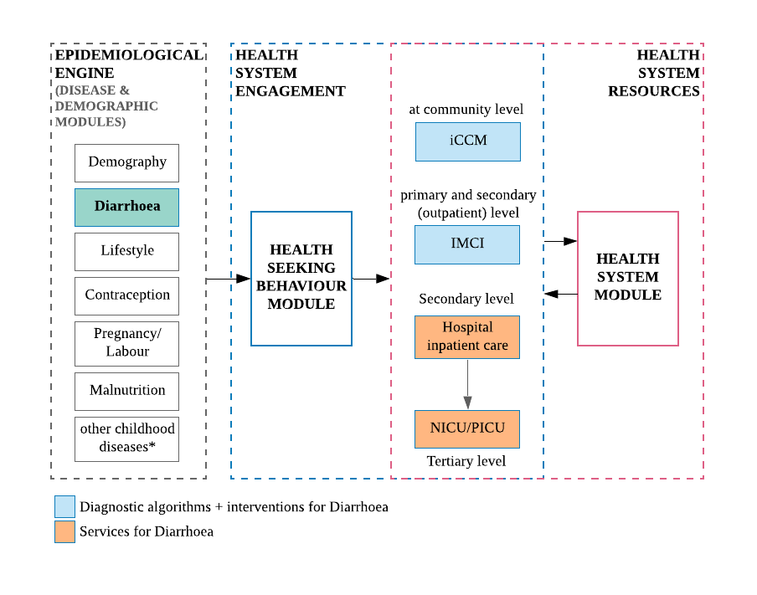

*other childhood diseases include: Acute Lower Respiratory Infection, HIV, TB, and Malaria – might not interact with the latter two.

Interactions with the health system require careful conceptualisation to not only accurately reflect current burden of disease during the neonatal and childhood periods, but also to fit within the larger TLO model of all health and health care provision in Malawi, and to allow tailoring of the interventions to improve health outcomes given available and projected resources. The diarrhoea module will be based on parts of the epidemiological and health systems aspects of the TLO model, developed by members of the Epidemiology and Modelling team – this includes, demographic and social characteristics (Demography module), lifestyle-related risk factors (Lifestyle module), fertility rate deriving the under-5 population number (Contraception Module), characteristics of the newborn at birth (Pregnancy and Labour modules), interactions with other childhood-related disease modules, health care seeking (Health Seeking Behaviour module) and the interactions with the Health Systems module which will provide the availability of resources (health facility type, staff availability, drug stock, diagnostic tests) for the interventions to take place.

# Approach to modelling diarrhoea: rationale for model structure and choice of parameter values

## Disease definition and clinical classifications

Diarrhoea continues to be the second leading cause of death in children under 5 years of age, and the leading cause of malnutrition (WHO, diarrhoea fact sheet). Children are particularly at greater risk of life-threatening dehydration since water constitutes a great proportion of a child’s bodyweight.

It is usually a symptom of an infection in the intestinal tract, but is not a single disease entity and has many different aetiologies. Thus, there has been considerable variability in the definition of diarrhoeal episodes1. According to WHO, diarrhoea is defined as the passage of loose or watery stools at least three times per day (or more frequent passage than is normal for the individual)(WHO, diarrhoea fact sheet). Because WHO-definition of diarrhoea is the most widely used in field studies in low- and middle income countries and therefore, in the estimation of global burden of diarrhoea, it will be the definition used in the design of model structure.

Based on the WHO classification of diarrhoeal diseases, there are three clinical types:

**Acute watery diarrhoea** – the most common type of acute diarrhoea, usually lasting for several hours or days. It is classified according to stool volume: it is a mild episode if less than 5% of body weight, moderate if between 5 to 10% of body weight, and severe if over 10%2. Most episodes are mild and self-limited, lasting an average of 4.3 days3, but severe cases can be potentially life-threatening due to the significant fluid loss and rapid dehydration in an infected individual. This clinical type does not require antibiotics to treat the gastrointestinal infection, only suspected cholera cases need antibiotic treatment.

**Acute bloody diarrhoea or dysentery** – this clinical type includes any diarrhoeal episode in which loose or watery stools contain visible blood, with or without mucus. The most common bacterial pathogen is *Shigella dysenteriae*, it causes inflammation and damage of the intestinal mucosa, with direct nutrient losses. It generally requires antibiotics to treat the infection, to limit the acute complications and long-term health impacts.

**Persistent diarrhoea** – a diarrhoeal episode that begins acutely and persists for more than 14 days. The progression to persistent diarrhoea, with or without blood, is more common in children with poor immunity: protein-energy malnutrition, micronutrient deficiencies in vitamin A and zinc, and AIDS can result in poor mucosal healing and persistent diarrhoea. Diarrhoea, in turn, tends to worsen their condition, in a vicious cycle of infection and malnutrition, leading to stunted growth and cognitive impairment in some children2.

By categorising into these three main types, it enables health workers following WHO recommendations to recognise the problem and to provide rapid and effective treatment through standard case management. The correct strategy for the treatment of diarrhoea can prevent up to 90% of deaths due to diarrhoea.

Table 1 - The three types of diarrhoea and respective percentage of death preventable by standard case management 4

|  |  |  |  |
| --- | --- | --- | --- |
| Type of diarrhoea | % of all cases of childhood diarrhoea | % of all childhood deaths due to diarrhoea | % of death preventable by standard case management |
| Acute watery | 80 | 50 | 100 |
| Dysentery | 10 | 15 | 80 |
| Persistent | 10 | 35 | 80 |
| Total | 100 | 100 | 90 |

## Conceptualisation of diarrhoea model structure

The natural history of diarrhoea depends on several factors including, the biology of the pathogens, its virulence and inoculum size; the susceptibility of the host, previous exposure and pre-existing immunity or passively acquired immunity from breast milk; and the health and nutritional status of the individual at the time of exposure2. Exposure to gastro-enteric pathogens does not necessarily lead to infections, and infection does not necessarily lead to clinical illness. It can manifest from no symptoms, to self-limiting mild or moderate diarrhoea, to severe and life-threatening condition. The susceptible individual can develop one of the three clinical types of diarrhoea described above, which will be the focus in the modelling of the natural history of diarrhoea for TLO.

Figure 2 - Proposed structure of diarrhoea natural history model

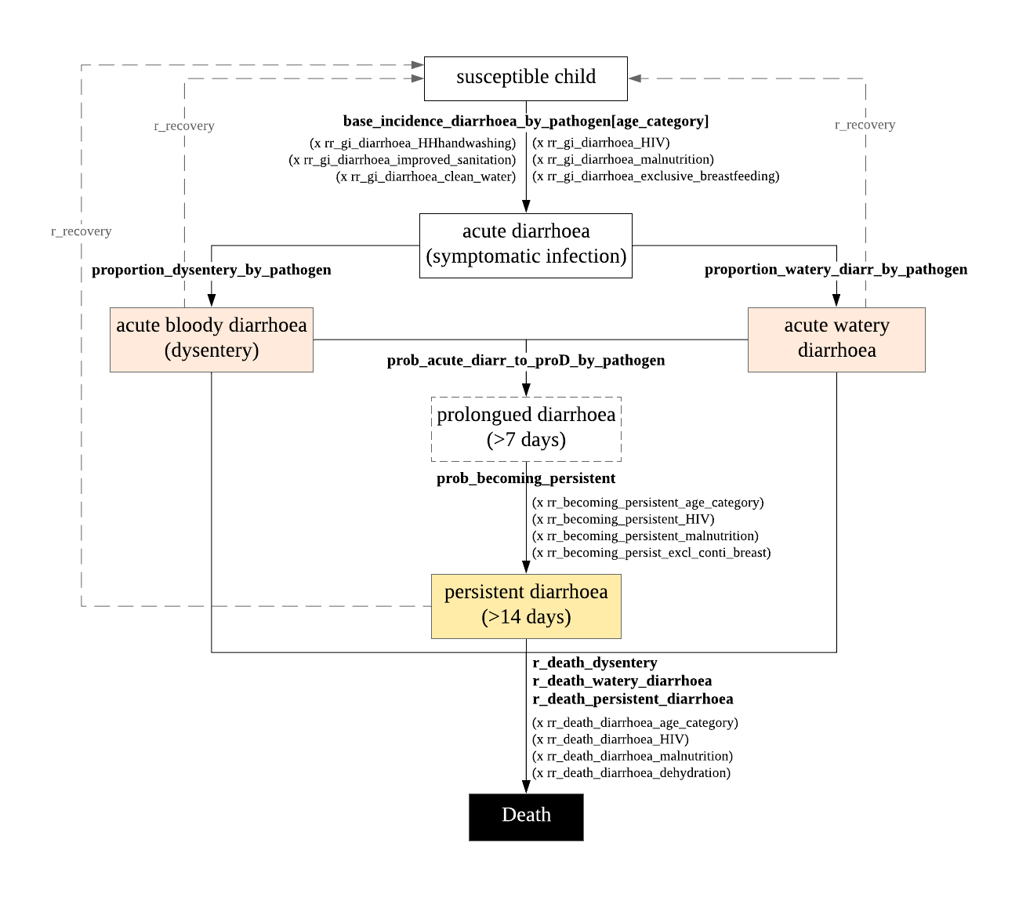

*This current structure does not include associated complications arising from diarrhoea. The main acute complications from diarrhoea is dehydration, from which life-threatening complications arise: shock (circulatory failure, multi-organ dysfunction) to death. Dehydration is not included in the natural history structure, though it will be a key condition in the causal pathway to death, among other important conditions associated with diarrhoea mortality, such as, malnutrition, and HIV.

The WHO pocketbook pointed out complications associated with dysentery: dehydration, potassium depletion, high fever, rectal prolapse, convulsions (hypoglycaemia), haemolytic uraemic syndrome, toxic megacolon, intestinal perforation.

The proposed structure is based on the WHO’s definition and classification of clinical diarrhoea. The parameterization of diarrhoea model is be based on the results of two important studies on the burden of diarrhoeal disease among children in developing countries. These are the Global Enteric Multicentre Study (GEMS), a case-control at seven sites5 and the Aetiology, Risk Factors, and Interactions of [Enteric Infections](https://www.sciencedirect.com/topics/medicine-and-dentistry/intestine-infection) and [Malnutrition](https://www.sciencedirect.com/topics/medicine-and-dentistry/malnutrition) and the Consequences for [Child Health and Development](https://www.sciencedirect.com/topics/medicine-and-dentistry/child-development) (MAL-ED) multisite birth [cohort study](https://www.sciencedirect.com/topics/medicine-and-dentistry/cohort-analysis)6.

The GEMS study was a 3-year, population-based, case-control of acute moderate-to-severe diarrhoea (MSD) among children under-5 seeking care at a health centre, in Kenya, Mali, Mozambique, The Gambia, Bangladesh, India and Pakistan. This study captured cases that were more severe: bloody stools, evidence of dehydration, hospitalization, or administration of intravenous fluids5. Whereas, the MAL-ED study was a longitudinal community-based study following a newborn cohort until their second birthday in Bangladesh, Brazil, India, Nepal, Peru, Pakistan, South Africa, Tanzania. The latter study was able to capture milder forms of diarrhoea disease and provides a more accurate measure of incidence. For the model, the study results used to inform the parameters are the most recent reanalysis studies of the data using quantitative PCR, as this method has higher sensitivity than the original methodology with microbiology7 8.

Due to the magnitude of biological diversity9, the childhood diarrhoea module models the top 10 pathogens responsible for pathogen-attributable diarrhoea, results from the reanalysis study of MAL-ED data7 and the reanalysis study of GEMS data8.

The model of childhood diarrhoeal disease begins with the susceptible population of children under 5 years of age. The incidence of diarrhoea caused by individual pathogens per age group [0-11, 12-23, 24-59 months] will directly assign diarrhoea status (symptomatic infection). Currently the model uses the incidence estimates from the MAL-ED reanalysis study in Tanzania for ages 0-11 and 12-24 months. For the 24-59 months old, the pathogen-attributable incidence is based on the GEMS total-countries estimate of less severe diarrhoea (LSD) + MSD in the 24-59 months category, adding to a total LSD+MSD incidence of 22.2 episodes per 100 child-years10 – which is then fractioned into pathogen-specific rate of diarrhoea based on the attributable fractions (AFs) for MSD in Mozambique (no reanalysis data on the LSD pathogen AFs). In terms of WHO’s classification of diarrhoea types, LSD are acute watery diarrhoea with no dehydration, whereas MSD include dysentery (with or without dehydration present) and acute watery diarrhoea with some or severe dehydration. The calculated estimates are shown in last column of Table 2. It assumes that AFs for the 10 pathogens causing MSD applies to the less severe diarrhoea cases.

Table 2 - Incidence of attributable diarrhoea episodes per 100 child-years using MAL-ED estimates from Tanzania for children aged 0-24 months and GEMS estimates for ages 24-59 months

|  |  |  |  |
| --- | --- | --- | --- |
| Pathogen | incidence among 0-11 months old | incidence among 12-23 months old | incidence among 24-59 months old* |
| rotavirus | 17.5245863 | 9.7007598 | 0.9324 |
| shigella | 11.7936462 | 7.8794104 | 9.3018 |
| adenovirus 40/41 | 5.8661803 | 8.7727311 | 0.6438 |
| cryptosporidium | 3.0886699 | 1.1792363 | 0.4662 |
| campylobacter | 9.8663257 | 2.7915478 | 0.4884 |
| ETEC | 27.9251462 | 17.0477152 | 1.9758 |
| sapovirus | 10.0972179 | 13.2603114 | 0.555 |
| norovirus | 20.4864004 | 6.6146727 | 0.0888 |
| astrovirus | 5.4208352 | 3.5974076 | 0.1332 |
| tEPEC | 6.0822457 | 2.2716889 | 0.1998 |
| Top 10 total | 118.1512538 | 73.1154812 | 14.7852 |
| other causes | 33 | | 7.4148 |
| Total | 128.5 | | 22.2 |

*incidence of diarrhoea by attributable pathogen in this age group was derived using the results from two GEMS studies.

The total incidence of diarrhoea among children aged 0-24 months in the Tanzanian study site was estimated to be 128.5 episodes per 100 child-years. These 10 pathogens make up 95.5 ep/100cy, or 74.32% of all-cause diarrhoea episodes.

Depending on the attributable pathogen, it can cause an episode of acute watery diarrhoea or bloody diarrhoea. The proportions for each clinical type are also based on the MAL-ED results.

Immunity overtime with recurrent infections is hindered in the incidence of diarrhoea by age category, as it decreases with age. And therefore, it is not included in the model.

### Risk factors for acquiring diarrhoea

After the assignment of base incidence of diarrhoea by pathogen for each age group, the effects of risks factors are added to the incidence rate. These are WASH components: clean drinking water, improved sanitation and handwashing with soap11 (values from lifestyle module), host factors such as, passive immunity through breastfeeding, impaired immunity (HIV/AIDS), nutrition status and rotavirus vaccination (for the incidence of diarrhoea by rotavirus only). The relative rate of diarrhoea for these risk factors are assumed to be the same across all pathogens.

Table 3 - Risk factors to consider for incidence of diarrhoea

|  |  |  |  |  |  |
| --- | --- | --- | --- | --- | --- |
| **Risk factor** | **Description** | | **Value** | **Ref** | **Notes** |
| improved sanitation |  | | RR = 0.75 (0.63-0.88) | 12 | meta-analysis and meta-regression |
| improved source of drinking water |  | | RR = 0.67 (0.62-0.73) |
| handwashing with soap | *interventions promoting handwashing with soap | | RR = 0.70 (0.64-0.77) |
| Exclusive breastfeeding | Exclusive vs partial breastfeeding 0-5 months | | RR=1.68 (1.03-2.76) | 13 | Meta-analysis |
| Exclusive vs no breastfeeding 0-5 months | | RR=2.65 (1.72-4.07) | Risk ratio on Diarrhoea incidence |
| Any breastfeeding vs no breastfeeding 6-11 months | | RR=1.32 (1.06-1.63) |  |
| Underweight | -3 to <-2 WAZ vs reference group less than 1 WAZ | | RR=1.2 (1.1-1.4) | 14 | RR- relative risk |
| HIV status | HIV-infected children were more likely to have MSD | | OR=5.6 | 15 | HIV+ MSD vs LSD GEMS Mozambique |
| Rotavirus vaccination | < 1 year old | RV1 prevents 63% of severe rotavirus cases | RR=0.37, (0.23-0.60) | 16 | Cochrane review, RR – risk ratio  High-certainty evidence |
| RV1 prevents 27% of severe all cause diarrhoea | RR=0.73, (0.56-0.95) | High-certainty evidence |
| RV5 prevents 57% of severe rotavirus | RR=0.43, (0.29-0.62) | High-certainty evidence |
| RV5 prevents 15% of severe all cause diarrhoea | - | Moderate-certainty evidence |
| 1-2 years old | RV1 prevents 35% of severe rotavirus | RR=0.65, (0.51-0.83) | High-certainty evidence |
| RV1 prevents 17% of severe all cause diarrhoea | RR=0.83, (0.72-0.96) | Moderate-certainty evidence |
| RV5 prevents 41% of severe rotavirus diarrhoea | RR=0.59, (0.43 to 0.82) | High-certainty evidence |
| RV5 prevents 15% of severe all cause diarrhoea | RR=0.85, (0.75 to 0.98) | High-certainty evidence |

### Risk factors for becoming persistent diarrhoea

An extra step in the acute phase of a diarrhoeal episode (< 14 days) was included in the model: the prolonged diarrhoea phase. Most episodes are mild and self-limited, lasting an average of 4.3 days3, but when an acute diarrhoea is not resolved in less than 7 days, it is considered to be prolonged (7- 13 days), before it is classified as persistent diarrhoea if the episode has been occurring for 14 days or longer.

Up to 20% of diarrhoea episodes can become persistent18, with higher risk of death. If dehydration is present, then in the health system it is considered to be severe persistent diarrhoea and managed differently from non-dehydration persistent diarrhoea. In the model, a proportion of those acute episodes will be prolonged, based on the MAL-ED reanalysis data, for which a probability of becoming a persistent episode is applied with added effects of risk factors on this progression: malnutrition, age, HIV status and exclusive or continued breastfeeding.

Table 4 - Risk factors to consider for persistent diarrhoea

|  |  |  |  |  |
| --- | --- | --- | --- | --- |
| Risk factor | Description | Value | Reference | Notes |
| HIV status |  |  |  |  |
| Vitamin A deficiency |  | aOR=4.28 (1.26-14.09) | 19 | Location – India  Small sample size, persistent cases = 60, acute cases=60 |
| Prior antibiotic use |  | aOR=5.28 (2.01-13.74) |
| Severe acute malnutrition | Z score (weight for height) <-2 | aOR=1.66 (1.0-2.77) |
| ALRI |  | aOR=3.69 (1.36-10.07) |
| Zinc deficiency |  |  |  |  |
| Exclusive breastfeeding |  |  |  |  |
| Cryptosporidiosis |  |  |  |  |

Currently in the model risk factors for persistent diarrhoea are dummy values for temporary properties of HIV status, malnutrition and breastfeeding. Which will interact with the responsible modules when merged in the Master code.

### Risk factors for death from diarrhoea

The biggest threat posed by a diarrhoeal illness is the associated dehydration. During a diarrhoeal episode, the loss of water and salts causes a disturbance of electrolytes. Without replacement of fluid (rehydration), it can progress to circulatory failure, dysfunction of critical organs and death. The WHO’s definition of dehydration level are stratified into: no dehydration (loss of less than 5% of body weight), some dehydration (loss of 5-10% of body weight) and severe dehydration (loss of over 10% of body weight).

If the pathogen is causing ‘any dehydration’ in that diarrhoeal episode, dehydration level is then categorised into ‘some’ or severe dehydration’. Levels of dehydration are classified from no dehydration, some dehydration to severe dehydration. Different levels require appropriate treatment plan.

Death rate from each diarrhoea type differ (watery vs. bloody), also depending on dehydration status and other important co-morbidities, such as malnutrition. Children with acute and chronic malnutrition are at increased risk of morbidity and mortality following a diarrhoeal episode. Malnutrition can make a diarrhoeal episode more severe, prolonged and more frequent than well-nourished children. With diarrhoea causing decreased nutrient absorption, aggravates malnutrition by causing weight loss and growth impairment. Treatment regimen for children with malnutrition is different18.

Table 5 - Risk factors to consider for death from diarrhoea

|  |  |  |  |  |
| --- | --- | --- | --- | --- |
| Risk factor | Description | Value | Ref | Notes |
| Dehydration | Diarrhoea without dehydration vs with dehydration | HR=0.29 (0.14-0.59) | 20 | LSD vs non-dysenteric MSD - risk of death in hazard ratio |
| Shigella | Presence of Shigella in non-dysenteric MSD | HR=2.2 (1.2-3.9) | Shigella was strongly associated with increased risk of death |
| Shigella associated with mortality while dysentery was not | OR=2.8, (1.6-4.8) | 21 | Meta-analysis pooled OR |
| Severe acute malnutrition | Just ‘malnutrition’ in the study | HR=4.13 (2.428- 6.877) | 22 | GEMS Mozambique MSD, Multivariate analysis |
| ALRI |  | HR=3.51 (2.158-5.682) | Hazard Ratio is the relative change in Hazard per one month increase in age |
| Cryptosporidium infection |  | HR=2.14 (1.289-3.487) |
| Invasive bacterial disease |  | HR=6.8 (2.435, 15.516) |
| HIV | Univariate analysis for HIV | HR=5.05 |  |
| Underweight | -2 to <-1 WAZ | OR=2.1 (1.6-2.7) | 23 | Reference group - more than -1 WAZ/HAZ/WHZ,  adjusted for socio-economic factors |
| -3 to <-2 WAZ | OR=3·4 (2.7–4.4) |
| <-3 WAZ | OR=9.5 (5.5-16.5) |
| Stunting | -2 to <-1 HAZ | OR = 1.2 (0.9 – 1.7) |
| -3 to <-2 HAZ | OR= 1.6 (1.1-2.5) |
| <-3 HAZ | OR = 4.6 (2.7-8.1) |
| Wasting | -2 to <-1 WHZ | OR = 1.2 (0.7 – 1.9) |
| -3 to <-2 WHZ | OR= 2.9 (1.8-4.5) |
| <-3 WHZ | OR = 6.3 (2.7-14.7) |

All these risk factors (disease acquisition, persistent diarrhoea and death) are not final, just place holder for the parameters’ values. It will require a more thorough review of the literature.

## Limitations in the design of diarrhoea model concept

The community-based attributable incidence of diarrhoea from MAL-ED study used to parameterise the model is based on the Tanzanian study site estimates. These were of a small sample size, n=145 analysed diarrhoeal stools in the 0-11 months old and n=26 in the 12-24 months old. However, using the overall countries incidence estimate may overestimate the population-incidence of diarrhoea in Malawi, due to the high burden of diarrhoea in some sites (Dhaka, Bangladesh; Vellore, India; and Bhaktapur, Pakistan).

Additionally, for the calculation of the attributable-incidence among the 24-59 months old, the GEMS data was used. The results from the GEMS study are based on active care-seeking population and therefore, may not reflect the overall and pathogen-specific population-based incidence values. Also, the attributable fractions of each pathogens used in this calculation, were based on the Mozambique estimates, with a sample size of MSD n=86 case-control pairs.

The model does not incorporate mixed infections, which may increase in diarrhoea severity. The case-control methodology of both studies can only inform an association between pathogens and diarrhoea, whereas we assume causal pathway in a mathematical model.

No seasonality of diarrhoeal infections is included in the model; it would need published data to inform these for each pathogen modelled, and to be specific to Malawi.

Modelling dehydration as the underlying complication in children with diarrhoea will not be accurate, as there is no gold standard in detecting dehydration in real-life settings, but only proxy measure through signs and symptoms severity.

## Properties and parameters of diarrhoea model

The Diarrhoea module updates information on each individual (under 5 years of age) with regards to their diarrhoea status every 3 months. The variables describing the state of the disease include diarrhoea status (yes/no), the attributable pathogen, the clinical type of the current/last episode (acute watery diarrhoea or dysentery), the duration of the episode (if >14 days it is considered to be persistent diarrhoea and treated accordingly) the level of dehydration (no dehydration, some dehydration, severe dehydration), and date of onset of diarrhoea, recovery and death, as described in Table 6.

Table 6 - Properties owned by the childhood diarrhoea module

|  |  |  |
| --- | --- | --- |
| Variable name (Properties) | Type | Description |
| gi_diarrhoea_status | Boolean | Clinical manifestation of an enteric infection - symptomatic infection |
| gi_diarrhoea_pathogen | Categorical  ‘rotavirus’, ‘adenovirus’, ‘cryptosporidium’, ‘shigella’, ‘campylobacter’,  ‘ST-ETEC’, ‘sapovirus’, ‘norovirus’, ‘astrovirus’, ‘tEPEC’, ‘other’ | Attributable pathogens |
| gi_ diarrhoea_type | Categorical  ‘acute watery diarrhoea’, ‘dysentery’ | Type of acute diarrhoea |
| gi_diarrhoea_duration | Integer | Number of days of the last episode of diarrhoea |
| gi_diarrhoea_dehydration | Categorical  ‘no dehydration’  ‘some dehydration’  ‘severe dehydration’ | Dehydration level  These are based on WHO categorization of dehydration |
| gi_last_diarrhoea_date_of_onset | Date | Date of onset of diarrhoea |
| gi_last_diarrhoea_recovered_date | Date | Date of recovery from diarrhoea |
| gi_last_diarrhoea_death_date | Date | Date of death due to diarrhoea |

‘gi_’ stands for gastrointestinal infection – as a prefix representation of properties within the Diarrhoea module.

ST-ETEC – Heat-Stable Enterotoxigenic Escherichia coli; tEPEC – typical Enteropathogenic Escherichia coli

The values of diarrhoea incidences by pathogen by age group are displayed in Table 7 as episodes per child per year, together with all other parameters of the natural history model and suggested values.

Table 7 - Parameters of the natural history of diarrhoea

|  |  |  |  |
| --- | --- | --- | --- |
| Parameters | Description | Value | Reference and Notes |
| base_incidence_diarrhoea_by_rotavirus | a list of incidence of diarrhoea caused by rotavirus in each age group [0-11, 12-23, 24-59] | 0.1752, 0.0970, 0.0093 | Platts-Mills et al 2018, Liu et al, 2016, Nasin, et al. 2019. Yearly incidence rate, ideally the base group of no improved sanitation, no clean drinking water, no handwashing with soap, and no exclusive breastfeeding, HIV negative, no SAM, no rotavirus vaccination. For ages 0-11 and 12-23 months, the attributable incidences are given by the MAL-ED study in Tanzania. Values were calculated from the GEMS study results using the total incidence of LSM + MSD for each age category 24-59 months, then multiplied by the attributable fraction of each pathogen in GEMS Mozambique to get the incidence of diarrhoea (non-severe and severe) by pathogen in age category 24-59 months |
| base_incidence_diarrhoea_by_shigella | a list of incidence of diarrhoea caused by shigella in each age group [0-11, 12-23, 24-59] | 0.1179, 0.0788, 0.0930 |
| base_incidence_diarrhoea_by_adenovirus | a list of incidence of diarrhoea caused by adenovirus in each age group [0-11, 12-23, 24-59] | 0.0587, 0.0877, 0.0064 |
| base_incidence_diarrhoea_by_crypto | a list of incidence of diarrhoea caused by cryptosporidium in each age group [0-11, 12-23, 24-59] | 0.0309, 0.00118, 0.00466 |
| base_incidence_diarrhoea_by_campylo | a list of incidence of diarrhoea caused by campylobacter in each age group [0-11, 12-23, 24-59] | 0.0986, 0.00279, 0.00488 |
| base_incidence_diarrhoea_by_ETEC | a list of incidence of diarrhoea caused by ST-ETEC in each age group [0-11, 12-23, 24-59] | 0.2792, 0.1705, 0.01976 |
| base_incidence_diarrhoea_by_sapovirus | a list of incidence of diarrhoea caused by sapovirus in each age group [0-11, 12-23, 24-59] | 0.10097, 0.1326, 0.00555 |
| base_incidence_diarrhoea_by_norovirus | a list of incidence of diarrhoea caused by norovirus in each age group [0-11, 12-23, 24-59] | 0.2049, 0.06614, 0.00088 |
| base_incidence_diarrhoea_by_astrovirus | a list of incidence of diarrhoea caused by astrovirus in each age group [0-11, 12-23, 24-59] | 0.0542, 0.03597, 0.00133 |
| base_incidence_diarrhoea_by_EPEC | a list of incidence of diarrhoea caused by tETEC in each age group [0-11, 12-23, 24-59] | 0.0608, 0.02271, 0.002 |
| rr_gi_diarrhoea_HHhandwashing | relative rate of acquiring diarrhoea for children with household handwashing practice | 0.7 | independent risk factors assumed to have the same values for all pathogens for now |
| rr_gi_diarrhoea_improved_sanitation | relative rate of acquiring diarrhoea for children with improved sanitation | 0.75 |  |
| rr_gi_diarrhoea_clean_water | relative rate of acquiring diarrhoea for children with access to clean drinking water | 0.67 |  |
| rr_gi_diarrhoea_excl_breastfeeding | relative rate of acquiring diarrhoea for children that are exclusively breastfeed | 2.65 |  |
| rr_gi_diarrhoea_conti_breast | relative rate of acquiring diarrhoea for children that are continued breastfeed | 1.32 |  |
| rr_gi_diarrhoea_HIV | relative rate of diarrhoea for HIV+ status | dummy |  |
| rr_gi_diarrhoea_malnutrition | relative rate of diarrhoea for severe acute malnutrition | dummy |  |
| rr_gi_diarrhoea_rotavirus_vaccination | relative rate of diarrhoea for children that are vaccinated for rotavirus | dummy | only for rotavirus-cause diarrhoea |
| proportion_AWD_by_rotavirus | proportion of acute watery diarrhoea caused by rotavirus | 0.977 | Platts-Mills et al 2018, pathogen causing AWD or dysentery, assumed to be constant throughout the age groups, estimates from MAL-ED study |
| proportion_AWD_by_shigella | proportion of acute watery diarrhoea caused by shigella | 0.862 |
| proportion_AWD_by_adenovirus | proportion of acute watery diarrhoea caused by adenovirus | 0.95 |
| proportion_AWD_by_crypto | proportion of acute watery diarrhoea caused by cryptosporidium | 0.971 |
| proportion_AWD_by_campylo | proportion of acute watery diarrhoea caused by campylobacter | 0.897 |
| proportion_AWD_by_ETEC | proportion of acute watery diarrhoea caused by ST-ETEC | 0.95 |
| proportion_AWD_by_sapovirus | proportion of acute watery diarrhoea caused by sapovirus | 0.966 |
| proportion_AWD_by_norovirus | proportion of acute watery diarrhoea caused by norovirus | 0.962 |
| proportion_AWD_by_astrovirus | proportion of acute watery diarrhoea caused by astrovirus | 0.974 |
| proportion_AWD_by_EPEC | proportion of acute watery diarrhoea caused by tEPEC | 0.961 |
| dehydration_by_rotavirus | probability of dehydration for rotavirus-attributed diarrhoea | 0.153 | Platt-Mills et al. 2018, pathogen-specific dehydration probability, assumed to be constant throughout the age groups, estimates from MAL-ED study |
| dehydration_by_shigella | probability of dehydration for shigella-attributed diarrhoea | 0.103 |
| dehydration_by_adenovirus | probability of dehydration for adenovirus-attributed diarrhoea | 0.079 |
| dehydration_by_crypto | probability of dehydration for cryptosporidium-attributed diarrhoea | 0.121 |
| dehydration_by_campylo | probability of dehydration for campylobacter-attributed diarrhoea | 0.073 |
| dehydration_by_ETEC | probability of dehydration for ST-ETEC-attributed diarrhoea | 0.076 |
| dehydration_by_sapovirus | probability of dehydration for sapovirus-attributed diarrhoea | 0.104 |
| dehydration_by_norovirus | probability of dehydration for norovirus-attributed diarrhoea | 0.091 |
| dehydration_by_astrovirus | probability of dehydration for astrovirus-attributed diarrhoea | 0.123 |
| dehydration_by_EPEC | probability of dehydration for EPEC-attributed diarrhoea | 0.113 |
| prolonged_diarr_rotavirus | probability of prolonged episode for rotavirus-attributed diarrhoea | 0.117706 | Platt-Mills et al. 2018, pathogen-specific probability of a prolonged episode, assumed to be constant throughout the age groups, estimates from MAL-ED study |
| prolonged_diarr_shigella | probability of prolonged episode for shigella-attributed diarrhoea | 0.165342 |
| prolonged_diarr_adenovirus | probability of prolonged episode for adenovirus-attributed diarrhoea | 0.116406 |
| prolonged_diarr_crypto | probability of prolonged episode for cryptosporidium-attributed diarrhoea | 0.169134 |
| prolonged_diarr_campylo | probability of prolonged episode for campylobacter-attributed diarrhoea | 0.152206 |
| prolonged_diarr_ETEC | probability of prolonged episode for ST-ETEC-attributed diarrhoea | 0.114177 |
| prolonged_diarr_sapovirus | probability of prolonged episode for sapovirus-attributed diarrhoea | 0.133209 |
| prolonged_diarr_norovirus | probability of prolonged episode for norovirus-attributed diarrhoea | 0.118223 |
| prolonged_diarr_astrovirus | probability of prolonged episode for astrovirus-attributed diarrhoea | 0.13511 |
| prolonged_diarr_EPEC | probability of prolonged episode for EPEC-attributed diarrhoea | 0.190845 |
| prob_dysentery_become_persistent | rate of dysentery becoming persistent diarrhoea, baseline group 0-11 months, HIV negative, no SAM, exclusive or continued breastfeeding, with no vitamin A and zinc deficiency | 0.01144 | Bhandari et al 1992 (not considered the risk factors for becoming persistent in each diarrhoea type) |
| prob_watery_diarr_become_persistent | rate of acute watery diarrhoea becoming persistent diarrhoea, baseline group 0-11 months, HIV negative, no SAM, exclusive or continued breastfeeding, with no vitamin A and zinc deficiency | 0.04056 |
| rr_bec_persistent_age12to23 | relative rate of dysentery or acute watery diarrhoea to become persistent for ages 12-23 | dummy |  |
| rr_bec_persistent_age24to59 | relative rate of dysentery or acute watery diarrhoea to become persistent for ages 24-59 | dummy |  |
| rr_bec_persistent_HIV | relative rate of dysentery or acute watery diarrhoea to become persistent for HIV+ status | dummy |  |
| rr_bec_persistent_SAM | relative rate of dysentery or acute watery diarrhoea to become persistent for severe acute malnutrition | dummy |  |
| rr_bec_persistent_excl_breast | relative rate of dysentery or acute watery diarrhoea to become persistent for not exclusively breastfeeding upto 6 months | dummy |  |
| rr_bec_persistent_cont_breast | relative rate of dysentery or acute watery diarrhoea to become persistent for not continued breastfeeding from 6 months to 2 years | dummy |  |
| rr_becoming_persistent_vitA | relative rate of dysentery or acute watery diarrhoea to become persistent for vitamin A deficiency | dummy |  |
| rr_becoming_persistent_zinc | relative rate of dysentery or acute watery diarrhoea to become persistent for zinc supplementation | 0.73 | Lazzerini and Wanzira 2016, zinc reduces the number of children whose diarrhoea persists until day seven |
| case_fatality_rate_AWD | case fatality rate for acute watery diarrhoea | 0.0056 | Bhandari et al 1992 |
| case_fatality_rate_dysentery | case fatality rate for dysentery | 0.0427 |
| case_fatality_rate_persistent | case fatality rate for persistent diarrhoea | 0.1395 |

## Disability Adjusted Life Year

DALYs for Diarrhoea will be computed by the Health Burden Module. Currently we consider three diarrhoeal states; mild, moderate and severe which relate to the DALY weights presented below.

Table 8 - DALY weights associated with diarrhoea disease

|  |  |  |  |  |  |  |
| --- | --- | --- | --- | --- | --- | --- |
| TLO-Code | Sequelae | Health state name | Description | Disability weight | Lower | Upper |
| 32 | Mild diarrhoeal disease | Diarrhoea, mild | has diarrhoea three or more times a day with occasional discomfort in the belly. | 0.074 | 0.049 | 0.104 |
| 35 | Moderate diarrhoeal diseases | Diarrhoea, moderate | has diarrhoea three or more times a day, with painful cramps in the belly and feeling thirsty | 0.188 | 0.125 | 0.264 |
| 34 | Severe diarrhoeal diseases | Diarrhoea, severe | has diarrhoea three or more times a day with severe belly cramps. The person is very thirsty and feels nauseous and tired. | 0.247 | 0.164 | 0.348 |

The sequelae ‘mild diarrhoeal disease’ equals to diarrhoea without dehydration, ‘moderate diarrhoeal disease’ equals to diarrhoea with some dehydration, and ‘severe diarrhoeal disease’ equals to diarrhoea with severe dehydration, as per WHO classification of dehydration. (Assumption)

# Integrating Diarrhoea with the Health System

## Health care seeking

A set of signs and symptoms arising from diarrhoea module are incorporated in the Symptoms Manager. This is a module in the TLO model that manges all symptoms coming from all disease modules and organises them for Health Seeking Behaviour module's use. The latter will then assign a probability of care seeking based on the Ng’ambi et al. 2020 analyses of the 2016 Malawi Integrated Household Survey data24. Those who sought care will then interact will the health system.

Diarrhoea module generates the following symptoms: diarrhoea, bloody stools, fever, vomiting, and dehydration signs (ideally, each sign on the WHO IMCI algorithm for dehydration – though dependent on data available to inform these). Symptoms of fever and vomiting are assigned to each individual with diarrhoea according to the attributable pathogen. This is also applied for prolonged episode and any dehydration in the diarrhoeal episode. These parameter values are informed by the MAL-ED reanalysis supplementary material.

## Delivery of interventions at the health system

Key measures to prevent diarrhoea:

* Vitamin A supplementation
* Vaccination: rotavirus
* Access to safe drinking water & use of improved sanitation, handwashing with soap
* Exclusive breastfeeding for the first 6 months of life
* HIV prevention / Cotrimoxazole prophylaxis for HIV-infected and exposed children

Key measures to treat diarrhoea:

* Improved care seeking and referral
* Case management at the health facility and community level
* Supplies: Low-osmolality oral rehydration salts (ORS), zinc, and continued feeding (including breastfeeding)

Additional interventions to consider adding to the model to estimate impact:

* Probiotics

At the health system level, the interventions are delivered in the context of Integrated Management of Childhood Illnesses (IMCI), an integrated approach to manage sick child present to health facility and in the community through integrated Community Case Management (iCCM). With case management of diarrhoea, the IMCI programme trains health workers to assess and treat diarrhoea, by evaluating signs of dehydration, dysentery and duration longer than 14 days. The three essential interventions in the management of all children with diarrhoea are rehydration therapy, zinc supplementation, and counselling for continued feeding and prevention. WHO guidelines recommend antibiotic therapy for dysentery. However, the presence of blood in stools is a poor marker of Shigella infection. In the MAL-ED TAC study, 86·2% of the attributable incidence for Shigella was non-dysenteric.

WHO classification of dehydration is based on signs displayed by the child (Table 10). All children presenting diarrhoea at the health facilities are assessed for dehydration levels. Since there is no test for dehydration, and dehydration detection is based on score systems, this may present a challenge in referencing values for the determination of these signs for the natural history model, to then feed into the health systems algorithm module. The rehydration regimen is selected according to the degree of dehydration. By assessing the severity of dehydration, the presence of blood in the stools, and establishing the duration of the diarrhoea episode, the trained health worker is able to categorize the type of diarrhoea and decide on appropriate treatment.

Table 10 - Signs of dehydration in children and classification by IMCI WHO

|  |  |
| --- | --- |
| SIGNS | Level of dehydration |
| two of the following: | SEVERE DEHYDRATION |
| lethargic or unconscious |
| sunken eyes |
| not able to drink or drinking poorly |
| skin pinch goes back very slowly |
| two of the following: | SOME DEHYDRATION |
| restless, irritable |
| sunken eyes |
| drinks eagerly, thirsty |
| skin pinch goes back slowly |
| not enough signs to classify with severe or some dehydration | NO DEHYDRATION |

Table 9 – Diarrhoea-related intervention effectiveness

|  |  |  |  |  |
| --- | --- | --- | --- | --- |
| Intervention | Health outcome | Effectiveness | Ref | Notes |
| ORS | Mortality | Prevent upto 93% with 100% coverage | 25 | meta-analysis, pooled effect size |
| Zinc | Acute diarrhoea >6 months | Shortens duration by half day MD −11.46 hours, 95% CI −19.72 to −3.19 | 26 | Cochrane review, Zinc for treatment of diarrhoea |
| Acute diarrhoea with malnutrition >6 months | Shortens duration by a day MD −26.39 hours, 95% CI −36.54 to −16.23 | High certainty evidence |
| Persistent diarrhoea duration | Shortens duration by 16 hours MD −15.84 hours, 95% CI −25.43 to −6.24 | moderate certainty evidence |
| Incidence | RR=0.87 (0.85-0.89) | 27 | moderate quality evidence, Cochrane review, Zinc supplementation |
| Vitamin A supplementation | mortality due to diarrhoea | RR=0.88, (0.79-0.98) | 28 | high-quality evidence, 9 trials |
| Cochrane review, reduction for vitamin A supplementation |
| Antibiotics for dysentery | Mortality | cure rate > 99% | 29 | ciprofloxacin, ceftriaxone and pivmecillinam |
| Promotion of breastfeeding |  |  |  |  |
| Probiotics | Persistent diarrhoea duration | reduce duration by mean difference 4.02 days (4.61-3.43 days) n = 324, two trials | 30 | Cochrane review |
| Acute diarrhoea duration | mean difference 24.76 hours (15.9 to 33.6 hours) n=4555, trials=35 | 31 | Cochrane review |
| reduced diarrhoea lasting ≥4 days (risk ratio 0.41; 0.32 to 0.53) |

### Case management at the primary level

The assessment of diarrhoea is based on the duration of the episode, the presence of blood and the signs of dehydration which determine the severity of diarrhoea. I have based the Health System Interaction events on the health facility level, as management of childhood illness is according to the facility level capacity.

The following figures 3- 6 illustrate the approach to determine the quality of service provided by health workers at the first level health facility (health centres and community hospitals) for WHO-defined diarrhoea.

As well as the assessment of diarrhoea, the health worker should assess for blood in stools to classify the episode as acute bloody or acute watery diarrhoea, and the duration of the episode to classify the episode as acute or persistent and manage accordingly. To capture the quality of care provided, a sensitivity of correct assessment for these two components of the IMCI algorithm is applied. The values will be informed by the Service Provision Assessment Malawi data, or Malawi-specific IMCI service quality studies.

Figure 3 - Health worker’s assessment of dysentery



Figure 4 - Health worker’s assessment of persistent diarrhoea



Depending on symptoms generated in the natural history model, an IMCI classification of ‘no dehydration’, ‘some dehydration’ and ‘severe dehydration’ will be generated in the diagnostic algorithm module, and presented as the ‘gold standard’. Then, a sensitivity of correct classification by the health worker is applied, if the case was not correctly classified, it will be given a probability of a classification of the other two possible classification. E.g. a child presenting symptoms that fall into the IMCI ‘severe dehydration’ can be either given the right classification, or the other two ‘no dehydration’ or ‘no dehydration’ classification, which will then be treated according to the health worker’s classification.

Figure 5 - Health worker's classification of diarrhoea vs IMCI gold standard



Figure 6 - Health worker's treatment decision according to the classification given



Treatment Plan A, B, and C are described in the WHO IMCI chart booklet, 2013.

Figure 7 - Schematic diagram of Health System Interaction events at each level

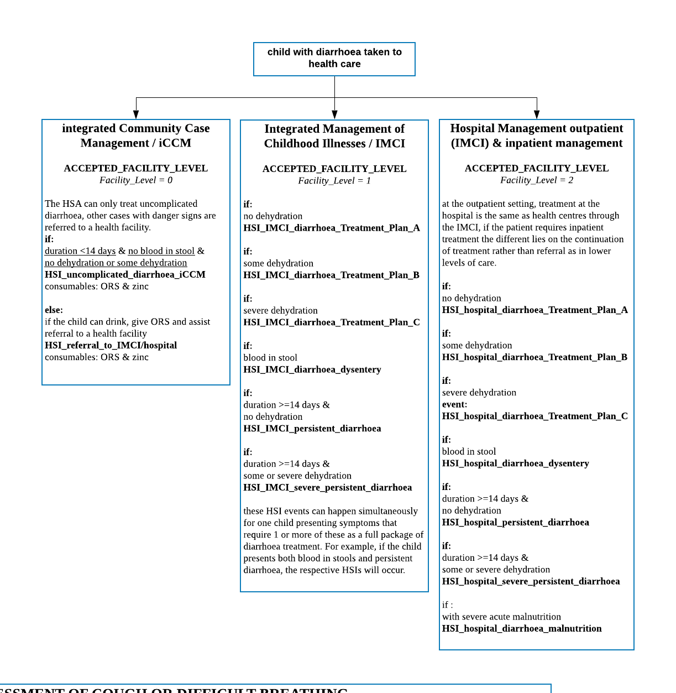

HSI_ prefix are the events that are scheduled when a sick child with diarrhoea presents to care at each health system level, following the algorithm diagnostic module that will sort the event that will take place.

All health systems interaction activities, including the diagnosis and treatment of diarrhoeal diseases from iCCM, IMCI and hospital services are coded in the python files: dx_algorithm_child.py, dxmanager.py and diarrhoea.py.

# Next steps

## Literature review

* Consider the dehydration levels and its association with death rate.
* Less likely to become persistent if sought care and treated early?? Consider how specific signs and symptoms will prompt care seeking
* Add low birth weight as risk factor?
* Diarrhoea in the neonates
* Mean duration (+SD) of diarrhoea by pathogen (from MAL-ED data)
* Dehydration level - dehydration distribution in time and severity (lack of published data)

## Code in Python program

* Interventions to be added to the model: Monovalent rotavirus vaccine (Rotarix, RV1) was introduced on 29th October 2012 in Malawi at the WHO recommended schedule of 6 and 10 weeks of age. The diarrhoea module will use the properties from the EPI module for Rotavirus vaccine.

## Things to consider adding to the model:

* Risk of death by pathogen
* **Signs and symptoms related to diarrhoea and dehydration to then compute scores - Vesikari / Clark/ Dhaka**
* Apply the results on pathogen AFs from the Malawi case-control study among hospitalized children 32

# Model outputs

## Preliminary model outputs – without health systems input

The following model outputs are from a simulation run from 01/01/2010 to 01/01/2020 for a population size of N=20,000 people (all ages) under no health system interactions.

Figure 8 - Incidence of diarrhoea by pathogen in each age group (model output vs calibrating data)

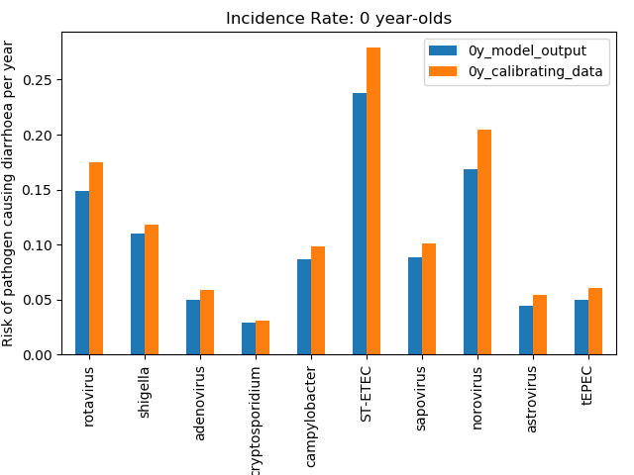

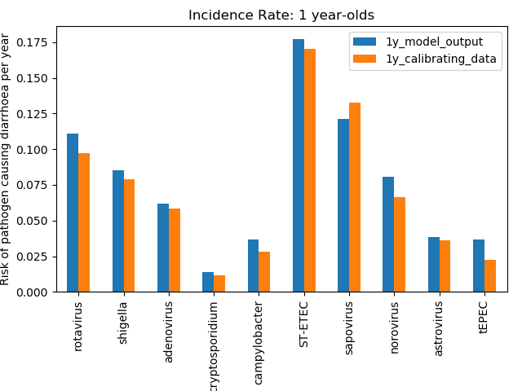

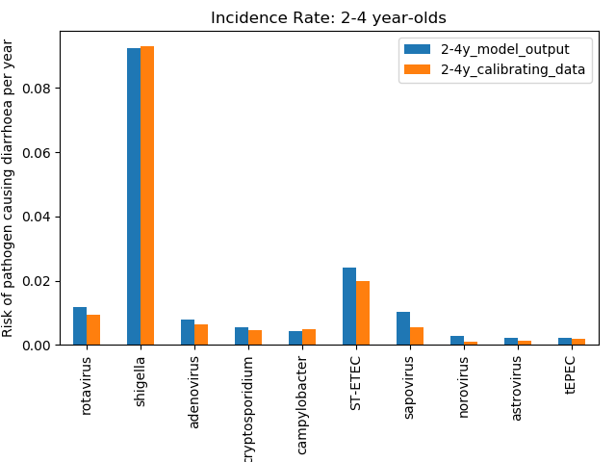

The calibrating data is the input values for the incidence of diarrhoea by pathogen by age group informed by the MAL-ED study, displayed in parameters table 7. The risk of pathogen causing diarrhoea per child per year is a mean of all years in the simulation.

Figure 9 - Incidence rate by pathogen in infants per year (model output vs calibrating data)

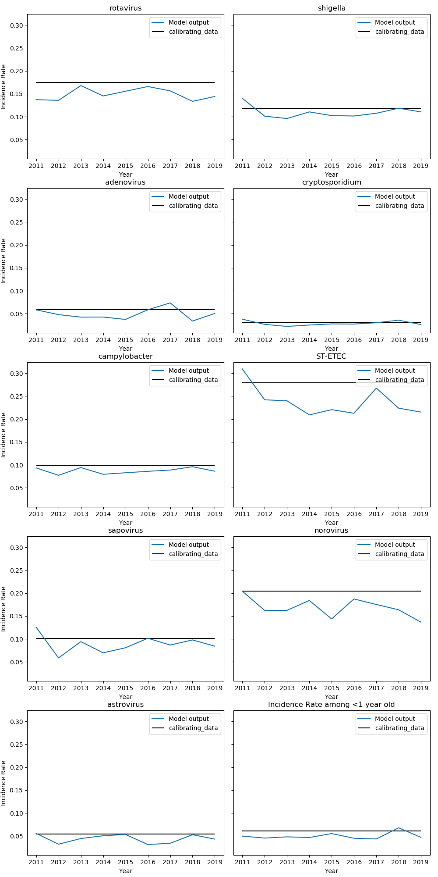

Here is another way of viewing the model run, with a graph showing the incidence by pathogen for infants only, overtime during the simulation. The flat calibrating_data line is the input value.

Figure 10 - Death rate from 2010 to 2019 (model output vs Global Burden of Disease estimates)

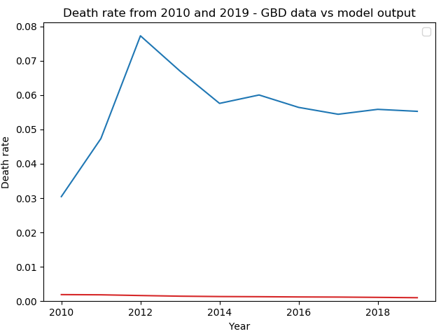

Death rate per child per year from the model is dictated by the input values in the parameters table 7. The case-fatality rate for each diarrhoea type (dysentery, acute watery, and persistent) is informed by a cohort study in rural North India in 199233. As we aim to simulate the natural history of diarrhoea, currently we use historic CFR, although ORS were already in use at the time.

# References

1. Baqui, A. H. *et al.* Methodological Issues in Diarrhoeal Diseases Epidemiology: Definition of Diarrhoeal Episodes. *Int. J. Epidemiol.* **20**, 1057–1063 (1991).

2. Keusch, G. T., Walker, C. F., Das, J. K., Horton, S. & Habte, D. *“Diarrheal Diseases”. In: Disease Control Priorities (third edition): Volume 2, Reproductive, Maternal, Newborn, and Child Health,* . (2016).

3. Lamberti, L. M., Fischer Walker, C. L. & Black, R. E. *Systematic review of diarrhea duration and severity in children and adults in low- and middle-income countries*. *BMC Public Health* **12**, 276 (2012).

4. Improving Child Health, IMCI: The integrated approach.

5. Kotloff, K. L. *et al.* Burden and aetiology of diarrhoeal disease in infants and young children in developing countries (the Global Enteric Multicenter Study, GEMS): a prospective, case-control study. *Lancet* **382**, 209–222 (2013).

6. Acosta, A. M. *et al.* The MAL-ED Study: A Multinational and Multidisciplinary Approach to Understand the Relationship Between Enteric Pathogens, Malnutrition, Gut Physiology, Physical Growth, Cognitive Development, and Immune Responses in Infants and Children Up to 2 Years of Age in Resource-Poor Environments. *Clin. Infect. Dis.* **59**, S193–S206 (2014).

7. Platts-Mills, J. A. *et al.* Use of quantitative molecular diagnostic methods to assess the aetiology, burden, and clinical characteristics of diarrhoea in children in low-resource settings: a reanalysis of the MAL-ED cohort study. *Lancet Glob. Heal.* **6**, e1309–e1318 (2018).

8. Liu, J. *et al.* Use of quantitative molecular diagnostic methods to identify causes of diarrhoea in children: a reanalysis of the GEMS case-control study. *Lancet* **388**, 1291–1301 (2016).

9. Kotloff, K. L. *et al.* The Global Enteric Multicenter Study (GEMS) of Diarrheal Disease in Infants and Young Children in Developing Countries: Epidemiologic and Clinical Methods of the Case/Control Study. *Clin. Infect. Dis.* **55**, S232–S245 (2012).

10. Nasrin, ( D *et al.* *Center for Vaccine Development and Global Health The incidence, aetiology, and adverse clinical consequences of less severe diarrhoeal episodes among infants and children residing in low-income and middle-income countries: a 12-month case-control study as*. *The Lancet Global Health* **7**, (2019).

11. Darvesh, N. *et al.* Water, sanitation and hygiene interventions for acute childhood diarrhea: a systematic review to provide estimates for the Lives Saved Tool. *BMC Public Health* **17**, 776 (2017).

12. Wolf, J. *et al.* Impact of drinking water, sanitation and handwashing with soap on childhood diarrhoeal disease: updated meta-analysis and meta-regression. *Trop. Med. Int. Heal.* **23**, 508–525 (2018).

13. Lamberti, L. M., Fischer Walker, C. L., Noiman, A., Victora, C. & Black, R. E. Breastfeeding and the risk for diarrhea morbidity and mortality. *BMC Public Health* **11**, S15 (2011).

14. Black, R. E. *et al.* Maternal and child undernutrition: global and regional exposures and health consequences. *The Lancet* **371**, 243–260 (2008).

15. Acácio, S. *et al.* The role of HIV infection in the etiology and epidemiology of diarrheal disease among children aged 0–59 months in Manhiça District, Rural Mozambique. *Int. J. Infect. Dis.* **73**, 10–17 (2018).

16. Soares-Weiser, K., Bergman, H., Henschke, N., Pitan, F. & Cunliffe, N. Vaccines for preventing rotavirus diarrhoea: vaccines in use. *Cochrane database Syst. Rev.* **2019**, (2019).

17. Moore, S. R. *et al.* Prolonged Episodes of Acute Diarrhea Reduce Growth and Increase Risk of Persistent Diarrhea in Children. *Gastroenterology* **139**, 1156–1164 (2010).

18. *IMCI Integrated Management of Childhood Illness HANDBOOK Department of Child and Adolescent Health and Development (CAH)*. (2005).

19. Umamaheswari, B., Biswal, N., Adhisivam, B., Parija, S. C. & Srinivasan, S. Persistent diarrhea: Risk factors and outcome. *Indian J. Pediatr.* **77**, 885–888 (2010).

20. Levine, M. M. *et al.* Diarrhoeal disease and subsequent risk of death in infants and children residing in low-income and middle-income countries: analysis of the GEMS case-control study and 12-month GEMS-1A follow-on study. *Lancet Glob. Heal.* **8**, e204–e214 (2020).

21. Tickell, K. D. *et al.* Identification and management of Shigella infection in children with diarrhoea: a systematic review and meta-analysis. *Lancet Glob. Heal.* **5**, e1235–e1248 (2017).

22. Acácio, S. *et al.* Risk factors for death among children 0–59 months of age with moderate-to-severe diarrhea in Manhiça district, southern Mozambique. *BMC Infect. Dis.* **19**, 322 (2019).

23. Black, R. E. *et al.* Maternal and child undernutrition: global and regional exposures and health consequences. *www.thelancet.com* 243 doi:10.1016/S0140

24. Ng’ambi, W. *et al.* Factors associated with healthcare seeking behaviour for children in Malawi: 2016. *Trop. Med. Int. Heal.* (2020). doi:10.1111/tmi.13499

25. Munos, M. K., Fischer Walker, C. L. & Black, R. E. The effect of oral rehydration solution and recommended home fluids on diarrhoea mortality. *Int. J. Epidemiol.* **39**, i75–i87 (2010).

26. Lazzerini, M. & Wanzira, H. *Oral zinc for treating diarrhoea in children*. *Cochrane Database of Systematic Reviews* **2016**, CD005436 (John Wiley and Sons Ltd, 2016).

27. Mayo-Wilson, E., Imdad, A., Junior, J., Dean, S. & Bhutta, Z. A. Preventive zinc supplementation for children, and the effect of additional iron: A systematic review and meta-analysis. *BMJ Open* **4**, (2014).

28. Imdad, A., Mayo-Wilson, E., Herzer, K. & Bhutta, Z. A. Vitamin A supplementation for preventing morbidity and mortality in children from six months to five years of age. *Cochrane Database Syst. Rev.* **2017**, (2017).

29. Traa, B. S., Fischer Walker, C. L., Munos, M. & Black, R. E. Antibiotics for the treatment of dysentery in children. *Int. J. Epidemiol.* **39**, (2010).

30. Bernaola Aponte, G., Bada Mancilla, C. A., Carreazo, N. Y. & Rojas Galarza, R. A. Probiotics for treating persistent diarrhoea in children. *Cochrane Database of Systematic Reviews* **2013**, (2013).

31. Allen, S. J., Martinez, E. G., Gregorio, G. V. & Dans, L. F. Probiotics for treating acute infectious diarrhoea. *Cochrane Database of Systematic Reviews* **2010**, (2010).

32. Iturriza-Gómara, M. *et al.* Etiology of Diarrhea Among Hospitalized Children in Blantyre, Malawi, Following Rotavirus Vaccine Introduction: A Case-Control Study. *J. Infect. Dis.* **220**, 213–218 (2019).

33. Bhandari, N., Bhan, M. K. & Sazawal, S. Mortality associated with acute watery diarrhea, dysentery and persistent diarrhea in rural north India. *Acta Paediatr. Suppl.* **381**, 3–6 (1992).