Loan fee report remove serial after FTR into wrong reservation.

Technical documentation

|  |  |  |  |
| --- | --- | --- | --- |
| Version | Changed on | Changed by | Description |
| 1.3 | 23/08/2024 | Eduardo F. | Enhancement to the loaner report |

# Purpose of the document

Detail the changes made to prevent loan fee report from exhibiting the sets returned with the wrong reservation after FTR into surgery.

# Functionality

Selection created inside the loan report to ensure that the previous object for the returned loansets is not CONSI/SET_OPS/INVST.

For specific case of single original reservation without any extensions parameter calculation return must include calculation type flag.

# Technical solution

## Description

Taking all of the sets that have an actual return date we search for their equipment numbers

Those equipment numbers can be used with standard table CDHDR and CDPOS to read the changes in EQART as equipments are SAP standard functionality that MMS leverages.

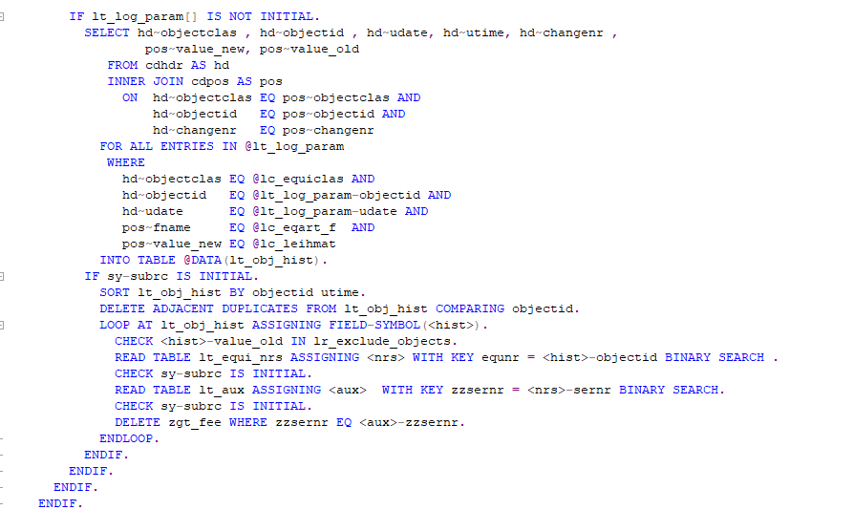

With the logs at hand we can then proceed to do a clean up of the wrong serial numbers while keeping the correct ones.

Calculation type flag:

In method

Calculation of index for number of days at customer was returning the wrong index. Essentially returning the wrong value even if the number of days that must incur fees was calculated correctly.

Ex:

Reservation is 2 days late at customer.

Before fix index 2+3 were used which returned a total of 50 + 75 = 125

After fix index 1 + 2 were used which returned a total of 75.

Flag was turned to return ‘X’ for reservations without any extension, and only affects these specific cases.

## Technical assumptions and Dependencies

N/A.

## Quality requirements

Must be able to remove serial number independent of how many times a set was dispatched and returned on the same day.

## Customizing

N/A

## Development objects

|  |  |  |
| --- | --- | --- |
| Object type | Object name | Description |
| Method | SELECT_AND_PREPARE_DATA | Data prep for Loanfee report. |
| Method | FIND_CALCULATION_PARAM | Returns parameters for fee calculation |

## Related Jira/HS tickets

AMS-995

## Transport Information

|  |  |  |
| --- | --- | --- |
| No | System | Transport Number |
| 1 | DS4 | DS4K917084 |