A Deployable Nuclear Reactor for Disaster Relief

You have been assigned to design the control system for a next generation nuclear reactor on an aircraft carrier that can serve the dual purpose of providing power to the drive shafts and generate electricity for external use. The purpose of the second objective is to occasionally deploy the aircraft carrier offshore of a natural disaster stricken area. The nuclear reactor on-board the aircraft carrier would then be able to provide an electrical power source that could be used to re-energize the local electrical grid. This “extension cord” from the aircraft carrier would assist in recovery efforts and help the affected area rebuild infrastructure.

You’ve been asked to recommend a power system design that would provide power to an electrical grid with a highly variable load. A preliminary analysis reveals that a nuclear reactor is not sufficiently responsive to react to the types of disturbances expected from a disaster stricken area. It is suggested that a combination of energy storage in the form of batteries (1-2 seconds for load changes but small capacity), natural gas turbines (3-5 minutes for load changes and short term fuel capabilities), and a nuclear reactor (1-2 hours for load changes but long-term load capability) would provide the best combination to meet the required demand. Design a system that can provide 100 MWe of power and demonstrate the ability to react to power load changes.

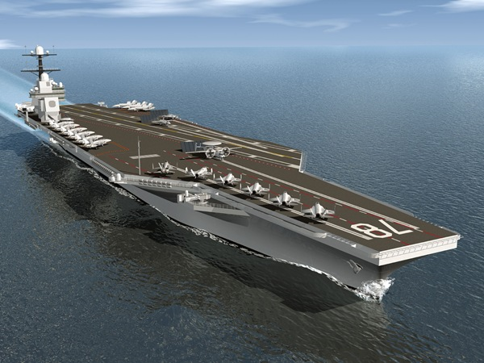



**Fig 1.** A deployable 100 MWe system that can be dispatched for disaster relief.

The nuclear navy (traditionally not a big fan of process control) proposed the following manual control scheme with the demand composed of random disturbances every 30 minutes, a daily sinusoidal cycle, and a base load of 70 MW. The power demand is met by the nuclear reactor, natural gas turbine (LNG supply), and battery. Your task is to propose a modified scheme that will follow the anticipated load over a 24 hour period.

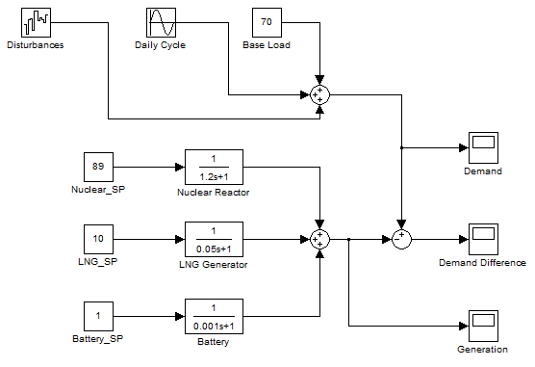

**Fig 2.** Simulated demand and production of power from three energy sources and the associated dynamics. The summation of Disturbances, Daily Cycle, and Base Load produce a total demand.

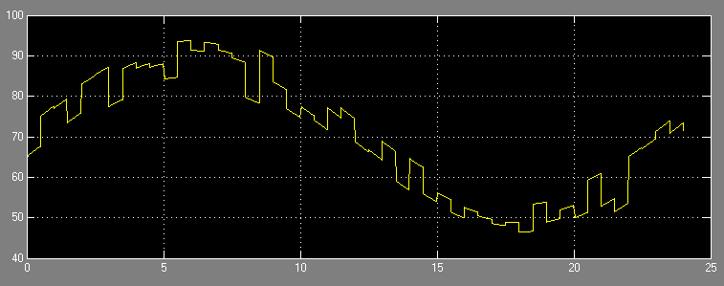

**Fig 3.** Demand over a 24 hour period with y-axis of load (MW) and x-axis in time (hr).