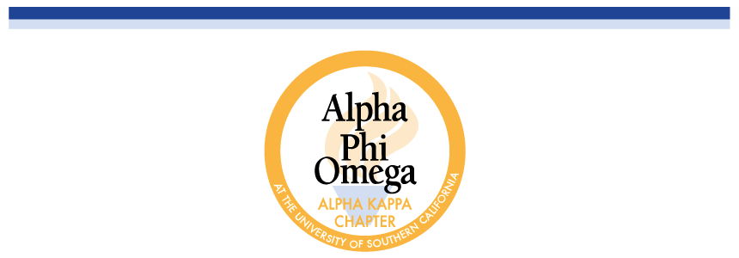

**Fall 2019 Nominated Officer Questionnaire**

**INSTRUCTIONS**

Please attach your **current résumé** and **Fall 2019 schedule** (class, work, other extracurricular activities).

This questionnaire is due **no later than** **SUNDAY April 14th at 11:59 PM.** Please send this document and all supplemental materials to [president.apousc@gmail.com](mailto:president.apousc@gmail.com) and cc webmaster.apousc@gmail.com .

*Election Day:* Candidates for President and Pledgemaster will have three minutes to give their speeches. Candidates for all other positions will have two minutes.

You may present **one slide** **per position** you run for at the time of your speech. If you are running all or nothing for a co position, you may share a speech with your running mate and have **up to** **two slides**. If you are not running all or nothing, you must have a separate speech and slide. Slides are due by **SUNDAY April 14th at 11:59 PM** to [president.apousc@gmail.com](mailto:president.apousc@gmail.com). You will not be allowed to pass out additional materials or papers during your speech.

**PART I: GENERAL INFORMATION**

Name: Justin Chang

Year: Sophomore

Major: Political Science & Human Biology

Pledge Class (Year): Alpha Lambda (Fall 2017)

**Please mark which elected position(s) you are running for with an X:**

[X]  President

[  ]  Pledgemaster

[  ]  VP of Service

[  ]  Co-VP of Membership

[  ]  VP of Fellowship

[  ]  Co-VP of Finance

[  ]  VP of Communications

[  ]  IC Chair

Name of person you are running with (leave blank if no running partners):

Are you running all or nothing (leave blank if not applicable)?:

**PART II: SHORT ANSWER QUESTIONS**

1. **Why do you want the position(s) you are running for?**

I want to be the President of APO because I want to bring this chapter to its prime. Next semester will be my 5th semester in APO and I believe that I have an excellent understanding of the current state of the chapter: its strengths and its weaknesses. By being on Excomm for the past two semesters, I have developed a good grasp of how our chapter functions on many levels. With this experience behind me, I believe that I am the most qualified candidate to be APO’s next President.

1. **What is your vision for APO and what are your goals for the position(s)?**

The APO community here at USC has always been changing and developing, as it evolves and brings in new members ever semester. However, despite this change, the one thing that remains the same are the values that APO ingrains within its pledges and actives. As a service fraternity, we should all recognize the importance of service and be able to see the role that service does in connecting those who have a passion for service. By performing community service with those around you, we are all connected through this love of helping the underserved and underrepresented here at USC. Furthermore, we are also brought together as a LA community, linking those who have a passion for service with the underserved. LA is our home and I believe that APO connects us together as a family through this vision.

If elected as the next President of APO, I plan on bringing a more concrete role to the position of President in APO. That being said, I also want to provide more structure to the APO experience for both pledges and actives, as we move towards a new focus on service. To accomplish this, I have two main goals for the position, and I plan on implementing change internally within USC and externally through the national APO office.

1. **What new ideas can you bring to the position and organization as a whole? Please provide examples.**

In order to provide a more concrete role to the position, I first want to focus on Excomm and its development throughout the semester. I plan on working closely with every E-board position and their respective A-board members by mandating a weekly report for all VPs. Through a simple google survey due every weekend, I want to be able to visualize the weekly goals and plans for every E-board member. Throughout my own experience in Excomm, there were many times when I wish I had more concrete/structured guidance in how to approach the role in my position. In this weekly report, I want to know what each E-board member plans on accomplishing that week and what they have accomplished in the previous week, in regards to APO. I also want to know what they plan on accomplishing with their A-board members. For example, how is the VP of Communications assisting the Webmaster this week with their DTA video? Or how is the VP of Service working with Phil this week during rush? By asking questions like these, I hope to help each E-board member not just develop their leadership skills within their respective committees, but also to provide more structure to the weekly doings of every Excomm member. With the information gathered from these weekly report, I will personally follow up with every E-board member to play a closer role as president into the ideas of the VPs and assist them with the implementation of those ideas.

I also plan on playing a more helpful hand by attending/auditing various comms every week to assist in the development of weekly goals and plans of every Excomm member. In other words, every week, I plan on randomly attending a specific comm and helping that group of APO members work through whatever may be discussed that week.

Lastly, I plan on revitalizing EBM by providing more structure to the process. As has been discussed in previous semesters, I hope to rearrange people who attend EBM in a way that better facilitates discussion. Instead of sitting in your seat and reading your slide, I hope to have every Excomm member walk to the front of the room and present their slides as the rest of Excomm participates in the discussion. By providing a more formal approach to EBM, I hope to establish a better standard for Excomm so that we can all have a greater understanding of each other’s goals and plans for the upcoming week.

Externally, I plan on establishing APO as *the premier* service organization at USC. To do this, I want us to have a move to a greater focus on service. By applying for service grants from the APO national office, such as the APO Service Innovation Grant, to support events throughout the semester, I hope to be able to hold large-scale service events with the VP of Service and the Phil Chairs at USC and around DTLA so that people outside of APO recognize us as a large organization that has a focus on service. This past year, UCLA’s APO chapter won this grant and I hope to do the same for us. My goal is to make APO recognized as a service organization. I also plan on applying for USC awards for service such as the Tommy awards, in which USC APO has won in the past, legitimizing us as one of the best service organizations on campus that year.

Lastly, I hope to continue the relationship we have with Gabe Valenzuela, the Director of Campus Activities, and Jennifer Perdomo, the Lead Student Program Advisor, on continuing on working towards the recognition of APO at USC as a recognized student organization. By working with Student Affairs and developing a good rapport with USG, I am confident that we can finally get our chapter recognized as an official organization.

1. **What relevant experience, if any, have you had working in committees or other organizations for the position(s) you are running for? Please be specific.**

I have been involved in APO for 4 semesters now and through my experiences, I have served as Pledge VP of Fellowship, VP of Communications and the Co-VP of Membership, currently. Through all of these positions, I have a very great understanding of our chapter and the way it functions. I understand our strengths and weaknesses. I know how to solve these weaknesses and carry on with our strengths.

1. **What other time commitments will you have next semester (i.e. other student organizations, work, research, etc.)? How do you plan to balance APO executive board duties with those commitments?**

I have no other commitments other than my pre-med course load. In the past, I have always taken at least 2 or 3 STEM courses a semester. Next semester, I will only have 1 STEM course so I will definitely have more time on my hands.

Additionally, I am a part of USC’s Model UN team; however, I only participate in their conference once a semester.