

**Fall 2020 Executive Board Application**

**INSTRUCTIONS**

Please attach your **current résumé** and **Fall 2020 schedule** (class, work, other extracurricular activities).

This questionnaire is due **no later than** **SUNDAY, APRIL 19th at 11:59 PM.** Please send this document and all supplemental materials to [president.apousc@gmail.com](mailto:president.apousc@gmail.com) and cc [webmaster.apousc@gmail.com](mailto:webmaster.apousc@gmail.com).

*Election Day:* Candidates for President and Pledgemaster will have three minutes to give their speeches. Candidates for all other positions will have two minutes.

You may present **one slide** **per position** you run for at the time of your speech. If you are running all or nothing for a co position, you may share a speech with your running mate and have **up to** **two slides**. If you are not running all or nothing, you must have a separate speech and slide. Slides are due by **SUNDAY APRIL 19th at 11:59 PM** to [president.apousc@gmail.com](mailto:president.apousc@gmail.com). No changes to your slide may be made after this date. You will not be allowed to pass out additional materials or papers during your speech.

**PART I: GENERAL INFORMATION**

Name: Jessica Woon

Year: Sophomore

Major: Human Biology

Pledge Class (Year): Fall 2019 Alpha Omicron

Will you have finished your requirements by April 27th?: Yes

**Please mark which elected position(s) you are running for with an X:**

[ ]  President

[  ]  Pledgemaster

[  ]  VP of Service

[  ]  Co-VP of Membership

[  ]  VP of Fellowship

[  ]  Co-VP of Finance

[X]  VP of Communications

[  ]  IC Chair

Name of person you are running with (leave blank if no running partners):

Are you running all or nothing (leave blank if not applicable)?: n/a

**PART II: SHORT ANSWER QUESTIONS**

1. **Why do you want the position(s) you are running for?**

The VP of Communications has an integral role in keeping our APO actives and pledges well-informed throughout the semester. Personally, I am very grateful for all of the past VP of Communications during my time in APO to keep me updated on new announcements or changes to requirements and accountable for the things I need to get done. Especially for next semester, where there is a possibility that we might be having an online semester, it will be crucial to maintain constant communication between the E-board and members. Although another semester of zoom university in the fall might cause many of us to lose track of time and provoke a decrease in motivation and engagement, I believe that I can keep myself on track and ensure that our members receive timely updated information and important updates to have a successful semester. Nevertheless, I also believe that I have the creative capabilities in making the APO emails, slides, and PowerPoints visually engaging for my audience to retain attention and viewership (ideas will be discussed below). Furthermore, I have the essential organizational and detail-oriented skills from prior experience in taking good notes for all of my classes and doing administrative paperwork for my clinical research lab at CHLA to be qualified for the VP of Communication position. Lastly, not only can I contribute to the Alpha Kappa chapter, I believe that I can gain from this experience as well in promoting my own skills of leadership, giving back to the chapter, and better integrating myself with the chapter.

1. **What is your vision for APO and what are your goals for the position(s)?**

My goals for VP of Communications is to:

*Maintain/Increase viewership* – Especially since next semester might be online, my goal for VP of communication is to ensure that our members continue to read the weekly newsletters so that they are informed of the necessary information. In order to do so, I will make sure the weekly emails are engaging, making the reading experience more enjoyable. I want to make it so that newsletters are something members look forward to reading every week.

*Close the Gap and Build Community*– Reading the newsletters shouldn’t just be a list of information. I want the newsletters and Instagram page to also provide updates on our members as well, and to keep the interaction within our chapter and to the community. Strengthening our community could be accomplished through spotlights, fun facts, member Q&A, and having opportunities for members to request suggestions.

*Provide Important Information* – One of the most important roles as VP of Communications is to provide the necessary information to the members to keep people informed. Examples of important information to include are pledge team/E-Board updates, upcoming events for the week, and reminders of requirement deadlines (binder checks, quizzes, dues, auctions).

Elaboration of ideas will be shown through the examples below

1. **What new ideas can you bring to the position and organization as a whole? Please provide examples.**

* Spotlights: I want to continue spotlighting Excomm, pledges, and actives by providing a fun fact about them or showing what they have been doing in quarantine, but I think a new thing we could add is spotlighting the service organizations we work with as well. This could provide new pledges more information about each service organization and keep them updated on what the service organizations have been up to in the community. Spotlights will be posted on both the weekly emails and Instagram.
* Address Excomm issues Arnold brought up in his proposal for President by adding an anonymous form at the end of emails for people to submit any feedback.
* Birthday shout outs on the Instagram story page! For the weekly newsletter, I can acknowledge the birthdays for the week, as well as include a google form for any submissions of birthday wishes for those with birthdays in the following week. Birthday wishes will be submitted as quotes on the Instagram story, with a picture of the person (permission will be asked first).
* Post lead pictures or videos from events on the Instagram story page to show our community what we have been up to and the type of service we are doing.
* Work with the VP of Fellowship to include any fun/silly photo submissions people send to the APO Compliments page in the weekly newsletter, as well any compliments for the week (spread the love!).
* Continue creative designs on the PowerPoints, Minutes, and Emails
* Continue but have more often: “Who is most likely to” superlative poll on the Instagram close friends’ story.
* Weekly Myrtle Q&A where pledges/actives can acquire more hints throughout the semester to have a better guess on who Myrtle is. I can also occasionally post a poll to show the pledges’ current guesses. This would be included in the weekly emails.
* Open to any other suggestions!

1. **What relevant experience, if any, have you had working in committees or other organizations for the position(s) you are running for? Please be specific.**

Although I currently don’t have any prior experience in working on an E-board for a club in college, I believe that I still have the relevant skills and qualifications to do an excellent job as VP of Communications. For my classes, I always make sure to meet deadlines and take good notes for studying (pictures of notes shown below. Sorry in advance for any Pre-Med PTSD I might cause). On top of this, I have organizational experience from my research lab in making sure I stay organized with data entry and patients’ consent paperwork. Lastly, I am also minoring in Web Technologies and Applications where I must utilize creative graphic design skills to create engaging websites, which will serve useful when I design the weekly newsletter.

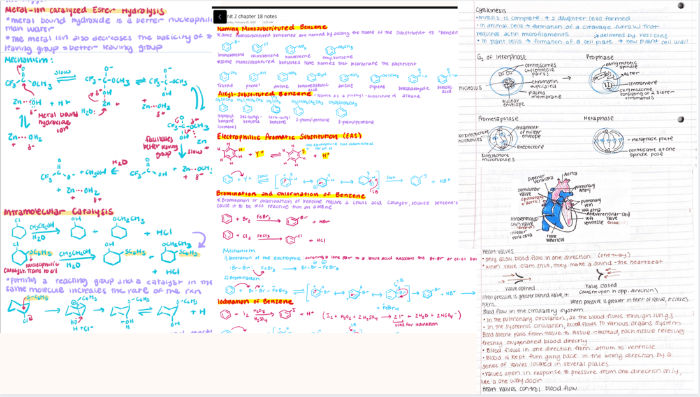

1. **What other time commitments will you have next semester (i.e. other student organizations, work, research, etc.)? How do you plan to balance APO executive board duties with those commitments?**

Next semester I will be taking 16 academic units on top of clubs such as APO, Science Outreach, and AMWA (American Medical Women’s Association). Science Outreach meets once a week for general board meetings and once a week at the volunteering schools. AMWA is a very low commitment club, where it is only required to attend 3 meetings a semester to stay active. I will also be doing 10 hours of lab research at CHLA. All of these extracurriculars combined are manageable as I have been able to balance clubs, schoolwork, research, exercise, and a good mental health this semester. As of now, I currently have no plans in adding any additional duties. I was able to balance my time through good time-managing, planning on my calendar, and limiting any distractions that could have led to procrastination. By adding another responsibility, such as APO E-board, I am confident that I will be able to fully commit as I already have experience balancing my existing responsibilities and academic workload.