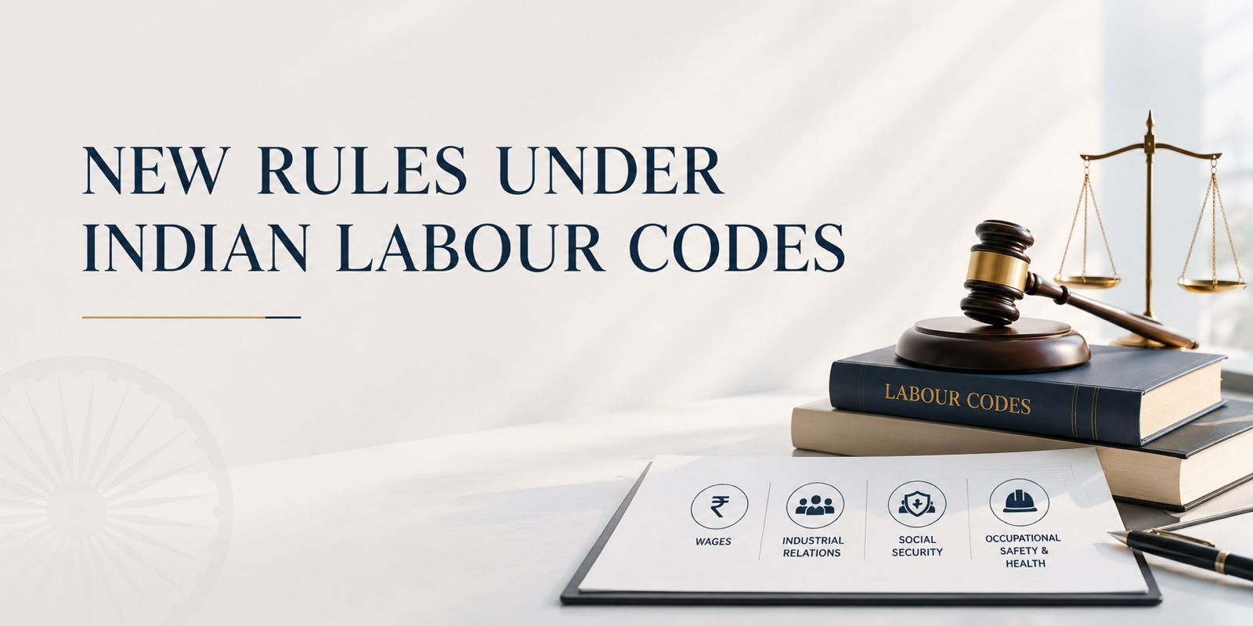

UPDATE: NEW RULES UNDER INDIAN LABOUR CODES

- New Central Rules

The Central Government has on 8 May 2026 notified rules (collectively, “Central Rules”) under India’s four Labour Codes (collectively, “Codes”):

- Code on Wages, 2019 (“Wage Code”): Code on Wages (Central) Rules, 2026 (“Wage Rules”);

- Industrial Relations Code, 2020 (“IR Code”): Industrial Relations (Central) Rules, 2026 (“IR Rules’);

- Code on Social Security, 2020 (“Social Security Code”): Code on Social Security (Central) Rules, 2026 (“Social Security Rules”);

- The Occupational Safety, Health and Working Conditions Code, 2020 (“OSH Code”): Occupational Safety, Health and Working Conditions (Central) Rules, 2026 (“OSH Rules”).

The Codes themselves were brought into force on 21 November 2025. During the intervening period, the government had clarified that existing labour regulations, along with their rules, notifications, and schemes, would continue to remain in force, creating a transitional grey zone for employers.

- Are the Codes now completely operationalised?

Since labour and employment laws are a concurrent subject under the Constitution of India, both the central government and state governments have the power to make laws in this regard. The Codes require both the Central Government and the respective State Governments to notify their own rules before the Codes can come into force for establishments within their jurisdiction.

The central rules mainly apply to central government bodies and public sector enterprises. Private enterprises are mainly governed by the state rules. As an exception, for companies with offices in more than one state, the Central Government would be the 'appropriate government' under the Social Security Code, and the Social Security Rules would apply.

Most State Governments are yet to notify state rules under the Codes. It is expected that state governments will adopt rules in the near future. Nevertheless, to the extent that the Central Rules inform and set the template for the State Rules that are expected to follow, this is a welcome and meaningful step towards implementation of the Codes.

- What are the key takeaways?

The Rules are procedural and operational in character, implementing rather than amending the Codes. Since, for the most part the Codes themselves did not substantially alter the existing legal regulations for employment in India, the Central Rules also do not change day to day operations of the employer. For example, the thresholds (in terms of number of employees in an establishment, maximum wage thresholds etc.) for providing statutory benefits such as provident fund benefits (“EPF”), employee state insurance benefits (“ESIC”), gratuity have not changed. Similarly, for establishments (other than for factories) the retrenchment and lay off mechanism and thresholds has also remained the same.

Some key takeaways from the Central Rules are as follows:

  - Wage Rules

    - 50% Wage Rule: The new regime introduces a structural floor ensuring that at least 50% of an employee's total compensation must qualify as 'wages', preventing employers from artificially suppressing the wage component through allowances and exclusions. The Ministry’s FAQs (March 2026) and the Wages Rules together clarify the inclusions and exclusions to ‘wage’ for the purposes of computing the 50% wage calculation, which we have captured in the below table:
Inclusions | Exclusions
- Employer provident fund contributions  - Employer pension contributions  - Statutory bonus  - In-kind benefits (food coupons, ration items, mobile recharge) | - Gratuity  - Employee state insurance contributions  - Retirement benefits  - House rent allowance  - Overtime allowance  - Conveyance allowance

  - IR Rules

    - Worker Re-skilling Fund Operationalised: The IR Rules now clarify how employers are required to deposit funds in the Worker Re-skilling Fund (a social safety measure for retrenched workers). As context, under the IR Code employers are required to deposit 15 days’ last-drawn wages of every retrenched worker into the Worker Re- skilling Fund, maintained by a labour officer, within 10 days of retrenchment of the worker. This amount is then transferred by the relevant labour officer from the fund to the retrenched worker within 45 days of retrenchment to enable such retrenched worker to utilise that amount for re-skilling. The Central Government operationalised the Worker Re-skilling Fund by way of a separate notification on 8 May 2026.
    - Sector Specific Model Standing Orders: The Central Government has also separately notified Model Standing Orders for manufacturing, mining, and services sectors. The model standing orders are largely aligned with the model standing orders under the old regulations.

    - Grievance Redressal Committee (GRC): Every covered establishment is now mandatorily required to constitute a GRC, with no opt-out for those with pre-existing internal mechanisms. The IR Rules further clarify the manner in which the GRCs are to be constituted, with equal employer-worker representation and mandatory women’s representation. Grievances may be filed electronically or by post within one year from the date on which the cause of action arose. Unresolved grievances escalate to Conciliation Officers, the list of officers appointed for mediating in and promoting the settlement of disputes for different areas was specified on the same date through a separate notification on 8 May 2026.

    - Arbitration: Under the previous regime, an industrial dispute between an employer and workman could be referred to arbitration by a written agreement, any time before it had been referred to a Labour Court/Tribunal. However, once proceedings had commenced before the Labour Court or Tribunal, the dispute could no longer be referred to arbitration. This pre-condition has now been removed, and a dispute can be referred to arbitration via a written arbitration agreement (in the prescribed format) at any stage.

  - OSH Rules

    - Mandatory Appointment Letters: The OSH Rules prescribe the format of the appointment letter that employers are required to issue to all their employees. This includes details such as employee's designation, category, details of wages, and details of applicable social security benefits, including EPF and ESIC entitlements, allowances, and the broad nature of duties. This was previously not mandatory in most states.

    - Easing Compliance: The Codes ease compliance requirements by introducing a single registration regime under the OSH framework, in place of multiple registrations previously required under the Factories Act, Contract Labour (Regulation and

    - Abolition) Act, Inter-State Migrant Workmen Act, and other enactments. In addition, both the Codes and the Central Rules encourage a move towards electronic filings and electronic maintenance of unified registers, rather than numerous statute-specific paper registers and returns.
    - Women Workers: During the transition when the rules were not operational and the old rules had to be followed, there was some confusion amongst industries/factories on how to reconcile the new code, which permitted women workers to work in all establishments at all times, with the old rules which specifically prohibited women

  - Social Security Rules

    - Expanding statutory protection: The Social Security Code expands social security benefits to gig workers and platform workers. Further, the Social Security Rules has expanded the role of the National Social Security Board, to design and implement dedicated schemes for gig and platform workers under the Social Security Code (funded largely by mandatory contributions from aggregators). The NSSB will be composed of representatives of aggregators, gig and platform workers, ESIC and EPF, expert members and state representatives.

    - Maternity Benefits: Under the Social Security Rules, the certification process for availing maternity benefits has been made more accessible by allowing certification from a wider range of healthcare providers, including ASHA workers and auxiliary nurses, in addition to doctors and midwives.

- Do we still need clarity on certain points?

While the Central Rules along with FAQs released by the Central Government from time to time provide clarity on most provisions in the Codes, certain areas remain works in progress. For example, Contribution rates and manner of such contribution for gig worker social security under the Social Security Code are yet to be prescribed. Likewise, while the OSH Code defines ‘core activities’ broadly for the purpose of regulating contract labour engagement, particularly in services, manufacturing, and IT sectors where significant contract workforce deployments are common, the rules themselves do not provide detailed guidance on what would constitute a core activity in practice.

SCHEDULE 1

Status of State Rules under the Codes in Key States

State / UT | Wage Code | Social Security  Code | IR Code | OSHWC  Code
Karnataka | Draft rules  only | Draft rules  only | Draft rules  only | Draft rules  only
Delhi | Draft rules  only | Draft rules  only | Draft rules  only | Draft rules  only
Maharashtra | Draft rules only | Draft rules only | Draft rules only | Draft rules only
Haryana | Draft rules only | Draft rules only | Draft rules only | Draft rules only
Gujarat | Notified | Notified | Notified | Notified

This update is for information purposes only. For further insights please reach out to contact@appartners.in

Ministry of Labour & Employment, Press Note on Transitional Arrangements (Nov. 22, 2025) (India); see also Additional FAQs on Labour Codes (Mar. 16, 2026) (India)
The Worker Re-skilling Fund is required to be maintained by the Chief Labour Commissioner (Central) or the office of the Deputy Chief Labour Commissioner (Central) or the office of the Regional Labour Commissioner (Central) or the office of the Assistant Labour Commissioner (Central)
Covered establishment means any industrial establishment with twenty or more workers
Electronic registration can now be done on the Shram Suvidha Portal.

