# The Open Contracting Innovation Challenge

How would you use data to strengthen the integrity and effectiveness of public procurement?

We are looking for entrepreneurs, government innovators, data journalists, civic technologists, hackers, open data enthusiasts, citizen activists who understand the transformational impact on people’s lives that better public contracting can have in terms of scale and impact. We are particularly interested in ideas for projects that:

* Detect and prevent fraud & corruption
* Create fairer competition
* Deliver better value for money for governments
* Drive effective goods & service delivery for citizens

**Any idea is valid:**

* A tool that helps businesses compete on government contracts?
* An investigative project that reveals inefficient use of government funds?
* A Twitter bot that queries an open tender database?
* A new way of connecting contracts to other relevant data?

**Then think about how that project can achieve scale and reach in a trillion dollar marketplace.**

**Entries open** 18 April 2017

**Submission deadline** 24 May 2017

**Six finalists announced** 14 June 2017

**Finalist meetup in London** 28 June (tbc)

**Incubation & mentoring** 25 June -25 Sept 2017

**Grand prize award** 30 Sep 2017 One team wins $30,000

# Introduction

Your submission will be assessed according to five judging criteria listed below, you can [download more information about the judging criteria here](https://docs.google.com/document/d/1k1fkIUfempRKhM94d-gNp89aY5L6JY4NPZ5uacT2PDM/edit). The minimum requirement at the start of the challenge is that you have an idea for a project which can deliver significant, quantifiable progress between June to September 2017.

* **Potential for Impact**:  
  How does your idea relate to the challenge question?  
  Can you explain its likely positive impact on society logically?
* **Innovation:**  
  Does your idea represent a substantive new and innovative contribution in the field?
* **Use of data:**  
  How central is data to your idea?
* **Sustainability:**  
  Can your idea sustain itself or be reproduced in other contexts or markets?
* **The Team:**  
  Are your team equipped with the skills, knowledge and expertise they need to deliver the idea?

This application form is designed to ensure you respond to each of these criteria fully and have the best possible chance at success so please take your time and save your responses as you go through.

Please note that once your application is made, a very short summary will appear in the community section of the Open Contracting Innovation Challenge website. This will include the name of your project, the name of your team, a very brief description (140 characters) and an image representing your idea.

[**Step 1 -** Project Basics](http://challenge.open-contracting.org/apply-for-the-challenge/)

What is the name of your project?*

digitaltwins.info 50 max characters

What is the name of your team or organisation?

AIAEU (iControl, TK UAS )__ 50 max characters

If you are an individual applicant unaffiliated to a team, please put down your name

**Are you applying as a government (for the prestige prize) or as another organisation (for the cash prize)?**

Government

* + Organisation

**Describe your idea in 140 characters or less**

Create digital twin of OpenContracting Item.Description on basis of Open Catalogs and Codelists according to ISA95, AutomationML standards

140 max characters

**What scale are you working on?**

* Local
* National

Global

What is the geographic and demographic focus of your project?

*Ukrainian market of Automation and IT products and services*

**In your own words, how does your idea respond to the challenge question?**

Use Open Products&Services catalogues for digitalizing procurement Item descriptions. Monitor and control technical policies conformity.

Define these technical policies with "iControl" experts community in Association of Industrial Automation Enterprises of Ukraine (AIAEU). Legalize them as an standard with technical committee 185 (Industrial Automation) in Ukrainian Agency for Standardization.

(100 words)

**Please upload an image that represents your project or idea**

* Accepted file types: png, jpg, gif, pdf

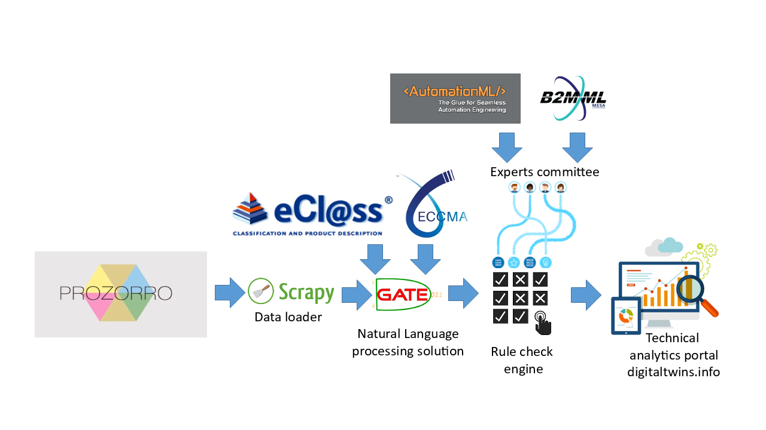

[**Step 2 -** Potential for Impact](http://challenge.open-contracting.org/apply-for-the-challenge-step-2/)

**What is the problem that you are trying to solve or improve?**

*Informal way of describing procurement item can be the source of manipulation and unfair competition (disqualifying proposals and suppliers as an major influence instrument). In the same time ignoring general technical policies can significantly influence on quality, TCO and even on successful and legal operations of procured equipment.*

(150 words)

**What is the potential or current impact of this problem?**

Please make some attempt to quantify the scale of the impact, how your idea will change this situation and how you will measure this change. What’s your methodology for quantifying and measuring change?

*Direct measurements:*

*percentage of "direct model" illegal descriptions ("iPhone 7" instead of "mobile phone")*

*percentage of "double meaning" descriptions ("Notebook" - with no technical description)*

*percentage and cost estimation of "price before quality" procurement decisions.*

*percentage and cost estimation of "hidden costs" in procurement items ( services, software, regulation requirements which are not mentioned)*

*Indirect measurements:*

*estimated TCO reduction*

*estimated budget savings on avoiding "worldwide recognized brand" illness*

*estimated "productivity" increasing*

*estimated "asset lifetime" increasing*

(200 words)

**How have you tested your idea with potential users and key stakeholders? Who are they? Which diverse stakeholder groups do they represent? What have their responses been so far?**

Please include testimonials and quotes if you have them.

*Last 10 years we unite community who are responsible for technical policies at corporate sector. "Technical policy" is an instrument, which allow big companies to drive their investments effectiveness and TCO goals.*

(200 words)

**Which other society sectors have been involved in the development of your idea? Please name the groups and their role.**

End users (companies who procure industrial automation solutions): define and approve rules and technical policies. Approve effectiveness and quality.

System integrators: Define and approve technical policies. Monitor and raise unfair competition cases.

Vendors: Through technical policies ensure that new and modernized products are having a greenlight.

(100 words)

[**Step 3 -** Innovation](http://challenge.open-contracting.org/apply-for-the-challenge-step-3/)

**What is your innovation? How will it benefit users?**

There are two points of innovation:

- first is an automatic transform from informal natural language description of proposal into fully digital AutomationML system model, with lifecycle operations description added on B2MML language. This automatic procedure from one side simplify the process, form other side make it formalistic - to avoid any misunderstanding claims. It is based on natural language processing technologies, which utilize machine learning algorithms.

- second is an automatic rules check on basis of digitalized models. It utilizes pattern recognition algorithms. Benefits are near the same - simplification and better quality because of automation and avoiding of any manipulations with technical expertise thanks to formalized rules.

(300 words)

**How did this idea come about?**

Please tell the story of how you came up with this innovation.

During last years there were a lot of discussions in Ukrainian industrial automation community about rules and policies at the market. The common understanding is coming step-by-step. The need of communication and formation of the common view come first. Standards following requirements come next as a common agreement. When prozorro.gov.ua system come to market - a lot of cases of unfair competition and manipulations were putted on table. As of now - growing technology readiness and market situation understanding is summarized and implemented in this project.

(150 words)

**Which of the following categories does your idea fall into?**

* **Does your innovation apply an existing idea in an entirely new way (e.g. new sector)?**
* **Is open contracting data (or OCDS) used to radically improve an existing idea?**

**Does your idea constitute an entirely new concept in the marketplace?**

**What similar ideas exist in the market at the moment and what have you learnt from these projects?**

Idea is based on new combination of existing technologies and practices. Most of them are already sustainable and recognized on market. Moreover - open standards are used as an basis of informational model of proposed system, open Product Catalogs and CodeLists. As an continuation of "prozorro" system - our project will also be open sourced and developed with wide public discussion with most stakeholder groups.

(200 words)

[**Step 4 -** Use of Data](http://challenge.open-contracting.org/apply-for-the-challenge-step-4/)

* Please complete the following fields to describe all the procurement datasets that you are using. If you are using more than one dataset, please select ‘add another datatset’ and complete the fields multiple times (All fields in table mandatory)

## Dataset 1

**Publisher** https://prozorro.gov.ua/

**Country** Ukraine

**Data URL** https://prozorro.gov.ua/

**File Format** (ex: JSON, CVS, PDF, TXT, DOC etc.)

**Does this dataset follow the Open Contracting Data Standard?**

* + **Yes**

**No**

**Language** Ukrainian (ex: English, Spanish, etc.)

**Open License**

* + **Yes**

**No**

**License** Apache License 2.0

**Stages Covered**

**Planning**

* **Tender**
* **Award**

**Contract**

**Implementation**

**What specific fields from this dataset does your idea rely upon?**

* Item. Description; Item. Documentation

(ex: Budgeted Amount, Transaction Date, Project ID, etc)

## Dataset 2

**Publisher** http://www.eclass.eu/

**Country** Germany

**Data URL** http://www.eclasscontent.com/

**File Format XML** (ex: JSON, CVS, PDF, TXT, DOC etc.)

**Does this dataset follow the Open Contracting Data Standard?**

**Yes**

* + **No**

**Language** English; German

**Open License**

* + **Yes**

**No**

**License** http://www.eclassdownload.com/catalog/conditions.php?language=en

**Stages Covered**

**Planning**

* **Tender**

**Award**

**Contract**

**Implementation**

**What specific fields from this dataset does your idea rely upon?**

* Classification; Definition; Keywords; Properties;

(ex: Budgeted Amount, Transaction Date, Project ID, etc)

## Dataset 3

**Publisher** https://eccma.org/

**Country** USA

**Data URL** http://www.eotd.org/prod_search/index.php

**File Format XML** (ex: JSON, CVS, PDF, TXT, DOC etc.)

**Does this dataset follow the Open Contracting Data Standard?**

**Yes**

* + **No**

**Language** English

**Open License**

* + **Yes**

**No**

**License** Open registry

**Stages Covered**

**Planning**

* **Tender**

**Award**

**Contract**

**Implementation**

**What specific fields from this dataset does your idea rely upon?**

* Classification; Definition; Keywords; Properties;

(ex: Budgeted Amount, Transaction Date, Project ID, etc)

**What other relevant open datasets are used in your idea?**

Codelists and classifications included into open standards

(30 words)

**What, if any, previously closed data (either data you compile, or data compiled by other organisations) is opened up through your idea? \***

We will negotiate and resolve the issue

(100 words)

**How is public procurement data central to your idea? What specific procurement data types or fields are central to your idea?**

Description of tener items are central in our idea. Documentation of tender items and awards documentation are also used.

(150 words)

**Does your idea use the Open Contracting Data Standard? If so, please describe. \***

Yes - we use it as a format of source data for our system.

(150 words)

[**Step 5 -** Sustainability](http://challenge.open-contracting.org/apply-for-the-challenge-step-5/)

**What benefit does your idea provide for your beneficiaries or end users?**

formal procedure of technical evaluation avoid possible fraud and unfair competition,

confidence in RFQ and proposal quality,

simplification of the procurement process,

Potential positive impact on ROI, TCO, project risks mitigation.

(200 words)

**What milestones have you reached so far? \***

* **Concept defined**
* **Concept user tested**

**Prototype built**

**MVP built**

**Company registered/incorporated**

**External users engaging with the product**

**First clients have paid for product**

**Others**

**To be eligible for the grand prize, your idea must deliver some clear outcomes by 14 September. Please list the key milestones for your project. When will it launch/end?**

June 2017 - prototype built

July 2017 - MVP built

August – September 2017 - External users engaging with the product

**What will you do to make your idea sustainable beyond the Open Contracting Innovation Challenge Funding?**

We will participate in Open Data Challenge and utilize other fund rising opportunities

(150 words)

**What business model could you apply to your idea?**

For prozorro.gov.ua system and government sector we will use system as non-profit.

But in parallel we try to apply this idea for corporate sector, where we plan to sell consulting services with profit proportional to benefits and incomes achieved. For example, as an percentage from TCO decreasing achieved.

(150 words)

**Have you considered using your idea elsewhere (other markets, sectors or geographies)? If so, where could it be applied? If your idea has already been reproduced in other markets or geographies, please tell us where \***

We will start from industrial automation market, but same approach can be applied for any engineering market - industrial equipment, IT market, etc...

(100 words)

[**Step 6 -** Team](http://challenge.open-contracting.org/apply-for-the-challenge-step-6/)

**What is the name of your team leader?**

Maksym Romanov; Alexandre Yurchak

50 max characters

**What is their email address**

maksim.a.romanov@gmail.com

(for communication about your challenge progress)

**What is their twitter account?**

**What vital skills, knowledge, networks and experience do they bring to the project?**

Maksym Romanov: CTO role (10 years of experience as CIO, Head of automation in corporate sector) Technical policy writer, system implementation responsible person.

Alexandre Yurchak: CMO role (General director of AIAEU) User engagement responsible person.

(up to 50 words)

**How many team members do you have?**

1

2

3

4

* + 5

more than 5

**What is the name of your first team member?**

Romanov Maksym

**What is their role in the team?**

CTO role, PM role.

50 max characters

**What vital skills, knowledge, networks and experience do they bring to the project?**

Technical policy writer, system implementation responsible person.

(up to 50 words)

**What is the name of your second team member?**

Alexandre Yurchak

**What is their role in the team?**

Chief marketing officer

50 max characters

**What vital skills, knowledge, networks and experience do they bring to the project?**

User engagement responsible person. He is a General Director of AIAEU and has wide contacts network. More than 15 years experience in marketing and sales.

(up to 50 words)

**What is the name of your third team member?**

Lev Vanyan

**What is their role in the team?**

Software implementation

50 max characters

**What vital skills, knowledge, networks and experience do they bring to the project?**

He is CEO of Ukrainian automation vendor company, and can provide human resources for idea implementation.

(up to 50 words)

**What is the name of your fourth team member?**

Perto Mackovich

**What is their role in the team?**

system implementation, policy writer

50 max characters

**What vital skills, knowledge, networks and experience do they bring to the project?**

He is CTO of Ukrainian process control system integrator company. He will be responsible for rules system implementation because he has deep knowledge of process control and experience in pattern recognition techniques

(up to 50 words)

**What is the name of your fifth team member?**

Igor Gavrilov

**What is their role in the team?**

Legal and licence rules validation support.

50 max characters

**What vital skills, knowledge, networks and experience do they bring to the project?**

Igor Gavrylov graduated from Kyiv Shevchenko University as Master of Laws in 2005. He has more than 10 years of experience in consulting Ukrainian and international companies on a wide array of legal issues, from investments to business structuring. He also has perfect intellectual property law knowledge, big contacts network between legal in Ukraine. He will be also responsible for accounting and project documentation.

(up to 50 words)

**What challenges have you encountered in progressing your project so far? How have you dealt with them and how will you mitigate against any potential risks?**

The biggest challenge we see in reaching agreement on technical policy document between major market players. Association of Industrial automation enterprises of Ukraine is the best platform for such open discussion. It also is a cofounder of "Industry 4.0 in Ukraine" national consortium, so we will use this platform to reach an agreement faster.

Second risk we see in correct use of Open Technical Dictionaries and other open data. To mitigate it we involve legal into project team. We also will need legal support to correctly approve policy document as an Ukrainian standard and create basis for government companies to legally use it.

(200 words)

**What is your capacity to deliver quantifiable outcomes or impact from your project between June - September 2017?**

We plan to finalize major technical tasks in June 2017 and test the prototype of NLP system and rules engine. In July 2017 we will run the system for 2016-2017 year tenders from prozorro.gov.ua source. As MVP we will issue the dynamic report about technical policies conformity till the end of July 2017. In August - September 2017 we plan to negotiate with big state enterprises like Ukrainian Railways, Ukrainian Gas Mining Company, Ukrainian Military Defence Enterprises consortium - to run some tenders with our service support - to see the real impact of the system.

(100 words)

[**Step 7 -** Finish](http://challenge.open-contracting.org/apply-for-the-challenge-step-7/)

**Finished & double checked\***

* **I have finished and double checked my application**