***Patty’s Motor Car* by Carolyn Wells - 1911**

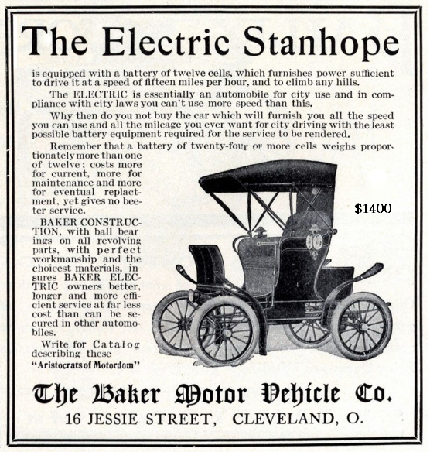Reviewed by Bob Bruninga, PE – January 2019

***Patty’s Motor Car,*** published in 1911 was the 9th in a series of 17 teen girl adventure books by Carolyn Wells about the adventures of the teenager as she entered a challenging advertising contest and won her first electric motor car. At the beginning of that decade, at least a third of all cars in the cities were electric. Patty’s EV motor car, a Stanhope runabout, had a range surprisingly comparable to most of the first modern EV’s a century later of 90 miles or so and almost 6 hours of continuous driving. And in the authors words, despite the objections of her suitor “Why infant, you’ll break your blessed neck!”, she retorts “Indeed, I won’t! I guess I’ve the brains enough to run an Electric Car!”[27]… scooting around…

[at the breakneck top speed of 15 MPH].

Similar to modern Tesla’s a century later, the delivery date slipped a few weeks, but eventually arrived to the excitement of all. Her friends prepared a shower of gifts in celebration consisting of a silk riding hood, a thin most elegant motor veil, gauntleted motor gloves, a motor-clock, a vanity case for her personals, a compass and a glass and gold flower vase.[95] Also similar to modern autonomous Tesla’s, to this young teen a century before, the car was automatically garaged and charged and brought around when needed to the front door, not by computer, but by Miller, the family chauffeur. And like Tesla voice recognition, Patty admits “sometimes, when I am out alone in it, I talk to it just as I would to a person, and she seems to understand… and she almost talks back.”

The motor car was “of graceful design and fine lines. The body was Royal Blue with cushions of broadcloth of the same color. There was a top which could be put up or down at will, wide skirt-protecting mudguards, and a full equipment of all necessary paraphernalia such as storm-apron, odometer and a complete set of tools.”[97] Patty informed her father “to make it go…you just release the pawl that engages the clutch that holds the lever that sustains the spring that lets go the brake – and there you are!”[30] You just stick in a key and turn it, and grab the brake handle, and take hold of the steering bar and push and pull whenever you think you ought to.”[110] “But I’m not going to take anybody riding until I learn how to manage the frisky steed myself.”[94]… “Then followed a careful lesson, in speed changing, stopping suddenly, turning, going backward, and all the various emergencies that occur in driving.”

Most popular among women at the time, compared to gasoline cars, “this is different, but so much simpler, that it’s no trouble at all,” said Patty.[113] “Soon the Swift Camilla [her name for it] was skimming along the country roads.” Her adventures consisted of getting stuck in sand, a few blown inner tubes, a crushed fender and her idea to repair an open battery strap with the tinfoil wrapper from a package of sweet chocolate… “In less than 2 minutes, Van Raypen had wound the … tinfoil in its place… and jumped into the car beside Patty and they were flying along at top speed.” [188]