20 March 2003

ANDE MAGNETIC SEPARATION SWITCH TEST

Midshipman 1/c Adam Madson

PURPOSE
This test will determine the behavior of the magnetic launch separation switches used on the CAPE/ANDE spacecraft system to prevent premature activation of the ANDE communications system prior to separation. The test will answer the following questions:

- Does the orientation of the magnet affect the switch closure distance?
- Does the angle of the magnet with respect to the switch affect the distance at which the switch closes?
- Does the placement of aluminum in between the switch and the magnet affect the distance at which the switch closes?
- What is the best orientation of the switch?

TEST PROCEDURE
The test materials consisted of a .19-inch square by 1-inch long rectangular magnet with strength of 1400 Gauss, a magnetic reed switch, and an electronic ohmmeter. The ohmmeter is attached to the switch so that it acts in the normally closed position. The switch was taped to a sheet of graph paper with distance and angles marked on it. The magnet was slowly moved towards the switch until the switch opened. The distance from the magnet to the switch was then recorded. The magnet was then moved away from the switch until the switch closed again. The distance was again recorded. The test was repeated with the magnet at four different orientations and six different angles.

To test for operation of the switch through aluminum the test was repeated with varying thickness of aluminum sheets between the switch and the magnet.

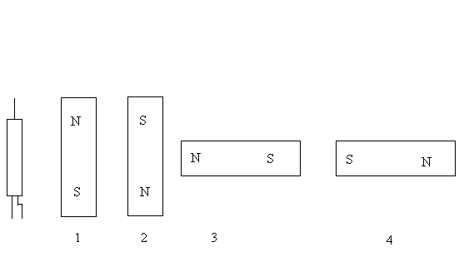

Fig. 1 – Magnet Orientations

TEST RESULTS

- The tests revealed that the orientation of the magnet affected the distance at which the magnetic switch would close. The maximum distance from the switch at which it would close was found with a magnet orientation parallel to the orientation of the switch as shown in 1 or 2 and independent of the actual polarity. A magnet orientation of 3 or 4 yielded similar closing distances off the end of the switch after subtracting one half-length of the switch. Further testing revealed that a null exists when the magnet is perfectly orthogonal to the switch axis.

- The rotational orientation of the switch around its axis had no significant impact on the activation distance. The maximum deviation of range through all orientations about the axis was less than 10%.

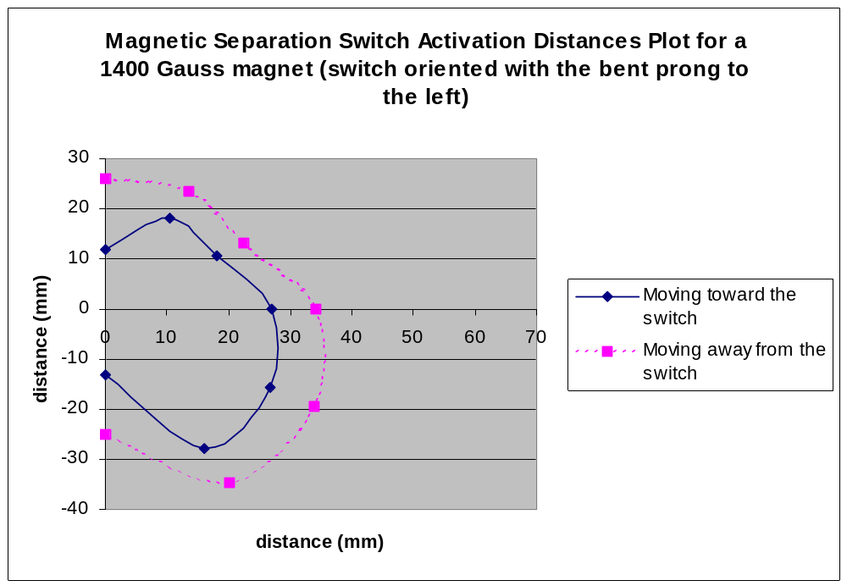
Fig. 2 – Distances of activation with magnet orientation 1 and vertical switch

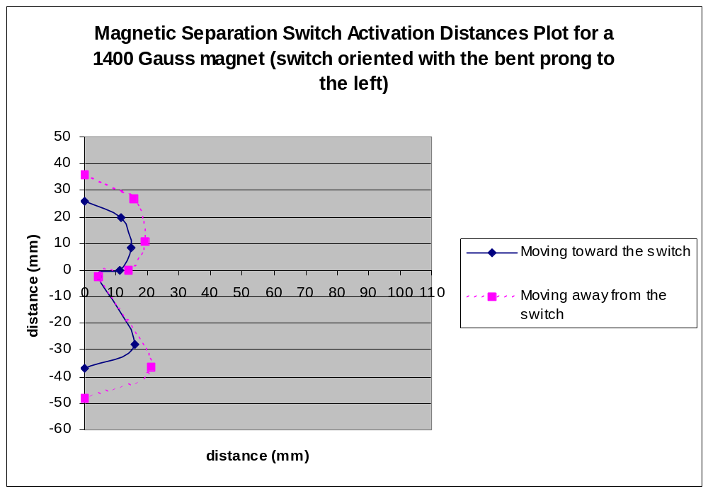Fig 3 – Distances of activation with magnet orientation 3 and vertical switch

- The distance for switch activation was higher when moving the magnet away from the switch. This hysterisis creates a buffer zone where the magnet can tolerate a certain degree of movement and still hold the switch open.

- The placement of the aluminum had no effect on the distance at which the magnet would close the switch.

Thickness of aluminum (in) | Distance of switch activation (in)
0 | 1.0625
0.032 | 1.0625
0.122 | 1.0625
Table 1 - Distance of switch activation with thickness of aluminum in between magnet

- The results of the test with the switch in the A position is the determination of a minimal 27 mm activation distance with parallel orientation of the magnet and the switch. At this orientation any rotational change of the magnetic field to the axis of the switch approaching 90 degrees could result in a null at exactly 90 degrees possibly allowing one or more switches to close.

- The tests were conducted a second time with the switch aligned radially to the ANDE sphere with the magnet at orientations three and four. The results showed similar distances as before. Orientation three showed greater distance than four, showing that the polarity of the magnet would be significant on final installation. The results of this test are shown below in figure 4. The maximum distance is 38 mm but includes the half-length of the switch.

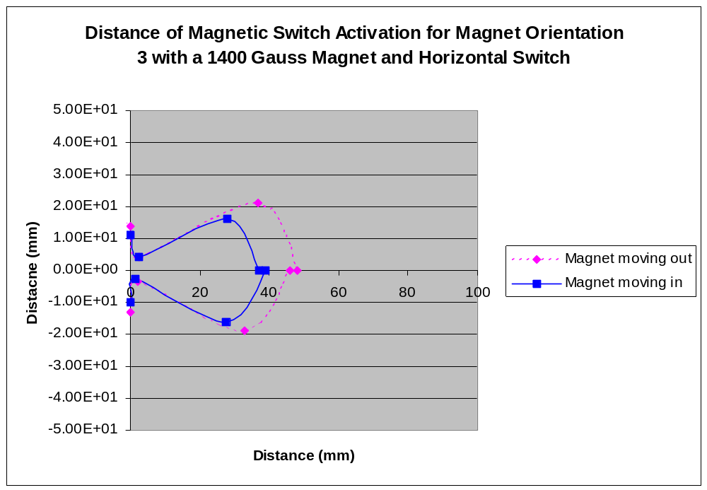Fig. 4 – Distance of activation with magnet orientation 3 and horizontal switch

RECOMMENDATIONS

- The tested magnetic switches will be suitable for use on the ANDE separation switch.

- The switches should be arranged on a PC board vertically. This would allow for the switches to remain closed even if the satellite underwent rotation about the z-axis because the magnets would never become orthogonal to the switch.

