AVRS, Automatic Voice Relay System
WB4APR,Dec 2001

This draft paper is a follow on to my original AVRS plan and suggests how we can integrate APRS with the growing capabilities of Internet/Radio linked voice to capitalize on the data exchange capabilities of APRS in the call set-up and monitoring of the status/configuration of the internet/voice-radio system. Goals are to permit station A to do any or all of these things:

- Station A sends APRS msg to B with his IRLP# and asks for a return call
- Station A Queries APRS for nearest node to Station B worldwide. Returns Node#
- IRLP/I-Link node dumps NODE status to Radio LIST showing recent node status
- Worldwide APRS system transports any MSG to "AVRS" to all other AVRS users
- All APRS/AVRS mobiles receive any/all messages to "AVRS" message group
- All AVRS mobiles include IRLP or I-LINK number in their mobile posit reports
- Mobile selects AVRS station on station LIST, hits MSG and IRLP connection is made
- Permit Station A to join into a named net.

Since there are thousands of mobile and handheld Kenwood D7 and D700 radios with front panels capable of hundreds of “pages” of information display, this AVRS design goal is to take advantage of these capabilities as a starting point. Other laptop or palm software can easily match this standard signaling plan. ALl of the data exchange and pushing the list information to the mobile is entirely now possible, but the NODE dumps cannot be done on 144.39
due to congestion. See the AVRS web page for details on those functions.

NODE Names: The first things we need to do is to up the node number field to 4 digits and we also need to assign an 8 character Geographic Node name to all nodes to facilitate displaying them in the existing callsign fields in most APRS applications (and these radio front panels). This leaves the 9th byte available for the node status (idle, connected, down, or offline). See examples below.

The remainder of this paper talks about how to support the AVRS data exchange on a local dedicated AVRS frequency if not the IRLP/I-Link frequency itself!

The following diagram suggests how the APRS TNC is simply added to an existing IRLP or Ilink system to add additional functionality for the end user. All existing capabilities of the IRLP node remain. The only impact is that voice users must use CTCSS to be able to mute their radios during any signaling.
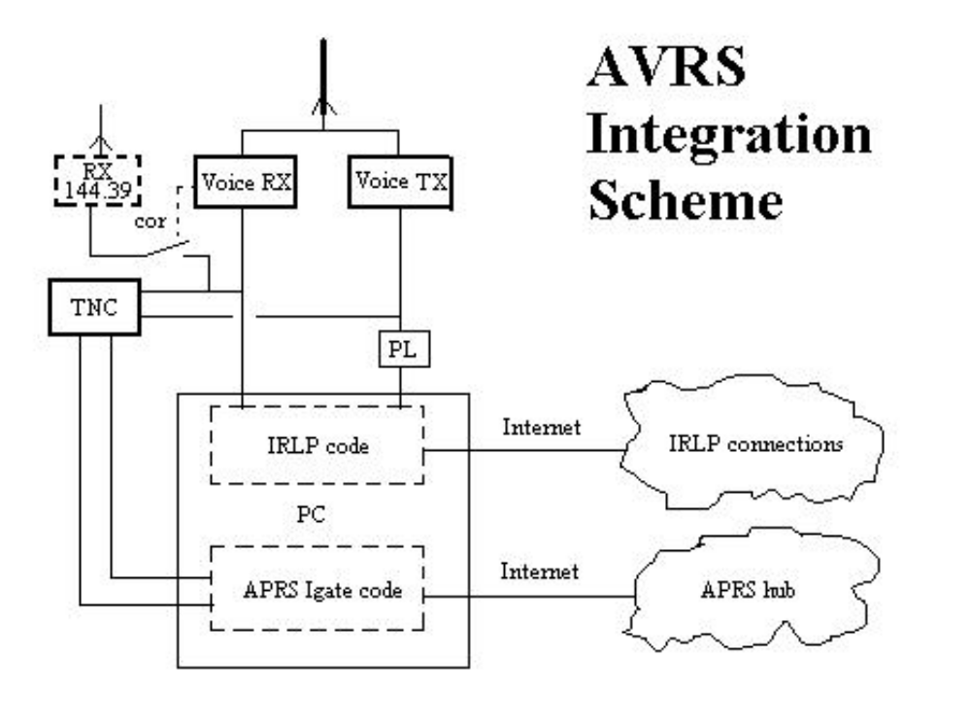
Although an auxiliary 144.39 APRS data receiver is shown, this is only a convenience for monitoring the local channel when the IRLP node is not in use. For normal operation, the AVRS user is presumed to be only on the AVRS voice channels with PL silencing his speaker. In this way, he and all other users of the AVRS node do not hear any data, but will hear all voice from the AVRS node when used.

OPERATIONS:

Here is the operational concept of how this system will work. These are based on the actions of the end users. The most visible initial capability to be added to AVRS is the ability to display the status of all nodes of interest on the radio front panel. This is like viewing the current ACTIVE-NODE WEB page, but it is presorted and shrunk to fit the display. The sorting is simply based on the status of all of the"recently used" nodes from this node. Thus the most recently accessed node will be the top one on the list. The depth of this recently used node stack can be from say 5 to the full 40 depth of the radio's display.

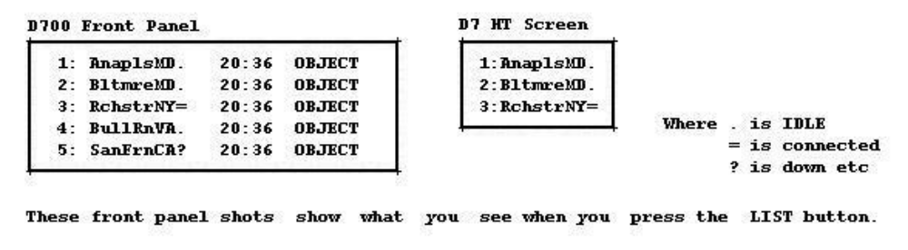
Then for each node in the list, a simple click on that node will display the amplifying information about that node and its location and status:
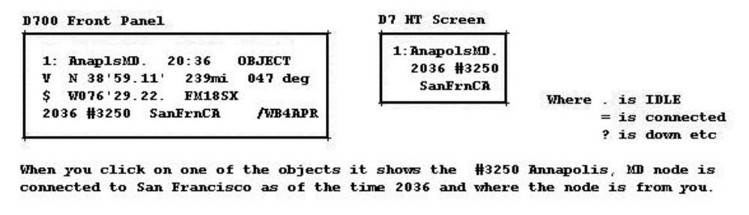

The following paragraphs then describe three different ways that the operator can operate his radio in conjunction with IRLP depending on his immediate communications needs.

Routine Driving: In this condition, the APRS operator has his APRS operations on 144.39 in Band A and he operates any repeaters or voice needs on Band B. In this mode, he is:

- Tracked and located worldwide via APRS
- Can send and receive any messages to/from anyone
- Can send/RX AVRS messages to/from anyone else with AVRS MSG GRP set
- Can Query APRS and will get back the Node# closest to that station
- Can initiate an AVRS connect request to anyone
- Will receive any ACKS from the end user or from AVRS

AVRS Operations: In this condition, he tunes his APRS band A to the local AVRS node frequency and monitors only this channel on Band A and is still free to use Band B in any way. In this mode his APRS operates in “PTT” mode so that it does not transmit except when he unkeys the mike so as not to interfere with any existing voice QSO in progress. He can still then do ANY
of the above operations PLUS he can monitor all voice activity on that node.

AVRS SIGNALLING:

This section suggests some initial formats for the APRS/AVRS signaling that will be used. To request a connection, one simply sends a message to the indicated end user or existing “named” reflector with the text “!AVRS” as the first word in the message as follows:

WB4APR>APK001:KC9XG :!AVRS }x <-- an End user
WB4APR>APK001:AMSAT :!AVRS }x <-- an existing reflector
WB4APR>APK001:W3ABC :?AVRS }x <-- Queries for nearest node to W3ABC

The responses to these messages are as follows:

KC9XG>APK001:WB4APR:ACKx ⬅ from the end user
Zzzzz>AVRS:WB4APR:KC9XG at IRLP #mmm ⬅ from the distant AVRS node
xxxxx>AVRS:WB4APR:Standby, linking to AVRS #nnnn ⬅ from the local AVRS node
xxxxx>AVRS:WB4APR:Linked to AVRS #nnnn ⬅ from the local AVRS node
xxxxx>AVRS:WB4APR:W3ABC-13 @ #nnnn 12 mi and #mmmm 23 mi <-- Shows nearest and dist

Notice how the response from the END user is entirely APRS and indicates that there is connectivity end-to-end between them. The distant AVRS node notices that the target station is within range AND it notices the “ACK” message to know that he is ACTIVE. Next, the LOCAL AVRS node sees both the ACK and the distant AVRS node response and so it begins to establish the voice link since it now knows that both ends are available.

In the case of the connection to the named reflector, the link is made if available without waiting for an ACK.

However, there are many other cases where the targeted end user is not immediately available or on line. The APRS system will respond with the following:

xxxxx>AVRS:WB4APR:KC9XG is not on line ⬅ No packets heard in last 2 hours any SSID
or
xxxxx>AVRS:WB4APR:KC9XG is not on line. Try KC9XG-9 ⬅ But his mobile call has been heard
or
xxxxx>AVRS:WB4APR:KC9XG at IRLP# nnn. Last packet was xx hrs ago
or
xxxxx>AVRS:WB4APR:KC9XG on IRLP# nnn. Last packet was xx m ago

Notice the last two responses use the words “at” or “on” to indicate whether the user is only in the area of IRLP node #nnn (at) or is actually using the IRLP node (on).

The QUERY response is from an AVRS engine that watches for these kinds of queries and responds with the 3 nearest nodes to the distant station showing
the distance to each. Notice I used 4 digit Node numbers because it wont
be long before that is required!

FORMATTING MESSAGES: The above wording and examples are very specifically formatted to fit nicely on the 12|12|12|9 two page, two line display of the D7 and the 21|22|21 3 line display of the D700. These line and page breaks should always be considered when formatting data for the end user.

APRS IGATE SOFTWARE CONSIDERATIONS:

The Igate software integreated into the IRLP PC does the normal APRS-Igate functions with some slight additions. First It has a more sophisticated file describing the “coverage” of the local IRLP node. This file is written as simple records of numbers indicating the expected workable range within any number of sectors for three different class stations as follows:

AZ1, AZ2, HT, MOB, BASE

They show the ranges of an HT, a Mobile and a BASE station. In general, the ICON of the D7 or D700 will be used to determine the category. Thus the Igate can determine quite well if the end user is within range of the give IRLP node. Notice, if the user is ON the AVRS frequency in that area (packets have been heard there recently), then he is “ON” that node. Otherwise, the range rules are applied and then the response only indicates he is “AT” that AVRS node.

AVRS INFORMATION AVAILABILITY:

In addition to the basic signaling, the following additional data is available to the end user:

1) returns a dump of the active AVRS users (most recent 40)
2) returns a dump of the status of the recently active AVRS nodes
3) returns a dump of the busiest active AVRS nodes
4) returns a dump of all nodes alphabetically starting with the letter X

These dumps fill the D7/D700 station list with all of the AVRS nodes as APRS objects showing their ID, STATUS, Range and bearing, LAT/LONG etc..

