  Event Date:  28-29 June 08  Date Submitted:  5 June 08  Date Circulated:  Date Approved:  _________________ | Special Events Application for Private Use of Public Space/Services # -08  THIS PERMIT IS REVIEWED BY ALL CITY DEPARTMENTS INVOLVED SPECIAL EVENT SERVICES  A "SEAPUPS" application is required in order to consider whether the activities proposed are in conformance with applicable laws and regulations and to ensure that activities are not detrimental to the public health, safety and welfare, as the City of Annapolis may have authority to permit or authorize. The following application is made pursuant to Section 11.12.050 Chapter 11.12 of the Code of the City of Annapolis (1996 Edition);"Public Peace and Order;" subtitled "Parades and assemblies - Permit Required." Pursuant to City Code Section 6.04.210, “Finance and Taxation Generally”, the Applicant of a parade/assembly permit will be responsible and billed for any and all costs the City incurs as a result of the approved event. The City will provide an estimate of expected costs associated with the event.  A pre-application discussion with the Special Event Coordinator is required.  This permit application, with requested attachments, must be submitted 20 days prior to the event.  Events requiring legislation must be submitted at least 120 days prior the event.  ANY APPLICATION TO CLOSE MORE THAN 2 BLOCKS FOR MORE THAN ½ HOUR  must be filed at least 90 days before the closure, with an alternate traffic route plan and provision for public notice and public comment. All expenses of public notice are borne by the applicant.  Contact Karen Engelke at 410-263-7996 or kengelke@annapolis.gov. A SEAPUPS will be e-mailed to you, which you must e-mail to submit. APPLICATIONS SHOULD NOT BE FAXED.  Karen Engelke, Event Permits, Office of the Mayor  - Duke of Gloucester Street, Annapolis, Maryland 21401.  A $25.00 non-refundable application fee must accompany this application. It will NOT be reviewed until the fee is paid…check can be mailed, credit card called in or cash delivered.  fee paid __ ______
EVENT TITLE | Amateur Radio Field Day See WEB page plan: http://www.ew.usna.edu/~bruninga/aprs/field-day2008.html |  |  |  |  | Sponsoring Organization  Status → |  |  |  City Residential or Community Group   Not for profit   Private Citizens
Sponsoring Organization | Members of: US Naval Academy Amateur Radio Club  Anne Arrundel Radio Club  ARINC Radio Club
Contact Person | Bob Bruninga. Satellite Engineer, USNA  FCC License WB4APR |  |  |  |  | X Open to Public
Address of sponsoring organization | Satellite Lab  590 Holloway Rd  Annapolis, MD 21402 |  |  |  |  | Phone/ &  Cell for event contacts |  |  | 410-293-6417
Address of sponsoring organization |  |  |  |  |  | E-mail |  |  | bruninga@usna.edu
Address of permitted site | City Dock |  |  |  |  | WARD # Historic District? YES  NO 
Location & route of event  (Attach MAP) | Desire to set up a 10x10 Sun awning over 3 tables, plus have two parking spaces for support trailers/vehicle  See attached.
Describe activities & participants including VIP’s | A one-day annual national event where Ham radio operators demonstrate their emergency communications capabilities to the public. We would operate for 24 hours from noon Saturday, to noon Sunday and talk to the public about emergency communications preparedness
Purpose of Event |  Educational XXXX  Public Service Demonstration XXXX
Date// Rain date | 28-29 Jun |  | none |  | Estimated Economic Impact :  (Information Required)  Event budget = N/A  Net fundraised = N/A  Estimated audience expenditures = |  | Approx # event staff or performers |  |  | 4 to 8
Times event is open to public | Noon-noon |  |  |  |  |  | Estimated # audience |  |  | Casual walkers-by a half-dozen at a time maybe
Times access needed to site | Set up  8 AM | Breakdown  To 4 PM |  |  |  |  | Primary source of audience: |  |  | Local   XXX | Regional   |  | National  
If YES to any questions below, please describe in detail:  (The City requires every event producer who wants to serve or sell alcohol on any City property to appear before the Alcohol Control Board (ACB). In addition, any vending or peddling, and various components of event preparation and presentation require additional permits. Contact specific departments for permit application ) |  |  |  |  |  |  | FOR CITY USE ONLY:  License//Permit Service  Required Fees Other City costs
Selling or serving?  - Food/ non A  Beverages  - Alcohol  - Dry Goods  ACB meets 3pm first Wed.; applications due to City Clerk  30 days prior to this meeting. | Applicant as server//vendor? YES NO XXXXX  Are there additional outside vendors?  YES NO XXXXX  How many? N/A  Description of merchandise: N/A |  |  |  |  |  | All sales in the Historic District require specific legislation.
Electrical connections needed?  DNEP410.263.7946 | 5 amps max  (or none) |  |  | Amplified Music? Type, duration: see noise ordinance!  NONE |  |  | Electrical permit required
Docking or mooring needed?  Harbormaster | If possible, two adjacent mooring slips would be desired  Suitable for two under 36’ craft
Temporary structures erected?  Fire Marshal & DNEP | A sun-awning (sand-bagged) |  |  |  |  |  | Tent, Stage, require permit
Fireworks?  Fire Marshal | (Over water= Coast Guard permit 135 days for a new event; 60 days for a repeat event) |  |  |  |  |  | State Fire Marshal + City
Street or walkway closings?  Public Works & Police | none
Parking plan?  Police | Two-adjacent parking spaces for 1 trailer and 1 solar car. Plus one temporary set-up/drop-off/logistics space
Security & Event management plan? | Self provided |  |  |  |  |  | 1 per 600 attendees
Toilet facilities plan? | none |  |  |  |  |  | 2 per 100;  ADA compliant
Need for ancillary bus//shuttle service?  Transportation | none
Trash & clean-up?  Name of responsible company, #’s | None (we will police our trash if any)
Notification of impact zone occupants:  Provide copy of flyer or notice you will distribute | none
You may make payment for City Services & Fees with a credit card. Make any checks payable to The City of Annapolis |  |  |  |  |  |  | TOTALS:
Use of City property for special events may be subject to review by City Council, which may require legislation. Approved permit or lease must be on site and available during event, including additional permits & licenses as required. The applicant organization or individual furthermore agrees to indemnify and hold harmless the City and its agents against any and all losses, injuries or damages to any person or thing that shall arise from the applicant's use of and City property and/or personnel. The City requires an insurance rider covering the City from damages arising from the permitted event; this requirement can be waived by the Office of Law.
I have read and understand all the terms and conditions of this application. I am authorized by the applicant organization to sign on its behalf. My signature represents my acceptance of these terms and conditions.
Signature:_(MAY BE TYPED) __Robert (Bob) Bruninga____________Date of Application:_______5 June 2008___________________
Please initial, date and return to Special Events Coordinator
CC:  DNEP_________________________________  Fire Department__________________________________
 Police Department_______________________  City Clerk __________________________________
 Harbormaster___________________________  Public Works ___________________________________
 Recreation & Parks ______________________  Mayor’s Office ___________________________________
 Transportation ______________________  Office of Law ___________________________________
 Public Information Officer _________________  Office of Emergency Management ____________________
 Simpson_______________________________  Other City /Alderfolk _______________________________
 Dept. General Services/Parking____________  Health Department_________________________________
Event Application is hereby □ referred to Office of Law for legislation for City Council □ approved □ disapproved □ approved with the following modifications:

cc. Ward Alderman, City Web site
Date: | On behalf of the Mayor,  Signature of Event Coordinator

We are still undecided on which possible location would be best. We have sketched up two possibilities. Probably Harbor Master and City Hall will offer considerations that will force that decision for us. But at this moment, Plan A2 or B are Preferred…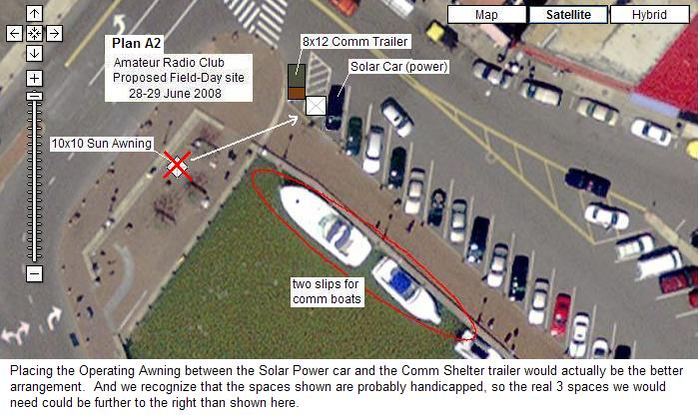

Plan B has the better arrangement for logistics, but is a little less visible to the casual public.

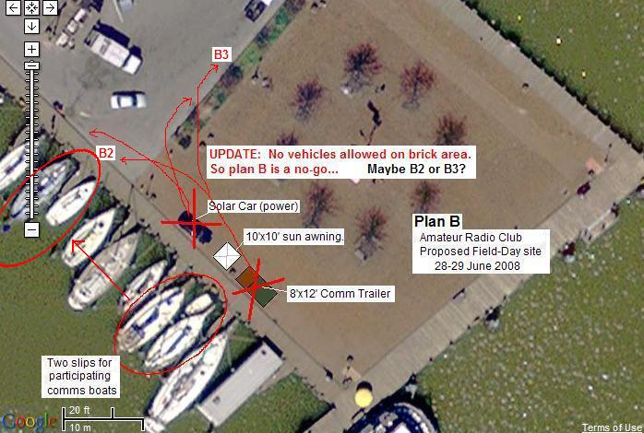

A Third option is to place the trailer, solar car and 10x10 canopy in the parking area as shown below:

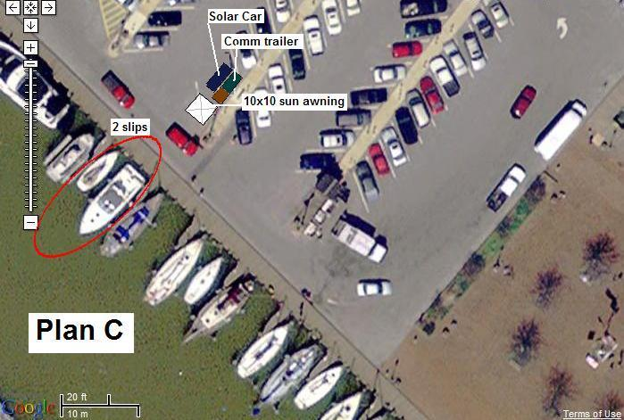
The Communicaitons Shelter is a small trailer about 6 by 12 feet that contains some of our radio equipment. Here is a photo with it crawling with cub scouts. Also, if it is a sunny day, we hope to operate entirely from solar power. One source of solar power will be from the roof of our solar charged electric car also shown here:

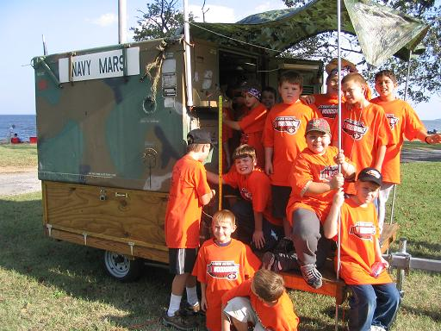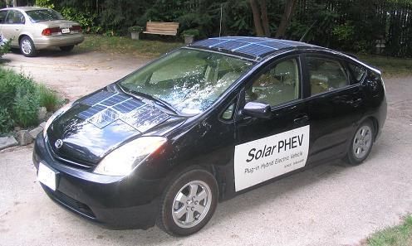

The operating positions (2 long tables) under a sun-awning will be similar to the photo below. This photo however is of a larger installation than what we propose for City Dock. We will only use a smaller sun canopy with open sides which will only be 10 x 10 feet or so. Operators will face outward so they can interact with the public.

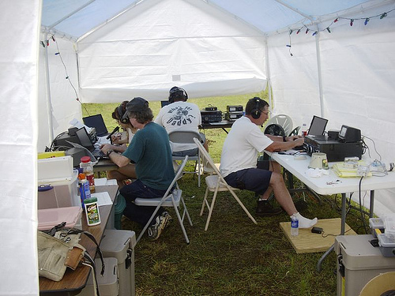

If there is any other information we can provide, please let us know. There are similar events planned at the Davidsonville Recreation Area and at Downe’s Park, but they are in the group-camping areas and are not as well exposed to the public.

Bob Bruninga, WB4APR
USNA Satellite Lab
410-293-6417

