6-Week Status Report
1/C Dendinger

Attitude Control System

The current design for P-Sat calls for both magnetic torqueing coils and reaction wheels. This combination will allow for a sun-pointing capability along with other attitude maneuvers. The ADCS will require sensors to determine the orientation of the spacecraft. These sensors will be the currents from the solar panels when in sun, and a magnetometer for use both in sun and in eclipse. The magnetometer’s readings must also be referenced to a pre-loaded model of the Earth’s magnetic field in order to determine the attitude of the spacecraft when in eclipse. When in sun, a sun vector can be developed by using the currents from the solar panels and using the inverse cosine relation that exists for determining solar panel orientation.

Our magnetometer is the MicroMag3, as shown in Figure 1.
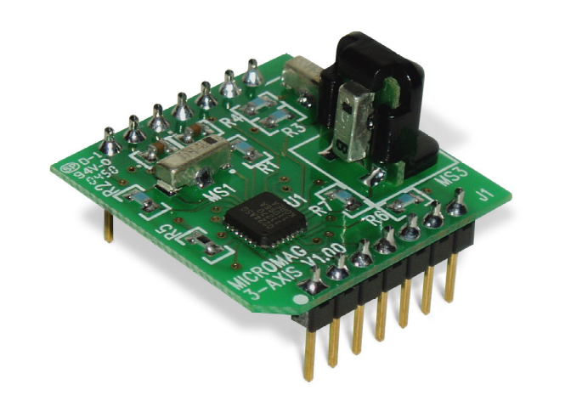
Figure 1.

It provides either raw magnetic field readings or pitch, roll and yaw based on a fixed declination calibration. The pitch, roll and yaw features will not be of use to us while in orbit because of the wide variety of declinations that the spacecraft will be experiencing. The pin I/O is shown in Figure 2.

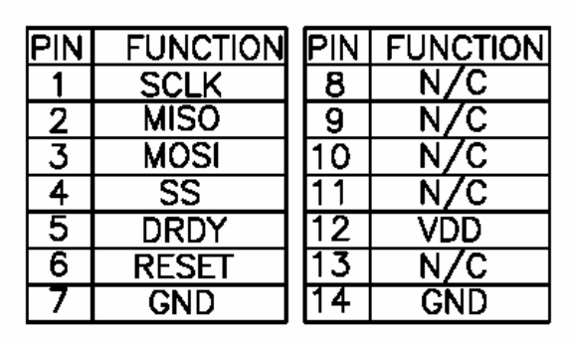
Figure 2.

The following descriptions for the I/O pins are taken from the MicroMag3 Datasheet.

MOSI (Master Out Slave In)
The data sent from the master to the MicroMag3. Data is transferred most significant bit first. The MOSI line will accept data once the SPI is enabled by taking the SSNOT low. Valid data must be presented at least 100 nS before the rising edge of the clock, and remain valid for 100nS after the edge. New data may be presented to the MOSI pin on the falling edge of SCLK.

SSNOT (Slave Select Line)
Selects the MicroMag3 as the operating slave device. The SSNOT line must be low prior to data transfer and must stay low during the entire transfer. Once the command byte is received by the MicroMag3, and the MicroMag3 begins to execute the command, the SSNOT line can be deselected until the next SPI transfer.

SCLK (Serial Clock)
Used to synchronize both the data in and out through the MISO and MOSI lines. SCLK is generated by a master device. SCLK should be 1 MHz or less. The MicroMag3 is configured to run as a slave device, making it an input. One byte of data is exchanged over eight clock cycles. Data is captured by the master device on the rising edge of SCLK. Data is shifted out and presented to the MicroMag3 on the MOSI pin on the falling edge of SCLK.

MISO (Master In Slave Out)
The data sent from the MicroMag3 to the master. Data is transferred most significant bit first. The MISO line is placed in a high impedance state if the slave is not selected (SSNOT = 1).

RESET
RESET us usually low. RESET must be toggled from low-high-low.

DRDY (Data Ready)
DRDY is low after a RESET; after a command has been received and the data is ready, DRDY will be high. It is recommended that the DRDY line always be used to ensure that the data is clocked out of the MicroMag3 only when it is available. If it is determined that the DRDY line cannot be used due to lack of I/O lines to the host processor, then the times listed in the table below can be used to set open-loop wait times. The values listed in Table 1. are the maximum delays from the end of the SCLK command until the rise of the DRDY at each period select setting. The maximum delay occurs when the sensor being sampled is in a zero field.

Period Select Maximum Delay

/32 | .500mS
/64 | 1.0 mS
/128 | 2.0 mS
/256 | 4.0 mS
/512 | 7.5 mS
/1024 | 15 mS
/2048 | 35.5 mS
/4096 | 60 mS

Table 1.

In order to determine the accuracy of the magnetometer, a non-magnetic gimbaled test stand was constructed to compare magnetometer output to the actual value. The results of two tests are shown in Figures 3. and 4.
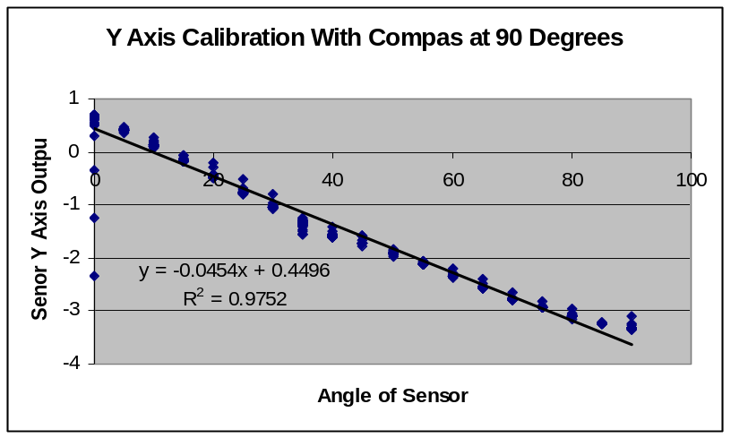
Figure 3.
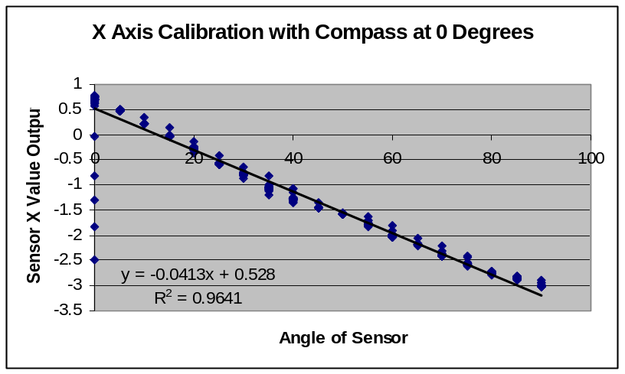
Figure 4.
These test shown an accuracy of ± 5% for pitch and roll from 0 to 90 degrees with a declination of 10°.

The processing of this information will be somewhat intensive compared to what we have done before on USNA satellites. The BASIC Stamp microcontroller is what has been chosen for most telemetry and housekeeping operations. It is small in size and has low power consumption which make it an ideal microcontroller for these activities.

In order to accomplish the floating point processing necessary for ADCS, a more capable microcontroller is being investigated. Online research determined that the Rabbit Microcontroller and its supporting hardware (which is made by the USNA Weapons and Systems Lab) would suit our needs and provide all of the functions of the BASIC Stamp in addition to higher processing capability needed for ADCS. The Rabbit microcontroller has 14 channels of I/O and 10 A/D channels which could make telemetry and control much easier then in the past. The Rabbit is programmed using a variation of C programming language. A RabbitCore 3000 was loaned to me from the Systems Engineering Department and I am working on learning how to make use of its numerous capabilities. I am also expecting to receive a more detailed document on the limitations and capabilities of the board the RabbitCore plugs into.

