Interface Design Spec
USNA Small Satellite Program
SPID
Joseph Campbell
Rachel Barton

]

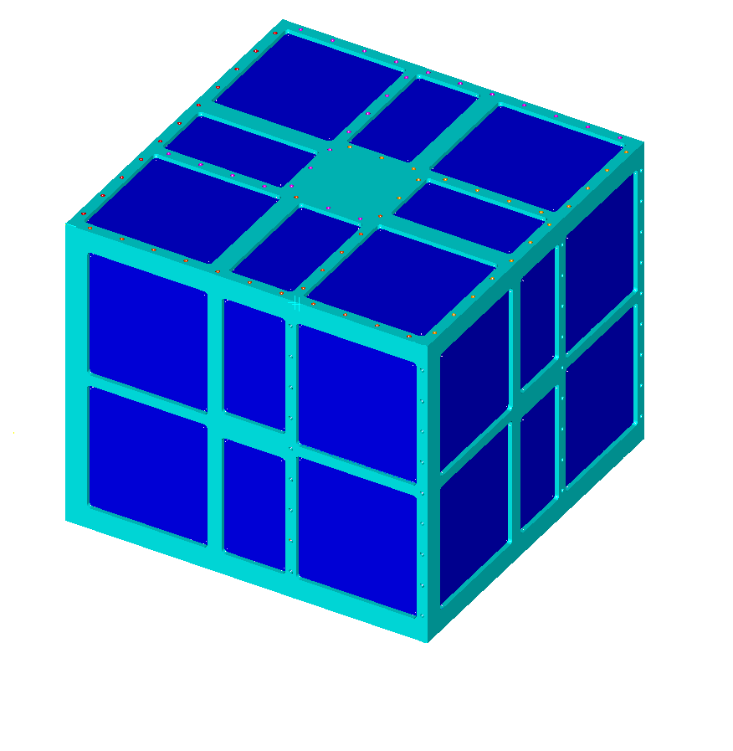

United States Naval Academy
Annapolis, Maryland

Signature Page
Fill in names and titles and also move this to the front page

Reviewed by:
 | Mids: Name, ParkinsonSAT Team, email |  | Date
Reviewed by:
 | Mids: Name, SPID Team, email |  | Date
Reviewed by:
 | Name, SPID Principal Investigator, email |  | Date
Reviewed by:
 | Bob Bruninga, PE, ParkinsonSAT Principal Investigator, Bruninga@usna.edu |  | Date

Revision Log

Revision | Description | Author | Date | Approval
1
2
3
4
5
6
7
8
9
10

Table of contents

Signature Page ii
Revision Log iii
Table of contents iv
List of Figures vi
List of Tables vi
List of Drawings vi
Acronyms vi
1 Introduction 2
1.1 Scope 2
1.2 SPID Experimental Description 2
2 Administration 4
2.1 Configuration Management- 4
2.2 Precedence of Documents 4
3 Interface Definitions and Description 5
3.1 Units 5
3.2 Payload Name 5
3.2.1 Mechanical Interfaces 5
3.2.2 Mounting and Alignment 6
3.2.3 Thermal Interfaces 6
3.2.4 Electrical Connections 7
3.2.5 Mechanical Interface Drawings 7
3.3 Electrical Power 8
3.3.1 Voltage 8
3.3.2 Current 8
3.3.3 Power Quality 8
3.3.4 Loads 8
3.3.5 Grounding 8
3.3.6 Power Draw Profiles 8
3.4 Discrete Electrical Signals 9
3.4.1 Discrete Analog Inputs 9
3.4.2 Discrete Analog Outputs 9
3.4.3 Discrete Digital Inputs 9
3.4.4 Discrete Digital Outputs 10
3.5 Serial Digital Communications 10
3.5.2 Input Signals from ParkinsonSAT to SPID 10
3.5.3 Output Signals from SPID to ParkinsonSAT 10
3.6 Software Interfaces 11
References 12
Appendix A: Sensor Calibration Data 13
Appendix B: Sensor Calibration Data 14

List of Figures
Figure A.1. SPID attached to +Z of ParkinsonSAT 2
Figure A.2. SPID Deployment 3
Figure A.1. Calibration of Transducer 1 13

Acronyms
 attitude and directional control system
 automatic packet reporting system
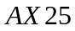 communications packet protocol
 computer processing unit
 electric power system
 high-level data link control
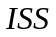 International Space Station
 National Aeronautics and Space Administration
 Naval Research Laboratory
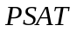 Parkinsonsat
………………………...Small Particle Impact Detector
 United States Naval Academy

Introduction

Scope
ParkinsonSAT is a free flying cube shaped satellite. The satellite will serve as a data exfoliation transponder for both commercial customers as well as users in amateur satellite service.

ParkinsonSAT Description
Insert all the same photos and diagrams and paragraphs about ParkinsonSAT from the ODTML document here… And use it for guidance for the next section as well…

SPID Experimental Description
There are several experiments onboard. This particular document concerns SPID, Small Particle Impact Detector. SPID is a resistive grid that uses an acoustic system to detect particle impact and determine particle size.

DESCRIBE all we know about this mission and the hardware and software.. Describe how it fits on Psat and what the following daiagrams represent..

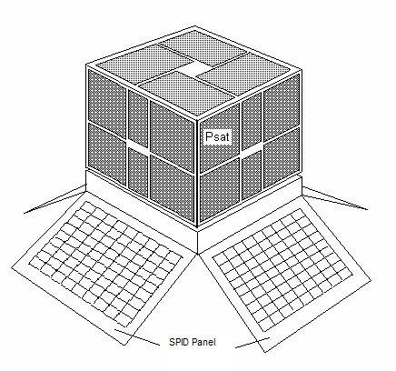
Figure A.1. SPID attached to +Z of ParkinsonSAT
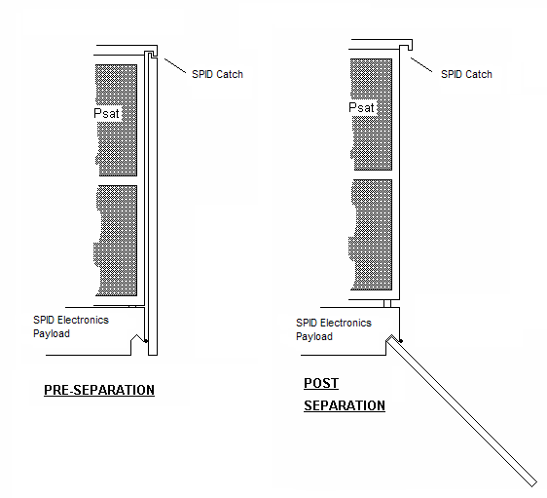
Figure A.2. SPID Deployment

Administration

Configuration Management-

Precedence of Documents

Interface Definitions and Description

Units
All references to sizes onboard ParkinsonSAT will use English Engineering Units.

Payload Name
SPID, Small Particle Impact Detector

Mechanical Interfaces

Physical Properties

Dimensions
The SPID experiment will consist of an electronics package and four separate deployable impact detection panels attached to the four side of the ParkinsonSAT flight unit. By locating the majority of the SPID experiment in an outboard compartment, and with attached outboard panels, there is minimal impact in the base ParkinsonSAT structure if there are any substantial changes to the SPID payload.

The external portion of the SPID experiment will be located on the external +Z face of the ParkinsonSAT flight unit.

The estimated dimensions of the external SPID electronics package are. 4.25” x 7.25” x 10.125”..

The estimated dimensinons of the external SPID impact panels are 12.75” x 12.75”x by 14” if the electronics package is 2” deep. This height is negotioable at this time, but should be minimized. The resistive impact grids cannot exceed the 12.75” width and cannot extend more than the sum of the 10.125” ParkinsonSAT side panel plus the 2” depths of the SPID electronics enclosure.

Materials-
The ParkinsonSAT flight unit will be constructed from milled 6061 aluminum. Structural components will be fastened by #4-40 hardware and #6-32 hardware.

Mass-SPID mass budget is limited to 5 kg.

Surface Treatments-The aluminum spaceframe components will be either anodized or iridited. Internal surfaces will usually be black anodized for thermal balance.

Mounting and Alignment

Mounting Specifications
SPID will be attached to the +Z face of the ParkinsonSAT. The coordinate system within Psat is NED (North East Down).

Alignment Specifications
On ParkinsonSAT, the –Z face is sun pointing and so the +Z location of the spacecraft is Earth pointing. In this case, the SPID electronics enclosure will be maintained in a dark attitude with usually no sun illumination.

Thermal Interfaces

Temperature Limits
Since the SPID experiment will be +Z pointing away from the sun, the package will never be exposed to direct sunlight. The package will however be exposed to the Earth’s reflecting albedo. The estimated temperatures of Parkinsonsat are
(GET THESE FROM ODTML DOCUMENT)

Temperature Monitoring Components
Independent if any SPID requiremnts, ParkinsonSAT requires a temperature sensor on the +Z face of the SPID electronics enclosure. This temperature will be included in basic ParkinsonSAT health telemetry.
(GET THESE FROM ODTML DOCUMENT)

Thermal Control Components
The sun pointing attitude of PSAT has been designed to spread the heat collected from the -Z face throughout the structure. Heat transfer through the bulkheads will be radiated out of the cold space facing faces. Due to the design, individual thermal control components should not be needed. There is insufficient electrical power for any heater devices. SPID must be designed with passive thermal control to maintain its own termperature requirements. The +Z foace of ParkinsonSAT to which the SPID electronics package is attached will probably be within the limts of -10°C to 40°C.

Electrical Connections

Connector Hardware Specifications
Connectors will all consist of standard sized crimp pin “DB type” connectors for the flight model. At no time shall the current on any pin exceed 2 amps.
(someone needs to look this up!)

Ground Straps Ground
The four resistor impact panels shall be bonded with a ground strap to the SPID electrical enclosure. The SPID electrical enclosure shall be bonded to the ParkinsonSAT spaceframe with a ground strap.

Connector
Pin-outs: A Standard DB connector will be used.

Bonding Specifications
Using the crimp pin style “DB 25,” there will be no soldering joints due the risk of cracking during launch phase of the flight. All pins will be crimped.

Intra-payload Harness
The internal SPID wiring harness will be staked or mechanically fastened every 3” minimum to prevent cross movement.

Mechanical Interface Drawings


Drawing A.1. Practice Drawing 1

Electrical Power
Insert description from ODTML here and check the below paragraphs for comonallity in concepts to the ODTML ones.

Voltage
Both bus A and B will be 8 volts. This will be distributed using a #22 AWG wire. Operating voltages vary between 7.2 to 8.4 volts. Voltages as low as 6 volts may occur, but at any voltage below 6.6 volts all loads should drop off line with a brown-out low voltage cut-off.

Current
SPID can be fed from either side A or B 8 volt busses. Each feed can provide up to 1 amp peak and 100 mA average power to SPID. The fuse will be rated at 2 amps.

Power Quality
The unregulated 8 volt bus is driven by six NiCd cells and will vary between 7.2 and 8.4 volts. operationally. A low voltage cut out will occur at 6 volts. During battery charging, bus voltages as high as 8.8 volts can occur.

Loads
The peak load from SPID can not exceed 1 amp for more than 5 seconds. The duty cycle of such peak loads cannot exceed 12.5 percent or a maximum total average power of 5 watts.

Grounding
Both buses will be grounded to a single ground point.

Power Draw Profiles

Average Power
The whole orbit average power over a twenty four hour basis shall not exceed 5 watts on the 8 volt bus. The power to SPID is under the control of the ParkinsonSAT operating system and will be enabled as a primary mission objective as long as there is adequate power available.

Peak Power

Nominal Operating Power

Standby Power
Stand by power is .16 watts at 8 volts. Stand by power may be lost during periods of low spacecraft power or under voltage conditions.

Duty Cycles
As noted above peak power and duty cycle will not exceed the average power noted in paragraph 3.3.6.1.

Discrete Electrical Signals

Discrete Analog Inputs
The thermister is part #_______________________. The certification date is provided in appendix _________.

Thermister +

Thermister return

Discrete Analog Outputs
Get all these from ODTML for now… all the way through 3.5

SPID RXD two discretes. TBD RS-232 data from ParkinsonSAT to SPID.

Discrete Digital Inputs
SPID TXD two discretes. TBD RS-232 data from SPID to ParkinsonSAT.

Discrete Digital Outputs

Serial Digital Communications

RTS
Request to send

CTS
Clear to send

Input Signals from ParkinsonSAT to SPID

Signals Characteristics
RS-232, RS-422 on TLL levels 0-5 volts.

Command Protocols
All commands from ParkinsonSAT to SPID use the printable ASCII subset with no control codes. The prescence of extraneous ASCII character in the serial data bus to other payloads will occur. SPID protocols must be immune to the other unintended signals.

Data Input Protocols
TBD

Command Upload Protocols
TBD

Output Signals from SPID to ParkinsonSAT

Signal Characteristics
Same as 3.5.2.2 Command Protocols

Telemetry Output Protocols
Routine health and housekeeping Telemetry will be sent from the SPID to the ground via the ParkinsonSAT processor in the following format. Psat will place this data into an AX.25 HDLC packet frame with check-sum for error free delivery to monitoring ground stations. The format is:

}SPID>APvvvv:T#NNN,111,222,333,444,555,XXXXXXXX

Where “SPID>APvvvv:” is a fixed pseudo packet header to identify the source of the data as coming from SPID. The “vvvv” field is optional and can contain a version number of any other identification data if needed by SPID.

Where “T#NNN” is a serial number from T#001 to T#999.

Where “111,222,333,444,555” are five fixed 3 byte wide decimal telemetry values. Each value may range from 000 to 999 for about 9.9 bits of A/D resolution.

Where “XXXXXXXX” is a string of 8 consecutive discrete bits indicated by the character either “0” or “1”.

Data Output Protocols

All other data outputs from SPID intended for communications to the ground will use a similar pseudo packet hearder followed by any necessary SPID data. The only restriction on SPID data in this case remains that only the printable ASCII character set may be used. The format is:

}SPID>APzzzz:{PX…. Data…

Where “SPID>APzzzz:” is the pseudo packet header identifying the source of the data as SPID and the type of data can be uniquely identified by “zzzz”.

Where “{PX” is a special fixed field which indicates the type of special data and the format follows. The “{“ is a required delimiter. The “P” indicates thisis a PCSAT unique format and the “X” byte can be chosen from up to 92 or so uniquely defined possible formats.

Software Interfaces
3.6.1 The ParkinsonSAT payload serial data bus will contain packetized printable ASCII data to and from all onboard experiments, and also to and from all user ground stations and any other serial data on the channel. The individual payload processors (SPID) must ignore all such data except for the packets specifically addressed to it. All data on the Serial Data Bus will be in the following standard AX.25 format:

SOURCE>DEST,PATH,PATH:xxxxxxxxxxxxxxxxxx….

Where SOURCE is a 3 to 9 byte variable length field indicating the originator of the packet. Only the uppercase and numeric characters are used in the first 6 bytes and the final 3 may contain a one or two byte numeric field (“-1” to “-15”).

Where DEST is a 3 to 6 byte destination field. This field has the same character restrictions as the source. Since most data on the payload bus is transmitted in broadcast manner, the destination field is often used to indicate a version number or other identifier.

Where PATH is a series of from none to seven comma separated fields indicating the RF path for the data. These fields are also limited to the character restrictions of the source field. Typically if a packet is relayed by a ground station or another satellite, the callsign of that station will be included here.

Where all data after the “:” colon is free field from 0 to 128 bytes.

3.6.2 There is no software flow control.

3.6.3 Hardware Handshaking: SPID may transmit onto the bus only if CTS is clear and when it begins to transmit, it must assert RTS.

References
Barlow, Jewel B., William H. Rae, Jr., and Alan Pope. Low-Speed Wind Tunnel Testing: Third Edition. New York: John Wiley & Sons, Inc., 1999.

Appendix A: Sensor Calibration Data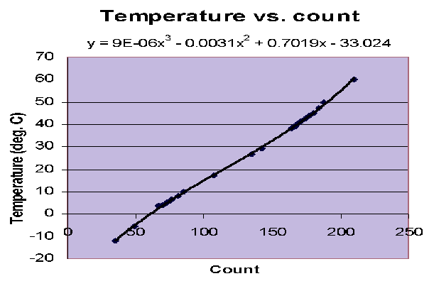

Figure A.3. Calibration of ParkinsonSAT Thermister KC006-ND

