UHF Interference Mitigation Experiment
on
ParkinsonSAT



Cameron Marcellus Lindsay∗
United States Naval Academy
Annapolis, Maryland

Table of contents

Table of contents ii
1 outline 3
1.1 Introduction 3
1.1.1 Scope 3
1.1.2 UHF RFI Background 3
1.2 USNA Ground Segment 5
1.2.1 Atlantic UHF Helix Antenna 5
1.2.2 Conus Helix Antenna 8
1.2.3 Antenna Performance 8
1.2.4 Antenna Control 9
1.2.5 USNA UHF Receiver Spectrum: 10
1.3 11
References 14
Appendix A: Link power budget - UHF 15
Appendix B: link power budget - parkinsonsat 2

outline

Introduction
An UHF Radio Frequency Interface mitigation experiment will be flown onboard the USNA satellite ParkinsonSAT as a secondary payload. The objective of this report is to establish the background for this experiment.

Scope
UHF Follow-on (UFO) Satellites are responsible for basic naval asset communications for all ships and submarines. Presence of interference has the potential of jeopardizing message and communication accuracy, along with a mission’s success. This experiment consists of the background material, the Ground segment and the on-orbit segment.

UHF RFI Background

2The frequency range from 300 MHz to 310 MHz is the uplink band in the ultra high frequency range for the Navy’s Fleetsats and UFO’s. It is not uncommon for these communications channels to be interrupted unintentionally and sometimes intentionally by world wide users. In the naval applications, the UHF Follow-on (UFO) satellite series is responsible for communication between naval ships and operational units around the world. Currently the navy has 11 UFO satellites in operation and unfortunately the communication links between these satellites and Department of the Navy certified receivers often experience interference experiment from a variety of sources including some intentional. The goal of UHF Interference Mitigation will be to help isolate the location of the interference.

To better understand the Navy’s UHF connected satellites we first want to establish the USNA UFO monitoring capacity. This project will involve the organizing of roof antennas and completion of a transmitter antenna. The roof antenna and transmitter will be used in the monitoring and eventually help in correcting UFO interference problems experienced over Europe, South America, and the United States. Specifically, two helix antenna will be used in monitoring the UFO satellite over the Atlantic that is assumed to be in a geosynchronous orbit at 23 degrees east longitude and the CONUS satellite at about 100 degrees west longitude. A tunable VHF/UHF receiver (model TH-F6) will be implemented for use with PCsat.

Current Fleet SATCOM Configurations

Commercial
Wideband
Protected
Broadcast
Narrowband
LHA
LHD
SSN
LPD
LSD
CG
FFG
DD
MCM/
MHC
LPD17
DDG
T-AH
AS
AGF/
LCC
CV/
CVN
FFG
INMARSAT B HSD
WSC-8(V) CWSP
USC-38 EHF
USR-10(V) GBS
WSC-6 SHF
WSC-3 (UHF)
SSGN
SSBN
Sub SHF

Large Decks

Medium Decks

Small Decks/Other

SUBs

Figure 1: Current Fleet SATCOM Naval Application

UFO Satellite Coverage
10° look angles
UFO/EE: UHF Follow-On Enhanced EHF
UFO 7 172.0 W LDR
UFO 4 177.0 W LDR
UFO 8 172.0 E LDR
UFO 5 100.0 W LDR
UFO 9 22.5 W LDR
UFO 6 105.0 W LDR
SATELLITE LOC CAP
UFO 11 72.0 E LDR
UFO 10 72.0 E LDR
SATELLITE LOC CAP
SATELLITE LOC CAP
90
180
90
0
90
East
West
East
60
50
40
30
20
10
0
75
60
50
40
30
20
10
75
30
60
120
150
150
120
60
30
30
60
120
150
NCTAMS PAC
NCTS GUAM
NCTAMS LANT
NCTAMS EURCENT
NCTS BAHRAIN
NCTS GUAM
NCTAMS EURCENT
NCTS BAHRAIN

Figure 2: UFO Satellite Coverage and Locations

USNA Ground Segment

Atlantic UHF Helix Antenna

The severely damaged UHF helix was recovered from the 3rd floor boiler room and moved downstairs outside the satellite control room for refurbishment. With a total of 10 turns on the antenna, every turn had three points that were to be braced to the brackets that extended perpendicularly from the antenna, in addition to the splicing of two separate broken joints in the antenna’s helix turn was of priority. Figure 3 depicts the brackets used in for the Atlantic Helix Antenna.

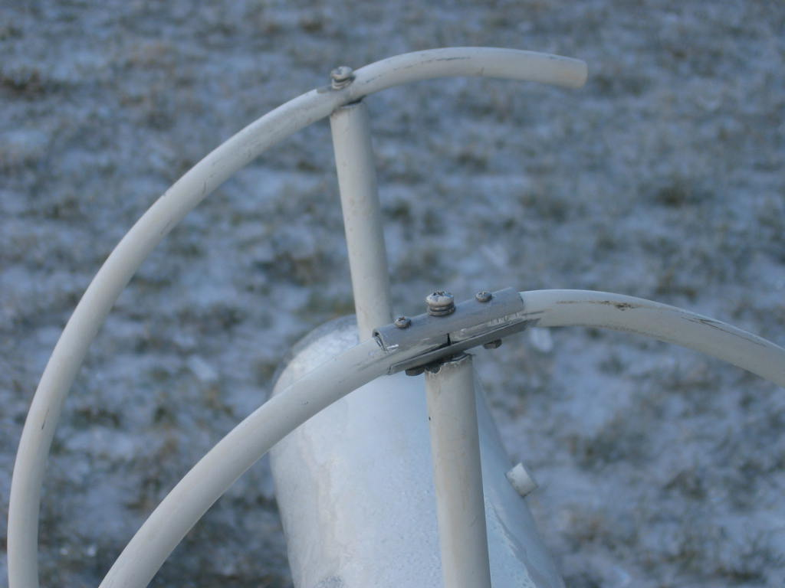

Figure 3: Aluminum Jointing Brackets.

For splicing the two broken portions of the helix, brackets were made from aluminum piping. The two brackets were cut down one side to allow for a pressure fit of the bracket around the antenna leads for good electrical conduction. Two screws were placed through the brackets and broken helix ends to secure them. One more screw held the bracket into the helix ring braces that extend perpendicularly from the antenna.

Following the splicing of the two broken sections, every part of all of the remaining helix turns were secured with a single screw into each of each of the 30 braces as shown in Figure 4.

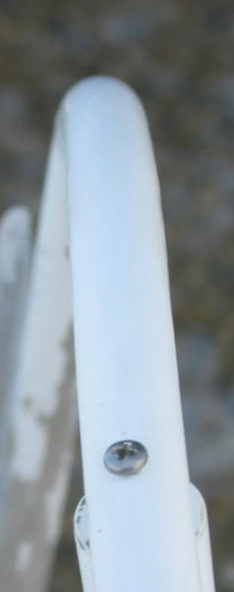

Figure 4: Helix Turn Fastening with Screws

The antenna’s center of gravity was adjusted by ballast and sliding the location of the pivot point. A linear activator from a 3 meter TVRO dish was installed to rise and lower the antenna depending on the polarity of 24 DC applied to it. Both the linear activator is shown below in Figure 5.

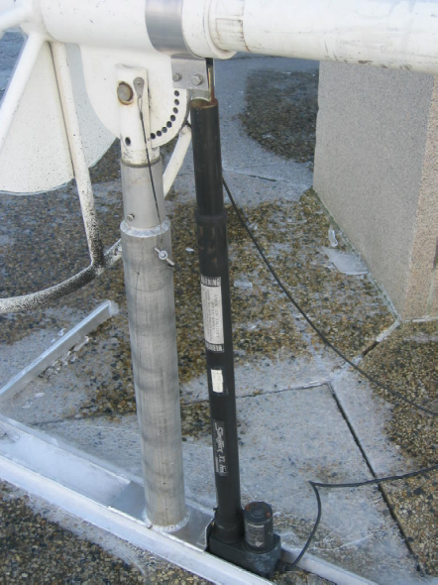

Figure 5: Linear Activator

After an initial test with a spectrum analyzer and of 30 dB of low noise amplifiers, the antenna was moved outside of RI22 on the north corner of Rickover facing easterly towards the Atlantic Satellite. The azimuth of the antenna in relation to the base of Rickover is illustrated below in Figure 6.

Antenna azimuth of 122.5 degrees

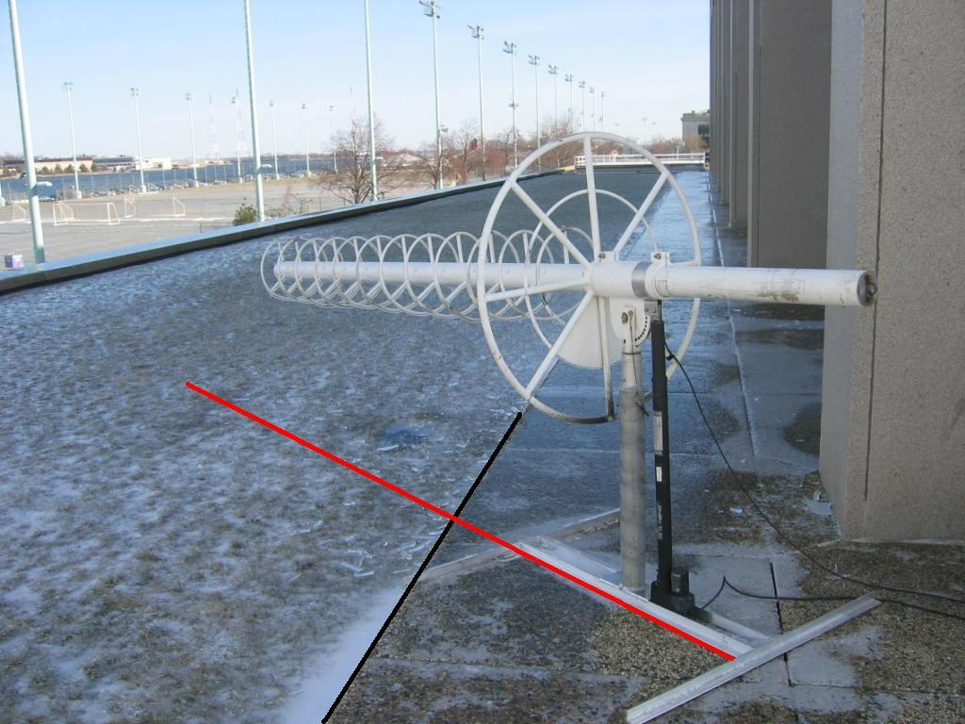
Rickover Base Azimuth at 133 degrees

Figure 6: Antenna Helix Orientation

Conus Helix Antenna
A second damaged helix antenna was repaired using a portion of PVC piping fitted on top of the helix antenna post. A total of 7 turns are to be created leading to the determination of 32 more inches of PVC piping will be required along with the necessary helix antenna ring material. Helix supports have been created out of wooden dowel rods and extend along the entire PVC piping length in support of the planned helix pattern continuation. This is exemplified in Figure 7.

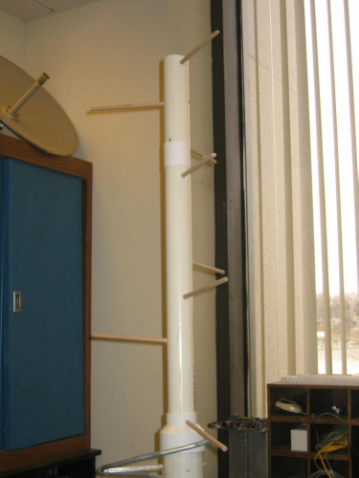

Figure 7: Antenna Helix Construction

Antenna Performance

Gain and Beamwidth Calculation

Knowing the UHF antennas operate in the radio spectrum with a frequency between 250 to 310 MHz wavelength between 1 and 10 cm the gain and beamwidth of both antennas can be calculated with the application of Equations 1 & 2. All helix antennas have a conical beam shape. The antenna gain is defined as the ratio of the effective aperture area, A_{r}, to the effective area of a hypothetical isotropic antenna, λ²/4π. Alternatively, the peak gain in dBi can be calculated based upon the dimensional parameters of the antenna. Table 1 shows the dimensional parameters of both antennas.

Antenna Parameter Dimensions
f | 3.10E+09 | Hz
λ | .96774 | m
 | Antenna 1 | Antenna 2
 | (m) | (m)
L | 2.8440 | 1.8790
D | 0.3810 | 0.2845
C | 1.1969 | 0.8937
C=πD |  | η=0.70

Table 1: Antenna Parameter Dimensions

Furthermore the peak gain of the antennas in dBi can be calculated using Equation 1 as shown below.

 Equation 1
for 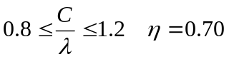

The gains of the antennas were found to be 10.95 and 10.52 dBi for antennas 1 and 2, respectively.

Similarly the half-power beamwidth (deg) can be calculated based upon the same dimensional parameters of the antennas.

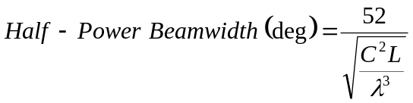 Equation 2

The Half-power beamwidths were found to be 24.5 and 40.4 degrees.

Antenna Control

The linear position feedback for raising and lowering the antenna consist of pulses from the motor that correspond to a certain number of pulses per degree. A total of three runs were made from 0 degrees (horizontal and parallel to the ground) up to 45 degrees. The average for raising and lowering the antenna was unable to be found by counting the audible pulse tones given a digital multimeter. This was because the frequency of the pulses occurred at such a great rate that while one tone was heard there multiple pulses being sent during the duration of the tone. This was proven visually by the pulse counts observed when the hydraulic motor was interfaced with the computer programs Basic and Matlab.

Following, the UFO satellite was determined to be at an elevation of 19 degrees and azimuth of 122.5 degrees from the north. Since the wall of Rickover is aligned to 133 degrees, making azimuth alignment easy. Figure 7 shows the alignment and current positioning of the antenna.

USNA UHF Receiver Spectrum:
In order to more closely monitor the UFO satellite channel activity, the signal received by Atlantic helix antenna requires proper amplification and filtering. Before reaching the spectrum analyzer, the incoming coaxed is powered with 12 volts DC. Following the signal passes through a LC and Helical Filters. The LC filter has been hand tuned to obtain the maximum signal to noise ratio at the given operating voltage and frequency. Lastly, the signal is passed through a 20 dB line amp before reaching the spectrum analyzer. Figure 8 depicts the experimental setup for filtering and amplifying received signals form the Atlantic UFO satellite.

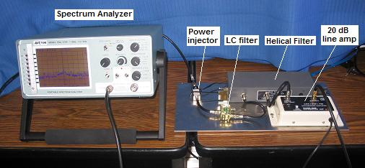

Figure 8: UHF Receiver Experimental Setup

UHF Signal Illustration
Shown below as Figure 9, is the downlink received from the Atlantic UFO satellite. Verification of the satellite can be made by counting the number of peaks in the signal, each correlating to a channel on the UHF UFO satellite.

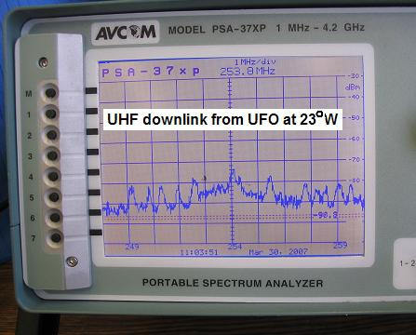

Figure 9: UHF downlink from Atlantic UFO satellite

UhF RFI On orbit Receiver
On board ParkinsonSAt will be a TH-F6 Handheld receiver. The receiver will be used to communicate between ParkinsonSAT and its ground station. In addition, the receiver will be used to monitor and compared the downlink signals of UFO satellites, to those experience at the UNSA ground station. This comparison will aid in detecting and triangulating the location of interference sources through a process called geolocation. Figure 9 below depicts the process of geolocating an interference source.

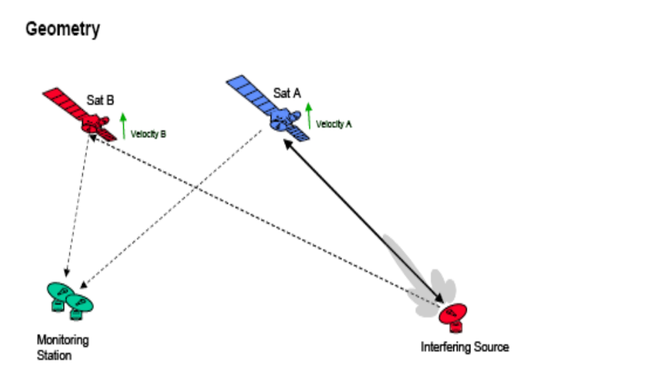

Figure 9: Geolocation of Interfering Signal

Mechanical Interface

The UHF RFI receiver will be housed in the ParkinsonSAT Side A or Side B transponder components, which measure to 4.25” x 7.25” x 8.125.” Displayed below as Figure 10, is the TH-F6 handheld receiver that will be onboard ParkinsonSAT. The long ferrite antenna will be removed from size and fitting purposes.
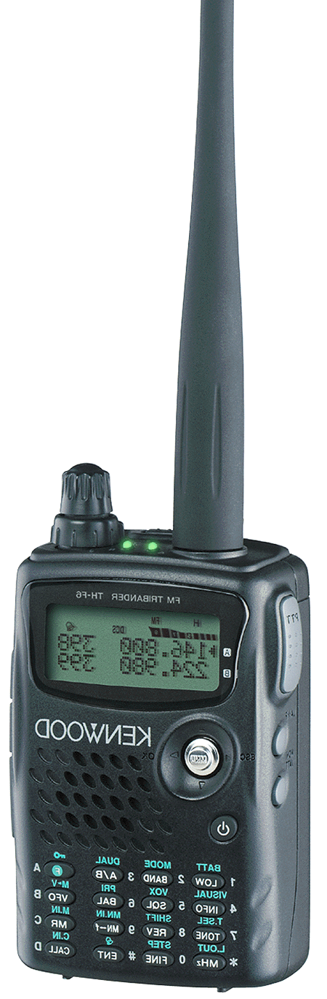

Figure 10: TH-F6 Handheld Receiver

Specifications

The specifications for the UHF RFI mitigation flight receive are given below:

Kenwood TH-F6 Handheld Receiver

- 100 kHz – 1300 MHz
- Built to MIL-STD-810 C/D/E standards
- Dual channel receive capability
- Modes: FM, LSB, USB, CW, AM, FM
- Sensitivity: less than 0.18μV (-121.88 dBm)
- Selectivity: -6 dB more than 12 kHz
- 40 dB less than 28 kHz
- Operating Voltage: 5.5 – 7.5 V
- Operating Current: 30-35 mA
- Mass – 250 g

Mounting and Alignment

Mounting specifications
The UHF receiver will be attached to the TBD face of the ParkinsonSAT side XX transponder enclosure.

Thermal Interface

Temperature Limits
Since the experiment will be +Z pointing away from the sun, the package should never be exposed to direct sunlight. The package will however be expose to the Earth’s reflecting albedo.

Temperature Monitoring Components
A temperature sensor on the UHF RFI receiver will be included in the basic ParkinsonSAT health technology.

Thermal Control Components
The sun pointing attitude of ParkinsonSAT has been designed to spread the heat collected from the –Z face throughout the structure. Heat transfer through the bulkheads will be radiated out of the side facing cold space. There is insufficient electrical power for any heat devices. UHF RFI must be designed with passive thermal control to maintain its own temperature requirements.

Electrical Components

Connector Hardware Specifications
Connectors will all consist of crimp pin “DB type’ connectors for the flight model. There will be associated pins corresponding with t, the double redundant positive terminals of the battery, telemetry for the resistive grid as well as telemetry for the acoustic PINDROP sensors. At no time shall the current in any pin exceed 60 mA.

Ground Straps
UHF RFI would be attached to the communication system single point ground.

Discrete Electrical Signals

Discrete Analog Inputs
The thermistor is part # DIGI-Key # KC00GE. The calibration data is provided appendices.

Discrete Analog Outputs
None

Discrete Digital Inputs
UHF RFI: two discretes – TBD
RS-232 data from ParkinsonSAT to SPID

eferences
Larson, Wiley J. and James R. Wertz Space Mission Analysis and Design: Third Edition. Boston: Kluwer Academic Publishers, 2005.

Appendix A: Link power budget - UHF
FLTSATCOM SATELLITE
UHF Mitigation Project

FLTSATCOM Satellite Characteristics:

18 Turn Helical Antenna
Operational Orbits: - 100º W and 23º W
UHF antenna coverage: - 19º (earth coverage)

System Operating Temperature: 300 K

23º W FLTSATCOM Receive and Transmit Frequency:
Channel 8- Plan C - Down-link Frequency 267.05 MHz
- Up-link Frequency 308.05 MHz
- Nominal Bandwidth 25 kHz

FLTSATCOM Statistical Data:

10 transmission channels
15 encrypted sub-channels rate: – 75 bps
One-way transmission rate: – 12,000 bps

Eight 25 kHz downlink channels: - 26 dBW EIRP
Two remaining downlink channels: - 28 dBW EIRP

Receiver G/T: - 16.7 dB/K

Atlantic Helix Antenna Statistical Data:

11 Turn Helical Antenna
Peak Gain (dBi): - 10.95
Half – Power Beamwidth (deg): - 24.5º

Range of signal to transmitter: - 3.610 x 10⁷ m

FLTSATCOM SATELLITE
UHF Mitigation Project

LINK POWER BUDGET

Link Equation:

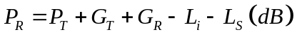

L_{a} – transmission path loss
L_{l} – line loss
L_{s} – space loss
T_{s} – system temperature (K)
S – path length to satellite (m)
R – transmission data rate (bps)
k – boltzman’s constant

All loss terms (incidental losses) except for space loss will be assumed to equal a total of 3 dB.



Link Power Budget: Atlantic Helix Antenna:

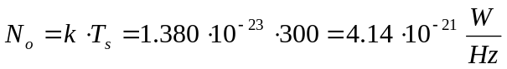

Appendix B: link power budget - parkinsonsat
ParkinsonSAT SATELLITE

LINK POWER BUDGET

ParkinsonSat Operation Frequencies

UHF: 435 MHz VHF: 145.825 MHz

Range of Signal to Transmitter: 3000 km

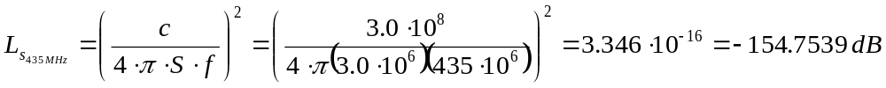

ParkinsonSat to Buoy:
Receiver Gain - 0 dB Omni-Directional
Transmitter Gain – 0 dB Omni-Directional

Transmitter Power – 5 Watts

Link Power Budget: 435 MHz

Link Power Budget: 145.825 MHz

Buoy to ParkinsonSat:
Receiver Gain - 0 dB Omni-Directional
Transmitter Gain - 0 dB Omni-Directional

Transmitter Power – 5 Watts

Link Power Budget: 435 MHz

Link Power Budget: 145.825 MHz

ParkinsonSat to Command Station
Receiver Gain - 10 dB
Transmitter Gain – 0 dB Omni-Directional

Transmitter Power – 5 Watts

Link Power Budget: 435 MHz

Link Power Budget: 145.825 MHz

Command Station to ParkinsonSat
Receiver Gain - 0 dB Omni-Directional
Transmitter Gain - 10 dB

Transmitter Power – 50 Watts

Link Power Budget: 435 MHz

Link Power Budget: 145.825 MHz

 Midshipman First Class, Aerospace Engineering Department, EA303 Laboratory report

