EA467 Antenna and Link Equation Lab (rev a) Fall 2016

**EA204 Summary:** This antenna lab is a hands-on experience with different types of antennas (some of which were previously modeled in EZNEC), as well as some principles from the transmission lines lab. In EA204 Labs, students were previously exposed to:

Antenna types, frequency, and wavelength. ½ wave dipole and ¼ wave monopole

Fleetsat measurement of Signal-to-Noise ratio (SNR) and simple link budget

Manpack satellite Antenna and simple link budget

C-band Parabolic Dish Beamwidth

Signals Bandwidth (TV, radio, cell phones, data)

GPS familiarization

**Laboratory Summary:** The antenna experiment stations are in R122 and in the lobby or plaza. Form teams of 2 or 3 as directed by your instructor and move to an unused station to perform the required steps. **Sketch a diagram of the lab setup, record observations, and data as required.** You will make qualitative and quantitative observations concerning:

1. Antenna gain patterns of a dipole and a LABsat model at 642 MHz
2. Link calculations for SPYsats at 0.17 and 0.88 miles and extrapolate to LEO orbit.
3. Beam pattern and relative performance of parabolic dish antennas.
4. Received power from a spacecraft and antenna Standing Wave Ratio (SWR).
5. Antenna matching and minimizing SWR.
6. Antenna summing (Phasing) for increased gain.

**Introduction:** Antennas are fundamental to communications. This lab will provide hands-on experience with antenna performance and patterns, as well as how antennas affect the link budget equation. Space loss due to the distance between transmitter and receiver is the largest source of signal loss in spacecraft communications. Antenna characteristics have the next most significant effect. The main trade-off in system design is where to add the power and gain required for successful communications (ground or satellite), while allowing some margin for variations in the terrestrial and space environment and equipment.

The Link Equation (in dB) PR = PT + GT + GR – LI – LS

where PR = Power Received, PT = Transmitter Power, GT = Gain of Transmit Antenna, GR = Gain of Receive Antenna, LI = Incidental Losses, and LS = Space Loss.

Spacecraft Considerations: A powerful satellite transmitter can be used with a low gain antenna, but this will add weight and expense to the spacecraft. Alternatively, a higher gain antenna can be used with a lower power transmitter, but this will decrease the antenna beamwidth and require greater pointing accuracy as well as increased spacecraft volume and a complex deployment strategy with greater risk of failing on orbit.

Ground Station Considerations: Ground stations contend with similar issues. Smaller antennas require higher power transmitters on the spacecraft and produce weaker received signals. Each receiver has performance limits. Mobile platforms have antenna size and transmitter power limits. Reducing electromagnetic interference with more highly directional antennas also plays a part in ground station design.

Communications Subsystem: The communications subsystem consists of both the spacecraft and ground system design which must meet end-user requirements while conforming with all the other spacecraft subsystem constraints as well frequency management concerns. The overall design is dependent on the link budget of both the uplink and downlink.

**Part A. Spacecraft Monopole Antenna Pattern:** This experiment as well as part B is conducted from the grass plaza outside the lab so that it has a clear view to the MD Public TV station antenna, located just north of the I-97/US50 Interchange, on UHF at 642 MHz as the signal source about 3° left of the water tower.

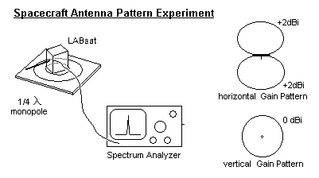A simple monopole antenna is mounted on a LABsat outdoors on a remote controlled rotator so it can be rotated horizontally to observe the basic antenna gain pattern. Although one would expect the monopole antenna on one face of the satellite to give an unbalanced radiation pattern when rotated horizontally, in fact, the pattern will not be that much different from that of a ½ wave dipole pattern. This is because the ground plane of the spacecraft is small relative to wavelength and simply acts like the missing half of the dipole.

1. On the AVCOM spectrum analyzer, set the Band Select to 1-1100 MHz, the Resolution Bandwidth to 3 MHz, and the Reference Level to -40 dBm. Finally, set the Span Width to 10 MHz/division and adjust the Tuning knob to center the frequency on 642 MHz. The peak is rather broad and is sometimes not symmetrical, but if you always read at the peak value then you will get consistent results.
2. Using the controller knob inside R122, slowly rotate the LABsat dipole. Notice there is almost 20 dB or more of signal variation as the antenna is rotated. Rotate until you find the maximum and this is your reference level. Make sure to record it. Make other measurements in dB below this value. Rotate the base of the controller so that the pointer points at the zero (North) point on the compass rose at this maximum signal. Record the relative signal strength as the dipole antenna is rotated through 360o in 20o increments. Smaller increments *are necessary* in the vicinity of the narrow nulls to get the exact angle of the null. Sketch your data on a polar plot to make sure your data is meaningful before you leave the station. It should look roughly like the cross-section of a dipole donut pattern.

**For Antenna Lab Report:** Your plot will show the antenna gain pattern in azimuth of this monopole antenna mounted on the top of a LABsat (set horizontally). How does this antenna pattern compare with the EZNEC model?

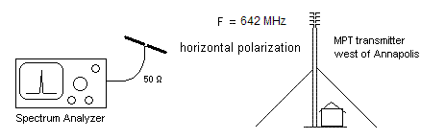**Part B. Antenna Combining for Gain:** This experiment out on the grassy plaza outside the R122 lab, will validate the gain pattern of a dipole and the 3 dB gain of two dipoles combined in phase by the ¼ wave transmission line transformer technique you demonstrated in the Transmission Lines Lab. You will also observe that this gain is only in the favored directions where they add in phase, with commensurate reductions in gain due to destructive interference in other directions. In other words, you can sum antenna elements to achieve gain in one direction, but this is always at the expense of gain in other directions and more nulls in the antenna pattern.

1. Connect the single hand held dipole antenna to the spectrum analyzer tuned to MPTV west of Annapolis at 642 MHz. Hold it horizontally to match the horizontal polarity of the TV station. Move it around several feet to get a feel for the variability in its performance due to polarization, directivity and multipath. Find the optimum location for this measurement and record the best signal strength.
2. Now add the second dipole connected with the ¼ wave phasing harness as shown below. Note that it uses two ¾ wave (in coax) lengths of 75 ohm coax in order to reach the antenna spacing we need (1λ in air). Since ¾ λ is an odd multiple of ¼ waves, it will transform the two 50 ohm antenna impedances to 100 ohms so that they can be paralleled with a “T” connector to match the 50 ohm impedance of the line.
3. 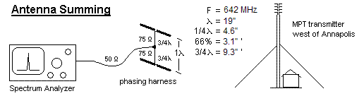Place the stacked dipoles where the best signal was found in step 1 and again move it to find the best signal. These dipoles are spaced vertically about 1 wavelength for optimum gain. In the absence of any degrading reflections, the gain from this two-antenna system should be about 3 dB greater than that of the single dipole. Another benefit of increased antenna gain is that it reduces the multipath nulls from the ground (though this might barely be noticed with only a 3dB gain antenna). Record your results and observations.
4. Now lean the stack backward so that the top antenna is about ½ wavelength farther from the TV station than the bottom one (9 inches). Look for a minimum signal. Notice that just as the second antenna can add signal (+3dB by doubling the signal available), it can also subtract and significantly cancel out the original signal. This shows how simply changing phase of antenna elements can re-direct the main lobe of an antenna (as in Phased arrays) Record the depth of the best null and any other observations. Lastly, hold the big aluminum reflector about ¼ wave behind the dipoles (with the dipoles in the maximum gain orientation). How much more gain should be obtained with this reflector? How much do you observe?

**For Antenna Lab Report:** Compare the plots generated in Part A of the EZNEC portion of this lab with your observations from moving the two-antenna system around. Did you find max gains and nulls in similar orientations and magnitudes?

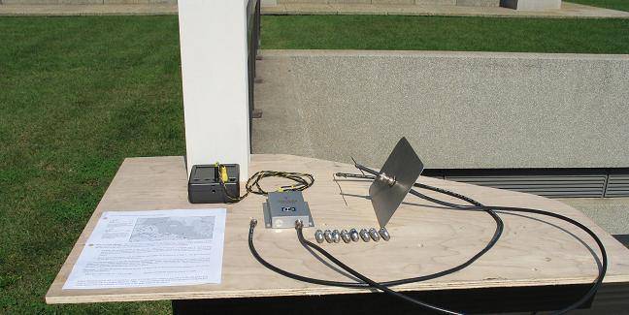

**Part C. 1.2 GHz Dipole Antenna Gain and Link Margin:**

The figure below shows how we have placed three LABsats with image sensors and microwave transmitters at several points within line-of-sight of the Rickover Plaza. First we will look at the Soccer Field transmitter from the plaza rail out the lobby door towards Michaelson Hall using the equipment shown here.

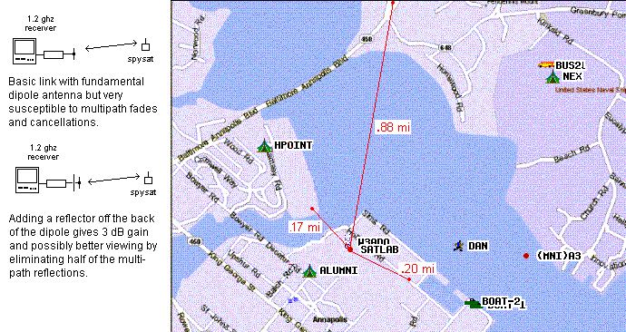

1. Connect the simple dipole to the attenuator-receiver and turn on power at the battery. Set attenuator to 0 dB. Move the antenna around to find the best signal from the LABsat on the Soccer field bleachers (note that the best spot will have the least cancellation from reflections). Notice how the broad antenna pattern of a dipole gives relatively consistent signals except in the presence of a null (nulls due to location or orientation). To measure the link margin at the strongest location, see how much attenuation you can add and still see a useable video signal. This attenuation equals the link margin available for this link.
2. Next connect the dipole with the reflector and repeat the procedures of step 1. More attenuation should be required for the same useable signal, with the difference being the relative gain of this reflector. Also, by eliminating waves from the back of the dipole, you should see some directivity and less cancelling effects of multi-path from surrounding buildings.

**Post-Lab:** Calculate the power received for the 0.20 mile link to the Soccer field bleachers on 1.2 GHz using the link equation:

PR = PT + GT + GR – LI – LS (in dB) (assume incidental losses (Li) total to 3 dB)

Where Transmit power, PT is 5 milliwatts, gain, GT, of the omni transmit antenna is 0 dB, and gain of the receiver antenna, GR is a simple dipole (2.1 dBi). Then re-compute the link received power using the gain of the dipole with rear reflector as indicated in the steps listed in the figure.

**Part D. 2.4 GHz Parabolic Antenna Gain and Link Budget:** This exercise is located on the stairs between Nimitz and Rickover. It uses a small 18” dish with a 2.4 GHz “S” band offset feed to explore the antenna pattern, gain and 3 dB beamwidth of a parabolic dish antenna. . With a simple dipole at the focal point of a dish, the aperture of the dipole is drastically increased to the full size of the parabolic reflector. The increase in aperture area yields a corresponding antenna “gain”. As discussed in class, placing a small reflector behind the dipole at the focal point doubles the energy into the dish and minimizes sidelobes, thus adding to the overall gain by about 3 dB. The dipole antenna is connected to the video receiver via a variable attenuator.

1. 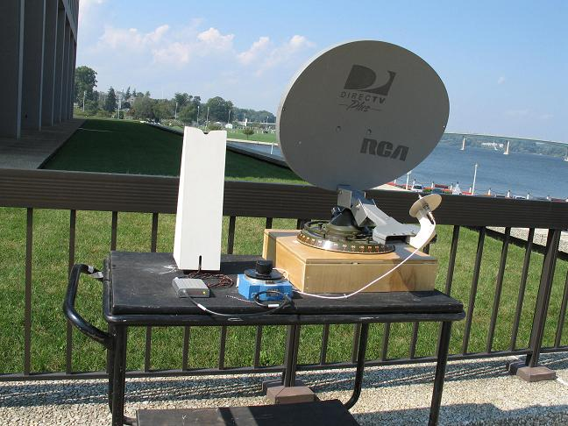Dipole Baseline: Unmount the dipole/ reflector feed from the Dish (held in place with one vertical screw) and hold it generally facing the small SPYsat that is operating on the corner of Hospital point field. Set the receiver to channel 4 and orient the dipole for the best signal. Also see if you can see the SPYsat across the Severn (near the War memorial) on channel 2 (you might just barely). Now pointing back to the Hospital point SPYsat, increase the attenuation to find out how much link margin you have before the signal becomes unusable. This attenuation level establishes your baseline for this experiment.
2. 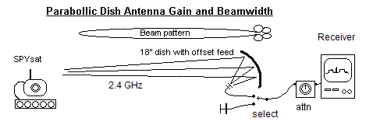Dish Gain: Now remount the dipole feed at the focal point of the dish and point it at the Hospital Point SPYsat. Next, add more attenuation until the point where the signal becomes unusable again, making sure to optimize the dish pointing as the signal gets weaker. This *additional* attenuation is the measure of the added gain of the parabolic dish compared to the dipole.
3. Path Loss: Set the variable attenuator back to 0 and point the dish across the river to the war memorial and see if you can now see the channel-2 SPYsat. It is at the top of the hill facing USNA with a similar omni antenna as the one on Hospital point. See how much attenuation you can add and still keep a usable signal. This *difference* in attenuation compared to the Hospital Point measurement is now the added path-loss due to the increased distance (0.17 to 0.88 mi).
4. Antenna Beamwidth:Now, peak the antenna on the signal and then adjust the attenuator again to the minimum usable signal. From that value, reduce the attenuation (improve the signal) by 3 dB. Now carefully swing the dish left and right to where the signal is again minimally useable. This is the angle where the signal drops by 3 dB. The angle difference between these two – 3dB points is called the 3 dB beamwidth of the antenna. Compare the 3 dB beamwidth of this antenna with the parabolic dish modeled in EZNEC.

**Post Lab:** Calculate the gain of this 18” dish from its dimensions using the link equation. How does the gain compare to the gain you measured as link margin (attenuation) in step 2? Use the link equation to compute the minimum receive power for this 2.4 GHz receiver to give a decent image, assuming a transmit power of 5 milliwatts. How does the link margin (attenuation in dB) of the two links of 0.17 and 0.88 miles compare to the ratio of the difference in distance?

As an exercise, now calculate how much power onboard a satellite in LEO (say 1000 km) would be required to make this image sensor system work if transmitting to a 10’ receive dish (i.e. to give you the same minimum usable signal received as you calculated in this lab). Hint: Keep the PR the same, but increase the GR of the dish (scaling up from 18” to 10 feet), keeping GT the same and then solve the link equation for PT.

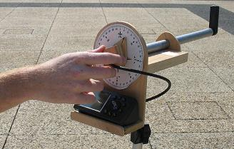

**Part E. L‑Band GPS Antenna:** This exercise is out on the plaza. The GPS constellation of 24 satellites gives us excellent signals for experiments since multiple satellites are always in view. Since the GPS unit must receive these multiple simultaneous signals, omni-directional antennas are always used. Typical omnidirectional GPS antennas are either a patch antenna or a short quadrifilar helix. In this experiment, we will plot the antenna pattern for the GARMIN GPS-III unit that uses a quadrifilar helix antenna (see instructor’s model).

1. Select the Horizon Plot page on the GPS unit, which shows graphically the approximate azimuth and elevation of each satellite. The inner ring is 45°. The outer ring is the horizon. Point the antenna straight up and record the Az/El and signal strength of the GPS satellites in view as shown (you will need this data to answer the post lab question)
2. Choose the satellite that is closest to directly overhead. Tilt the antenna (and rotate the stand) as needed to point directly to that satellite. Hold the antenna still and align the dial to 0/360. Now record signal strength for that satellite as you rotate the antenna knob +/- 180 degrees in 30-degree steps away from that satellite. Assume each line on the GPS signal strength bar graph represents 5dB. At each angle, pause 15 seconds or more for the GPS to re-measure the signal strength before taking your readings. You will use these readings to make a polar plot of the antenna pattern.

**Post‑Lab:** Discuss the reason for the differences in signal strength among all the satellites in view. (Hint: Where are they on the GPS’ sky-view display?) Plot the antenna pattern on a polar plot based on your recorded values. Comment on the antenna gain pattern for this short one-turn helix, which is quite different from that of the longer multi-turn helix that you modeled in EZNEC.

**Part F. LABsat Antennas Matching and Tuning:** Every antenna must be precisely tuned to resonance for the frequency of operation and to match the output impedance of the transmitter. Recall from the Transmission Lines lab that any mismatch will result in power being reflected back from the antenna and not radiated. The SWR gives us a good measure of the quality of this match. Numerically, SWR represents the ratio between the forward wave power and the reflected wave power or the ratio between the impedance of the antenna to the impedance of the line. When measured as forward and reflected power, SWR is given by:

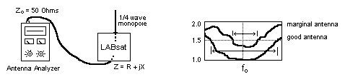

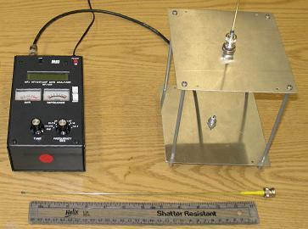The complex impedance (R+jX) of an antenna is a function of its length, its breadth, its frequency, and all conducting materials within its near field (including you). Thus, antennas have to have their final tuning completed in–place on the actual spacecraft. In this experiment, you will use an antenna analyzer to measure the SWR of a VHF and UHF antenna for your LABsat. An SWR of 1.0 is perfect, an SWR of 1.5 delivers 96% power, 2.0 delivers 89% and 3.0 delivers only 75% of power. Most designs strive for 1.5 or better. Any reflected power is not transmitted and is dissipated as heat in the transmitter, adding unnecessary heat to the thermal system and stress to components.

1. Calculate the length of a ¼ wave resonant monopole at 145.8 MHz. At resonance, the reactance component (jX) goes to zero so that maximum power can be delivered to the real resistive component (R), (usually designed to be 50 ohms). Note that the calculated ¼ λ is just the starting point, and the exact resonance length will be affected by the specific geometry of all metal in the vicinity. Perfect resonance is often not achievable, but the minimum SWR is desired.

2. Place the longer antenna onto your LABsat model and extend it to your calculated length. Make sure the analyzer frequency dial is positioned at 114-170MHz. Tune the analyzer to 145.8MHz and record the SWR (be sure UHF button is out). Tune the meter to find the minimum SWR. The best SWR frequency will tell you if your antenna is too short or long. Carefully extend or contract the antenna to minimize the SWR at 145.8 MHz. You can add clips to the antenna to simulate a fatter element if needed. Remove your hands after each adjustment, and record the lowest SWR antenna length.

3. Next, tune the analyzer up and down in frequency and record values (at least 8 points) so that you can make an SWR bandwidth plot between the two frequencies that exhibit 3.0 SWR. Move in the vicinity of the antenna. Notice the effect on the impedance and SWR (you will comment on this in the lab report).

4. Since this LABsat is on the order of the dimensions of the resonant monopole, you may find another resonant frequency where the spaceframe itself may combine with the whip to also form a resonance. What other resonant frequencies do you find (if any)?

5. Insert the shorter antenna into the test fixture. Repeat steps 2 and 3 for UHF (436 MHz). Press the UHF button on the Antenna Analyzer to read UHF on the display. Again use clips to help find a good match. Depress this button when you finish.

**Post‑Lab:** Use the data from lab to plot the SWR for the two antennas over the frequency range between the 3.0 SWR points. How good was your SWR? How does the best SWR and the usable bandwidth (between 3.0 SWR points) compare to your optimized EZNEC labsat monopole model (note they may be somewhat different because the EZNEC model was for 642 MHz)? Comment on the main learning points of this experiment.

**Antenna Laboratory Report:** Each group of 2 or 3 must produce a formal laboratory report in accordance with the Aerospace Engineering Department report-writing guide.

1. In your Introduction, make sure to describe the purpose of this lab and discuss wavelength, the link equation, antenna gain, antenna beamwidth, and SWR.
2. In your Methodology section, briefly describe the elements in each laboratory experiment using text and diagrams. Ensure that your description of experiments ties back to your purpose statement(s) in the introduction.
3. Present your data with appropriate analysis (i.e. the technical explanation of what your results mean, why they may differ from theory and what you can reasonably conclude from them) in the Results and Discussion (R&D) section. Compare the measurements, EZNEC plots and theory. You should be able to determine a theoretical gain and beamwidth for each antenna system using SMAD, Spacecraft Communications and Power (EA465) notes and/or EZNEC. Make sure to answer the questions from this lab handout in your R&D section as they will point you to some of the key takeaways from this lab. Your results and subsequent analysis should lead you to conclusions that are important for spacecraft designers. A couple possible examples:
   * 1. What are the implications of antenna gain to the link equation for spacecraft, a ground terminal/station?
     2. What are the differences in the various antenna types? What drives the designer to choose one over another?
     3. The role and importance of antenna testing and tuning: Did EZNEC model these antennas adequately? How would you use EZNEC in a design environment? Would you still need to test the antenna if you have a tool like EZNEC?
4. In your Conclusion section, summarize your main conclusions from your R&D section (no new conclusions should be introduced in the conclusion section) and the key takeaways for spacecraft designers.