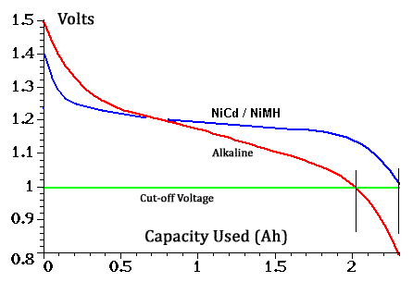EA-467 Electrical Power System (EPS) Part 1 – Battery Charge/Discharge (rev c) Fall 2016

**EPS Elements Covered in EA204:**  IV curve, solar cell efficiency, incidence angle, 1/r2 distance, RTG’s

**Elements Covered in this Lab**: NiCd/NiMH cells, charging/discharging, cell voltage, battery testing of your LABcube battery board.

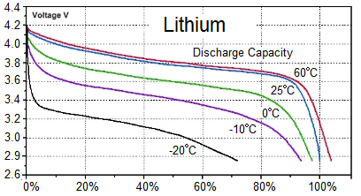**Cell Voltage:** As shown in the discharge curve to the right, the “voltage” of a battery cell is more a matter of a naming convention than an actual voltage. A typical “1.5V” alkaline cell will begin at 1.5 volts but by the time it has delivered 90% of its energy, it will be down to below 1 volt. The NiCd and NiMH cells have a flatter curve that begins at 1.4V when fully charged but rapidly drops to the 1.2V range (hence “1.2V” AA Ni-Cd battery) for most of its delivered energy. Again, 1.0 volts is usually considered the cutoff limit to protect the cells.

Lithium cells have a similar curve, but fully charge to around 4 volts per cell. All curves are temperature dependent and so Voltage cannot be used as a gauge of battery capacity.

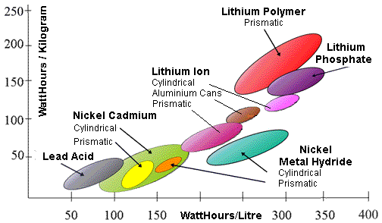How many alkaline cells typically are needed for a 12 volt boom-box? _____ How many NiCd cells for the same device? ________. How many Lithium?

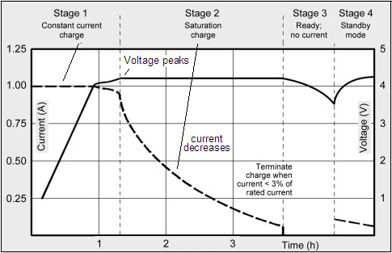**Cell Chemistry:** Lead-Acid cells have been used for over a century, NiCd almost as long, NiMh about 25 years and Lithium about 10 or so, each with higher capacity density and higher cost. Also newer/better chemistries also come with narrower tolerances, and greater risks. Both Lead Acid and NiCd’s can be overcharged and over-discharged with little damage. NiMh and Lithium cannot be overcharged at all or they explode or catch fire. Over-discharging Lithium destroys the cell permanently. A typical Lithium charging profile is shown at right.

With these limits, and constraints, there are good applications for each from Submarines, to Golf Carts, to EV’s and to Space depending on need.

**Your LABcube uses NiCd** for smallsats because they are the most robust and forgiving to Midshipmen events. Also, they can be overcharged, and over discharged without instant failure (like Lithium) and do not need a smart charger or battery management system. NiMh can double the capacity of NiCd, but have high self-discharge (as high as 20% in the first day) and are more fragile to over discharge.

**Lithium cells**, on the other hand, are so critical to operating conditions that almost all Li-ion batteries need to contain a Battery Management System (BMS) processor chip to protect the cell from all the possible dangerous conditions.They operate under pressure and the electrolyte is flammable.Even the battery in your cell phone has a management chip inside for safety.

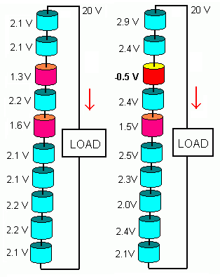**Batteries:**  A battery is a collection of ***cells*** connected in series to achieve a given system voltage. Cells may also be paralleled to give greater current capacity (though parallel cells have other complications and should usually be avoided). In this lab you will be testing one of the cells chosen for flight in the upcoming PSAT-2 satellite design. PSAT-2 contains ten AAA size 1.2V NiCd cells in 2 packs of 5 with an EPS voltage of about 12 volts. Notice that a fully charged ten cells will be 14 volts and will discharge to around 11 volts. Hence, battery “voltage” is a rather flexible term. Your 12V car battery charges to 13.8V and discharges safely to 10v.

**Battery Failure:** The cause of almost all battery failure is cell imbalance. Batteries usually are composed of cells in series and there is always one cell that is slightly different than the others. In both charge and discharge, this out of balance cell just gets worse and eventually is over discharged or overcharged leading to failure and then failure of the entire battery. Even sensing “low voltage” cannot protect such imbalance as shown in the figure at right. Setting a low voltage limit of 2.0V per cell in a ten cell battery should signal a safe stop-use condition as shown on the left. But only if all cells are perfectly the same. They never are. One cell gets out of balance and although the overall battery voltage is above threshold on the right, the one weakest cell has been discharged to failure.

**Battery Capacity:** Battery capacity is measured in Amps over Time (Amp-Hours) and is described as “C”. So a given battery can give lots of current over a short time, or less current but over a longer time with the same capacity “C”. Since there are inefficiencies at either extreme, for consistency, the industry has standardized on a “C” rating measured over 10 hours. A 10 Ahr battery will give 1A for ten hours, but will fall short of 10 Amps in 1 hour. Also it will not provide 0.1A for 100 hours, but come close.

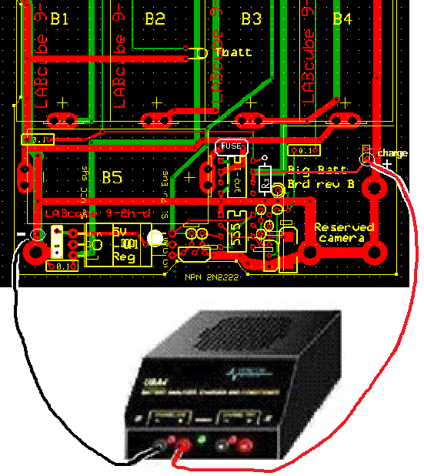**Part A: Universal Battery Analyzer (UBA):** The UBA shown here automatically controls the charging and discharging current of a battery. It does this while monitoring the voltage and current over time to characterize the battery’s performance. Connect it to your LABcube battery as shown.

Your UBA is connected to the right-hand work station serial port. You will test one LABcube per team per period. ***Your batteries should have been trickle charged overnight at 7.0 volts*** and should be fully charged at the start of the first lab period. Once a test is started, do not stop it. Let it run to the end of the period (and longer if directed by your instructor). The UBA has two channels and the next class period will use the second channel.

**Test Cycle:** The normal “test” cycle will test the cells three times with two managed charges in between. Usually the first test is an “info only” type of test, because the initial state of the battery is unknown (but should have been charged overnight). But after the first discharge and subsequent controlled charge, the UBA has a good idea of the initial charge state for the next discharge cycle. It then repeats that cycle a third time. Usually the largest capacity is seen on the second test after the battery has been fully cycled once. You will not have time to observe the final test as the sum of the two test cycles is over 8 hours. Discharge is performed at 1C.

1. 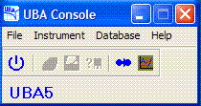Connect the UBA channel for your class to your cell to be tested. Make certain to connect black to black and red to red.
2. Find the “UBA Console” icon on the desktop and open it. This will open a simple UBA console window as shown here at right.
3. Select File then Options and then select COM1 and click “OK” to activate channels 1 and 2.

**Battery Discharge Test:** Configure the test for your cell as follows:

1. From the main UBA console window, under INSTRUMENT, select Battery Analyzer and then “yes” to go to the Network window. Select COM1 and click to open your given channel. This should bring up the “Start a Battery Analysis” screen for your channel.
2. In the window:
   1. Enter the number of cells as 5
   2. Enter the capacity as 350 mAH.
   3. Select the Battery Analysis Routine called *NiCd Test with Peak Charge.bar*
3. 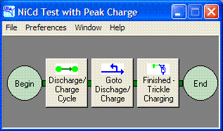In the “Analysis Results Filename” box, enter the name of your output file. Name the file “psat-bat-test-no___.uba” for your particular cell number. Make sure to save it in the instructor-directed drive folder, so that we will have battery analysis results for all of our LABsat battery cells in one location. Then start the test. The test will take all lab period. At any time you can click on the little chart-graphic at the top of the window to see the battery voltage profile. Continue with the rest of the lab below.

**Part B. Battery Analysis Routines:** While your UBA test is running, you can use the built-in Battery Analysis Routine Designer mode to view the details of the test. This gives you insight into battery testing as well as showing you how you can design your own battery test and analysis routines.

1. On the UBA console, select FILE then *Battery Analysis Routine Designer*
2. Select FILE open and find the *NiCd Test with Peak Charge.bar* file and open it.
3. 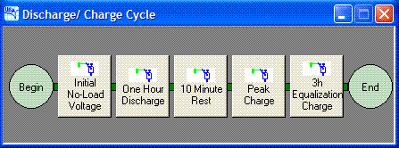Note, this is a 3 stage test as shown above right. It begins with a Discharge/Charge cycle and then repeats it once before finishing with a final 3 hour trickle charge as shown.
4. To see additional detail on each of the steps in the Discharge/Charge cycle, click on that box.
5. Then you will see the 5 step process shown (right). First there is an initial No-Load Voltage test to measure the starting voltage of the battery. Then, a 1 hour discharge. Click on that box and find another window with several tabs as shown below right. These give additional insight into the design of the test.
6. 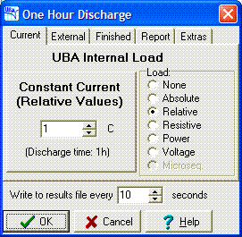Explore each of the 5 sections in the Discharge/Charge Cycle and their respective tabs to discover the default settings (do not change them) and comment on what they mean:
7. How long is the initial no-load Voltage test? __________
8. What is the maximum cell voltage allowed in the peak charge step? __________
9. What are the different ways to specify the load for the discharge step? _____. _____, _____, _____, _____, _____
10. What is the cut-off voltage for the discharge test (end criteria for the one-hour discharge step)? ___________
11. While the test is running you can view the graphs of current and voltage in the battery by clicking on the icon that looks like a graph in the test window (the one titled “COM1: Unit 1 Chan#”). Open these graphs and seek to understand the shapes of the curves. Note: the graphs do not continue to update in real time while open, you have to close them and re-open periodically to see all the test data.)
12. At this point, you may work on other material in the lab as indicated by your instructor. But keep an eye on your battery process and when it reports the test fails (i.e. Voltage drops to 0.9v per cell) report the capacity measured to the class (on the front blackboard). The test will automatically continue with first a 10 min rest period followed by a 130% charge at a 1C rate until it sees a slight peak. Then it shifts to a 3 hour equalization charge at a trickle charge rate (0.1C).
13. Near the end of the period, report the status of your battery test to your instructor and comment on whether or not you believe your battery is performing nominally. All results will be saved to a common drive for you to access for your report. To view the files, however, you will have to use the workstations in R122 and the UBA File Viewer.

The goal of this testing is to find the most closely matched cells for PSAT flight. This is why we purchase 100 cells when we only need say 10 for our satellite mission. We do extensive testing to find the 10 most perfectly matched cells. IF we bought a flight battery, we would pay 100 times as much because someone else had to do all the testing for us.

In the next EPS lab you will use the Arduino Labsat Telemetry system to study the Labsat solar panel IV characteristics and learn about Voltage Regulators.