# EA-467 LABsat Power System Design Challenge (rev f) Fall 2016

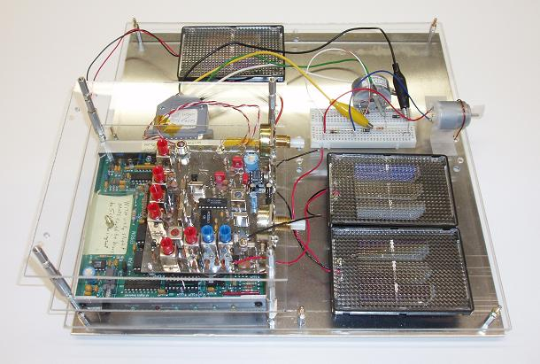**Spacecraft Power Budget:** A power budget for a spacecraft is more than just summing solar panel currents and load currents. You have to consider the orbital illumination and eclipse of the panels in flight attitudes as well as the duty-cycle of the loads. Your objective in this lab is to design a Solar Power system to match a LABsat power budget. There are 8 different solar panels of various voltages and currents which you may use. You will be scored on how well you meet mission objectives to not only provide the required power budget, but also to fit the 1 square foot layout for your LABsat as shown to the right. Your EPS design will be tested for 1 minute in the Sun spot to evaluate its performance. If the motor runs, the telemetry shows good voltage and the current meets requirements for one minute, you have mission success. Otherwise, your spacecraft will die on orbit.

**LABsat Hardware Requirements:** Your LABsat will have to operate with the loads as follows.

* Receiver 5v 21 mA continuous
* Transmitter 5v 412 mA only for a 1 sec telemetry packet every 30 seconds
* Telemetry Arduino 5v 12 mA continuous
* Momentum wheel 5v 80 mA continuous
* Battery Charging 5v ___ mA 35/65 m eclipse/Sun & 90% charge efficiency

**System Battery:** Batteries store solar power for use in eclipse and for peak currents for intermittent loads but do not affect your power budget. A power budget balances incoming average power (solar) to outgoing average power (loads) and so must work on overall orbit and operations averages. The battery only evens out fluctuations in loads and in solar power due to eclipses. It adds nothing to the power budget since all power must originally come from the solar panels. It would take hours of orbit cycles to see if your design would stabilize with a good balanced energy design. So this lab does not use a battery, but runs everything at their average power requirement on the solar power available.

**Eclipse Power:** A satellite in the sun also has to collect additional power for use later when in eclipse. In this lab you calculate this additional power for a 65/35 minute eclipse orbit and add a load resistor to simulate the battery charge current requirement when in the sun.

**Solar Cell Temperature:** Cell power is reduced by higher temperatures. (and these cheap cell packages will melt!). Your spacecraft temperature limit is 60 C. Keep an eye on your temperature telemetry.

**Receiver/Transmitter:** The LABsat transmitter draws 30 times its average power and so a battery provides the peak power. But as noted above, the energy in a battery would void this lab’s 1 minute flight test. So we simulate the average transmitter power with a resistor equivalent to the TX ***average*** current.

**Arduino Telemetry System:** The Arduino sends 5 channels of telemetry to a PC to capture conditions on your LABsat. Assume the Arduino board requires 12 mA at 5 Volts. Note: The Arduino actually gets power from the USB connector while attached to the PC so we add a 430 ohm additional resistor in your load to simulate that current.

**Momentum Wheels:** The wheel motor draws 80 mA at 3 volts. We will run it from about 7 volts so you need to add a series resistor to drop 4 volts at 80 mA. What value resistor do you need_____? Ch 1 telemetry will show the motor current and channel 3 shows the input voltage from the solar panel.

**Design Power:** First, calculate the *average current* for your transmitter above. _______? Then add all the other load currents to find your average *design load current* ______? This total would be the solar power requirement if your mission was always in full sun.

**Eclipse Power:** But your orbit is 35 minutes eclipse and 65 minutes in sun which requires additional current for battery charging while in Sun to store energy for the current needed in eclipse. We annotate Energy in Amp-Hours or in this lab as milliamp-minutes. So, how many mA-minutes do you need in Eclipse _______? Assume that charging the battery is only 90% efficient (assume discharging is 100% efficient), then how many mA-minutes are needed to be put into the battery in the sun to get the required amount of eclipse energy out_______? How many mA do you then need to charge during the 65 minutes in the Sun to accumulate that much energy? _____. Now, add that average charge current requirement to your previous total load current and the result is the total required average solar current while you are in the Sun______.

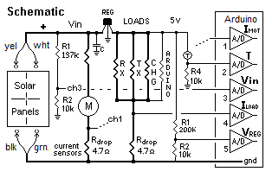**Design EPS Hardware System:** Your LABsat continues to be wired for telemetry for solar and load voltages and currents as in the previous Telemetry and initial EPS lab. To get the power from the solar cells in this lab you will have a yellow/white set of clip leads for the positive terminals to bring power into the 5v regulator as shown and a green/black set of clips wires for the negative return to ground.

Now you will calculate load resistors to simulate the loads.

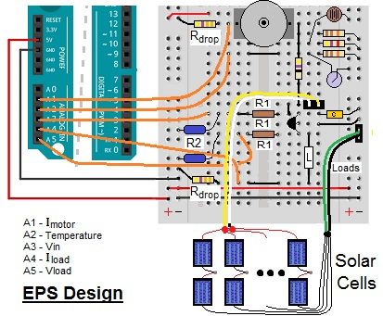Compute the three equivalent load resistors to represent the average current needed by the Receiver _______, the Transmitter ________ and battery charging circuit ________. Use 4.5v for this calculation since each load loses 0.5v drop across the Rdrop current sensing resistor. Now, instead of fumbling around with these 3 resistors plus the 430 ohm Arduino simulator resistor, calculate the parallel combination of all of them into a single load simulating resistor. _______. Get that value from your instructor and insert in the location shown as Resistor “L”.

The motor and motor resistor are already wired for you to run on the solar voltage input to the regulator (7v) (because our tiny 3-terminal 5V regulator is only rated at 100mA and cannot handle the added load of the motor. This circuit also contains another Rdrop resistor so that the channel A1 telemetry input can display motor current in the telemetry also.

**Arduino Software:** You will have to modify your Telemetry code to include the new A1 value for the motor current, and to include the Temperature conversion on the Thermister count to read in actual Deg C. Get this working first.

**Telemetry:** Your goal is a one-line 2 second format: **T#nnn, Imotor, Temp, Vin, Iload, Vreg.**

**Use the equation for telemetry in Degrees C:**  T = 8.7E-5*X2 + 0.00254*X +5.06 in degrees C

**Solar Panel Design:** You must design your solar panel system to power all these circuits, providing a nominal 7 volts (note: the requirement to pass the flight test is at least 6 volts for the entire minute) and supplying a minimum of your computed current requirement. The surface area available for solar panels for this mission is three 6” square areas as shown above on the FLATsat models. There are eight different solar panel modules that come in multiple sizes, voltages, currents and price. <http://store.sundancesolar.com/small-solar-panels/> Their approximate IV curves are shown below.

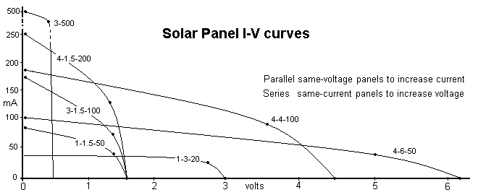

Cheap hobby solar cells and panels are often listed with their open circuit voltage and short circuit current specs instead of the more meaningful peak-power value. Your peak power will be quite less than the given product of open circuit voltage and short circuit current shown in the table below. You must consider the operating voltage and current at the maximum-power point for each panel to determine the optimum design and also the loss over time due to heating. Observe the plot and estimate the peak power and optimum power density and add to the chart below.

The first digit of the solar cell nomenclature is the size, 1”, 3” or 4”. The next digit is the voltage (though the decimal point is omitted). The last number is approximately the short-circuit current in mA.

The PCSAT and Psat panels are shown for comparison, but are not used.

|  |  |  |  |  |  |  |  |  |
| --- | --- | --- | --- | --- | --- | --- | --- | --- |
| Number | 1-3.0-20 | 1-1.5-50 | 3-500 | 3-1.5-100 | 4-1.5-200 | 4-4.0-100 | 4-6.0-50 | Pcsat |
| Size | 1 x 1.75 | 1 x 1.75 | 1.75 x 3 | 1.75 x 3 | 2.5 x 3.75 | 2.5 x 3.75 | 2.5 x 3.75 | 5.3 x 4.5 |
| SC Current | 20 mA | 50 mA | 500 mA | 100 mA | 200 mA | 100 mA | 50 mA | 60 mA |
| OC Voltage | 3 Volts | 1.5 Volts | 0.5 Volts | 1.5 Volts | 1.5 Volts | 4.0 Volts | 6 Volts | 18 Volts |
| Cost $ | $11 | $9 | $8 | $10 | $13.50 | $17 | $18 | $32 |
| Mass | 5g | 5g | 13g | 13g | 24g | 24g | 24g | 76g |
| Quantity | 12 | 24 | 18 | 24 | 22 | 32 | 24 | 12 |
| Peak Pwr |  |  |  |  |  |  |  |  |
| W/sq-in |  |  |  |  |  |  |  |  |

**Connecting the Solar Panels:** The wire harness from your LABsat to the solar array area has two positive wires (yellow & white) and two negative wires (black & green). Having two wires for each makes it easier to connect parallel strings of cells if your design needs it. You are also given a number of clips that you can use to hold the red/black wires from all the cells together in your series/parallel combinations. ***A sketch of your panel wiring is required at the launch site*** to assist in debugging.

You are constrained by available surface area for your body mounted panels, and by cost and mass. Also, you must place cells ***in series*** to get sufficient bus voltage (*including a margin for high temperature)* to meet the minimum requirements of all loads on the spacecraft (in this case, 7 to 8 volts). And you will need to ***parallel*** panels to add their currents. *Remember you can only series panels with the same current rating and you can only parallel panels with the same voltage*. Your design must balance all of these constraints. *Be sure to do a quick acceptance test of any panel to verify that it works before you try to use it for flight and bring your design sketch!*

**FLIGHT TEST:** Once you have selected your solar panel design and laid it out on your LABsat model with all loads, you will then set it in the Sun spot to evaluate its performance. You must achieve the following mission for one full minute to pass:

* The motor runs
* The LABsat does not overheat (i.e. exceeding 60C via telemetry)
* Your telemetry voltage remains above 6 volts
* Your telemetry current exceeds your computed requirement

Be sure you have a good solid mechanical design to survive the rigors of launch (carrying it to the launch site). We have two lights in the hall. One for a quick check that your system powers up and runs the motor, and then the other actual flight test lamps by the door. When your system is known to be working, plug in the Arduino to the launch PC and then place your LABsat model and solar array in the Sun spot to fully illuminate your panel to one-Sun illumination. We should start to see its telemetry every 2 seconds when it powers up. Watch the PC display and see if you are able to log 1 minute of telemetry to demonstrate your success (up to T#030). If successful, copy/paste your telemetry and email it to yourself from the console PC. Measure or estimate each of the electrical and mechanical parameters of your array for your report. Also sketch your solar panel layout.

**WARNING!!! Do not keep your satellite in the Sun spot for more than a few minutes or it will MELT! You will be penalized if you melt your solar panels (or drop your LABsat).**

##### SCORING: Unfortunately, this simple spacecraft design laboratory cannot give you all the range of options nor demonstrate some conflicting requirements to fully simulate all of the system design drivers in a real spacecraft, but at least you get the idea of the challenges involved. Teams whose design passes the minimum mission objectives will be ranked on these quantities:

* Cost and Mass of solar panels used
* Peak design power, and peak measured power.
* Array arrangement efficiency (packing density, i.e. array areas divided by 100 sq inches)
* Array electrical efficiency assuming 100W per square foot illumination.
* Solar Bus voltage ( Voltage will tell available power)

Tabulate the key parameters already answered in this lab during the design phase plus these parameters to help you compute your team’s overall score.

Transmitter average current (from page 1) _________.

Average load current (less battery charge) _________

Battery charge current _________

Total average current _________ Overall Equivalent Load Resistor _____

Solar panel choice ______________ Design Operating voltage ___________

Number of solar cells in each string _________ Number of series strings __________

Total solar panel area _________ Solar Panel mass ___________

Actual operating voltage ___________ Total solar module cost ___________

Many Government contracts are scored by complex weighting formula to see which contractor wins the contract or to award bonuses for outstanding work. Your project will be scored according to these scoring rules and your teams ranked accordingly. You may attempt to fly for better score once (twice if time permits) after achieving your first successful flight. Turn in a homework summary that includes your 15 flight test telemetry packets, the computed parameters above, and your overall score.

Ending operating voltage (ch3 in volts) times system current (ch1 + ch4 in mA) at T#060.

Divide by solar module total area in square inches. Multiply by 100

Divide by mass in grams of solar panels. Multiply by 100

Divide by temperature count of the last data packet. Multiply by 100

Divide by solar module cost in dollars

The result is your score. The team with the highest score receives the largest bonus.

**Laboratory Report:**

Hand in a one page homework summary document your data and calculated score including your sketch of your solar array design and give its overall specifications. Comment on the results

You will use this type of power budget analysis for your LABcube design report.

Prepare a team laboratory report with your partners. Discuss your results under the simulated full sun and compare actual measured values with design values and comment. You may combine the results of this EPS design project with your earlier two EPS lab exercises into one report that demonstrates what you have learned about solar power systems, battery charge/discharge and regulator systems.