**EA-467 Telemetry III – Sensors - Imaging and Control** (rev c) Fall 2018

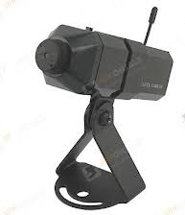

Concepts to be covered in this lab:

* Image Sensors, Field of View, Pixels, Resolution
* diffraction limit, NTSC and SSTV images
* LABsat command and control.

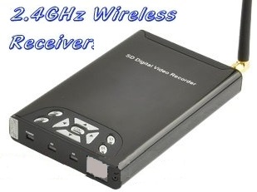**Introduction:** This lab adds an imaging sensor to your LABsat to teach some basic imaging principles as well as payload integration with the satellite bus and command/control. The imaging sensor is a 400 x 400 pixel CCD camera with microwave transmitters used in the Antenna Lab. The cameras operate on four channels in the WiFi S-band (2.4 GHz), for frequency diversity.

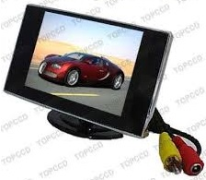**Electromagnetic Compatibility:** There are four wireless camera channels in S-band (WiFi): 2415, 2435, 2455 and 2475 MHz, So to avoid mutual interference only four can be operational in the same area. When we have more work stations, other groups may have to share a channel. But since the range to your TV receiver at your workstation is only about 1 foot compared to the other group on the other side of the lab which is 10 feet away, your signal should capture your receiver when your camera is ON. You will use a 2.4 GHz wireless receiver (pictured at right) to receive the video downlink and display it on a small “rearview” monitor. Your receiver will be closer to your transmitter so that should provide enough isolation.

To see the 20 MHz bandwidth of the signal, tune a spectrum analyzer to the 2.4 GHz band and see the wideband signal. Actually, you should see each of the four channels when they are on the air.

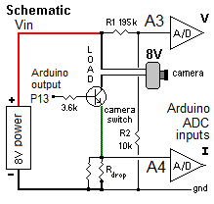**Part J – Imaging LABsat Design and Assembly:**  In this part you will add the imaging sensor (camera) in place of the Load resistor used in the previous telemetry lab and use the Arduino pin 6 as an output pin to turn the camera on and off, and pin 13 that drives the built-in LED so you can see when it is on or off. The telemetry lets you use the pin A3 Voltage and pin A4 Current circuits from the previous lab to monitor the battery voltage and current of the camera as shown here.

Your instructor will set up the wireless receiver and small monitor for each team. Your LABsat is connected as shown in the figure below. Before powering up the board, confirm the following steps are completed.

* 1. You ***MUST*** move the red wire from the Arduino 5v to Vin pin as shown in the figure below (pink circle).
  2. Plug in 8v Power Supply under your monitor and connect to Ground and to +V on the right power rails.
  3. Verify a jumper from the Vin rail to the camera (just below the thermistor) shown in red on the figure.
  4. Add a Transistor as shown and black jumper down to the 4.7 ohm current sense resistor.
  5. Add a second 4.7 ohm shunt resistor in parallel to the 1st to reduce the voltage drop loss.
     + Now the 195k/10k (R1/R2) voltage divider will monitor the Vin voltage on A3.
     + The 4.7 ohm Rdrop resistors in series with camera ground lead lets ch A4 read camera current
  6. Plug the camera into the transistor carefully as shown

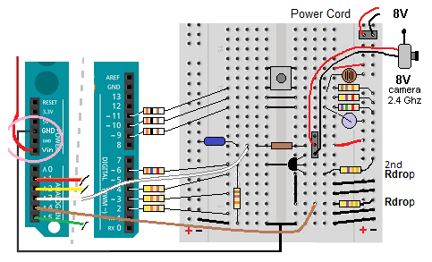

Load your working Telemetry lab I code that displays the 5 channels of telemetry including the Load voltage and current. (or see your instructor for a working version). To configure your serial port, confirm you have the statement **Serial.begin(9600);** in **setup()**. Next**,d**eclare a variable for turning the camera on and off, **int cameraON = 0**;. Also configure both pin 6 for the camera and pin 13 for the blue LED as output bits, **pinMode(6,OUTPUT); and pinMode(13,OUTPUT);.** Then, in **loop(),**  as in the last lab for the GPS input, put a statement to check the serial input from the keyboard via the serial monitor for a character, read it into the character variable (a) and then decide if it is a“A” or a “B” to turn the camera and LED on or off, as follows. Verify functionality before proceeding. Note the voltage levels as you turn the camera on and off.

if (Serial.available()){

char a=Serial.read();

if (a == 'A') digitalWrite(6,1); digitalWrite(13,1); // Camera On

else if (a == 'B') digitalWrite(6,0); digitalWrite(13,0); // Camera OFF

}

**FailSafe:** Now add a conditional statement that will turn off the camera if the Voltage level drops to below 6.0 volts. Remember though, that we designed the Voltage Telemetry to read in tenths of a volt, so 6.0 volts is actually a count of 60. This protects the battery from over discharge later when you disconnect from the computer and fly your Arduino satellite down the hallway. Add a Serial.Print to announce when it is in safe mode to aid in troubleshooting. Verify everything is functioning properly.

**Operate:** , Next, turn on the 2.4 GHz video receiver. ***Use the “D” button to match your camera channel. The receiver channel LED will flash equal to your channel number.*** We use pin 6 for control because it is already connected to the transistor base from a previous lab. But also output to pin 13 because it is already connected to an LED and easy to see its state. Verify your commanding works by typing an ‘A’ or ‘B’ followed by ENTER in the top serial-monitor input dialog box. When the pin 6/13 LED output is working you should see your camera turn on and off and see your image on the small monitor***. When your camera is not actually in use, command it off or unplug the 8v power supply so other teams can share the channel if needed.***

**Image Resolution:** The CCD Camera is rated at about 400 by 400 pixels, (you can also think of that as 400 lines by 400 pixels per line when the camera is “scanning” the image). We want to measure the actual field of view and resolution of your image sensor as follows.

1. Point your camera at the wall to observe the field of view (FOV). Estimate the distance to the wall and the width of the field of view (floor squares are 2’). Given that the camera width is 400 pixels, calculate the size of a pixel on the wall in cm. If your SPYsat is 400 km in altitude, calculate the FOV in kilometers on the ground that it would see on orbit. What is the size of a pixel on Earth in this larger FOV?
2. 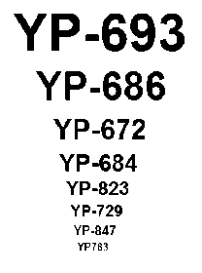To determine your actual resolution, hold the SPYsat “eyechart” (shown at right) several feet away. Pick the thrid line from the top and move it closer until you can just make out the hull number on your display. Record this distance from the “eyechart” and the width of that hull number on the chart. From step 1), calculate the width of the FOV at this distance (which represents 400 pixels). Measure the width of the hull number and determine how many pixels comprise that width (hint: compare to the FOV width). Estimate the actual resolution of your SPYsat camera in pixels required per character. Now calculate how far away your LABsat can be to be able to read the hull numbers on an actual YP, which are 3 feet wide?
3. **Hallway Flight Test:** Command the camera to ON. Plug a 9v battery into the prototyping board in parallel with the 8v power supply, and then unplug the 8v power supply and the PC USB cable so your astronaut partner can carry the satellite around and down the hall to see what kind of range you can get. Go over to the console area and tune the big screen TV to your channel. He should point the camera so you can see where he/she is when signal is lost. The effects of multipath causing fading on the signal will be very evident as the spacecraft is moved around indoors and down the hall. Look for the maximum distance where even momentarily you still can get a good picture..
4. The astronaut carrying the camera should be aware of the pin 13 Blue LED to know if/when the satellite enters safe mode due to low battery power and return to dock.
5. Return to your workstation and plug in the USB cable. Turn camera **OFF** with the keyboard command and verify the camera is off by observing the telemetry current. Remove battery for recharging.

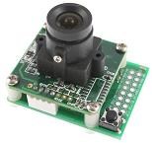

**Post-Lab Questions:**

**SSTV Analog Image Scanning:** The Instructor will demonstrate a Slow Scan TV imager for transmitting pictures over an analog voice radio channel. SSTV is used to keep ground receivers simple and low cost. Weather satellites typically use this kind of analog line-scanning method that simply modulates a carrier according to the instantaneous pixel amplitude as a single photo diode detector sweeps out the swath on the ground. Typically, an SSTV image is only only 120 x 120 pixels for a minimum resolution picture.

In 2011, Midshipman Ballester’s EA469 project involved integrating an SSTV camera onto the Transit satellite hanging in the Rickover Lobby. Using only a walkie-talkie, he could command it to take an image and transmit it back to our Ground Station receivers. The SSTV scan takes 40 seconds per image. Compared to the 30 images per second of the NTSC camera on the LABsats, how much more bandwidth should the NTSC camera require? Given that the radio Link Budget power is directly proportional to bandwidth, how much more power would an NTSC link require compared to MIDN Ballester’s 1-Watt radio?

**Diffraction Limit:** Resolution is also limited by the size of the lens used. The diffraction limit angle, also known as the Rayleigh Limit, is a function of the wavelength and lens diameter and is given by:

DL (radians) = 1.22 * wavelength / Aperture diameter (Assume a visible light wavelength of 500 nm)

Optical resolution is often given in arc-seconds where one radian equals 206,265 arc-seconds. The Hubble telescope with its 2.4 m aperture has a diffraction limit of 0.05 arc seconds. What is the diffraction limit of your 2.4 mm lens?

Using basic trigonometry and your diffraction limit, what size lens would your LABsat need to resolve the 3 foot wide YP hull numbers from 400 km altitude orbit (assume slant range of 400 km)? If it was pointing at Earth, could the Hubble see them from this orbit?

**Swath Movement Considerations:** With the spacecraft moving at orbital velocity, the image of the earth’s surface also moves in the field of view of the sensor. Assume the image is “looking down with the top of the image in the velocity direction”. How many meters/sec (on the ground) is the image moving down the screen? To prevent blurring, each scan line in the image has to be scanned fast enough so that the pixel’s location has not moved more than lets say half its width in the scan interval. To calculate that scanning speed, lets assume the CCD camera uses the NTSC standard 525 lines per image and 30 images per second. How many lines per second are being scanned? At that line scanning rate, what is the resolution limit in meters per line such that the line has only moved half its height in it’s sampling interval?

**Link Budget, Bandwidth and Microwave Downlinks:** (Some questions below are relative to RF link budgests that are now after this lab instead of before. But they did have link budgets their youngster yaer; so a few minute refresher might be needed here). An imaging sensor can not only image Earth from space, but can also be used for tracking a star or the Sun for attitude determination (as in a later ADCS lab). However, image data requires orders of magnitude more bandwidth than simple telemetry and so we have used a microwave transmitter operating at L or S band (1.2 or 2.4 GHz) to get enough bandwidth. Here is a comparison in bandwidths:

LABsat 1200 bd telemetry – 15 KHz bandwidth. 120 bytes per minute. 2% duty cycle

LABsat imager – 30 MHz bandwidth. 525 lines of 240 pixels (24 bits) 100% duty cycle

* We know the noise limit in the ground station receiver is proportional to bandwidth (N=KTB), so wider bandwidth requires more link power for the same SNR. Compared to 1200 baud telemetry bandwidth, how many more dB of link performance must you obtain in your link budget to support an image downlink?
* Given that the LABsat can close the link for its telemetry using a 2 watt RF transmitter and 0 dB gain omni antenna, how much TX power is required to make the image link work if you assume that you can use 10 dB of TX antenna gain?
* In addition, if the imager and new transmitter is to be on all the time, what is the total impact on the electrical power system of the imager at 100% duty cycle compared to the TX power budget for the simple 1200 baud telemetry at its low 2% duty cycle?
  + A factor of _______ increase to a total of _______W. (Is this practical?)

**Laboratory Turn-in:** This lab completes the lab series on telemetry. Record your observations and calculations in your notebook as well as your Lab Report. The final Lab Report #1 contains the C&DH Labs as well as all 3 Telemetry Labs as content.