EA467 Communications Lab III – PSK on an FDMA channel (rev-c) Fall 2016

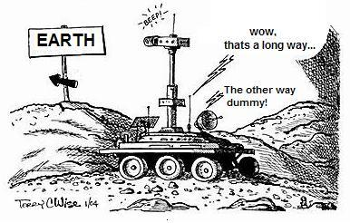

**Introduction:** This is the last section of the Communications lab on PSK (part E). In the last lab, you observed FSK signals and demodulation on the PC oscilloscope. The FSK signals were observed in the time domain, as an example of a shared Time-Division-Multiple-Access (TDMA) channel.

In this lab, you will perform a similar observation but using Phase-Shift-Keying (PSK) signals using a low data rate 31 baud narrowband signal. These signals will be sharing an FDMA (Frequency-Division-Multiple-Access) channel. Very low data rates allow for very weak signal detection and are often used on planetary missions due to the large distances involved. The Mars rovers used rates as low as 10 BPS or so to communicate back to Earth. The lower data rate allows for lower bandwidth and less noise which improves the signal to noise ratio.

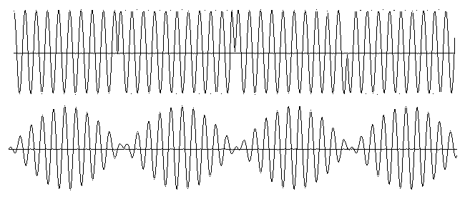**PSK Waveform:** Normally PSK is presented as shown in the figure to the right (top). This is Biphase or BPSK where the 180° phase shifts between bits are clearly visible. On one hand BPSK is relatively narrowband, because the carrier is always at the same frequency as shown in the upper right here, only the phase changes. But, on the other hand, the sharp 180° transitions in phase in the time domain increase the bandwidth of a BPSK in the frequency domain.

In this lab, we will be looking at a specially modified version of BPSK called PSK31 which has been smoothed at the phase transitions to minimize bandwidth. This is done by AM modulating the carrier frequency at each bit so that the amplitude of the signal is zero at the instant of the 180 degree phase changes as shown above (lower). The smooth phase transitions at each bit, make these signals occupy less bandwidth than a normal BPSK signal, though the change in phase over the full bit is still easy to detect.

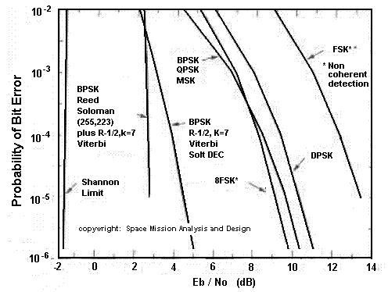**Bit-Error-Rates:** The receiver demodulation process has an impact on the Link Equation since it establishes the threshold of operability of the power received term (Pr) in the receiver. There has to be enough power received with enough SNR to be able to decode a signal. The chart at left shows the minimum SNR (denoted Eb/No) required to achieve specific bit-error-rates (BER) for various modulation and coding techniques. BPSK is clearly better than FSK by several dB.

What is the dB advantage on this chart of BPSK over FSK for a BER of 1 out of every thousand bits? ____________

## Part E: BPSK Reception on an FDMA Channel

Satellites with low power over long distances often use PSK instead of the simpler FSK because of the better signal-to-noise link for the same power. But this does require a more expensive linear receiver and linear transmitter. Another advantage of the narrow bandwidths of BPSK is that more signals can fit in the same spectrum of a multiple access transponder. A Frequency-Division-Multiple-Access (FDMA) shared transponder has a wide frequency bandwidth that can support multiple simultaneous signals in the frequency domain. This is in contrast to a TDMA channel observed in the FSK section of this Lab previously, where signals fully occupy the transponder one-at-a-time but share the channel over time.

**LAB Signals:**  We will use amateur BPSK signals from an HF radio combined with our own work station signals. The HF receiver is tuned to a narrow 3 KHz wide spectrum at 14.070 MHz and this is patched via the R-122 patch panel to the sound-card audio input of your RIGHT workstation PCs as shown below. This single 3 kHz wide radio channel can contain numerous international BPSK signals.

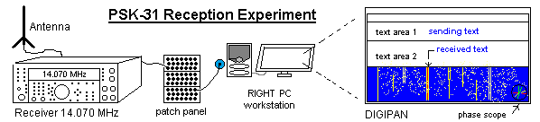

To receive and display the BPSK signals, you will use the free downloadable DIGIPAN software that uses the PC sound card for BPSK demodulation and also displays the receiver spectrum (in a time history waterfall display), a phase vector scope, and the recovered data text. The small phase vector scope in the lower right corner displays the instantaneous phase of the signal. Since BPSK-31 operates on 180 degree phase shift, you can see the quality of the decoding on this 360 degree phase scope. Good decoding will show green vectors near 0 and 180 degrees. Noise will cause errors in amplitude and phase that are visible in the recovered text and phase vector scope closer to 90 and 270 and are shown in yellow and red.

**Signal-to-Noise Improvement:** On this PSK band, weak transmitters as low as 5 watts can frequently communicate around the world using PSK at 31 baud. In contrast, a voice signal occupying the same 3 KHz of bandwidth would take hundreds of watts. The difference is the noise bandwidth of the receiver. For voice, the decoder (your ears) has to contend with all the noises in the full 3 KHz bandwidth to also hear the voice. But for the narrow PSK-31 signal, a receiver only has to contend with a much smaller spectrum of noise (maybe 60 Hz or so). It is this reduction in noise bandwidth in the Noise equation (recall N=KTB) that makes such a huge improvement in SNR (i.e. Pr/N). Deep space probes take advantage of the lower data rates as low as 10 baud to improve their link margin for a given spacecraft power (at the expense of taking longer to download appreciable data).

Since the SNR is limited by noise bandwidth, how much better performance in dB can the 60 Hz BPSK-31 user expect over the same channel as a 3 KHz voice user? _______ This improvement makes his 5W transmitter perform as well as what power level transmitter for the Voice user using this same RF channel? _______

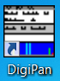

**Lab Procedure:**

1. Double click the DIGIPAN icon on the desk top.
2. The 14.070 MHz HF receiver is connected to the audio input of each right-hand PC via the signal patch panel in the front of the classroom. Note: The left-hand PC is connected as the Transmitter PC and is also mixed into the transponder channel, but will not be used until later in this lab.
3. Set the receiver audio level on your PC. Your PC speaker will be emitting the sound as well. You can adjust the receive audio level with the volume control on the speaker on the front of the monitor. On the Windows tool bar on the right hand side near the clock click the up arrow and then right click on the Volume control icon. Select Sound Manager. On the Tab bar, select “Line In”. Set the play back volume to the middle (approximately 45). Adjust the Recording Volume so there is some quiet blue and some yellow noise, but not too much noise. The spectrum displayed in DIGIPAN is from 0 to about 3000 Hz and represents a typical single voice audio bandwidth channel. PSK-31 signals will have two clear peaks or “tracks” representing the width of the modulated waveform in the frequency domain. You can decode a signal by clicking on it. As you first click on a strong signal, watch the vector scope in the lower right as the phase-lock-loop acquires the signal and gets into phase lock.
4. Receiver RF tuning must be very precise because of the very narrow bandwidth of each signal. But by eye you can easily find and click on a signal. Here is what to look for and document:
   * The number of signals, their frequency in the transponder and their individual bandwidth?
   * The purity of each signal (do any of them over-modulate and develop +/- sidebands which consume extra spectrum)?
   * What happens to other weak signals when a strong one begins transmitting?
   * How could you jam all users on this FDMA multi-user channel?
   * What is the overall bandwidth of this broadband multi-user FDMA transponder?
   * How many potential FDMA signals can fit in this transponder?
5. You can see where these signals are originating, by watching for 4-to-6 character call signs (usually in upper case) that have a single numeral for the 2nd or 3rd character. Use the USA map and World map provided on the front wall to identify the location or country of origin by the leading one or two letters. Try to find at least 3 decodable call signs. Usually they are preceded by “de” which in teletype (and French) means “from”. Other abbreviations are: CQ (seek you), K (over), SK (out), QTH (location), 73 (bye) and 88 (love&kisses).
6. Most stations will also exchange a Grid-Square like “FM19” to easily document their location. You can decode these on the green Grid-Square map of the world also provided on the front wall.

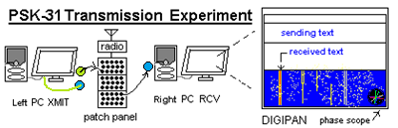**Part F. Transmitting BPSK:**

Propagation on this HF frequency improves the longer the sun is up, so 3rd/4th periods may see better signals than 1st/2nd depending on the space weather in the ionosphere. To be sure we have signals to work with, your left PC can transmit BPSK-31 onto the FDMA channel as well via the patch panel in the front of the room.

1. Your left PC speaker output should already be connected as shown above to the patch panel and also via a 13k resistor to the audio going to all the other workstations.
2. A copy of your transmitted signal should also be patched back to the orange/green audio adapter connected to the serial DB9 connector at your workstation.
3. On the LEFT PC, right click on the PC oscilloscope PS-2000E icon on the desktop and connect the Orange/Green wire DB-9 adapter to the Channel 1 probe.
4. Set the O’scope to 10 ms time base and the amplitude to a comfortable display similar to the one on the first page. You should see a pattern of modulation envelopes of energy at a 31 Hz rate superimposed on the audio carrier.
5. Set up your station’s callsign PC***XY*** where X is your row (A,B or C) and Y is your PC from right-to-left (1,2,3 or 4) under the CONFIGURATION and PERSONAL DATA tabs (note: may be already configured for your PC).
6. To transmit, click on an unused frequency in the waterfall and transmit your CQ. Either by typing it in, or clicking on some of the preloaded preambles and postambles buttons across the top of the DIGIPAN software.
7. Once you have selected your frequency, click TX on the lower part of the display to shift from RX to TX and back. Your station should now be transmitting and its tone will appear on all other consoles and on your PC-O’scope. You will use the O’scope presentation in the next section, but you might want to change the time base from 10ms to 5ms or less if you are transmitting a tone higher than 1 kHz to see a good signal.

You can now communicate with any other workstation in the room by watching their signal on the receive waterfall and transmitting on your left PC onto your transmit signal. You have to watch for new signals on the air, and quickly click on them on your receiver to capture their text.

Your goal is to observe the performance of the BPSK system, quality of signals in the vector scope, and operations of the FDMA channel while having two-way contact with other stations in the room.

**Post Lab:** Write up your observations and comments… Based on the bandwidth you observed, comment on the number of signals possible on this FDMA channel, the number you saw, the quality of the signals, the phase shift used, the relationship between the vector scope observations and quality of data recovery. How much bandwidth is used by each signal? How much “guardband” should be allowed between signals? What kind of impact did noise make on the signal? What happened to everyone on the channel when a strong signal drove up the AGC level (Automatic Gain Control) on the receiver?

**Part G. Waveform Capture:**

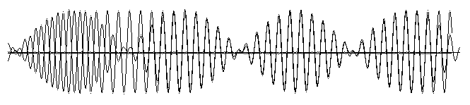In this part you will capture the BPSK-31 waveform like that shown on page 1 (and below) for analysis. As discussed, it is difficult to see the 180 degree phase shift that might be occurring at each of the transitions between bits in this AM smoothed BPSK because of the amplitude wave-shaping at the crossover points to minimize occupied bandwidth. By only doing phase shifts between bits in the waveform while the carrier is at zero amplitude, time domain transients and therefore bandwidth are reduced.

To make it easy to see the phase shift, you will capture an idle waveform from your transmitter with no data and then one with data. Then bring them into Paint, and do a cut of the plain waveform and paste it over the modulated waveform (with Paint set for transparent paste and black/white only). Carefully move it right or left to get a perfect superposition as shown above. By eye, it will be easy to see the bits that have the 180 degree phase shifted carrier from those that do not. Perform the following steps on your Transmitting PC so that you see only your own strong transmitted signal.

1. Your LEFT PC Transmit PSK31 audio is already patched to your right PC audio as used in part E and F above. Select a TX tone around 1000 Hz, which is easy to hear. Then click transmit. You should hear it on your speaker
2. Have the instructor disconnect the audio from the HF receiver at the patch panel (short red clips) to your PC so that you only hear and see your own transmit signal.
3. The PC oscilloscope on the LEFT PC set to 10 ms time base should see a pattern of modulation envelopes of energy at a 31 Hz rate superimposed on the 1000 Hz carrier you selected. Adjust the amplitude of the O’scope to a comfortable display similar to the one above.
4. To clean up that display for better analysis, go back to RX and change your selected frequency down to around 400 Hz or so. This will make the waveform easier to see. Select transmit again.
5. Now capture this idling waveform (alternating ones and zeros) and save it as a bit map BMP file.
6. Without touching anything else or changing any settings, click on one of the transmit text boxes (CQ) or (CQ or CALL3) and while it is transmitting some text, you will see a variety of patterns depending on the number of identical 00’s or 11’s in a row. Capture another waveform as a bit map.
7. Open these files side by side in PAINT. Save your images as a Monochrome BMP file. Then use the “Select” drop down menu, select the “Transparent selection” . Select and copy one of the images and over lay onto the other. By shifting left and right, You should clearly be able to see where the bits are in phase and 180 degrees out of phase.

**Laboratory Report:** This completes the Communications Lab series. Use the standard lab format for your report, which will also include the TX/RX lab where you learned about transmitter and receiver parameters, and the FSK lab where you learned about demodulating FSK into bits, bytes and words on a shared TDMA channel. This final PSK lab demonstrated how phase shift keying can also be used for very weak signal links and also for FDMA channel sharing. Determine **two** key takeaways about spacecraft communications design from the lab series and write a technical report that leads your reader to correct conclusions. Your conclusions should be developed in your Results and Discussion section and should flow naturally from clear and concisely worded theory, methodology, and results. Use relevant experimental data, figures and plots, as well as comparisons to theory where appropriate, to support your conclusions.