EA467 Communications Lab II –FSK and TDMA (rev-b) Fall 2016

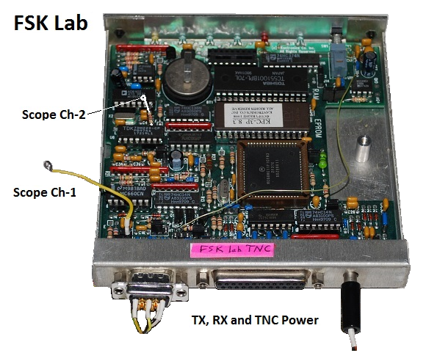

**Introduction:** In the Antennas lab you investigated the elements of the Link equation and in the first part of the Communications lab you learned how to transmit a signal (Part A) and receive it (part B) and how it must be stronger than the noise floor of the receiver (part C).

This lab will address the demodulation of the RF signal waveform into usable data. The demodulation method used also has an impact on the Link Equation since it affects the threshold of the power received term (PR) in the receiver. There has to be enough power received to achieve the minimum signal to noise ratio (SNR) required to accurately decode a signal. The chart below shows the SNR (denoted Eb/No [the energy per bit to noise power spectral density ratio] in the chart) required to achieve specific bit-error-rates (BER) for various modulation and coding techniques.

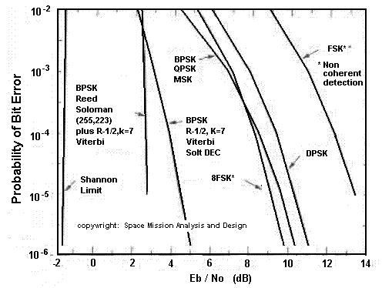This lab will demonstrate two common modulation methods used in space communications, FSK (Frequency Shift Keying) [Part D], which is used on most of our USNA satellites, and BPSK (Binary Phase Shift Keying) [Part E] used on USNA RAFT(2006), and now PSAT (2015) and many other spacecraft.

FSK is a frequency modulation scheme that transmits digital information via discrete frequency changes of a carrier wave. Some modulation methods perform better than others, as shown in the figure to the right (from SMAD). Notice that FSK requires the highest SNR (Eb/No). However, it is the simplest method and is therefore used in many applications such as command and control links on all of our USNA satellites. BPSK requires less Eb/No (by 4.5 dB or so), but requires significantly higher quality linear receivers and stability which adds to cost.

**Part D. FSK Demodulation – FSK Data Receiver on a TDMA Channel:**

Many spacecraft communication systems use FSK; some of the user channels on UFO and many amateur satellites are good examples. The USNA satellites and LabSats all transmit telemetry and user packets periodically using the AX.25 packet radio protocol using FSK. Packet digital communications is the name for “bursty” types of data exchange where many stations can share a channel or transponder in the time domain. This is called TDMA (Time Division Multiple Access) which you have observed in EA-204 from ISS, PCSAT, and the national terrestrial APRS channel (144.39 MHz).

In this lab, you will use an FSK demodulator and packet decoder for data reception of telemetry from the terrestrial APRS channel and a prototype of our next satellite, PSAT-2. This will provide plenty of activity on the channel and also let you see how TDMA works with multiple users.

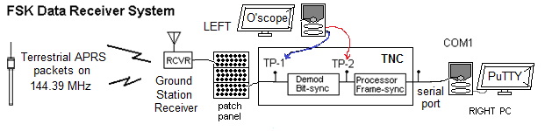

In the diagram above, the ground station receiver receives the VHF telemetry FSK signals as a pair of shifting audio tones. This is patched to all workstations via the patch panel so you can connect it to your packet decoder. You can see the two audio tones on test-point-1, or TP-1. The packet data transceiver or modem (called a terminal node controller [TNC] in our Labsats) then amplifies and demodulates the tones into individual bits (test-point-2, or TP-2), and then synchronizes these bits to the data clock in the Bit-Sync circuitry. Next, the Frame-Sync circuits identify the special flag bytes that signal the start and end of each packet frame. This process allows the frame sync to locate the beginning and end of a packet out all of the 8-bit bytes and send the corresponding string of ASCII characters to the PC for display (via the COM1 serial port).

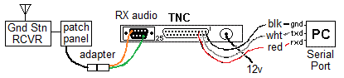**Lab Setup:** Use the orange/green audio adapter wires to connect the distribution cable audio to the radio input of your TNC as shown. Prepare/verify the setup for your TNC decoder as follows:

1. 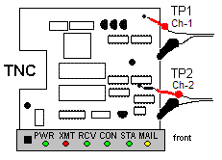**Terminal Node Controller (TNC):**  Connect the patch panel ground station receiver audio to the radio connector on the back of the TNC via the Green/Orange adapter and inserting the pins as shown above. Connect 12v DC power to the power jack on the TNC. Connect the COM1 serial port wires of your PC to the serial port pin sockets on the TNC as follows: connect the Receive Data (RXD)(red or brown) to pin 3, the Transmit Data (TXD)(white or yellow) wire to pin 2 and Ground (GND)(black) wire to pin 1 as shown.
2. **PC Oscilloscope:** Now turn the LABsat around so the front panel of the modem faces you and connect the PC O’scope probe channel-1 black lead to the Modem case and the red clip to the incoming receiver audio at test-point-1 (TP1), which is in the upper right corner of the TNC as shown here. Bring up your PC oscilloscope under Programs or on the desktop - PC-Lab2000SE. Set channel-1 to 2 volts per division and the time/div to 1 millisecond. Click on the RUN button. Turn on the Receiver volume control and verify that the oscilloscope shows the receiver noise and maybe some occasional tones. Adjust the Ch1 position slider to the middle of the top half of the O’scope display and adjust the receiver volume control to approximately fill that top half of the display.
3. **FSK Discriminator:** Connect the channel-2 O’scope black ground clip to the TNC chassis and the red probe to the discriminator output at TP-2 shown above. It is the top of a small resistor sticking up off of the discriminator chip. (Note that TP1 and TP2 correspond to the test points on the FSK Data Receiver System block diagram above). Treat this resistor gently or it can break off. Turn ON the TNC via the front panel power button. Observe the received waveform and data on the oscilloscope.
4. **PC Terminal Program:** From the START-All-Programs-PuTTY menu, select PuTTY. Then select *Serial* **Connection** type. The other defaults should be OK. (Under the Category tree, select serial and confirm COM1, 9600, N, 8, 1 and No parity, then toggle the flow-control to OFF). Select OPEN to open the comm. window, and you will begin to see the TNC-decoded FSK telemetry message data. Hit the ENTER key a few times to verify that the TNC responds with its ***cmd:*** prompt. Do not type any other commands!

**Gathering Data:**

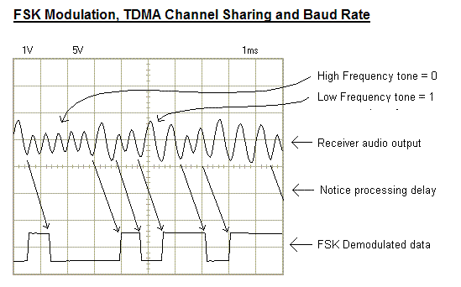Notice the radio output is the same FM noise we heard in the Receivers Lab. But when a signal is heard, the noise goes away and we can see the recovered audio tones. Capture a waveform similar to the figure below. When you hear a new data burst, quickly toggle-off the RUN button to try to capture the trace. The demodulator does not really know the difference between noise and signal so it is always trying to make sense out of the incoming noise and generates constant 1-0 transitions from the noise even in the absence of a tone. But these transitions will only “square-up” at bit rates equal to the true data rates when the desired signal (appearing as sinusoidal alternating tones on the receiver output on CH 1 as pictured below) is detected. Also, only when the decoder sees these regular/square bits does it recognize that a message is being received and then sends the decoded data to the PC display.

**Waveform Capture:** Capture the waveform by clicking on the RUN button to save the data burst’s analog waveform consisting of two alternating sinusoidal tones. One tone represents a digital 1 and the other tone represents a digital 0. Make sure you get a nice capture that shows lots of 1’s and 0’s and at least a continuous string of several 1’s or several 0’s in a row, because then it is easier to see the difference between the tones. Note that the first half of each telemetry data packet begins with a very regular pattern of about 7 zeros and then a one. Try to capture the second half of the data where the ones and zeros are more random. Save the image on the PC oscilloscope for use in your report.

**Observations:** Notice that the noise coming out of the receiver (ch 1) is quite high in level when there is no signal. This noise is called white noise, because it contains components of all of the frequencies in the receiver’s bandwidth. As we observed in the previous receiver’s lab, this noise is characteristic of FM receivers and will “quiet” when a signal is present depending on the SNR. The modulation tones can then be seen easily.

Note that the changes between the two tones correspond to the changes in the data stream which represent the ones and zeros. There is not a one-for-one correspondence between the number of cycles in the tone and the number of data bits. It is only the presence of one tone or the other that represents the ONE or the ZERO in the data. In determining the presence of one tone or the other, there is a delay while enough of a cycle is completed for the determination to be made. You can see the delay sketched on the figure on page 3.

**Amplitude**: Do not be confused by the waveform amplitude. Remember, this is FM. So just because the low tone appears higher in amplitude than the high frequency tone, this has nothing to do with the data. In fact, it shows that our receiver (or the transmitter) does not have a flat audio response.

**Calculations and Learning Elements:** Next, determine the following learning points from this waveform and data capture. This will give you an understanding of data transmission, demodulation, and decoding. Do this while in the lab so that if your data capture is not a representative sample, you can do it again until you get a good capture. Also, be sure you actually capture data and not just noise.

The discriminator does not know the difference between data and noise at this point in the data decoding process. The decision of determining if the ones and zeros mean anything comes later when the bits are synchronized to a data clock and checked for bytes in the frame-sync part of the TNC.

1. Estimate the frequency of each of the two analog tones represented by estimating the period of the sinusoid waveforms. Look for several consistent full wave cycles and measure the middle one.
2. Observe the data is in bursts (TDMA) of about one second with plenty of non-activity time in between. This allows multiple stations to share the channel. Count bursts for one minute and estimate the loading on the channel. (busy versus noise?)
3. Estimate the Bit rate. From your capture, look for the smallest bit width and assume that is a single bit wide. Estimate the approximate data rate (bits/sec) from that observed bit width.
4. Estimate (by what you hear by ear) the data packet length (audible signal length in time). With that duration, and your estimated bit rate, you should be able to calculate the total number of 8-bit bytes (one for each character) in each packet. Do you come close to the actual number of characters seen in the packet on the PC display? Note: there are as many as 50 null bytes at the beginning for synchronization which are not shown on the display.
5. Observe the ASCII equivalent of the FSK data words on the PC display. There should be several different types of data being received from the various transmitters we enabled for this lab. Some of these are simply a beacon text or a telemetry packet. Record a sample of each different type of data packet you see. (Copy and paste from the comm. window). Notice the number of bytes (characters) in a typical telemetry packet (example shown below). Later in the Telemetry Lab, we will decode these bytes into meaningful telemetry.

Telemetry Format: PSAT>APRS:T#SSS,111,222,333,444,555,11111111

**Post-Lab:**

Explain what is happening (and why) at each stage of the process (use the waveforms/testpoints as support). Answer the questions above and discuss the advantages and limitations of this FSK digital transmission type used by our satellites. Discuss the advantage of TDMA and relate it to the following question: PSAT’s mission is to relay data from remote sensors such as oceanographic buoys. If each buoy was transmitting a similar telemetry packet once every 30 minutes, how many buoys like this could share the TDMA channel? (Note: It has been found that a channel loading less than about 18% is optimal. At loadings above that, the successful throughput begins to be reduced due to collisions. So assume max loading of 18%). What can be done to reduce collisions on a TDMA channel?

**Laboratory Report:** This FSK/TDMA receiver lab is “Part D” of the Communications Lab series and will be included in the formal Communications Lab report along with a section from the next labs’s PSK experiment (Part E). You will use the standard lab format to describe the set-up, discuss data and results, answer questions and write conclusions. You should where possible relate the various parts of the lab series to each other to gain a comprehensive understanding of the overall communications system including the functions performed by and the issues concerning transmitters, receivers, noise, FSK and PSK modulation, and TDMA and FDMA channel access methods.