EA467 Communications Lab I: Transmitters and Receivers (rev-c) Fall 2016

**Introduction:** This lab continues our investigation into the elements of the Link Equation. The previous Antenna lab covered the two Antenna Gain terms (GT and GR) and the space loss term LS in the Link Equation. The Transmission Line Lab covered some incidental losses term LI (hopefully less than 3dB). This lab will address the hardware involved in the Transmitter and Receiver terms, PT and PR.

Recall the Link Equation: PR = PT + GT + GR – LI – LS

Transmitters require power on the order of Watts and consume significant power but often on a low duty-cycle. The challenges of transmitter design are heat generation and dealing with high peak current requirements. Receivers on the other hand must be capable of detecting signals as weak as 10-12 Watts while maintaining good signal-to-noise ratio (SNR). Receivers draw little power, but usually are on all the time so they have a 100% duty cycle and sometimes can require more average power than the transmitter’s average power. The challenges of receiver design are sensitivity, selectivity, losses, and noise. Noise is ever present and gets worse with every stage of the receiving process, every length of cable and every connector.

This lab uses our LABsat comm system to gain experience with transmitters, receivers, and noise. The testing completed in this lab exercise is similar to both functional and performance testing on real spacecraft components, and something you will perform as part of your capstone design project.

**Lab Groupings:** There are 3 group setups for Transmitters, 4 for Receivers and one for noise.

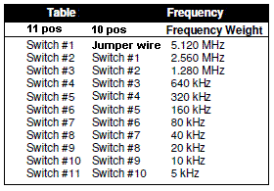

**Transmitter and Receiver Frequency:** Both the transmitters and receivers in this lab can be tuned to any frequency in the Amateur Satellite Band (145.8 to 146.0 or 435.0 to 438.0). Selection is made by setting the proper bits in the Frequency Synthesizer that locks the oscillators to a reference crystal. The table at right is used to set the proper frequency on the 10 or 11 bit select switch. The frequency is determined as the base frequency (either 140 or 430 MHz) plus the indicated total bit weight.

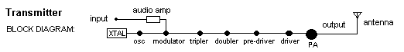

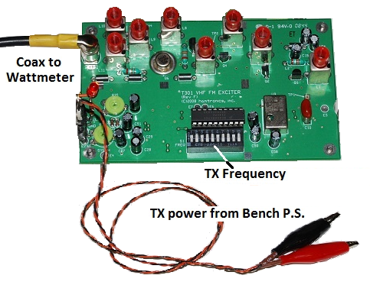**Part A. Transmitters:** A typical transmitter system block diagram is pictured above and includes an audio amplifier, modulator, tripler, doubler, pre-driver, driver, PA, and antenna. This experiment uses a PCSAT/LABsat transmitter to make typical measurements that are important in the design process. You will measure power output versus power input and calculate efficiency. You will also develop a performance curve for your transmitter over the range of voltages of your spacecraft bus and will measure the heat rise in the final amplifier stages, which must be accounted for in the thermal design of the spacecraft. You will also observe any spurious emissions on a spectrum analyzer. Perform the following procedures:

***WARNING: Do NOT exceed 14 Volts on the power supply or you will blow the transmitter!***

1. **Setup:** Confirm the setup as in the figure below. Notice the dummy load is connected to the transmitter via the wattmeter to have a matched load to avoid excessive reflected power that could destroy the final output transistor. Set the meter scaling factor to 1 and make sure the “factor=10” SWR slug is used. This makes the wattmeter read to 10 Watts full scale.

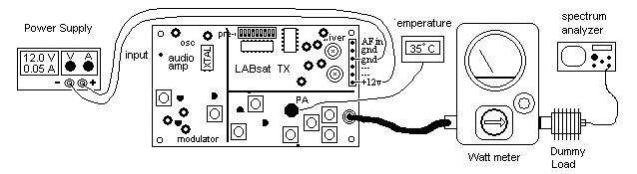

1. **Temperature:** There is a thermistor attached to the transmitter final power amplifier (PA) transistor heat sink (a black fin-shaped component) so you can observe the temperature rise. The transistor case is also soldered to the circuit board to help dissipate heat. Record the initial temperature. How well will each of these two heat-sink methods work in space?
2. **Power Supply:** Set the power supply to 8 volts. ***Do not exceed 14 volts****.* Temporarily connect the transmitter to the power supply (+ to red and - to black) and record power supply Volts, Amps, the RF Power output and temperature. Increase the voltage in half-volt steps up to 14 volts and take readings.

***WARNING: DO NOT CONNECT THE LEAD IN STEP 4 FOR MORE THAN 5 SECONDS***

1. 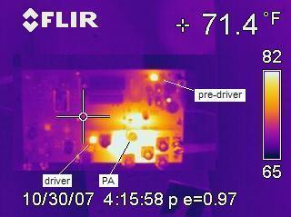**High Power Test:** For two more data points above safe ratings for this transmitter, disconnect the + lead from the power supply, adjust to 15 volts, and then BRIEFLY re-connect it for up to 5 seconds while taking another set of readings, then disconnect again. Repeat for 16 volts.
2. **Power Amp Heating:** Place your finger on the black fin radiator of the output transistor, driver and pre-driver transistors to observe that generally, all the heat is generated in the final stages of the transmitter. Ask the instructor for an IR camera to see the infrared image of the transmitter to the right.
3. **Electromagnetic Compatibility: RETURN TO 12 VOLTS**. Set the spectrum analyzer to the frequency of your transmitter (146 MHz), 10 MHz/div, 0 dBm level, 1 MHz BW. Connect/disconnect the transmitter power and observe on the spectrum analyzer the main carrier. Retune the SA up to 1000MHz looking for the 2nd, 3rd, 4th and 5th harmonics and other significant (spurious) emissions. Note the amplitude of the 146 MHz carrier and record all emissions that are above a value 60 dB below the carrier (note: on ISS, the requirement is for all spurs to be more than 80 dB below the carrier. All spectrum analyzers have a spike at 0 Hz, ignore that one. Lower the voltage to between 5 and 10v up and down and watch for instability in the transmitter on the SA.

**Post Lab:** Plot the DC input power, RF output power, efficiency (i.e. Pout/Pin) and temperature versus voltage (note: divide power by 5 and temperature by 10 to see all on the same graph). Based on these measurements, and the spectrum analyzer observations, comment on the impact of the transmitter on the design of a spacecraft and other payloads. Compare the levels of the spurious emissions to the typical receiver sensitivity you observe in part B. If this Transmitter is only on for six 10-minute passes over USNA per day, compare the average DC input power required by this transmitter to that required by the receiver in part B? Looking at your data, if the transmitter is rated for operation of X watts at 12 volts, how much could you degrade system voltage and still have a useful transmitter? (for the transmitter, assume “useful” means RF output down by no more than 3 dB and no instability as noted in #6 above).

**Part B. Receivers:** The most important aspects of a receiver in spacecraft design are sensitivity, selectivity, and power requirements. *Selectivity* means it has filters to block out unwanted signals that are not in its frequency band, while *sensitivity* indicates how well it can receive weak signals. This experiment will measure the sensitivity and selectivity of a typical receiver that we have used in PCSATs.

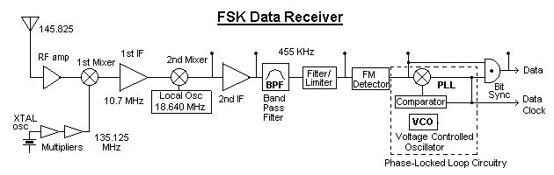

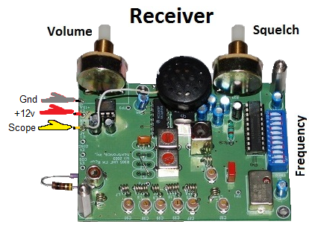A typical block diagram for a receiver is shown above. It consists of a low noise RF amplifier to get the signal above the noise floor, then a mixer to heterodyne it down to a first Intermediate Frequency (IF) where it is amplified and filtered with very efficient amplifiers. The signal is then typically mixed again to an even lower frequency and higher quality second IF amplifier and passed through appropriate filters before being passed to the detector. The detector demodulates the signal to recover the original signal from the carrier. In this lab, you will use an FM receiver where the detector is called a discriminator. An FM receiver delivers full Noise output when there is no signal. As the signal carrier increases, the noise power decreases until you get a good signal to noise ratio. Since FM receivers produce full audio output (noise) with no signal input, we actually measure SNR as the degree of “quieting” of that noise as the carrier signal level (with no signal modulation) increases.

**Lab Period: NOTE: You are familiar with *Power in dB = 10 log (P).* But for this lab, some readings are in volts and since P = V2/R then *Power in dB = 20 log (V).***

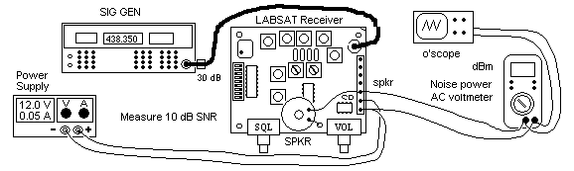

1. **Signal Generator Setup***:* Connect the signal generator to the receiver as shown and set the amplitude to a -127 dBm by pressing the amplitude button, then keying in the value, and then pressing the dBm button. Turn off modulation in the modulation section of the generator (press FM and then OFF) and toggle the RF ON/OFF button to off in the Carrier section. Press the Freq button and key in the frequency for your receiver (438.350 MHz) and press MHz. Confirm that your receiver switches are set to this frequency per the chart in the intro. The cable has a 30 dB external attenuator at the connection to the signal generator, so -127 dBm on the signal generator is really equivalent to -157 dBm at the receiver. You need to account for this extra 30 dB in all parts of the lab.
2. **LABsat Battery and Oscilloscope Setup***:* Set the bench power supply to 12 volts. Carefully connect the black wire to the ground terminal on the right side of the board and connect the red wire to the red wire terminal. Bring up the PcLab2000SE O’scope on your PC desktop with a RIGHT Click and “Run-as-administrator”. Set the O’scope Ch 1 to 0.5v per division, AC coupling, probe to x1 and set the time/div. to 0.5 ms.
3. **Voltmeter Setup*:*** Turn on the Digital Multimeter to the dBm/~V AC volt scale and press the SELECT button to display dBm instead of millivolts. Setting the voltmeter to read in dBm will make lab observations and calculations much easier since you do not have to constantly do the 20 log (V) conversion from volts to power.
4. **Receiver Setup***:* Confirm that the receiver test circuit is configured as shown above. First set the squelch and volume controls to minimum by turning the knobs fully CCW. The speaker and voltmeter/o’scope should be connected to the receiver audio output as shown (i.e. black to ground and red to the speaker output). Turn the volume control up until the level of AC noise (there is currently no signal) reads approximately 0 dBm on the voltmeter. *Do not change the volume after this setting!* The receiver draws about 50 mA at 12 volts (what is the power required for this receiver? __________ ). Note: spacecraft receivers are typically on all the time so even a low power requirement on the order of mA is not insignificant. Capture the noise waveform on the O’scope by clicking file, save image.
5. **Measure Receive Sensitivity** by observing receiver output signal-to-noise ratio (SNR) versus antenna input signal level. Since FM receivers produce full audio output (noise) with no signal input, we actually measure SNR as the degree of “quieting” of that noise as the carrier signal level (with no signal modulation) increases. Proceed as follows. With no input signal from the generator (RF ON/OFF button to Off), the FM receiver should produce maximum noise power on the voltmeter (about 0 dBm). Record this value as your reference ________. Toggle ON the RF ON/OFF button and begin to increase the amplitude 1 dB at a time using the AMPTD up arrow until you see the digital voltmeter reading start to go and stay negative. Since the voltmeter is measuring the strength of the noise, this point signifies that the noise is beginning to diminish because the signal is now strong enough to barely get picked up by the receiver. Record this signal (remember to subtract 30 dB for the attenuator) and the noise level measured by the voltmeter. Now continue to slowly step up the signal level 1 dB at a time while recording reduction in noise level on the meter (note: the numbers will be jumping around, so try to record the average value for each measurement). When you get to 10 dB of quieting (-10 dBm on the voltmeter), record the signal level (note: by this point you may be able to hear the difference in the noise level from the speaker compared to the original noise level). This signal level represents what is called the receiver’s “10 dB signal-to-noise” sensitivity. For comparison with your measurement: -122 dBm is the typical radio’s 10dB signal-to-noise sensitivity in this frequency band. Capture the waveform on the O’scope.
6. **Modulation Test*:***At this 10 dB sensitivity level, temporarily turn on the FM modulation (press FM) and adjust the deviation to 3 KHz and notice the quality of the tone signal relative to the noise. You will be able to see and hear considerable noise still on the signal. Do this for both 400 Hz and 1 KHz modulation buttons. This 10 dB SNR sensitivity is usually considered the minimum for voice communications. Capture the waveform (showing the noise superimposed on the sine wave signal) for your report. Turn the modulation back off (FM then OFF button).
7. **Improve the SNR*:*** With the modulation off, notice there is still quite a bit of noise on the O’scope. Continue to make measurements of SNR versus signal generator level in 1 dB steps on the sig-gen until you see the noise power has dropped by 20 dB (-20 dBm on voltmeter) from its initial value (0 dBm). Record this “20 dB SNR sensitivity” level and capture the waveform. This means the signal is now 100 times stronger than the noise and is considered a good quality signal (you should also hear much less noise on the speaker). Turn on the modulation as before and notice the audible modulation tone is quite pure now, and the sine wave is much cleaner on the O’scope. Capture the waveform.
8. **30 and 40 dB SNR*:*** Turn off the modulation again and further increase the signal to determine the 30 dB and 40 dB noise reduction (-40 and -50 dBm on the voltmeter) points. This time record your measurements in steps of 5 dB. A SNR of 40 dB is considered the minimum for broadcast quality signals. Continue to increase the signal generator level in 5 dB steps to -40 dBm on the signal generator (thus -70dBm signal received) Notice how quiet the receiver noise is now (Now what is the output noise level? ________), and how pure the audible modulation tone is (turn it on to listen). Note: you may not get to – 40dB of quieting in some receivers that have noisy stages.
9. **Measure the Selectivity (Bandwidth)** of the receiver by going back to the signal generator setting for 20 dB noise quieting (-20 dBm on meter with the FM modulation off). This is your 20 dB SNR reference level. Now change the signal generator frequency up in 1 KHz steps and record the noise power as you go. Continue to tune upwards in frequency to where you see the noise power increase by at least 6 dB (i.e. greater than -14dBm on the voltmeter). Do the same going down in frequency from the center. Plotting this response against frequency will let you see the “6dB bandwidth” (typical measure of usability for audio) of this receiver like the sketch below.

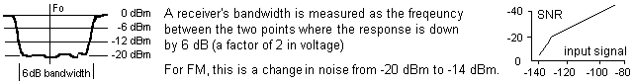

**Post Lab:** Plot your data of audio noise output levels (comparable to SNR for an FM receiver) in dBm (starting at 0 and going upwards to – 40dBm as pictured above) against the signal generator RF input level in dBm (as in the above graph) to see the improvement in SNR as the carrier power level increased. Was it linear? There should be a knee which shows the FM threshold effect, below which, small improvements in signal produce a rapid improvement of output SNR. This is the advantage of FM in providing superior quality signals above a certain minimum threshold (significant SNR improvements gained by modest improvements in carrier power). Plot the part 9 selectivity data to determine the useable bandwidth of your receiver. Comment on the spacecraft electrical power required to support this receiver in contrast to that of a spacecraft transmitter.

The sketch below is one thing we want you to learn from this lab. This chart is the typical way of showing how FM is superior to Linear modulation, (but only above a certain “FM threshold”), then you achieve better signal to noise ratio of recovered signal than you have in raw carrier to noise input or linear systems.

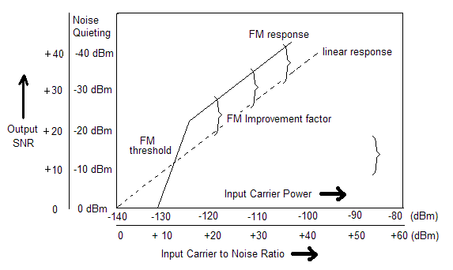

You made measurements not in output SNR, but in dB of noise quieting. Your input signals were in terms of dBm out of the signal generator. Convert them to SNR as shown above, and then your plot should have the characteristics similar to the sketch above…

**Part C. Sun, Galactic and Terrestrial Noise:** The Link Equation allows you to calculate the Power Received (PR) but this tells you nothing about the usefulness of this signal. The limit to how much you can amplify a weak signal depends on how much stronger it is than all other contributing noise sources. That is why we use the Signal-to-Noise Ratio (SNR) as the actual measure of receiving performance. Often 10 dB or more of SNR is required for good communications, but values as low as 2.2 dB are possible with extreme processing methods (you will look at modulation methods in the next lab). Recall the Equation for SNR:

SNR = PR / No  or: SNR = PR – No (in dB)

Significant Noise contributors are the noise of the receiver itself, thermal noise of components and cables plus the noise from the Sun, ground, and Galaxy. Thermal noise is given by the Thermal Noise Equation:

$$N_{o}=KTB$$

Where K is Boltzmann’s constant, T is the temperature in Kelvin and B is the bandwidth of the receiver (Hz). Clearly a wider bandwidth receiver lets in more noise.

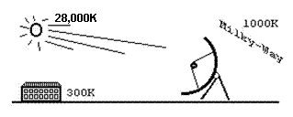 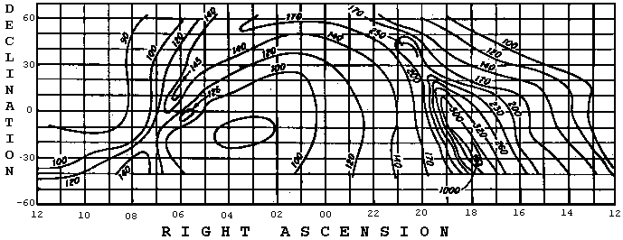

**Procedure:** Use the 5’ black dish configured for 4 GHz TV signals (down converted to 1000-1400 MHz). on the Rickover Plaza. The dish is connected to a satellite TV monitor and a Spectrum Analyzer (SA). Tune the SA to 1200 MHz and 100 MHz/div and observe the signal level on the display. Set the TV receiver with the squawker ON so you can hear the signal levels. This is handy for aligning the dish. Find a satellite on the GEO arc. The Chapel dome is due south. Note, that this receiver system LNA is supposed to have an equivalent noise temperature of 70K. This means the LNA adds the equivalent noise as a resistor at 70K. The ground and surrounding buildings are at roughly 300 K. The average Sun Noise Temperature at 4 GHz is typically about 28,000K, so you can see that it is quite easy to detect with our simple antenna. For easy comparison, just use the relative digital signal strength indicated on the TV receiver display for your comparisons below.

***Warning: BE CAREFUL! Do not let the antenna drop down against the mount or wrap around it***

1. Point the dish off to an area of cold sky (i.e. not at the sun, a building, or at the GEO arc) and record the minimum signal level at a middle frequency around 1200 MHz. This is the noise floor of the feed/LNA/downconverter (at 70K) plus any Galactic noise in that direction. If the receiver electronics were cooled to near absolute zero, then the receiver noise would be less and the only noise we would see would be the background cosmic radiation near 3K.
2. Have your partner place his/her hand directly in front of the feed point. You should see a noise increase because your hand is at about 310 K. Post lab, calculate the Noise power (N) for your hand in the receiver bandwidth of 30 MHz.
3. Point the dish towards a building (Rickover or Nimitz) and take a new look at the average noise floor at 1200 MHz. You should be able to see the noise increase due to the 300K noise temperature of the building.
4. Point towards the GEO arc (Southwest towards Maury and up about 40 degrees). You should be able to peak on a satellite and see several signals in the spectrum. Record the peak power of several of the largest. Observe how high they are above the noise levels you observed before.
5. Next, while avoiding the GEO arc if possible, point the dish at the Sun and peak for the maximum increase in the noise displayed on the bar graph. (Look at Sun’s shadow at the center of the dish). You might find this increase is not as much as you anticipated from a 28,000K source. Even though the Sun is very hot and noisy, remember that it’s cross sectional area is only about 0.5 degree compared to the 4 degree beamwidth of our antenna. Whereas with the dish pointed at the ground or Michelson, or your hand, the entire field of view was seeing 300k. How much does the reduced .5 degree view factor reduce the noise power from the Sun (in dB) compared to the 4 deg wide antenna beamwidth? (hint, simple geometry)
6. Another noise source is the center of our Galaxy. In the fall, our galactic center (Milky Way) rises about 12 PM in the East. Then you can point the dish at Sagittarius (a strong radio noise source) and detect its noise peak at the galactic center. If you are back in Rickover this afternoon, come try it.

**Post Lab**: Compare the Sun and ground noise powers to the cold sky measurements in dB. Discuss your observations on sky noise sources and how this impacts the signal-to-noise ratio and Link Budget.

**Laboratory Report:** Your formal communications lab report will cover this lab exercise (transmitters and receivers) and the ***next two*** lab exercises on modulation types. Use the standard lab format for your report. Make sure to address aspects of this lab exercise that are highlighted throughout the procedure and discuss their implications to spacecraft design. Make comparisons between your observations and communications theory where appropriate in order to guide your reader to the correct conclusions regarding communications design considerations. Use data tables, figures and plots as necessary to support your conclusions.