**SATT4 Design Documentation. PUBLIC** (rev k)30 June 2016

Bob Bruninga, WB4APR

Rev k adds section on using PuTTy to configure it.

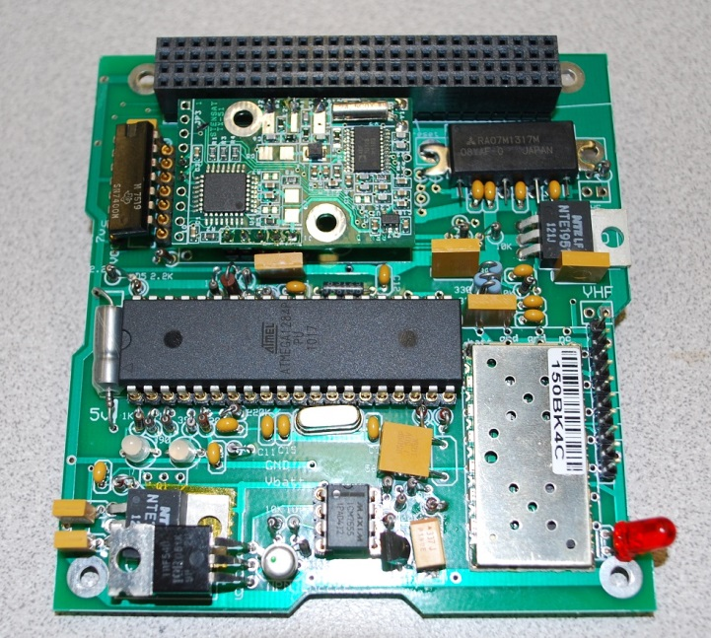The design goal of the SATT4 board is to be a low cost AX.25 and APRS compatible Cubesat comms board for telemetry, command, and control and to encourage Amateur Radio missions on student cubesats compatible with the worldwide network of volunteer ground stations. The comm board usually works on 145.825 MHz half duplex at 1200 baud to provide this compatibility with the APRS network while also providing for command uplinks and telemetry downlinks. This board also adds a CANSAT 9600 baud UHF downlink for higher data rate downlinks.

**The APRS mission** extends the ongoing AX.25 packet radio space relay network pioneered by the US Naval Academy (USNA) since PCSAT-1 in 2001[1] and subsequent spacecraft [2] [3] [4] [5]. These satellites are vital in the amateur satellite service to provide a remote date relay for student and amateur experimenters around the world. This mission also encourages young people to participate in STEM related education with hands-on access to satellites that all can use.

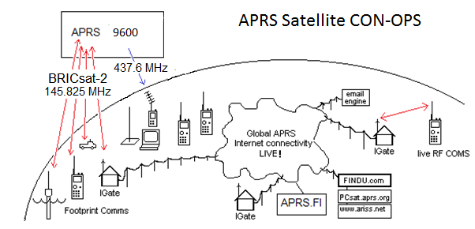

**SATT4 Specifications:** The SATT4 board’s VHF capability is a 2 Watt APRS transceiver capable of operating in the 2 meter amateur radio band. The board’s capabilities include the following:

* An APRS Digipeater function to relay user packets from uplink to downlink
* Five analog inputs for simple telemetry in a 1-minute beacon
* 8 digital output bits that can be toggled by ground control for spacecraft functions.
* A serial port for uplink and downlink between other boards and the ground
* An on/off Output bit and driver for an aux 200 mA load functions*
* A Heartbeat watchdog timer that power cycles the board if Telemetry every fails
* A password protected uplink command capability*
* A post-launch TX holdoff delay*
* A CANSAT 9600 baud high speed UHF downlink for data

**The SAT-T4 Cubesat System:**  The board uses the processor and VHF XCVR of the Byonics.com MTT4B transceiver on 145.825 MHz via the internal TXD and RXD serial lines and a CANSAT exciter for the UHF downlink available from http://www.stensat.org/.

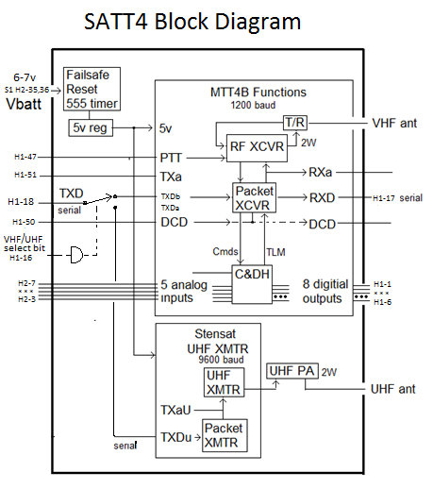

Figure 3: The SATT4 Inputs and Outputs

**SAT-T4 APRS Comms Board:** This comms board evolved from the MTT4B communications board available from Byonics.com. The MTT4B has been flown by USNA before on the PSAT-1 in May 2015. The MTT4B has all of the functional capabilities that are needed for the PSAT-2, however the dimensions of the MTT4B will not fit on the desired 10cm by 10cm satellite. Because of this, a new design was needed where the components of the MTT4B were rearranged to fit on a 10 cm x to cm board, and is shown below in figure 4. In addition, the 9600 baud UHF CANSAT module was included as well. The schematic is shown in Appendix A.

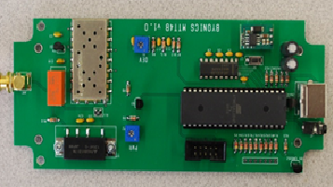

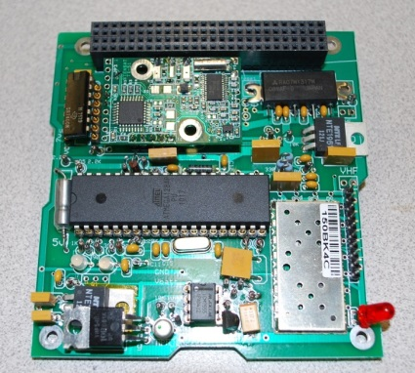

Figure 4. Layout challenge to reduce MTT4B Comm system to a Cubesat-104 board

**SAT-T4 Dual Bank Switching:** The SATT4 can be programmed with two separate operating configurations or banks as detailed in Appendix B. The main use of this feature is to enable and disable digipeating. The configurations in Bank0 and Bank1 are switched on the condition of the JP1 bit (the 5th Telemetry channel input). By strapping one of the uplink command bits (!OUT $20) to the channel 5 telemetry input via a diode pulldown can give BANK 1 select underground control. When the bit is high (normal ops), the same pin can be used for an analog Temperature Sensor purposefully biased high so that it can never have a value that can pull the bit too low to cause the bank switch.

**Bank 0 - TOCALL=APOFF: Bootup mode with minimum power. Ch5 is valid.**

**Bank 1 - TOCALL=APDIGI: normal, Digipeater ON, TLM Ch5 is meaningless**

The Bank-switch pin is JP1 which is also the 5th telemetry channel. Testing showed that the switchover point is about 460 out of the 999 possible telemetry range (almost half way) and that a 10k pull-up with a 7k pull down would not switch, but a 6k pull down would. To use one of the thermistors as the switch, we added a 10k in parallel to the thermistor to always keep it higher than the threshold and changed the R2 pull down to a 22k instead of a 10k to let it go higher and still be above this threshold. Then the $20 OUTPUT bit can pull it low to make the switch (and temperature is undefined in that state). But when the $20 bit is floating or high, then the thermistor can be read thought it will need a its own calibration curve sinc counts will only be from about 700 to 999 over the temperature range.

**SATT4 Telemetry:** The SATT4 board includes an inherent 5 channel analog telemetry capability. These 5 channels report voltages from 0 to 5 volts as a count from 0 to 1024. The typical use of these channels are shown here.

|  |  |  |  |  |
| --- | --- | --- | --- | --- |
| Channel | Function | Pin # | Cubesat Bus | Notes |
| Ch 1 | System Voltage | PA7 / 33 | H2-7 R1/R2 On Comm board |  |
| Ch 2 | System Current | PA6 / 34 | H2-6 External |  |
| Ch 3 | Temp-SATT4 CPU | PA5 / 35 | H2-5 thermister on comm brd |  |
| Ch 4 | Temp-EPS | PA4 / 36 | H2-4 External |  |
| Ch 5 | Tbatt and Bnk-Sw | PA3 / 37 | H2-3 External but also bankSW | Shared with Bank switch |

**SATT4 Telemetry Formats:**

The downlink from the SATT4 can contain three internal SATT4 generated packets; the fixed BText, the fixed LTEXT and the 5 channel Telemetry. In addition, the downlink can contain ANY type of any other packet format sent to it from any other processor on the spacecraft. In addition the downlink will also contain any USER digipeated packets if the digipeater BANK is enabled.

SATT4 telemetry: PSAT-2>APRSAT,ARISS:T#SSS,111,222,333,444,555,10101010

SATT4 BTEXT: PSAT-2>APRSAT,ARISS:any fixed BTEXT you want to go here

SATT4 LTEXT: PSAT-2>APRSAT,ARISS:any fixed LTEXT you want to go here

Other CPU data:: PSAT-2>APRSAT,ARISS:Any other CPU data goes here

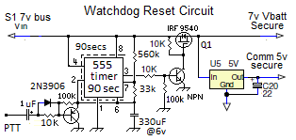

**Watchdog Timer Reset Circuit:** A special circuit is added to the comms board to recover the comms board from SEU events and latch-up and to reboot the comms board via a 2 second power-cycle whenever the 1 minute telemetry is lost. This circuit consists of a 555 timer chip and transistor switch to the input of a DC/DC regulator. The 555 chip is rated to 12 volts so a pair of series 0.7v diodes reduces the supply voltage into the safe operating range.

**5V Regulators:** The SATT4 contains a 555 Watchdog timer circuit and FET switch that will cycle power to the Vbatt bus if the SATT4 1 minute telemetry is lost. All circuit cards in the spacecraft with chips and processors can run from this protected Vbatt power and can be recycled in case of latchup or single-event-upsets in space. A second low-dropout regulator powers the separate higher power input of the power amp stages of the transmitters directly from the battery lines since these passive componnents are keyed on and off and do not latchup..

**The SATT4’s Power Budget** is shown in Table 1. The SAFE mode currents represent the always-on loads on the spacecraft. The additional columns show the total load current in the additional modes. Currently the budget shows that not all modes can operate full time.

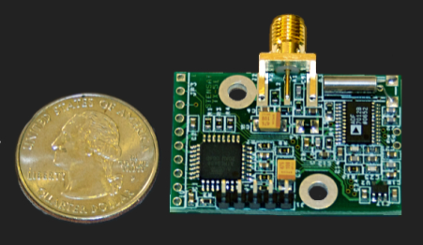SubFunction Current Duty Safe mode Operate

--------------- --------- ------- ------------ ---------

SATT4 RX 120 mA 100% 120 mA 120 mA

SATT4 TLM 750 mA 2% 15 mA 15 mA

UHF TX stby 20 mA 100% 0 20 mA

UHF XMIT 750 mA 2% 0 15 mA

------------------------------------------- ---------- ----------

Totals 135 mA 170 mA

CANSAT UHF transmitter

One power-saving technique being considered is to have a summary Sun bit that indicates dayside and night side operations*. About 10 minutes (TBD) after entering eclipse, the spacecraft will be near local midnight to users below and this bit can be used to power down user support systems. These systems then power back up at sunrise about 10 minutes later to be ready for user load. This saves about 10% of user load power (10 out of every 90 minutes).

**High Speed UHF Downlink:** The SATT4 board also includes a UHF 9600 baud downlink CANSAT transmitter made by Stensat with an added UHF power amplifier. The H1-18 TXD data line from the Cubesat is switched from the default 1200 baud VHF transmitter to the UHF 9600 baud transmitter when the H1-16 Select bit is pulled low. The TXD line is TTL level and is always operated at 9600 baud.

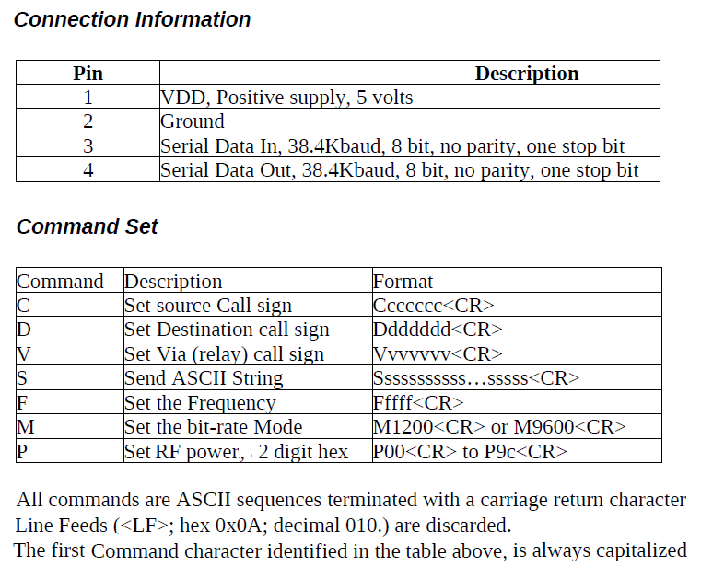

**UHF Downlink Format: Note,** The factory assembled CANSATs operate with a TTL input of 38.4 kBps and a channel rate of 1200 baud. We special ordered CANSAT modules set for 9600 baud TTL inputs though the channel rate still defaults to 1200 baud.. The command to change channel rate is M9600. The serial port rate cannot be changed. Any data to be transmitted on the UHF dowlink must have the first character be an “S” (for send) and be terminated with a <CR>. Any other character may be interpreted by the CANSAT as setup commands that can possibly scramble the CANSET settings. The CANSAT module commands are as shown above.

**To Transmit on VHF:** 1) Float or HIGH on H1-16

2) Send any data on the H1-18 serial TTL TXD line

3) End each line with a <CR>

**To Transmit on UHF:** 1) Ground or LOW H1-16

2) Send “M9600” once on H1-18 serial line

3) Send all subsequent

**SATT4B Uplink Command BITS:** The SATT4B has 8 uplink command configurable output bits ($XX). The $02 (internal) and $20 bank-select bits are already used. The rest can be defined for payload use. NOTE: The output bits are initially tri-state, meaning they are floating at a high impedance. It is best to design all control circuits to default to HIGH to match this condition and to be pulled low when commanded. As soon as any !OUT $XX command is sent, however, they are forced high and low as defined by the bits in the $XX command. So careful thinking is required. IE, a $00 command would turn on ALL FUNCTIONS at once. Conversly, a $FF command is benign because it simply switches the output bits from floating-to their default HIGH state. Then commanding of individual bits should be considered as subtracting from the $FF condition. Also, always keep the $02 bit high since it is used internally. And be careful of the $20 bit because it causes a bank switch and that might change the callsign for subsequent commands. The future flight SATT4 firmware allows these commands to be protected by a password system*.

SATT4 command !OUT $XX bit designations **–**

|  |  |  |  |  |  |  |
| --- | --- | --- | --- | --- | --- | --- |
| Function | Bit | MTT4-B  I/O Pins | SATTT4B  Functioin | Wire  Use | Fig LLL. I/O Pin diagram | BS2  Pin |
| Tristate, floats before first cmd |  |  |  |  |  |  |
| $00 all functions off |  |  |  |  |  |  |
| $01 TBD | 1 | 22 / PC0 |  |  | 1 | 8 |
| $02 SATT4 intl (xcvr setup) | 2 | 23 / PC1 | Sets RF Freq |  | 2 | 9 |
| $04 TBD | 3 | 24 / PC2 |  |  | 3 | 10 |
| $08 TBD | 4 | 25 / PC3 |  |  | 4 | 11 |
| $10 AUX board PwrON | 5 | 26 / PC4 | Voice Pwr-on |  | 5 | 12 |
| $20 Bank switch (only) | 6 | 27 / PC5 | Voice Audio |  | 6 | 13 |
| $40 TBD | 7 | 28 / PC6 |  |  | 7 | 14 |
| $80 TBD | 8 | 29 / PC7 |  |  | 8 | 15 |

**SPECIAL FIRMWARE REQUIREMENTS FOR SATT4**: These ideas will hopefully be negotiated with Byonics as we get closer to flight and if they think the SATT4 is a good project.

1. A post-launch hold-off delay? (5 to 45m)?
2. Possible on/off BIT control of the GPS switch
3. Possible usage of the PD7 bit?
4. Possible XCVR settings for PL, squelch or power saving?
5. Password match string protection on the !OUT command
6. Are there any other unused bits? If so, they could be used to de-conflict the use of the $02 bit (XCVR control) and the JP1 analog input conflict with analog telemetry.

**Configuring the SATT4 Settings:**

To configure the SATT4, connect a PC serial port via an RS232 to TTL converter to the TXD and RXD pins on the GSE connector 3rd and 4th pins up from the bottom (pin 2 is Gnd). The converter we used also needs 5v to power it so the 7th pin up provides that power. Prepare PuTTY to operate at 19.2 kbps.

Power up the SATT4 board and within the first 3 seconds you will see the message “Hit ESC three times to go to setup”. If you do that correctly, you will get the SATT4 prompt. At this point, you can type any of the commands (without their parameters) as shown in Appendix B to see the current settings. Be careful. Any change you make will be remembered.

Once you have finished checking or changing parameters, you can cycle power to return to normal operations or you can type the QUIT command. Remember, during normal operations the baud rate will be whatever is in the ABAUD and BBAUD commands. The 19.2 kBaud is only required for entering the settings mode in the first 3 seconds.

A complete list of all commands is in the byonics.com doucmentation for the MTT4B or the TinyTrack 4.

References:

[1] <http://aprs.org/pcsat.html> The original USNA APRS Satelliet PCSAT-1

[2] <http://aprs.org/pcsat-2.html> PCSAT-2 flew attached to the ISS in 2006

[3] <http://aprs.org/ande.html> ANDE Deployed form the ISS in 2006

[4] <http://aprs.org/raft.html> RAFT Deployed from the ISS in 2006

[5] <http://aprs.org/psat.html> PSAT-1 deployed in May 2015

Appendix A:

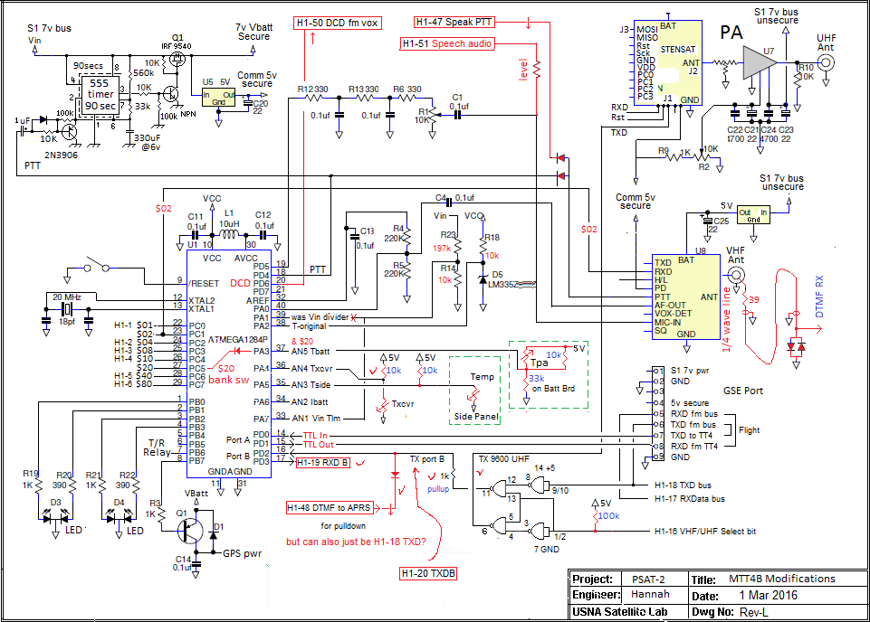

**\* - FOUO - \***

**Appendix B**. Setup and Programming commands for SAT-T4 Processor v0.70

For flight units wen now default digipeating to OFF. Reversing Bank1 and 0

Command Default BANK0 BANK1 (same as Bank0 except…)

---------------- --------------- ------------------------------- ----------------------------------------------

MYCALL NOCALL PSAT-2 PSAT-12

ABAUD 19200 9600 * (* means same)

ALIAS1 TEMP QKSPCL APRSAT

ALIAS2 % none ARISS

ALIAS3 % none WIDE

ALTNET APTT4 APDTMF APDIGI

AMODE Text text *

BANK 0/1 0 0 1 🡸 set during programming

BBAUD 4800 9600 *

BMODE GPS text *

BNKMODE 0 1 * 🡸 uses JP1 for bank switching

[uses PA3, CPU pin 37, J3?]

BPERIOD 0 175 * <a 3 minute beacon text>

BTEXT >TT4 alpha >DTMF-W3ADO CQ APRStt >DIGI is on, APRStt

CDMODE Tones ***Inverted -pin2 * <J1 pin 2 [CPU pin 20] to holdoff XMT>

DIGIID true true * <inserts MYCall in digipeated packets>

DIGIMY false TRUE *

DUPETIME 30 10 *

HEADERLN false false *

LEDS true true *

MSGCMD false true * <allows !OUT $xx commands to BS2 CPU >

NODISP false true * <Required for $xx PortC msg commanding>

PATH1 WIDE1-1 ARISS (via ISS) *

PATH2,3 WIDE2-1 (none) *

PKTICOM true true * <Enables received packets to PC text port>

PKTOCOM False true * <Lets hiSAT see our TX packets also>

PPERIOD 0 0 * <posit Prd (In sec), not used on QIKcom2

RXAMP 5 5 5 * <RX gain. Use MONITOR mode to adjust>

TELHIRES true true * <enables 0-999 values>

TELVOLT true False *

TELTEMP true False *

TELREAD true False * <Turns off human readable telemetry>

TPERIOD 0 60 * <Telemetry Period >

TXD 40 30 * <20 = about 150ms>

TXLEVEL 128 128? * <TBD for flight>

TXTWIST 50 50? * <TBD for flight>

TXFREQ 144.39 145.825 * <REUIRED IAW IARU!>

RXFREQ 144.39 145.825 * <REUIRED IAW IARU!>

Appendix C

The definitions of the pins of the Cubesat bus used by the SATT4 are indicated in the notes across the top. The command bits are on the left. Then the analog bus pins, some serial data pins then the battery and separation switch bus. Finally, on the right are four User defined pins and the six special user pins used for our particular PSAT-2 which have to do with sharing data and TX audio with the DTMF/Voice system.

