**Instructions & Methods for Digitizing AVA Boundaries**

1. Download the Federal Register document for your AVA of interest here: <https://www.wineinstitute.org/resources/avas> Note that the “Authorities” or “Authorities & Issuance” Section has the following subsections with information you will need later:
   1. Name - the official name of the AVA
   2. Approved Maps - the maps you should use for digitizing the AVA. Pay specific attention to the year or any other modifiers to the map(s) indicated.
   3. Boundaries - the description of the outline you will digitize.
2. Download the Approved Maps (again, pay attention to the year):
   1. Go to the USGS National Geologic Map Database’s topoView: <https://ngmdb.usgs.gov/maps/TopoView/viewer>
   2. On the right side of the map in the Map Scales box, select the scale of the Approved Map.
   3. Zoom into the general region of the AVA, and the names of the maps will appear inside the index bounding boxes.
   4. Select the map of interest by clicking inside the box.
   5. On the lower left of the window, a dialog box should appear with details about the map you selected. On the right side of this dialog, a section will indicate how many maps are available for the area. For example, the Mount George quad near Napa says “5 Maps”. Click on the number to see details about the maps available.
   6. On the table that appears, you will see a column for “Date” and another for “Edition”. Click on the date and edition that corresponds to the Approved Map listed in the Federal Register document.
      1. For example, one of the Approved Maps for the Coombsville AVA is listed as “Napa Quadrangle, California-Napa Co., 1951, Photorevised 1980”. For this map, select the Napa map with a date of 1951 and edition of 1980.
      2. In the event that the specific year for the Approved Map is not available, you may need to download one or two maps that are of a similar age and determine which has the landmarks indicated in the description.
   7. Make sure the text in the dialog reflects the map you want to download, then click the GEOTIFF download option.
   8. Save the file to your local computer. The file saved will be a zipped folder containing GeoTIFF files.
   9. Navigate to the folder where you saved the file. Right click the file and select “Extract All”. Browse to the folder you would like to unzip the folder to, then click the “Extract” button. The new unzipped folder should contain 4 files.
   10. Repeat all the substeps for Step 2 for each of the Approved Maps needed for your AVA before you move on to the digitizing process in Step 3.

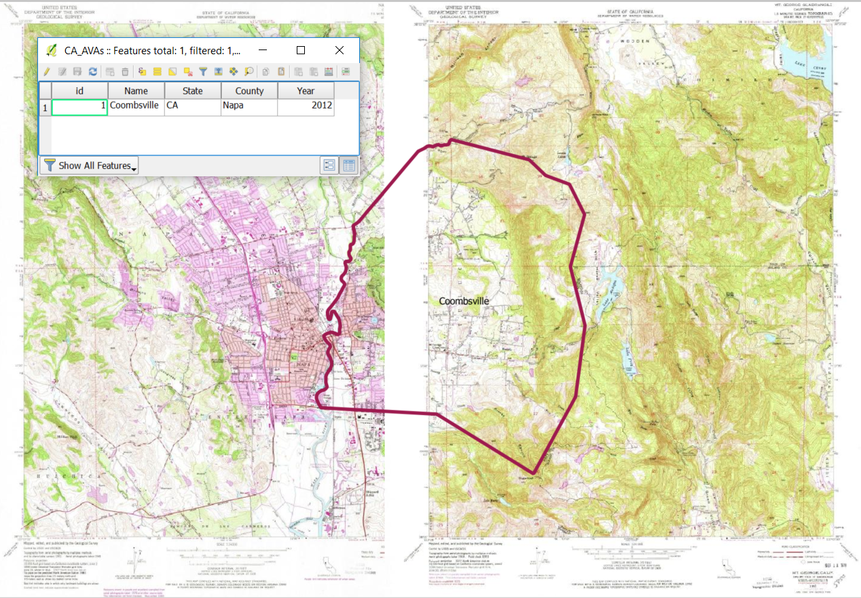

1. Get the most recent project files from GitHub. (We’ll describe how to do this with the GitHub for Desktop tool, but you may use the tool of your choice. We’ll also assume you’ve already set up your GitHub account and the GitHub for Desktop program.)
   1. Open GitHub for Desktop
   2. Select the AVA repository on the left sides of the window.
   3. From the menus at the top, either create a new branch and name it for the AVA you are working on (or select your existing branch from the dropdown menu). Click the Sync button on the right side of the window.



* 1. Updated data should now be available in your GitHub folder.
  2. Navigate to your GitHub folder and open the AVAs folder. Inside the AVAs folder, make a copy of the TEMPLACE_AVA.geojson and rename it with the state abbreviation, an underscore, and the AVA name (e.g. CA_Coombsville.geojson). This is a blank file with the attribute table already made.

1. Digitize the AVA Boundary based on the Boundaries description in the Federal Register document:
   1. Open QGIS
   2. Load data:
      1. All.geojson
      2. Your new AVA geojson file
      3. Approved Maps
   3. Set Parameters:
      1. Projection
         1. Open the Project Properties (Project menu → Project Properties)
         2. Set the Coordinate Reference System to NAD83 (EPSG:4269)
      2. Snapping
         1. In the Layers Panel (Table of Contents), select the all.geojson layer.
         2. Open the Snapping Options (Settings menu → Snapping Options)
         3. Set Layer Selection to “Current Layer” (the all.geojson layer you selected earlier in the Layers Panel), Snap To “To Vertex and Segment”, Tolerance to 20 Pixels (adjust this as needed), and finally check the boxes for “Enable topological editing” and “Enable snapping on intersection”.
   4. Toggle Editing on for the new AVA GeoJSON file.
   5. Add new polygon with the Add Feature tool.
   6. Digitize the boundary adding vertices according to the Federal Register Boundary description at a scale sufficient to identify the features needed from the topoquads. You can switch between the Add Feature tool and navigating tools as needed. Right click to finish. Note that as you near the edge of a map, you may need to turn off or reorder some of the maps to adjust for the white edges of the scanned maps that obscure the maps underneath.
   7. Fill out the attribute data (at minimum you must add the AVA’s name) in the window that pops up.
   8. Save Layer Edits.
   9. Toggle Editing off.
   10. Close QGIS if you’re done making new AVAs, or start over from Step 3e above to make another.
2. Update the all.geojson file to include your new AVA:
   1. Open R or RStudio.
   2. Load the mergeGeoJson.R file
   3. The first time you use this file, you’ll need to install the raster and geojsonio packages.
   4. In the console, set your working directory to your AVAs folder in your GitHub folder. Example: setwd(“C:\\Users\\yourusername\\Documents\\GitHub\\ava\\AVAs”)
   5. Run the mergeGeoJson code.
   6. Load all.geojson into QGIS to make sure your new polygon is in the file and has an entry in the attribute table.
3. Submit your changes to the AVA GitHub Repository
   1. In GitHub for Desktop, you should see a list of changes you’ve made to the files. Fill in the Summary and Description fields at the bottom of the window and then click the Commit button.
   2. If you are ready to incorporate your changes into the main branch, submit a pull request for your branch.

Additional Reference Material:

1. QGIS editing geometry manual: <http://docs.qgis.org/2.14/en/docs/user_manual/working_with_vector/editing_geometry_attributes.html>
2. Understanding the GitHub Flow: <https://guides.github.com/introduction/flow/>
3. USGS Topographic Map Symbols: <https://pubs.usgs.gov/gip/TopographicMapSymbols/topomapsymbols.pdf>

-----------------------------------------------------------------------------------------------------

Considerations for post-processing:

1. Densify the lines for areas with large distances between points so when people re-project the file it won’t distort.