BDMDM Course Project Report


Return Data Analysis of an E-Commerce Platform
Submitted by
Group 4
Sec - B

Name
Protik Das
Satyabrata Singh
Shekhar Yadav
Abhisek Samantaray
Aishwarya Pratap Singh

Summary
Between January 2024 and 14 November 2025 the platform recorded 4,066 returned orders out of 20,000: 20.3% of all orders, or 25.3% of orders that were not cancelled. They carry $2.43 million (20.4%) of order value, about $1.30 million a year. We asked what drives these returns and which decisions would reduce them cost-effectively.
The data cannot answer the first question, and the return label itself fails a basic validity check. Orders placed more than six months before the data ends are still "processing" or "shipped" 40.2% of the time, the same share as orders placed in the last month; in a working order system those statuses resolve within weeks. Groceries return at 20.4%, the same rate as clothing. Consistent with a label that carries no information, every test finds returns indistinguishable from a constant 20.3% chance per order: chi-square tests with power analysis, six classifiers plus regularised, resampled and tuned variants benchmarked against 200 shuffled-label models, three clustering methods, association rules, binomial and runs tests, control charts, and an independent re-run in Better Analyst. The tests could have found any category, brand or month returning 5 points above average, and any value band or gender 3 points above.
This rules out the usual targeted playbook (stricter windows for "high-return" categories, surcharges on large orders, blocking "serial returners") and means the 20.3% rate should not be used as a KPI until it is validated. We recommend three decisions:
- Fix the record first (weeks 0–4). Reconcile order_status with warehouse, courier and payment systems, and capture the eight return fields in the data contract (Section 7).
- Fund no-regret recovery now. Refund without collection below $23.50; inspect and grade returns above $1,000, which are 18.6% of returns but 59.6% of returned value. Halving write-off on that tier is worth about $42,000 a year net, whether or not any return is prevented.
- Gate prevention spending on evidence. Under base-case cost assumptions, a $50,000 prevention programme pays back only if it removes about one return in five (a 4.3-point cut, or 2.5 points if retained margin is counted). Pilot prevention only for return reasons the new codes show are large enough, randomised at the level where each fix operates.

1. Problem statement: why returns matter
Returns are one of the largest hidden costs in e-commerce. Each one pays for shipping twice, needs handling and inspection, often cannot be resold at full price, and ties up refunds. On this platform returns are as frequent as completed orders (20.3% vs 20.1%), and 38.8% of buyers (3,353 of 8,635) have returned at least one order. The project began as a customer-retention study, where our churn model found real signal (ROC-AUC 0.67). We moved to returns because they are a concrete, operational lever that directly reverses revenue.
Definitions used in this report
Return rate = returned orders ÷ all orders (20.3%), used throughout so every test shares one base. Because only delivered orders can be returned, the operational rate is higher: 25.3% of non-cancelled orders and 50.3% of orders with a final outcome (returned or completed). Orders still "shipped" may yet be returned, so all rates are right-censored. Money is in the dataset's currency ($); figures that rest on assumptions are labelled.

Research question: What drives order returns on this platform, and which decisions would reduce them cost-effectively, whether or not a driver can be found in the data? Before any return-specific test we wrote down five hypotheses from how returns arise in retail: H1 product (some categories or brands return more), H2 price and basket (expensive or large orders return more), H3 customer (new customers, segments or serial returners), H4 experience (complaints predict returns) and H5 timing (returns peak in some months or days). We followed CRISP-DM from business understanding to deployment.

2. The dataset
Table | Rows | Key fields | Used for
orders | 20,000 | order_date, order_status, total_amount | Target (returned) and order value
order_items | 43,525 | order_id, product_id, quantity, item_price | Basket size and composition (H2)
products | 2,000 | category (10), brand (12), price, rating | Product features (H1)
users | 10,000 | gender, signup_date | Customer features and tenure (H3)
reviews | 15,000 | rating (1–5), review_text, review_date | Experience signals (H4)
events | 80,000 | event_type: view, cart, wishlist, purchase | Engagement vs returns (H3)
Table 1. Six linked tables covering 1 January 2024 – 14 November 2025, joined on user_id, order_id and product_id.
Target. returned = 1 when order_status = "returned", else 0 (4,066 positives; about 1 : 4 imbalance). Unit of analysis. Orders (20,000) for tests and models, customers (8,635 buyers) for behaviour, products (2,000 SKUs) for product risk. Derived features, one row per order: line items, units, distinct categories, highest item price, mean catalogue rating, dominant category and brand (highest-value line), value quintile, customer order number, tenure, gender, month and weekday. At customer level we added recency, frequency, monetary value and average order value (RFM).
How the data can be used. The tables support three analyses at once: descriptive and diagnostic analysis of where returns occur, predictive modelling of which orders will be returned, and prescriptive sizing of what intervention is worth funding. What is missing: return reason, return and refund dates, refund amount, item condition, courier, warehouse, payment method and delivery attempts. Section 3 shows this gap matters more than anything in the data.

3. Descriptive analysis and data preparation

3.1 Missing and noisy values
All six files are complete: no null cells, no duplicate rows, unique keys and perfect referential integrity; line totals equal quantity × price and order totals equal the sum of their lines. None of the standard missing-value treatments was needed. The data problems are noise and inconsistency, handled as follows:
- Skew. Order value is right-skewed (median $308, mean $596): log-transformed for distance-based methods (kNN, K-means, DBSCAN, LOF) and binned into equal-frequency quintiles for contingency tests.
- Impossible dates. 49.7% of orders predate the customer's signup and 49.7% of reviews predate their order. Orders were kept (their return rate matches the rest); tenure was flagged as noisy and review timing was not used.
- Partial month and unusable fields. November 2025 (14 days) was excluded from time series. Name and email were dropped as identifiers, and city because it has 7,755 values for 10,000 users.

3.2 Descriptive summary
The status mix is almost perfectly even: shipped 20.6%, returned 20.3%, completed 20.1%, cancelled 19.6% and processing 19.4%. Returned and kept orders look identical: mean value $597 vs $596, 2.2 lines each, customers with 3.0 orders each. Returned value is skewed: median $300, top quarter above $770, and 758 returns above $1,000.

3.3 Validity audit: does order_status measure what it claims?
Before trusting a target we checked whether it behaves as a real operational field would. It does not:
Check | What a working system shows | What this data shows
Status by order age | Processing and shipped resolve within days or weeks | 40.2% of orders older than 180 days are still processing or shipped, vs 40.3% of orders under 30 days
Status mix | Dominated by completed orders | Five statuses at 19.4%–20.6% each
Return rate by category | Groceries far below apparel | Groceries 20.4%, clothing 19.9%
Date ordering | Orders after signup; reviews after orders | 49.7% of orders before signup; 49.7% of reviews before their order
Review text | Free text | Ten fixed sentences, about 1,500 uses each
Browsing funnel | Views lead to carts and purchases | 33 of 55,920 viewed user–product pairs were carted; 8 of 4,006 purchase events match an order
Prices | Discounts and price changes | Item price equals catalogue price on all 43,525 lines
Table 2. Validity checks on the target and linked fields.
There are two readings. Either the status was generated independently of everything else, as in a synthetic teaching dataset, in which case "no driver" is guaranteed; or the field is real but is not being updated, which is itself the first operational problem to fix. Both lead to the same conclusions: the analysis shows what this data cannot support, not how real customers behave; the 20.3% rate must be validated before it becomes a KPI; and the first action is data, not prevention. We still ran the full analysis, because it rules out targeted policies at known power and leaves a tested pipeline ready for real data.

4. Charts and insights
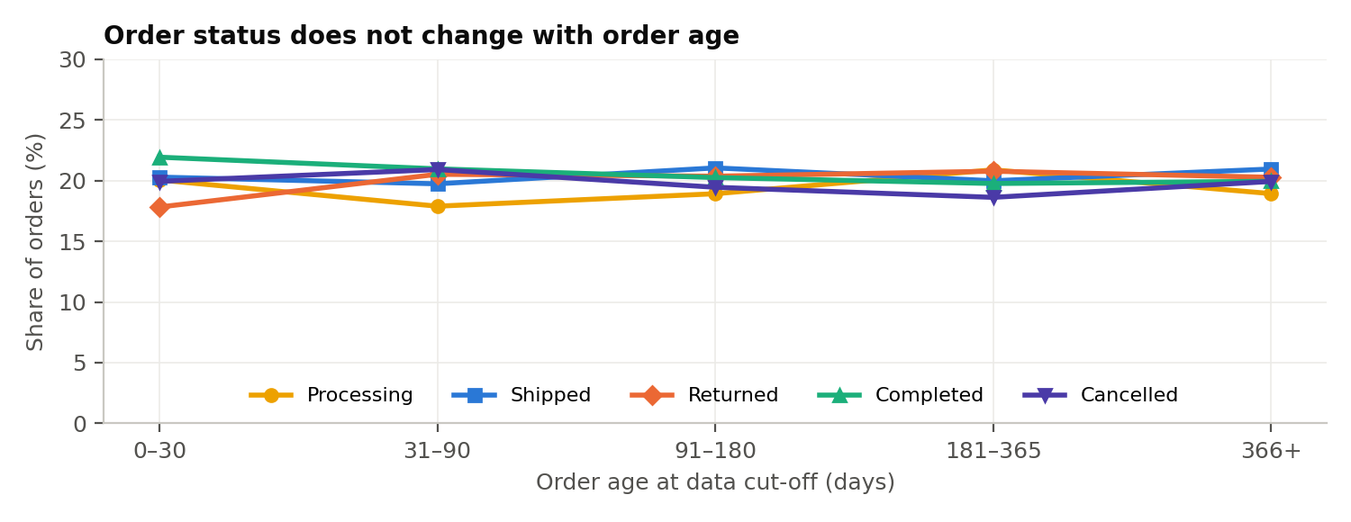
Figure 1. Status mix by order age. A real order ages from processing to shipped to completed or returned; here every line is flat.
Insight 1: the target is not a live operational field. Orders a year old are as likely to be "processing" as orders placed last week. This is the single most important chart in the report, because it decides how every later result should be read.
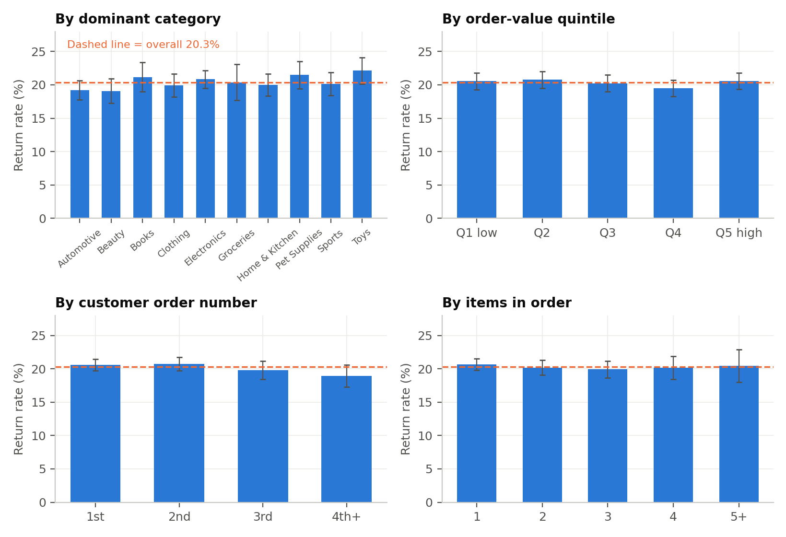
Figure 2. Return rate by dominant category, order-value quintile, customer order number and basket size, with 95% confidence intervals; dashed line = 20.3%.
Insight 2: no product, price or basket hotspot. Every bar's interval touches the average. Retail experience says clothing and electronics return most; here they return at 19.9% and 20.8%. The highest category, Toys at 22.1%, is still inside its interval.
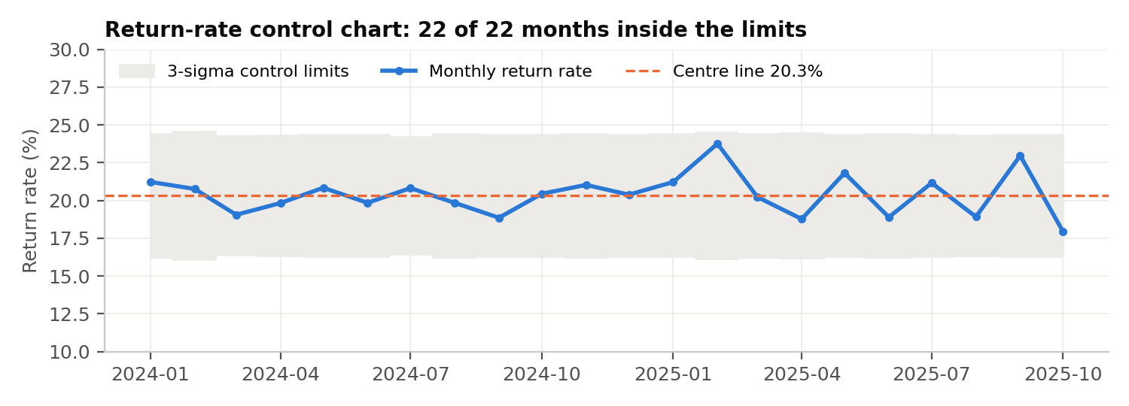
Figure 3. p-chart of the monthly return rate with limits p ± 3√(p(1−p)/n).
Insight 3: the process is stable. All 22 complete months sit inside their control limits (about 16.3%–24.4%), with no run of eight on one side of the centre line. Improvement therefore has to change the system every order passes through, not chase bad months.
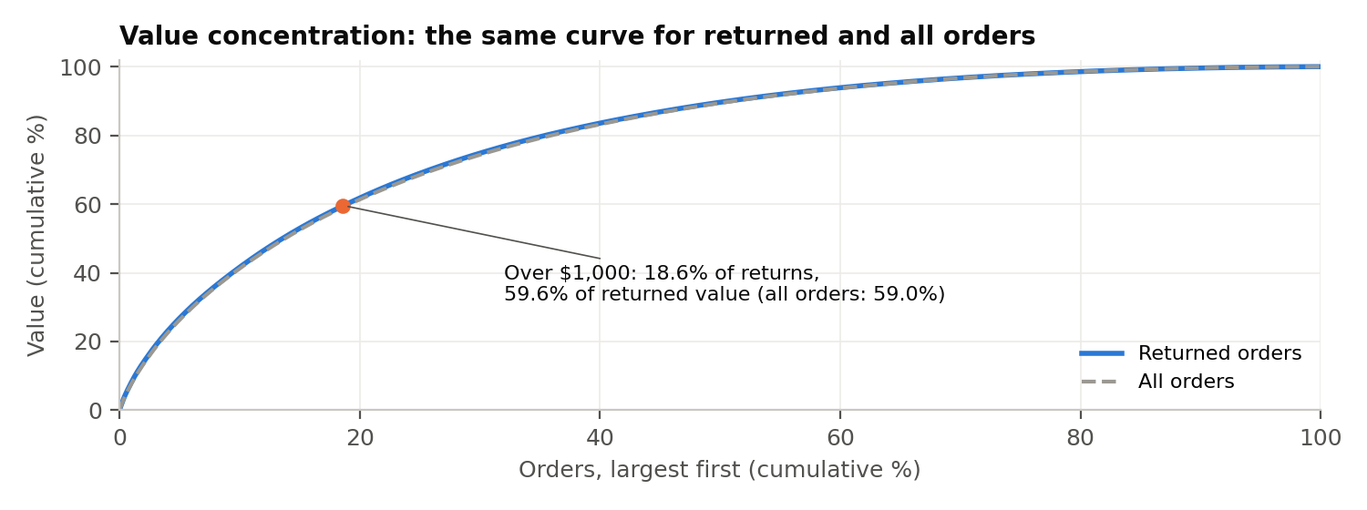
Figure 4. Cumulative share of value, orders sorted from largest to smallest.
Insight 4: the money is concentrated, but because of price, not behaviour. Returns above $1,000 are 18.6% of returns and 59.6% of returned value; for all orders the curve is identical (18.6% and 59.0%). That justifies tiering inspection by value, because that is where the money sits, but it is not evidence that expensive orders misbehave.

5. Techniques used
Module | Technique | Question it answers
1 Descriptive | Profiling, binning, chi-square, Cramér's V, Bonferroni, minimum detectable effect | Does the return rate differ by any attribute, and how large a gap could we have seen?
2 Unsupervised | K-means on RFM; hierarchical and DBSCAN; association rules; content similarity | Do segments, baskets or similar products return more?
3 Supervised | Logistic (L1/L2), tree, kNN, random forest, boosting, MLP; imbalance treatments; permutation test | Can returns be predicted better than chance?
3 Predictive | Naive, moving average, exponential smoothing, Holt, linear trend, MLP (back-tested) | How many returns should operations plan for?
4 Outliers | Isolation Forest, LOF, z-score; binomial, runs and dispersion tests | Are anomalies or serial returners behind returns? Is the label random?
Decision model | Expected-value cost-benefit with scenarios; power analysis for pilots | What is worth funding, and how would we know it worked?
Table 3. Techniques by course module.
Validation design. Models use a stratified 80/20 split (16,000 / 4,000 orders) and 5-fold cross-validation. ROC-AUC is the headline metric because accuracy misleads at this class balance: predicting "not returned" every time scores 79.7%. With ten attribute tests we used a Bonferroni threshold of p < 0.005, and every null test is paired with its minimum detectable effect (80% power) so that "not significant" reads as a bound. Better Analyst, an AI analytics platform, was given the same data and brief as an independent check.

6. Results

6.1 No attribute is associated with returns (H1, H2, H3, H5)
Attribute | Groups | χ² | p-value | Cramér's V | Observed range | Detectable gap
Dominant category | 10 | 9.84 | 0.363 | 0.022 | 19.1%–22.1% | 5.2 pp
Dominant brand | 12 | 11.88 | 0.373 | 0.024 | 18.8%–22.4% | 4.1 pp
Order-value quintile | 5 | 2.47 | 0.649 | 0.011 | 19.5%–20.8% | 2.6 pp
Items in order | 5 | 1.10 | 0.894 | 0.007 | 19.9%–20.7% | 4.7 pp
Customer gender | 3 | 2.65 | 0.265 | 0.012 | 19.8%–20.9% | 2.2 pp
Order month | 12 | 11.84 | 0.376 | 0.024 | 19.2%–22.3% | 5.0 pp
Day of week | 7 | 7.44 | 0.282 | 0.019 | 19.1%–21.6% | 3.0 pp
Customer order number | 4 | 4.27 | 0.234 | 0.015 | 18.9%–20.7% | 3.3 pp
Customer tenure at order | 4 | 2.45 | 0.485 | 0.011 | 19.6%–21.0% | —
Avg product rating band | 4 | 9.01 | 0.029 | 0.021 | 19.2%–21.2% | —
Table 4. Chi-square tests (n = 20,000). Detectable gap = smallest-group difference detectable at 80% power and α = 0.005.
No test clears the Bonferroni threshold and every Cramér's V is below 0.025, where 0.1 would count as weak. The rating band (p = 0.029) is the single nominal result expected by chance across ten tests (a 40% chance) and runs the wrong way. The power column turns "not significant" into a bound: no category, brand or month returns 5 or more points above average, and no value band, gender or weekday 3 or more.
Experience (H4). The rating distribution is identical on returned and kept orders (χ² p = 0.974; means 3.56 vs 3.54), and so is the review text (χ² = 4.33, p = 0.889). Complaints about damage, colour mismatch or quality make up 30.6% of reviews: 31.2% on returned and 30.4% on kept orders, so the quality issue is platform-wide rather than return-specific. With ten fixed sentences, real text mining was not possible. Browsing engagement is unrelated to a customer's return rate (all |ρ| ≤ 0.012, p > 0.28).

6.2 Returns cannot be predicted better than chance
Model | ROC-AUC | Accuracy | Precision | Recall | F1
Logistic regression (class-weighted) | 0.496 | 0.520 | 0.205 | 0.474 | 0.286
Decision tree | 0.500 | 0.496 | 0.200 | 0.494 | 0.285
kNN (k = 25) | 0.508 | 0.657 | 0.201 | 0.232 | 0.216
Random forest | 0.482 | 0.710 | 0.184 | 0.124 | 0.148
Gradient boosting | 0.500 | 0.676 | 0.203 | 0.203 | 0.203
Neural net (MLP) | 0.488 | 0.671 | 0.192 | 0.192 | 0.192
Baseline: flag every order | 0.500 | 0.203 | 0.203 | 1.000 | 0.338
Table 5. Holdout performance on 4,000 orders.
All six models land between 0.482 and 0.508 AUC, and none beats flagging every order on F1. Cross-validated AUC is 0.499 (±0.011) for logistic regression and 0.492 (±0.008) for the random forest. The decisive check is a permutation test: refitted on 200 shuffled versions of the labels, the noise models score between 0.484 and 0.517 (95% range), and 79% of them do at least as well as the model trained on real labels (0.495). Lasso keeps 2 of 33 coefficients with no loss of AUC. Class weights, oversampling and SMOTE lift recall to about 47% but precision stays at the 20.5% base rate: they move the threshold, they cannot create signal. At product level, return rates vary 0.999 times as much as binomial chance and regressions on price, rating, category and brand have negative cross-validated R². The random forest still ranks tenure, value and rating as "top features", a reminder that importances mean nothing until a model beats chance.

6.3 Customers, segments and baskets
Returns per customer | 0 | 1 | 2 | 3 | 4 | 5
Observed customers | 5,282 | 2,731 | 542 | 70 | 9 | 1
Expected if every order had a 20.3% chance | 5,300 | 2,698 | 551 | 77 | 8 | 1
Table 6. Returns per customer against the binomial expectation.
There is no serial-returner group. The binomial fit is almost exact, and the model predicts 38.6% of buyers would have at least one return against 38.8% observed. Only 18 customers are unusual at p < 0.01 ($35,078, 1.4% of returned value), within what chance produces across 8,635 tests. A customer whose last order was returned returns the next one 20.4% of the time, against 20.0% after a kept order (p = 0.74). Score-based watch-lists would chase luck: 42 customers score above 35% on a Bayesian propensity score, but a pure-chance simulation of the same customers produces about 47 (95% range 34–60); 19 "high-risk" SKUs compare with about 22 expected by chance (14–32).
Returns do not cost customers. Among orders at least 90 days before the data ends, 24.6% of returned orders and 23.4% of kept orders are followed by another order within 90 days (p = 0.13). The top 10% of customers hold 33.4% of order value and 33.6% of returned value. Segments and baskets add nothing: K-means on RFM (k = 4, silhouette 0.29) gives four clear segments with return rates of only 19.1%–20.9% (p = 0.195); Ward, complete-linkage and DBSCAN clustering find no returning segment beyond clusters of 6–25 customers; the 55 association rules {basket} → {Returned} have lift of 0.83–1.16; and Isolation Forest, LOF and z-score outliers return at 20.8%, 19.2% and 20.7%.

6.4 Time and forecast
Beyond the control chart (Figure 3), runs tests find no clustering by order sequence (p = 0.084) or time (p = 0.612), daily counts vary 0.90 times as much as binomial chance, and autocorrelation at lags of 1, 7 and 30 days is inside the noise band. Forecast: back-tested on May–October 2025, exponential smoothing and Holt cut mean absolute error to 15.6–15.7 returns a month against 20.7 for the naive method; the MLP was worst (26.7), overfitting 13 lagged training samples from 16 months. Smoothing forecasts about 182 returns and $108,000 of returned value a month; Better Analyst's linear trend gives about 180 returns and $97,000–$98,000. The gap is within back-test error, so operations should plan for 175–190 returns and $97,000–$108,000 a month.

6.5 Independent cross-check
Measure | Better Analyst | Our analysis | Agreement
Return rate / returned value | 20.33% / $2,426,918 | 20.33% / $2,426,918 | Exact
Chi-square: value, gender, month, weekday, order no. | 2.47, 2.65, 11.84, 7.44, 4.27 | Same | Exact
Category / brand p-value | 0.497 / 0.214 | 0.363 / 0.373 | Same conclusion
Review text χ² (p); mean rating kept vs returned | 4.33 (0.889); 3.542 vs 3.555 | Same | Exact
Classifier ROC-AUC range | 0.488–0.511 | 0.482–0.508 | Same conclusion
Unusual customers (p < 0.01) / value | 18 / $35,078 | 18 / $35,078 | Exact
Table 7. Better Analyst vs our pipeline. Category and brand differ only because Better Analyst defines the dominant line by frequency rather than value.
Better Analyst also caught its own error: its first category chart plotted numeric codes with 100% return rates, which it noticed and redrew. Agreement between two pipelines confirms the computation, not the data; both inherit the validity problem in Section 3.3.

6.6 The Returns Diagnostic Scorecard
A single return rate hides whether the number can be trusted, where money is lost and whether customers drive it. We designed a monthly scorecard in which each metric is tied to the decision it drives.
Metric | Definition | Value now | Decision it drives
Status Validity Gap | Share of orders > 180 days old still processing or shipped | 40.2% | Gate: no return KPI trusted until < 2%
Delivered Return Rate | Returned ÷ non-cancelled orders | 25.3% | Operational KPI once validated
Return Value Leakage | Returned value ÷ gross order value | 20.4% ($1.30M/yr) | Size of the prize
Return Process Stability | Months outside p-chart limits | 0 of 22 | System fix, not incident chasing
High-Value Return Share | Returned value share from returns > $1,000 | 18.6% → 59.6% | Where inspection and grading go
Watch-list Excess | Customers flagged ÷ flags expected by chance | 42 ÷ 47 = 0.89 | No watch-list unless > 1.5
Return Persistence Ratio | P(return | last returned) ÷ P(return | last kept) | 1.02 (p = 0.74) | No habitual returners: never block
Post-Return Loyalty (90-day) | 90-day reorder after return ÷ after kept | 1.05 (p = 0.13) | Alarm if < 0.95 after new rules
Experience Signal Gap | Complaint share on returned − on kept orders | +0.8 pp (30.6% overall) | Quality issue is platform-wide
Return Data Readiness | Fields captured ÷ 8 in the data contract | 0 of 8 | Instrumentation is step one
Table 8. Scorecard; highlighted metrics shape the programme.
Cancellations are tracked alongside, not merged in: 19.6% of orders and $2.30 million of value, with different causes (stock, payment, delivery promise) and a different owner.

7. Application: RETURN-SHIELD, a gated programme
The evidence sets four principles. Fix the record first, because the target fails validation and readiness is 0 of 8. Let effort follow value, because 18.6% of returns hold 59.6% of the money. Never punish customers, because persistence and loyalty ratios are about 1 and watch-lists match chance. Spend on prevention only against measured causes, because no driver exists in current data. The programme runs across the order lifecycle with a gate before each spending step.
The data contract (8 fields): (1) return reason code, with photo for damage, defect and mismatch; (2) return request and receipt dates; (3) refund amount and date; (4) item condition grade; (5) courier; (6) warehouse and packer; (7) payment method, including cash on delivery; (8) delivery attempts and return-to-origin. Status timestamps and a cancellation reason are captured alongside.
Phase | Timing | Actions | Gate to pass
0. Instrument and validate | Weeks 0–4 | Reconcile order_status with warehouse, courier and payment logs, with timestamps per status; capture the 8 contract fields; fix signup and review date errors | Status Validity Gap < 2%; Data Readiness 8 of 8
1. No-regret recovery | Months 1–3 | Refund without collection below $23.50; above $1,000: photo at packing, open-box delivery, inspect before refund, exchange first; A/B/C grading into restock, refurbish or liquidate; refund within 48 hours of grading | Write-off on the > $1,000 tier falls
2. Diagnose | Month 3 | Reason-code Pareto on the first ~550 coded returns; re-run this pipeline with reasons, couriers and payment method; per-courier p-charts | Reasons that each make up ≥ 15% of returns identified
3. Prevention pilots | Months 4–12 | One randomised test per large reason, using the matching control from Table 10 | Effect clears break-even (Table 11)
4. Scale and re-model | Month 12+ | Roll out winning controls; multinomial reason models; survival analysis of time to return; uplift targeting | Cross-validated AUC beats the permutation range
Table 9. Roadmap with spending gates.
Scenario | Prevent | Route when it happens | Recover
Damaged in transit | Packaging standard by fragility and value; courier scorecard | Photo; replace immediately | Courier claim
Wrong or missing item | Scan-to-verify picking | Replace without collection dispute | Restock A-grade
Not as described / colour | Colour-calibrated images; spec audit | Partial "keep-it" refund, else return | Fix listing within 7 days
Quality defect | Supplier QC on SKUs with coded defects | Photo plus defect code | Supplier chargeback; refurbish
Size or fit | Size guide; fit feedback | Exchange first | Restock
Buyer's remorse | Clear information; honest delivery date | Exchange or store credit offered | Restock or refurbish
Late / failed delivery, refused cash on delivery | ETA accuracy; courier SLA; prepaid nudges | Auto-flag; proactive credit | SLA penalty; return-to-origin tracking
Low value (< $23.50) | — | Refund without collection (annual cap) | Customer keeps item
High value (> $1,000) | Photo at pack; insured; open-box | Inspect before refund; exchange first | Grade and refurbish
Abuse or wardrobing | Tamper tags on high-value items | Review only on physical evidence at inspection; never auto-block | Recover item or deny with evidence
Table 10. Scenario matrix. Every row is a hypothesis until Phase 0 reason codes measure its size.

7.1 Decision rules
- Refund without collection below V = c ÷ r. At an assumed $20 collection-and-handling cost (c) and 85% resale recovery (r), collecting pays only above $23.50. That covers 224 returns (5.5%, $3,332): a customer-experience win more than a saving.
- Value-tiered handling above $1,000. About 405 such returns a year hold $773,000 of value; at a 15% write-off they lose about $116,000 a year.
- No blocking and no score-based watch-lists. Review is triggered by physical evidence at inspection, not by a customer's history.
- Control-chart alarms. Any month outside its limits triggers an incident review within five working days; once couriers are coded, the chart runs per courier and per warehouse, where fixes actually happen.

7.2 Decision model: what is worth funding
Inputs from the data are 10,695 orders a year, 2,174 returns and a $597 average returned order. Reverse logistics is mostly a per-parcel cost, so returns are costed on one basis, the same as the refund rule: a fixed cost per return plus a write-off share of value. We also show the margin kept when a prevented return becomes a kept sale, assumed at 25% gross margin on half of prevented returns.
Scenario (assumptions) | Cost per return | Annual cost of returns | Break-even cut: cost only | Break-even cut: with margin
Low ($15 handling, 10% write-off) | $75 | $162,000 | 6.3 pp | 3.1 pp
Base ($20 handling, 15% write-off) | $110 | $238,000 | 4.3 pp | 2.5 pp
High ($40 handling, 25% write-off) | $189 | $411,000 | 2.5 pp | 1.8 pp
Table 11. Prevention stream: break-even reduction in the return rate for a $50,000-a-year programme. All costs are assumptions for Finance to replace.
Write-off reduction on the > $1,000 tier | 0% | 25% | 50%
Net annual saving (after about $16,000 of grading cost at $40 per return) | −$16,000 | $13,000 | $42,000
Table 12. Recovery stream, independent of prevention.
Recovery can fund itself if grading halves write-off, so it goes ahead in Phase 1. The base-case prevention bar is high: a 4.3-point cut means removing about one return in five. If damage were a quarter of returns, a packaging fix alone would need to eliminate about 85% of damage returns to pay back, so prevention will usually need several reasons addressed together, funded only once reason codes show enough returns are addressable.

7.3 Pilot design: proving a fix works
Randomise where the fix operates. Content fixes cannot be split by order, because every visitor sees the same page, so randomise by SKU (fix half the affected listings). Packaging and scan-to-verify operate per warehouse or packing shift, so use a stepped rollout with difference-in-differences; courier changes are randomised by lane. Test one control per reason so the winner is identifiable.
Measure the reason, not the total. Halving a reason that is a quarter of returns (5% of orders down to 2.5%) needs about 905 orders per arm, while detecting the same 2.5-point cut in the overall rate needs about 3,880. Clustered designs need more, inflated by a design effect estimated from Phase 0 data. Decide on value, not significance alone: scale a control when its estimated effect clears break-even and the one-sided 95% interval excludes zero. Proving with 95% confidence that a true 5-point effect exceeds the margin-inclusive break-even (2.5 pp) needs about 2,900 orders per arm; proving it exceeds the cost-only break-even (4.3 pp) would need about 37,000, roughly seven years of orders. That is why the decision rule uses the point estimate plus a zero-excluding interval.
Risk | Mitigation | Trigger to act
New rules alienate good customers | No blocking; exchange and credit before refusal | 90-day Post-Return Loyalty < 0.95
Refund without collection is gamed | Annual cap per customer | Share of returns under $23.50 up > 2 points
Reason codes filled carelessly | Photo required; audit 5% of returns | "Other" > 20% of reasons
Couriers dispute damage claims | Photo-at-pack evidence; SLA in contract | Claim acceptance < 70%
Programme cost overruns | Phase gates; quarterly decision-model review | Net benefit negative two quarters running
Table 13. Risk register.

8. Learnings and limitations

Key learnings
- Validate the target before modelling it. Recognising that order_status fails a simple age check changed the recommendation from "fix returns" to "fix the record, then fix returns".
- A null result needs a bound. Minimum detectable effects and a permutation test turned "nothing is significant" into "no hotspot above 3–5 points exists", which is decision-useful.
- Baselines expose false signal. A random forest with 71% accuracy loses to "never returned" at 79.7%, and shuffled-label models match every real one.
- Scores need a chance benchmark. Our first draft proposed customer and SKU watch-lists; both matched what randomness produces and were removed. Likewise, an "Explainability Index" computed from the best of six test-set AUCs picked the luckiest model; on cross-validated AUC it is zero.
- Keep one cost basis and one scorecard. Two handling-cost assumptions had produced two inconsistent break-evens, and a 15-metric first draft contained metrics that restated others; the final ten each drive a decision.

Limitations
- Returns are flagged per order, so partial returns of one line are invisible, and "shipped" orders are right-censored.
- If the status was generated independently, the results say nothing about real customer behaviour; the recommendations are designed to hold either way.
- Tenure is contaminated by pre-signup orders. The order-level train/test split can place one customer's orders on both sides; a grouped split would be stricter, though a persistence ratio of 1.02 suggests it does not matter here.
- All cost figures are assumptions, and only the Phase 3 pilots can show that a fix causes fewer returns.

