MARUTI SUZUKI INDIA LIMITED
FY2026 Budgeted Profit & Loss, Balance Sheet and Cash Flow
A Comprehensive Driver-Based FP&A Budget, Ratio Analysis and Sensitivity Study
Financial Planning & Analysis (FP&A) Analyst — Live Project
Prepared for | Caplexus Capital — Live Project, FP&A Analyst Track
Company analysed | Maruti Suzuki India Limited (NSE: MARUTI, BSE: 532500)
Financial basis | Consolidated financial statements, Rs. Million (report also shows Rs. Crore)
Historical period covered | FY2022 – FY2025 (years ended 31 March)
Budget year | FY2026 (1 April 2025 – 31 March 2026)
Budget prepared as of | Q1 FY2026 (April – June 2025), using information publicly available up to that point
Accompanying workbook | MSIL_FY26_FPA_Budget_Model.xlsx (fully linked Excel model, 15 tabs)
Report date | 06 August 2026

Table of Contents
1. Executive Summary
2. Business Selection & Company Overview
2.1 What the Business Does
2.2 Corporate Structure & Shareholding
2.3 Manufacturing Footprint
2.4 Product Portfolio
2.5 Revenue Streams
2.6 Competitive Positioning
2.7 Recent Strategic Context (as of Q1 FY2026)
2.8 Rationale for Selection
3. Historical Financials (FY2022–FY2025)
3.1 Consolidated Profit & Loss
3.2 Consolidated Balance Sheet
3.3 Volume & Realisation Bridge
3.4 Ratio Analysis — Profitability, Efficiency & Leverage
3.5 Capex & Free Cash Flow Trend
3.6 Dividend History
3.7 MD&A-Style Commentary
3.8 Source & Methodology Note
4. Key Business Metrics & Drivers
4.1 Metrics & Drivers Map
4.2 Driver Trends at a Glance
5. Macro Assumptions
5.1 Macro Assumptions Table
5.2 RBI Repo Rate Path
5.3 How the Macro View Feeds the Micro Assumptions
6. Micro (Line-Item) Assumptions & Budget Methodology
6.1 Full Assumptions Register
6.2 Cost-Split Methodology Note
7. Revenue Budget
7.1 Volume × Realisation Build
7.2 Revenue Bridge
7.3 Illustrative Quarterly Phasing
8. Cost Budget
8.1 Cost Budget Schedule
8.2 Cost Structure Trend
8.3 EBITDA Bridge
9. Budgeted Profit & Loss Statement
9.1 Full Budgeted P&L
9.2 Common-Size P&L Comparison
9.3 Line-by-Line Commentary
10. Budgeted Balance Sheet (Stretch Deliverable)
11. Budgeted Cash Flow Statement (Stretch Deliverable)
12. Sensitivity Analysis
12.1 Three Key Risk Scenarios
12.2 Combined Downside & Bull Case
12.3 Bear / Base / Bull Scenario Range
12.4 Break-Even Analysis
12.5 Qualitative Risk Register
13. Conclusion & Recommendation
13.1 Overall Assessment
13.2 Recommendation
13.3 KPI Monitoring Dashboard
13.4 Items for the FP&A Team to Monitor
Appendix A: Sources & Methodology Notes
Appendix B: Glossary of Terms

1. Executive Summary
This report presents a fully-linked, driver-based FY2026 budget for Maruti Suzuki India Limited ("MSIL" or "the Company"), India’s largest passenger-vehicle manufacturer — built the way an FP&A analyst would build it at the start of the year: using the Company’s last four years of consolidated financial results (FY2022–FY2025) and macroeconomic/industry information available as of Q1 FY2026 (April–June 2025), not with hindsight of how the year actually played out. This report follows the exact task structure of the Scope of Work — Business Overview, Historical Financials, Metrics & Drivers, Macro and Micro Assumptions, Revenue and Cost Budgets, the Budgeted P&L, and Sensitivity Analysis — and goes beyond the minimum in every section: full ratio analysis, revenue and EBITDA bridges, illustrative quarterly phasing, a Bear/Base/Bull scenario range, and a numerically-solved break-even analysis are all included as additional depth.

Headline FY2026 Budget Outputs
Revenue from Operations of Rs 1,69,389 crore (+10.8% year-on-year), built bottom-up from ~5.5% volume growth and ~5.0% realisation/mix growth.
EBITDA of Rs 22,021 crore at a 13.0% margin, broadly stable versus FY2025’s 13.2%, as a firmer input-cost outlook offsets most of the benefit of the April-2025 price hike and revenue growth.
Profit After Tax of Rs 15,194 crore at a 9.0% margin, down modestly from FY2025’s 9.5%, reflecting the margin dynamics above.
A budgeted Balance Sheet that balances by construction, and a budgeted Cash Flow Statement showing Rs 24,789 crore of operating cash flow funding a Rs 5,570 crore capex programme, further investment build-up, and shareholder dividends.
A five-scenario risk framework — three individual risks, a combined "perfect storm" downside, and a mirror-image upside — brackets FY2026 PAT in a wide Rs 5,463 crore to Rs 25,776 crore range around the Rs 15,194 crore base case.
A break-even analysis shows that a Cost-of-Materials overrun of just +0.8% relative to budget (COGS rising from 71.3% to only ~71.9% of revenue) is enough, on its own, to erase the entire year’s budgeted PAT growth — the single most important number in this report.

How This Report Is Organised
This report mirrors the Scope of Work’s own task numbering. Section 2 profiles the business in depth (structure, manufacturing footprint, product portfolio, competitive position). Section 3 reviews FY2022–FY2025 historical performance, including a full ratio analysis and cash-flow trend, not just the headline P&L. Sections 4–6 lay out the key business drivers and the macro and micro assumptions used to convert history into a FY2026 budget. Sections 7–9 build the budget itself — Revenue, Costs, and the full Budgeted P&L, each with a bridge chart showing exactly what moves year-on-year. Sections 10–11 present the stretch Budgeted Balance Sheet and Cash Flow Statement. Section 12 stress-tests the budget from five angles. Section 13 concludes with a recommendation, a KPI monitoring dashboard, and a set of items for the Board/FP&A team to track through the year.

2. Business Selection & Company Overview

2.1 What the Business Does
Maruti Suzuki India Limited (NSE: MARUTI, BSE: 532500) is India’s largest passenger-vehicle manufacturer by both volume and revenue, and a 58.6%-owned subsidiary of Suzuki Motor Corporation, Japan. Established in 1981 as a joint venture between the Government of India and Suzuki, it has been a Suzuki-controlled subsidiary since 2002. The Company designs, manufactures and sells passenger vehicles and light commercial vehicles across its Mini, Compact, Mid-size, Utility Vehicle (UV) and Van segments and, since FY2026, its first battery-electric vehicle, the e-Vitara.

2.2 Corporate Structure & Shareholding
MSIL sits inside a broader Suzuki group manufacturing structure in India. Vehicle assembly is split between MSIL’s own plants and Suzuki Motor Gujarat Private Limited ("SMG"), a wholly-owned Suzuki Motor Corporation subsidiary that manufactures vehicles exclusively for MSIL on a cost-plus basis — a structure that shows up in the P&L as a large "purchase of vehicles" component within Cost of Materials Consumed rather than as MSIL’s own manufacturing cost for the Gujarat-made volumes.
Shareholder | Holding % | Notes
Suzuki Motor Corporation, Japan | 58.6% | Promoter; effective control since 2002
Public / Institutional Shareholders | ~41.4% | FIIs, DIIs, mutual funds, retail
Table 2.1: MSIL shareholding structure (approximate, as publicly disclosed)

2.3 Manufacturing Footprint
Production capacity has historically been concentrated in Haryana, with a second manufacturing base in Gujarat operated by SMG. The Kharkhoda (Haryana) facility, under construction/ramping through FY2025–FY2027, is the centrepiece of the Company’s "Maruti Suzuki 3.0" plan to roughly double India capacity to ~4 million units/year by 2030.
Facility | Location | Status (Q1 FY2026) | Approx. Capacity
Gurugram Plant | Haryana | Operational (legacy) | ~0.25 mn units/yr
Manesar Plant | Haryana | Operational | ~0.75 mn units/yr
Kharkhoda Plant (Ph.1–2) | Haryana | Ramping up | ~0.5–0.75 mn units/yr (building toward 1 mn+)
Suzuki Motor Gujarat (SMG) | Gujarat | Operational, expanding | ~0.75–1.0 mn units/yr
Table 2.2: MSIL/SMG manufacturing footprint (approximate capacities, illustrative of scale — not a precise disclosed figure for every line)

2.4 Product Portfolio
The portfolio spans five segments, with the recent product cycle skewed heavily toward UVs/SUVs — the segment driving both realisation growth and, via the e-Vitara, MSIL’s entry into electrification.
Segment | Key Models | Strategic Role
Mini | Alto, S-Presso | Entry-level volume driver; shrinking segment industry-wide
Compact | Swift, Baleno, WagonR, Celerio, Ignis, Fronx | Volume backbone; Fronx (crossover) supports realisation
Sedan | Dzire, Ciaz | Best-selling sedan nameplate in India (Dzire)
Utility Vehicle (UV) | Brezza, Grand Vitara, Ertiga, XL6, Victoris, e-Vitara (EV) | Highest-growth, highest-realisation segment; e-Vitara is the EV entry
Van / LCV | Eeco, Super Carry | Steady commercial/fleet demand
Table 2.3: MSIL product portfolio by segment (illustrative model line-up, Q1 FY2026)

2.5 Revenue Streams
- Domestic vehicle sales — the largest stream, across the Mini/Compact/Mid-size/UV/Van segments, sold through a pan-India dealership network.
- Exports — MSIL has been India’s largest passenger-vehicle exporter for five consecutive years, shipping to over 100 countries; export volumes have been growing faster than domestic volumes and carry management’s explicit growth focus for FY2026.
- Sales to other OEMs — vehicles supplied to other automakers under sourcing/badge-engineering arrangements (e.g. Toyota-badged variants of MSIL platforms).
- Spare parts, accessories and services — a smaller but steady revenue stream tied to the growing vehicle parc.
- Share of profit of associates and joint ventures — a modest non-operating contribution to consolidated profit from Suzuki-group entities in MSIL’s India supply chain.

2.6 Competitive Positioning
MSIL remains the clear market leader, though its share has been gradually eroding as Mahindra, Tata and other rivals gain ground in the fast-growing SUV segment — a trend directly relevant to the Realisation/mix assumption in this budget, since MSIL’s own SUV push (Fronx, Grand Vitara, Victoris, e-Vitara) is as much a defensive share move as a growth initiative.
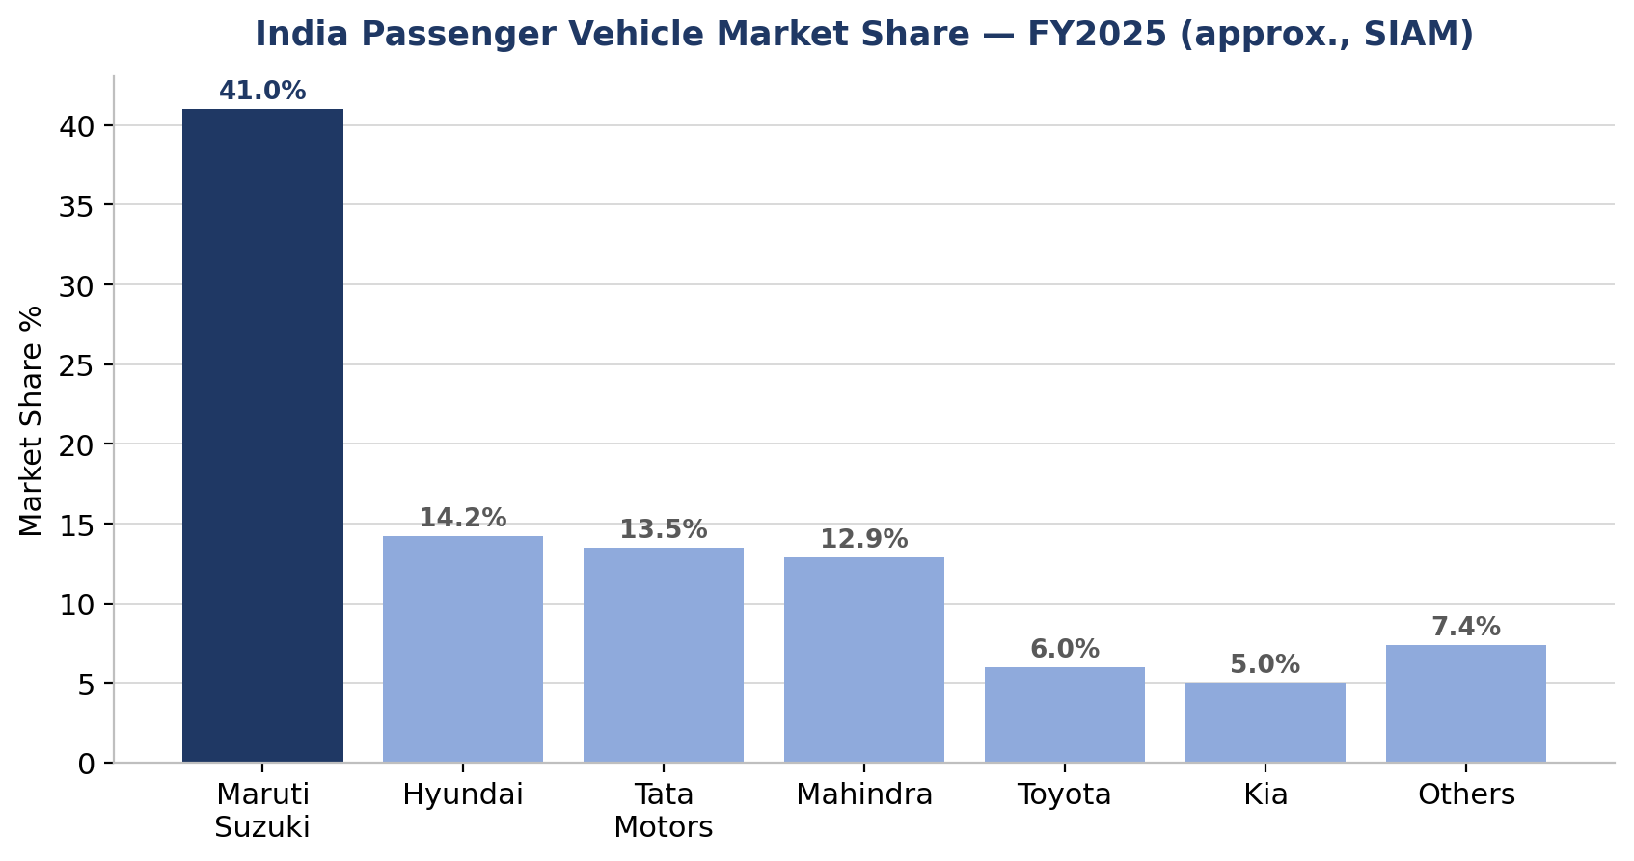
Chart: India passenger-vehicle market share, approximate FY2025 (SIAM-reported figures)
Competitor | Approx. FY25 Share | Positioning vs. MSIL
Hyundai | ~14% | Strong in compact SUVs (Creta, Venue); premium positioning
Tata Motors | ~13-14% | SUV and EV leader (Nexon, Punch, Sierra relaunch); safety-led marketing
Mahindra | ~13% | Fastest-growing major OEM; dominant in mid/premium SUVs (Scorpio, Thar, XUV700)
Toyota | ~6% | Premium/MPV segment via badge-engineered MSIL platforms plus own models
Kia | ~5% | SUV-focused challenger brand (Seltos, Sonet, Syros)
Table 2.4: Key competitors and positioning (approximate market share, illustrative — see Appendix A for sources)

2.7 Recent Strategic Context (as of Q1 FY2026)
Three developments materially shape the FY2026 outlook and this budget’s assumptions:
- Capacity expansion — the new Kharkhoda (Haryana) plant is ramping up as part of "Maruti Suzuki 3.0", supporting both domestic and export growth and directly underpinning the Fixed Assets and D&A assumptions in Sections 6, 8 and 9.
- Electrification — MSIL launched its first EV, the e-Vitara, in FY2026, targeting exports to Japan and Europe as the bulk of initial volumes — a contributor to both the export-volume and realisation assumptions.
- Pricing action — a list-price hike of up to 4% across models effective April 2025 is the single biggest input to the FY2026 realisation assumption used in this budget (Section 6).

2.8 Rationale for Selecting Maruti Suzuki for This FP&A Exercise
- It is a large, well-covered listed company with a rich, publicly-available four-year consolidated financial history and extensive management commentary (press releases, earnings calls, annual reports) — ideal raw material for a driver-based budgeting exercise.
- Its cost structure is dominated by a single large, well-disclosed line — Cost of Materials Consumed, at roughly 70% of revenue — and modest, well-disclosed volume/realisation dynamics, which lends itself cleanly to the volume × price revenue build and line-item cost drivers this SOW calls for.
- FY2026 is genuinely a live assumption-setting exercise rather than a mechanical extrapolation: new capacity, a first EV launch, a live price hike, and an uncertain input-cost environment all pull the FY2026 numbers away from a simple straight-line trend — precisely the situation where a driver-based FP&A budget adds the most value over a "grow last year by X%" approach, and (as Section 12’s break-even analysis shows) where the margin of error is thinnest.
Source: Company website (marutisuzuki.com/corporate), MSIL press releases (FY2025 and FY2026 results, capex/EV announcements), SIAM/industry market-share coverage (RushLane, Autocar India, CarDekho), and Screener.in company profile (background/JV shareholding facts only — not used for any financial figures).

3. Historical Financials (FY2022–FY2025)
All figures below are consolidated, sourced from Maruti Suzuki’s quarterly/annual financial results filed with BSE & NSE and company press releases, and independently cross-checked against reported PBT and PAT for every year (they tie out exactly). Full line-by-line sourcing, including the estimation methodology used to split the single "Operating Expenses" line into Cost of Materials Consumed / Employee Benefit Expense / Other Operating Expenses, is documented in Section 3.8 and on the Historical Financials tab of the workbook.

3.1 Consolidated Profit & Loss
Particulars (Rs crore) | FY2022 | FY2023 | FY2024 | FY2025
Revenue from Operations | 88,330 | 1,18,410 | 1,41,858 | 1,52,913
Cost of Materials Consumed | 66,118 | 85,738 | 99,966 | 1,07,953
Employee Benefit Expense | 4,047 | 5,249 | 6,265 | 6,892
Other Operating Expenses | 12,458 | 14,329 | 17,101 | 17,912
EBITDA | 5,706 | 13,094 | 18,526 | 20,156
EBITDA Margin % | 6.5% | 11.1% | 13.1% | 13.2%
Depreciation & Amortisation | 2,789 | 4,846 | 5,256 | 5,608
EBIT | 2,917 | 8,248 | 13,271 | 14,548
PAT | 3,880 | 8,264 | 13,488 | 14,500
PAT Margin % | 4.4% | 7.0% | 9.5% | 9.5%
Dividend Payout Ratio | 35.0% | 21.9% | 20.2% | 27.1%
Table 3.1: Consolidated historical P&L summary, FY2022–FY2025 (Rs crore)
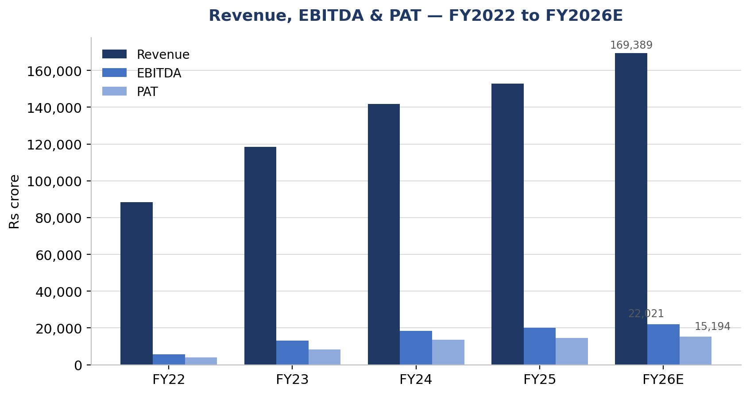
Chart 3.1: Revenue, EBITDA & PAT trend, FY2022–FY2026E
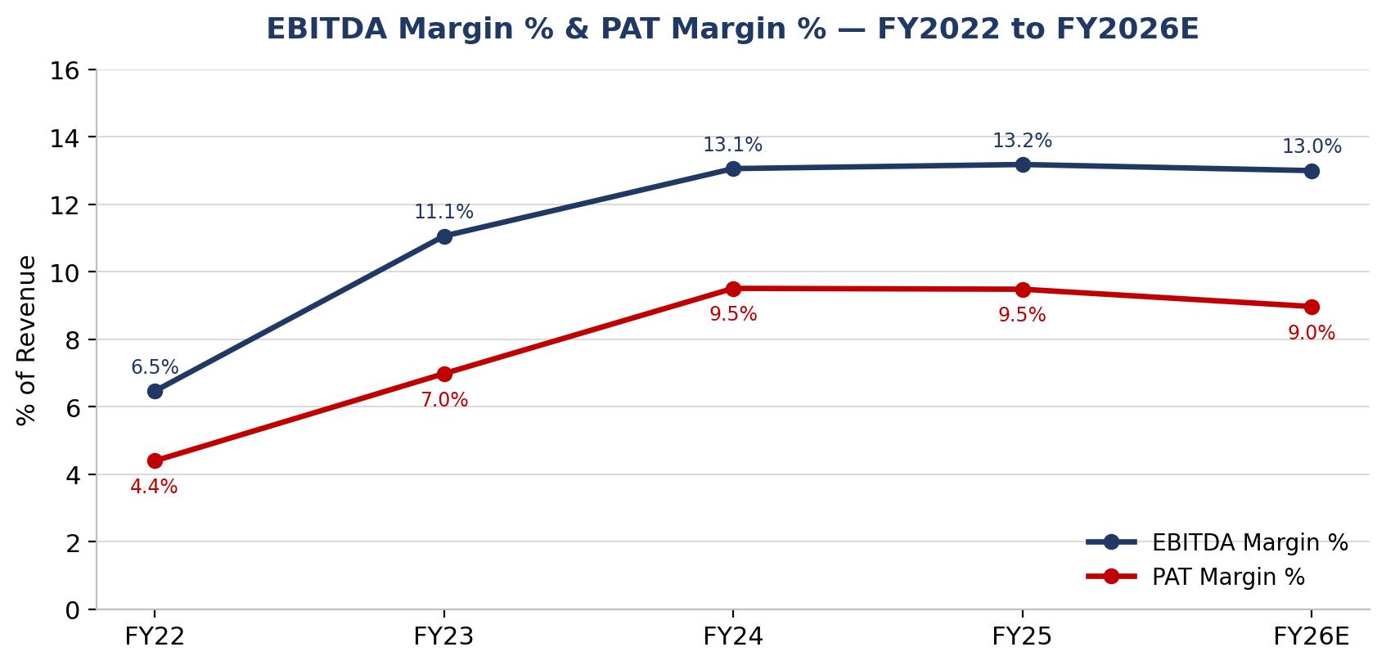
Chart 3.2: EBITDA Margin % & PAT Margin % trend, FY2022–FY2026E

3.2 Consolidated Balance Sheet
Particulars (Rs crore) | FY2022 | FY2023 | FY2024 | FY2025
Shareholders' Equity | 55,334 | 74,600 | 85,636 | 96,240
Borrowings & Lease Liabilities | 426 | 1,248 | 119 | 87
Other Non-Current Liabilities | 2,266 | 2,994 | 3,695 | 5,103
TOTAL LIABILITIES & EQUITY | 58,025 | 78,841 | 89,450 | 1,01,430
Fixed Assets | 16,044 | 31,448 | 34,915 | 40,020
Intangible Assets | 640 | 637 | 684 | 892
Investments | 42,035 | 49,184 | 57,296 | 66,265
Other Non-Current Assets | 3,244 | 3,448 | 3,734 | 3,608
Cash & Bank Balances | 3,042 | 2,749 | 2,827 | 553
Remaining Net Current Assets | (6,980) | (8,623) | (10,007) | (9,908)
TOTAL ASSETS | 58,025 | 78,841 | 89,450 | 1,01,430
Table 3.2: Consolidated historical Balance Sheet summary, FY2022–FY2025 (Rs crore)
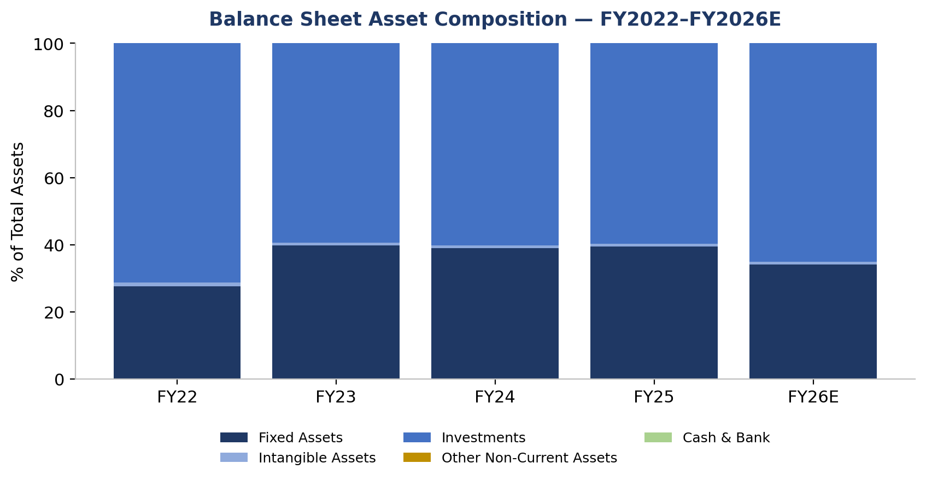
Chart 3.3: Balance Sheet asset composition, FY2022–FY2026E
Reading the composition chart: Investments (surplus cash parked in mutual funds/bonds) is consistently the largest single asset — over 55% of the balance sheet throughout — reflecting MSIL’s conservative, low-leverage capital structure and its practice of sweeping operating cash surplus into liquid investments rather than holding it as cash or returning it all to shareholders.

3.3 Volume & Realisation Bridge
Separating "how many cars" from "how much per car" is central to a driver-based revenue budget. The table below decomposes revenue growth into a volume component and a realisation (price/mix) component for each of the last two years, using standalone MSIL unit sales against consolidated revenue.
Particulars | FY2023 | FY2024 | FY2025
Total Vehicles Sold (units) | 19,66,164 | 21,35,323 | 22,34,266
Volume Growth % YoY | — | 8.6% | 4.6%
Realisation per Vehicle (Rs) | 5,72,205 | 6,31,881 | 6,84,399
Realisation Growth % YoY | — | 10.4% | 3.0%
Revenue Growth % YoY | 34.1% | 19.8% | 7.8%
Table 3.3: Volume & realisation bridge, FY2023–FY2025
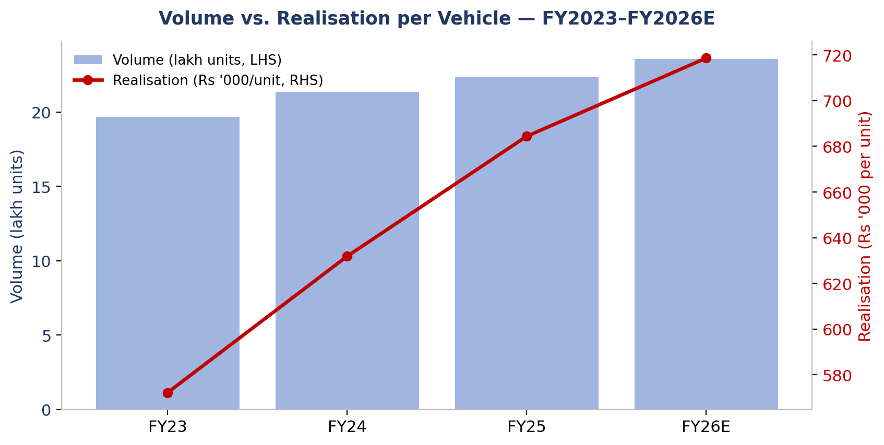
Chart 3.4: Volume vs. realisation per vehicle, FY2023–FY2026E
Pattern recognised: FY2024’s exceptional 19.8% revenue growth was roughly evenly split between volume (+8.6%) and realisation (+10.4%) — a genuine post-shortage demand and pricing recovery. FY2025’s much slower 7.8% growth was overwhelmingly a realisation story (+3.0% realisation vs. +4.6% volume) as the low-base effect faded. This is exactly the pattern the FY2026 budget assumes continues: modest volume growth (+5.5%) supplemented by a deliberate pricing/mix push (+5.0% realisation) via the April price hike and SUV/EV mix shift.

3.4 Ratio Analysis — Profitability, Efficiency & Leverage
A fuller ratio analysis than the P&L alone provides — tracking how efficiently MSIL has converted revenue and assets into returns, and how conservatively it is financed. All ratios below are computed on the Ratio Analysis tab of the workbook, fully linked to the Historical Financials and Budgeted P&L/Balance Sheet.
Ratio | FY2022 | FY2023 | FY2024 | FY2025 | FY2026E
EBITDA Margin % | 6.5% | 11.1% | 13.1% | 13.2% | 13.0%
EBIT Margin % | 3.3% | 7.0% | 9.4% | 9.5% | 9.1%
PAT Margin % | 4.4% | 7.0% | 9.5% | 9.5% | 9.0%
Return on Equity (ROE) | 7.0% | 11.1% | 15.8% | 15.1% | 14.0%
Return on Capital Employed (ROCE) | 5.2% | 10.9% | 15.5% | 15.1% | 14.3%
Return on Assets (ROA) | 6.7% | 10.5% | 15.1% | 14.3% | 13.3%
Asset Turnover | 1.52x | 1.50x | 1.59x | 1.51x | 1.48x
Fixed Asset Turnover | 5.51x | 3.77x | 4.06x | 3.82x | 4.35x
Debt / Equity | 0.01x | 0.02x | 0.00x | 0.00x | 0.00x
Interest Coverage (EBIT/Fin. Cost) | 23x | 33x | 69x | 75x | 80x
Effective Tax Rate | 17.4% | 20.8% | 22.6% | 26.1% | 25.9%
Table 3.4: Profitability, efficiency and leverage ratios, FY2022–FY2026E
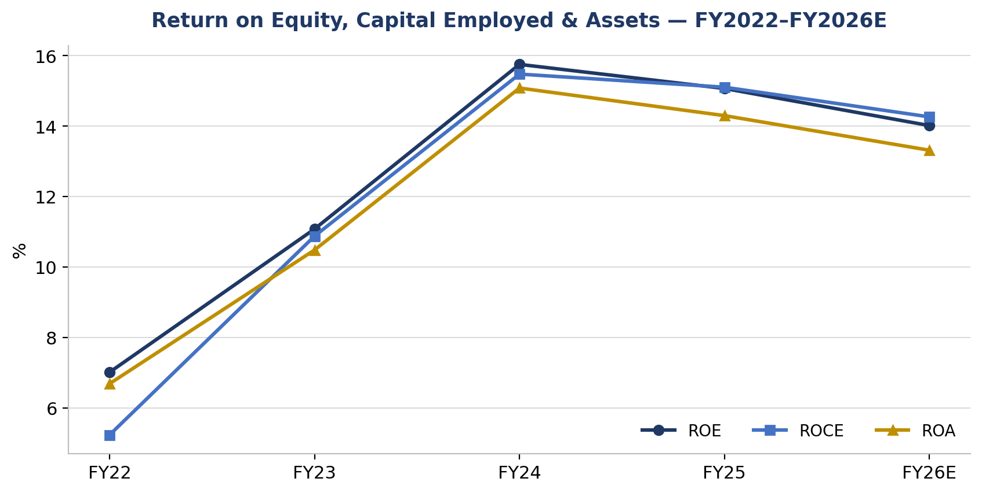
Chart 3.5: ROE, ROCE & ROA trend, FY2022–FY2026E
Pattern recognised: all three return measures (ROE, ROCE, ROA) peaked in FY2024 and have been gently declining since — not because the business is deteriorating, but because the denominator (equity, capital employed, assets) has grown faster than profit as MSIL has ploughed retained earnings and a large capex programme into the balance sheet. This is a normal, even healthy, pattern for a company mid-way through a multi-year capacity expansion, but it does mean returns are budgeted to keep easing modestly in FY2026 (ROE ~14.0% vs FY2024’s 15.8% peak) before the new capacity starts contributing fully to revenue.
Balance-sheet strength: Debt/Equity has been below 0.02x throughout the period and Interest Coverage exceeds 20x in every year, rising to ~80x by FY2026E — MSIL’s FY2026 capex programme is being funded almost entirely from internal accruals, not debt, which is itself a key reason the Finance Cost assumption in Section 6 is simply held flat.

3.5 Capex & Free Cash Flow Trend
MSIL does not separately disclose an annual capex figure; it is instead back-solved here as the increase in Fixed + Intangible Assets plus the year’s Depreciation & Amortisation charge (the standard roll-forward identity: Closing Net Block = Opening Net Block + Capex − D&A). A simplified Free Cash Flow proxy (PAT + D&A − Capex, before working-capital movements) is shown alongside it.
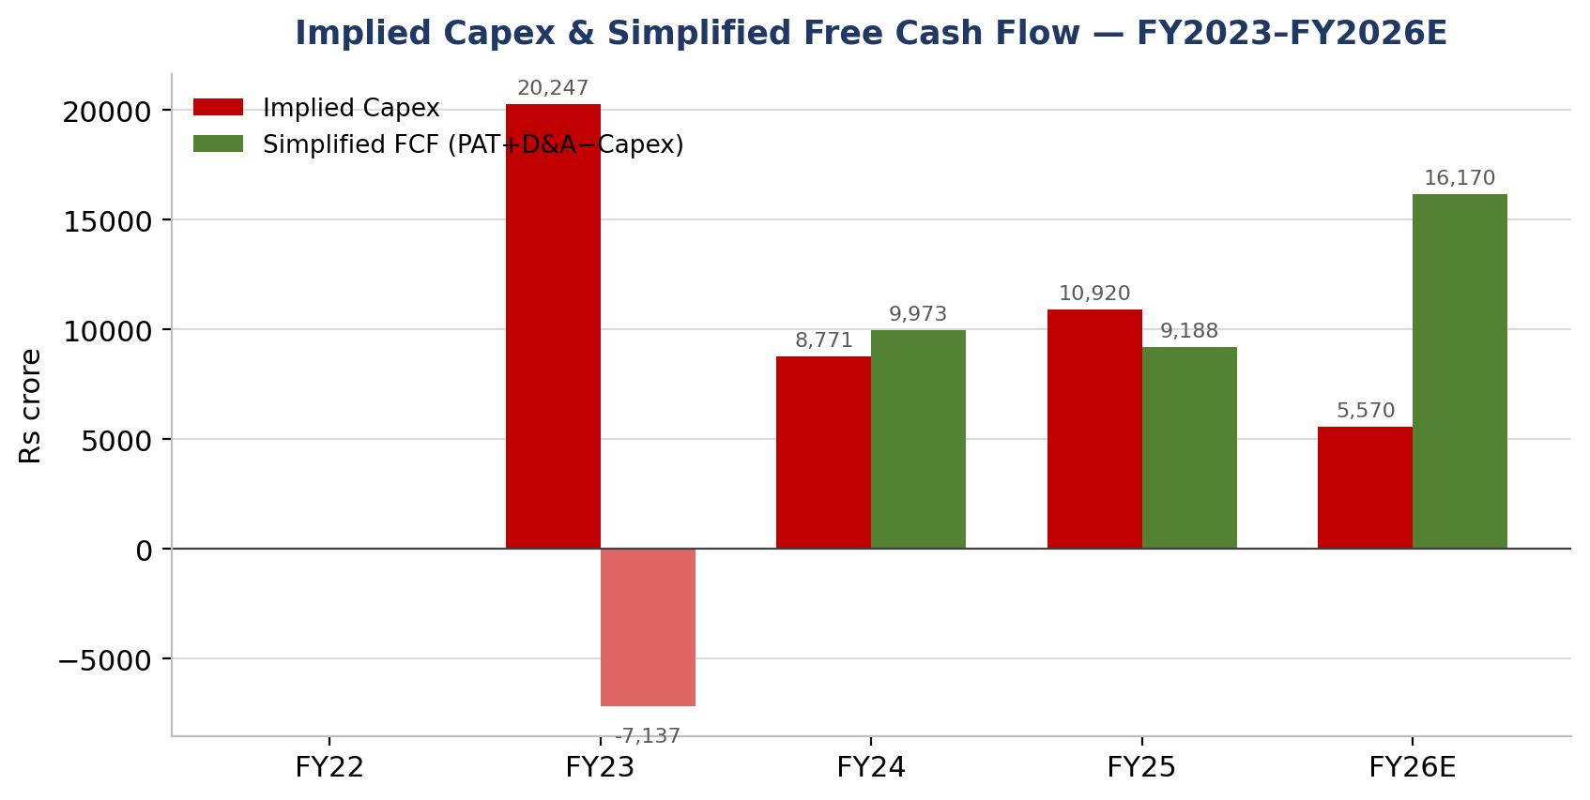
Chart 3.6: Implied capex and simplified FCF, FY2023–FY2026E (Rs crore)
Pattern recognised: FY2023 was an exceptionally heavy capex year (Rs 20,247 crore, coinciding with the Gujarat capacity build-out), large enough to push simplified FCF negative that year despite healthy PAT. Capex intensity has moderated since (Rs 10,920 crore in FY2025) and the FY2026 budget assumes a further step-down to Rs 5,570 crore as the Fixed-Assets-to-Revenue ratio normalises — consistent with the Kharkhoda plant substantially completing its heaviest construction phase. FCF is budgeted to reach its strongest level of the five-year window (Rs 16,170 crore), which comfortably funds both the ongoing capex programme and the dividend without recourse to debt.

3.6 Dividend History
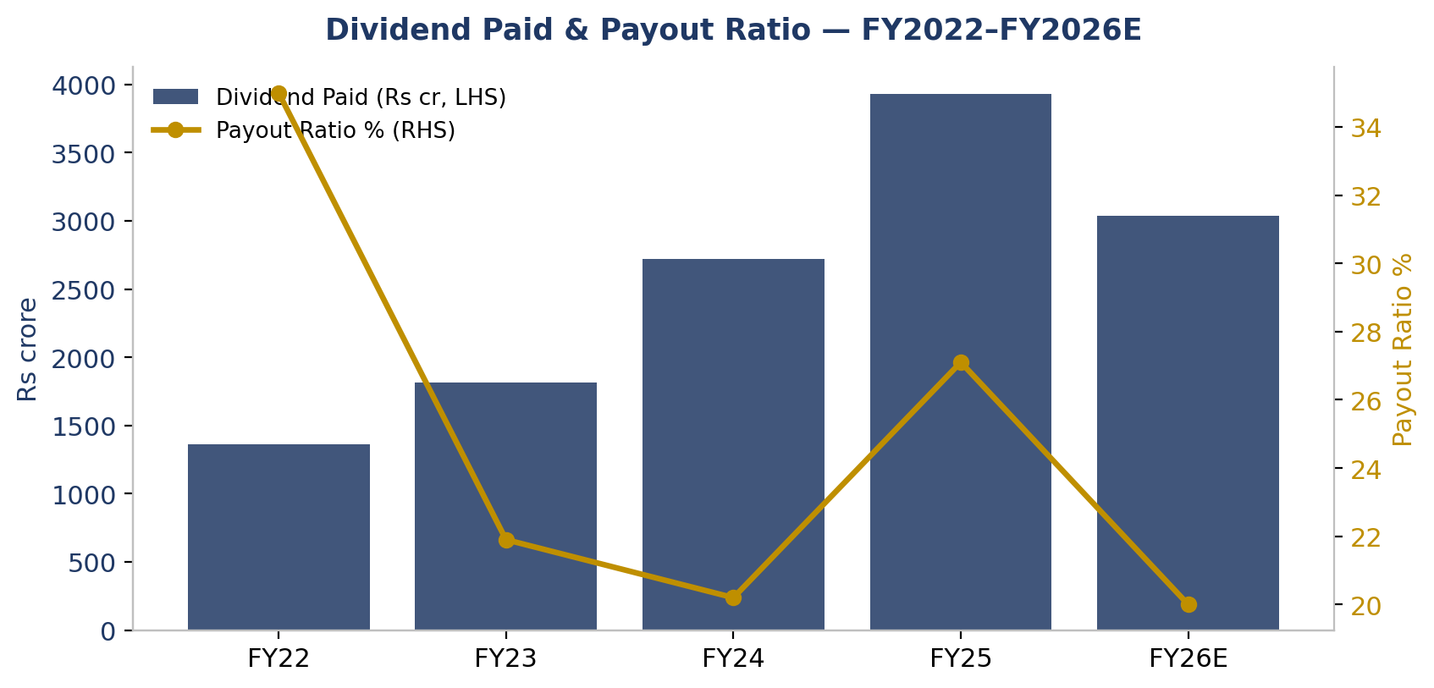
Chart 3.7: Dividend paid and payout ratio, FY2022–FY2026E
Pattern recognised: the payout ratio has been volatile (35.0% in FY2022, a low-profit year, down to ~20% in FY2024, then jumping to 27.1% in FY2025 alongside a highest-ever Rs 125/share dividend) rather than following a strict fixed policy. The FY2026 budget conservatively reverts to the 20% payout used in the source valuation model, which is towards the low end of MSIL’s recent range — a Board decision to pay out FY2025’s elevated 27.1% again in FY2026 would mechanically reduce the Investments build-up shown in Section 10 without affecting EBITDA or PAT.

3.7 MD&A-Style Commentary — Key Trends, FY2022–FY2025
- Revenue growth decelerated sharply — from +19.8% in FY2024 to +7.8% in FY2025 — as the post-pandemic/semiconductor-shortage low base effect faded and passenger-vehicle industry demand growth normalised to low single digits domestically.
- EBITDA margin expanded materially — from 6.5% (FY2022, still absorbing the FY2021-22 semiconductor shortage and a commodity cost spike) to 13.2% (FY2025) — as raw-material costs eased from 74.9% to 70.6% of revenue and operating leverage took hold on the Company’s recovering volumes.
- PAT more than tripled — from Rs 3,880 crore to Rs 14,500 crore — though PAT margin was roughly flat between FY2024 (9.5%) and FY2025 (9.5%), as a higher effective tax rate (22.6% → 26.1%, reflecting a one-off deferred-tax charge from the withdrawal of the indexation benefit on debt-mutual-fund gains) offset the operating-margin gain.
- Working capital remains structurally negative — MSIL’s net current assets were roughly -6.5% to -7.9% of revenue throughout FY2022–FY2025, a persistent source of funding typical of a dominant OEM with strong bargaining power over dealers and suppliers.
- Returns peaked in FY2024 and have been gently normalising since, as discussed in Section 3.4, without any deterioration in the underlying margin story.
- The balance sheet has stayed extremely conservatively financed throughout — Debt/Equity never exceeded 0.02x — funding growth from retained earnings, not leverage.

3.8 Source Authenticity & Methodology Note
1. Revenue, Other Income, D&A, Finance Cost, Share of Associates/JV, Tax, PBT and PAT (FY2022-FY2025) are consolidated figures taken from Maruti Suzuki India Ltd's quarterly/annual financial results filed with BSE & NSE and press releases. PBT and PAT independently cross-checked against company press releases for every year — all tie out.
2. Balance Sheet figures (FY2022-FY2025) are consolidated, reconstructed from reported line items; Assets = Liabilities+Equity confirmed to tie in all four years.
3. The source dataset carried a single blended 'Operating Expenses' line (no COGS / Employee / Other split). This was split using proportions derived from MSIL's own historical standalone common-size cost structure, then applied proportionally to the known, reported Opex total for each year, with Other Opex taken as the balancing figure. This is a documented ESTIMATE, not a company-disclosed line-item split — flagged here for transparency.
4. Vehicle sales volumes are standalone MSIL units (domestic + export) as disclosed in monthly/annual sales press releases; used only to build the volume/realisation bridge and are not part of the audited P&L or Balance Sheet.
5. Implied Capex and Simplified FCF (Section 3.5) are back-solved from Balance Sheet movements, not separately disclosed by the Company — flagged as an analytical construct, not a reported figure.

4. Key Business Metrics & Drivers

4.1 Metrics & Drivers Map
The table below links each metric that determines MSIL’s FY2026 financial performance to the underlying operational driver(s) behind it. This map is the bridge between Section 2’s qualitative business context and the quantitative assumptions in Sections 5–6 — every FY2026E figure in the right-hand columns below traces back to a named, sourced driver, not a generic growth rate applied blindly.
Metric | FY2024 | FY2025 | FY2026E | Operational Driver(s)
Revenue growth % | 19.8% | 7.8% | 10.8% | Volume growth × realisation/mix growth
Volume growth % (units) | 8.6% | 4.6% | 5.5% | Domestic PV demand (SIAM/ICRA) + Kharkhoda ramp-up + exports
Realisation/ASP growth % | 10.3% | 3.0% | 5.0% | Apr-2025 price hike (~4%) + mix shift to UVs/SUVs/EV
Cost of Materials Consumed, % of Rev. | 70.5% | 70.6% | 71.3% | Steel/aluminium/precious-metal costs, import content
Employee Cost, % of Revenue | 4.4% | 4.5% | 4.7% | Wage increments, Kharkhoda hiring ramp
Other Opex, % of Revenue | 12.1% | 11.7% | 11.0% | Advertising (EV launch), freight, warranty, R&D
EBITDA Margin % | 13.1% | 13.2% | 13.0% | 1 minus (COGS%+Employee%+Other Opex%)
D&A, % of prior-yr Fixed+Intang. Assets | 16.4% | 15.8% | 16.0% | Capex intensity (Kharkhoda, EV/SUV tooling)
Effective Tax Rate | 22.6% | 26.1% | 25.9% | Glide-path to 25.168% statutory rate
Net Current Assets, % of Revenue | (7.1%) | (6.5%) | (7.5%) | Dealer/supplier payment terms (negative WC)
Capex Intensity, Fixed Assets % of Rev. | 24.6% | 26.2% | 23.0% | Kharkhoda Plant-2, Gujarat D-line, EV tooling
Dividend Payout Ratio | 20.2% | 27.1% | 20.0% | Board policy, ~20-27% of PAT historically
Return on Equity (ROE) | 15.8% | 15.1% | 14.0% | PAT growth relative to retained-earnings-funded equity growth
Debt / Equity | 0.001x | 0.001x | 0.001x | Near-debt-free financing policy
Table 4.1: Key business metrics and their operational drivers, FY2024–FY2026E
Reading the table: the single largest lever is Cost of Materials Consumed, at over 70% of revenue — small percentage-point moves here dwarf the impact of any other line, which is exactly what Section 12’s sensitivity analysis confirms quantitatively.

4.2 Driver Trends at a Glance
The four charts below put the most important drivers side by side so the shape of each trend — not just the year-end numbers — is immediately visible.
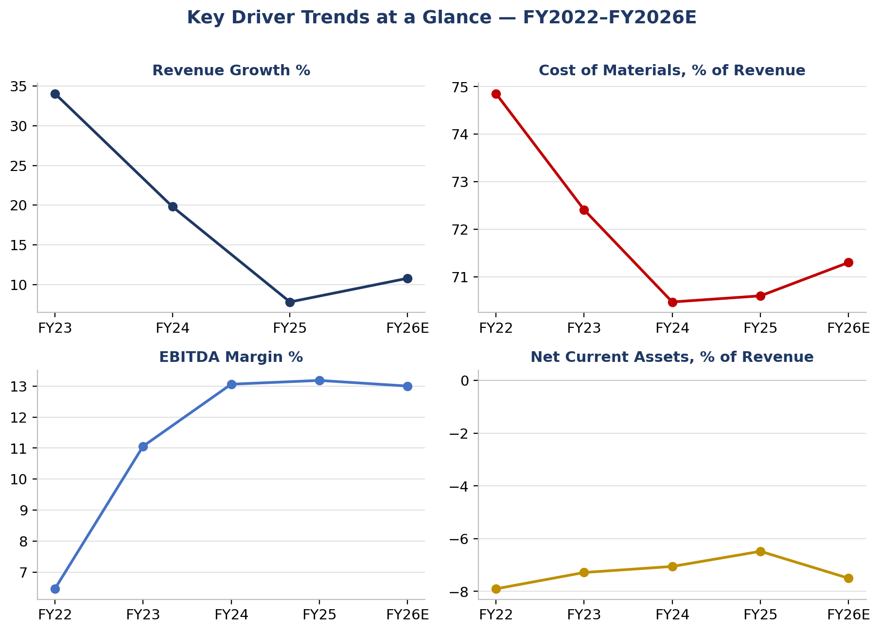
Chart 4.1: Revenue growth, Cost-of-Materials ratio, EBITDA margin and working-capital intensity, FY2022–FY2026E
Pattern recognised: three of the four panels show a "sharp move then plateau" shape — revenue growth and the COGS ratio both moved sharply in FY2022-24 and have since flattened; EBITDA margin shows the mirror image, rising sharply then plateauing. Only working-capital intensity (bottom-right) shows a genuine reversal — it had been trending toward zero (less negative, i.e. less favourable) from FY2022 to FY2025, and the FY2026 budget assumes it swings back to a more negative (more favourable) level. This is worth flagging as one of the less certain assumptions in the budget, since it runs counter to the recent trend rather than extrapolating it.

5. Macro Assumptions
Set as of Q1 FY2026 (April–June 2025) — using only information that would have been available to an FP&A analyst planning the year at that point, not with the benefit of hindsight.

5.1 Macro Assumptions Table
Macro Variable | FY2026 Assumption | Rationale | Source
Real GDP Growth (India, FY2026) | 6.5% | RBI’s April-2025 Monetary Policy Report projected FY2026 real GDP growth at 6.5%, alongside a 25bp repo rate cut to 6.0%, as growth was recovering from a soft H1 FY25 while inflation eased. | RBI Monetary Policy Report, April 2025; PIB press release, 9-Apr-2025
CPI Inflation (FY2026) | ~4.0% (within target band) | RBI’s April-2025 policy projected FY2026 inflation to remain within the 4% target band, supported by moderating food prices; underpinned the shift to an accommodative policy stance. | RBI Monetary Policy Report, April 2025
RBI Repo Rate / Interest-Rate Stance | Easing cycle; repo rate ~6.0%, accommodative stance | Two consecutive 25bp cuts (Feb-25: 6.5%→6.25%; Apr-25: 6.25%→6.00%) with a shift to ‘accommodative’ stance — lower cost of working-capital and vehicle-finance borrowing supports both MSIL and its dealers/customers. | RBI MPC resolutions, Feb & Apr 2025
INR/USD Exchange Rate | Gradual depreciation (mid-single-digit %, directional) | The rupee had already weakened >6% following the April-2025 US tariff announcement (up to ~26% reciprocal tariff on Indian goods); a continued mild depreciation bias was the base case for FY26, raising the cost of dollar/yen-denominated imports and Suzuki royalty payments. | Business Standard, Apr-2025 tariff coverage; FX outlook commentary
Steel & Key Input Commodity Costs | Firm-to-rising | World Steel Association projected India steel demand growth of ~9% for calendar 2026; raw-material cost volatility (iron ore, coking coal) flagged as a continuing risk — a headwind for MSIL’s largest cost line. | World Steel Association / industry steel-price outlook coverage, late-2025
Auto Industry (SIAM/ICRA) — PV Wholesale Growth, FY2026 | Modest: 1%-4% | ICRA (Aug-2025) projected FY26 domestic PV wholesale growth of just 1-4%, citing elevated channel inventory and a high FY25 base; MSIL management itself guided to industry growth of ~1-2% domestically, with company-specific growth to come from exports (+20% targeted) and new-model/capacity additions. | ICRA industry note; MSIL Q4 FY25 earnings call
Table 5.1: Macro assumptions underpinning the FY2026 budget

5.2 RBI Repo Rate Path
The chart below shows the actual repo-rate path through calendar 2025 for context — the FY2026 planning assumption itself was fixed at the April-2025 data point (6.00%, further easing to come), since a prospective budget cannot use information from meetings that had not yet happened.
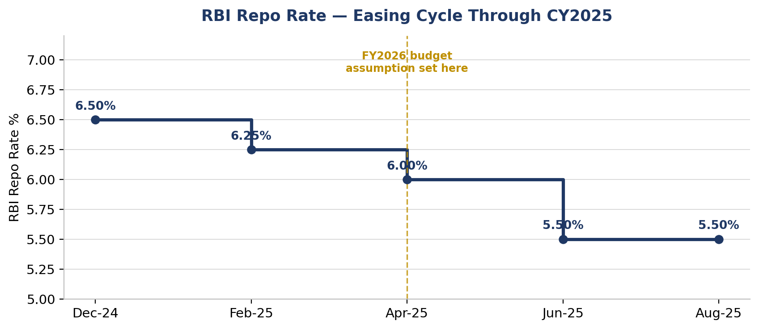
Chart 5.1: RBI repo rate, Dec 2024 – Aug 2025

5.3 How the Macro View Feeds the Micro Assumptions
Modest industry volume growth, combined with MSIL’s own capacity/export initiatives, feeds the Volume growth assumption on the Assumptions tab. The price hike (partly a response to input-cost inflation) combined with a favourable mix shift feeds the Realisation growth assumption. The firm steel/commodity outlook feeds a rising (not falling) Cost-of-Materials assumption. The easing rate cycle supports holding Finance Cost flat rather than assuming it rises. See Section 6 for the exact line-by-line linkage.

6. Micro (Line-Item) Assumptions & Budget Methodology
Every assumption below has a documented FY2025 base, a stated FY2026 value, and a rationale grounded in either the historical trend (Section 3), the macro view (Section 5), or management guidance — the SOW-required "one row per assumption... rationale column" format, reproduced here in full (not a selected subset).

6.1 Full Assumptions Register
Assumption | FY2026 | Rationale
Revenue Assumptions
Volume growth % | 5.5% | Blend of ~3% domestic volume growth (industry guided to +1-4%, high FY25 base) weighted 85%, and ~20% export volume growth (MSIL’s own FY26 target) weighted 15%.
Realisation/ASP growth % | 5.0% | ~4% list-price hike (Apr-2025) plus ~1% from mix shift toward higher-ASP UVs/SUVs and the e-Vitara EV.
Revenue growth % (derived) | 10.8% | (1+Volume growth) x (1+Realisation growth) minus 1. Cross-checks closely to the 11% used independently in the source FCFF/DCF equity-research model.
Cost Assumptions
Cost of Materials Consumed, % of Rev. | 71.3% | +0.7pp vs FY25: firm-to-rising steel/commodity outlook and import/royalty content, partly offset by the price hike.
Employee Benefit Expense, % of Rev. | 4.7% | +0.19pp vs FY25: annual wage increments plus incremental hiring to ramp up the Kharkhoda plant.
Other Operating Expenses, % of Rev. | 11.0% | -0.71pp vs FY25: operating leverage on fixed SG&A, netted against higher one-off EV-launch advertising spend.
Total Opex, % of Revenue (check) | 87.0% | Sum of the three lines above; +0.18pp vs FY25’s 86.8%.
Other P&L Assumptions
D&A, % of prior-year Fixed+Intang. Assets | 16.0% | Held at the FY25 ratio; a rising capex base (Kharkhoda, Gujarat D-line) still lifts the Rs crore depreciation charge.
Finance Cost | Flat YoY (Rs 194 cr) | MSIL is almost debt-free; the RBI easing cycle keeps incremental borrowing costs low.
Other Income, % of prior-year Investments | 7.5% | Held at the FY25 ratio; treasury/investment income scales with the growing investment book.
Share of Profit of Associates, growth % | 5.0% | Modest growth in line with historical trend (JV/associate earnings, incl. Suzuki Motor Gujarat-linked entities).
Share of Profit of Joint Ventures, growth % | 10.0% | 10% growth, consistent with the historical 3-year trend.
Effective Tax Rate | 25.9% | Gradual glide-path toward the 25.168% statutory rate as the FY25 one-off deferred-tax impact rolls off.
Balance Sheet Assumptions
Fixed Assets, % of Revenue | 23.0% | Continued capex under "Maruti Suzuki 3.0" keeps pace with revenue growth; down from FY25’s 26.2% realised ratio as the heaviest construction phase passes.
Intangible Assets, growth % | 9.5% | Continued investment in product development/software (EV platform, connected-car tech).
Other Non-Current Assets, growth % | 18.0% | 18% growth, in line with the historical 3-year trend.
Remaining Net Current Assets, % of Rev. | (7.5%) | MSIL’s negative working-capital model is structural and has been stable for years.
Cash & Bank Balances | Flat YoY | Held flat, consistent with MSIL’s practice of sweeping surplus cash into Investments rather than building idle cash balances.
Borrowings & Lease Liabilities | Flat YoY | MSIL is almost debt-free and self-funds capex from operating cash flow.
Other Non-Current Liabilities, growth % | 10.0% | 10% growth, in line with the historical trend (provisions, deferred tax liabilities).
Dividend Payout Ratio | 20.0% | Held at 20% of PAT (source DCF/equity-research model’s own assumption; towards the low end of MSIL’s recent 20-35% payout history — see Section 3.6).
Table 6.1: Complete FY2026 budget assumptions register, one row per assumption

6.2 A Note on the Cost-Split Methodology
The source dataset (an FCFF/DCF equity-research model for the same company) carried a single blended "Operating Expenses" line, not the Cost-of-Materials / Employee-Cost / Other-Opex split this FP&A exercise requires. That split was reconstructed by researching MSIL’s own historical standalone common-size cost structure (Raw Material Cost, Employee Cost, and Power & Fuel + Other Manufacturing + Selling & Admin + Other Expenses, each as % of sales, FY2022–FY2025), then applying those proportions to the known, reported Opex total for each year — with Other Opex taken as the balancing figure so the three lines always tie exactly to the reported total. This is flagged here, and on the workbook’s Historical Financials tab, as a documented estimate rather than a company-disclosed line-item split, in the interest of full transparency on Data Accuracy & Traceability.

7. Revenue Budget

7.1 Volume × Realisation Build
Consistent with the SOW requirement for a bottom-up build, FY2026 revenue is derived from Volume × Realisation per vehicle, not a single blended growth rate. Both build methods — the volume/price bridge and a straight revenue-growth-rate check — are reconciled on the Revenue Budget tab and agree to the rupee.
Particulars | FY2025 Actual | FY2026 Budget
Total Vehicles Sold (units) | 22,34,266 | 23,57,151
Volume Growth % | 4.6% | 5.5%
Realisation per Vehicle (Rs) | 6,84,399 | 7,18,619
Realisation Growth % | 3.0% | 5.0%
Revenue from Operations (Rs crore) | 1,52,913 | 1,69,389
Table 7.1: FY2026 Revenue Budget — volume × realisation build

7.2 Revenue Bridge
The waterfall below visualises the same build as a bridge from FY2025 actual revenue to the FY2026 budget, splitting the ~10.8% growth into its two component effects.
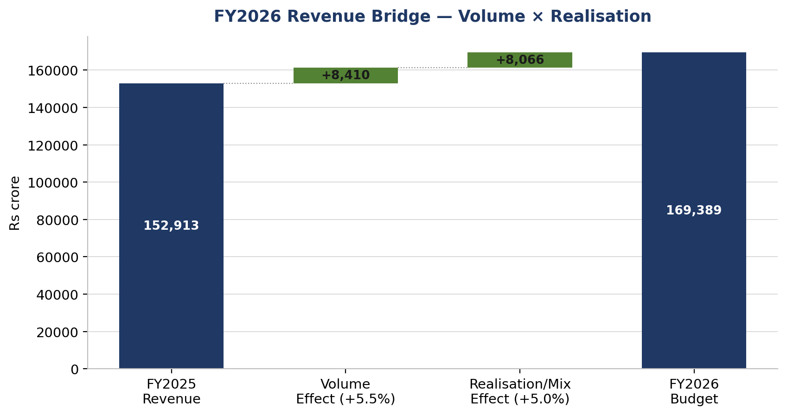
Chart 7.1: FY2026 revenue bridge — volume effect vs. realisation/mix effect
Volume growth of ~5.5% and realisation growth of ~5.0% combine to a revenue growth of ~10.8% — close to (and cross-validating) the 11% revenue growth used independently in the source FCFF/DCF equity-research model built for the same company on a different valuation basis. Notably, the two effects are almost exactly balanced (Rs 8,410 crore from volume vs. Rs 8,066 crore from realisation) — FY2026 growth is not a "price-led" or "volume-led" story but a genuinely blended one.

7.3 Illustrative Quarterly Phasing
As an additional planning/monitoring aid (not an SOW requirement, but standard FP&A practice), the annual budget is phased into quarters using typical Indian passenger-vehicle industry seasonality — a soft Q1 (summer/monsoon), building through Q2, peaking in the festive-season Q3 (Navratri/Dussehra/Diwali typically fall within October–December), and a firm Q4 (fiscal year-end dealer stocking, new launches).
Particulars (Rs crore) | Q1 (Apr-Jun) | Q2 (Jul-Sep) | Q3 (Oct-Dec) | Q4 (Jan-Mar)
Seasonality Weight % | 23.0% | 24.0% | 26.0% | 27.0%
Revenue from Operations | 38,960 | 40,653 | 44,041 | 45,735
EBITDA | 5,065 | 5,285 | 5,725 | 5,946
PAT | 3,495 | 3,647 | 3,951 | 4,102
Table 7.2: FY2026 budget phased by quarter (illustrative weights)
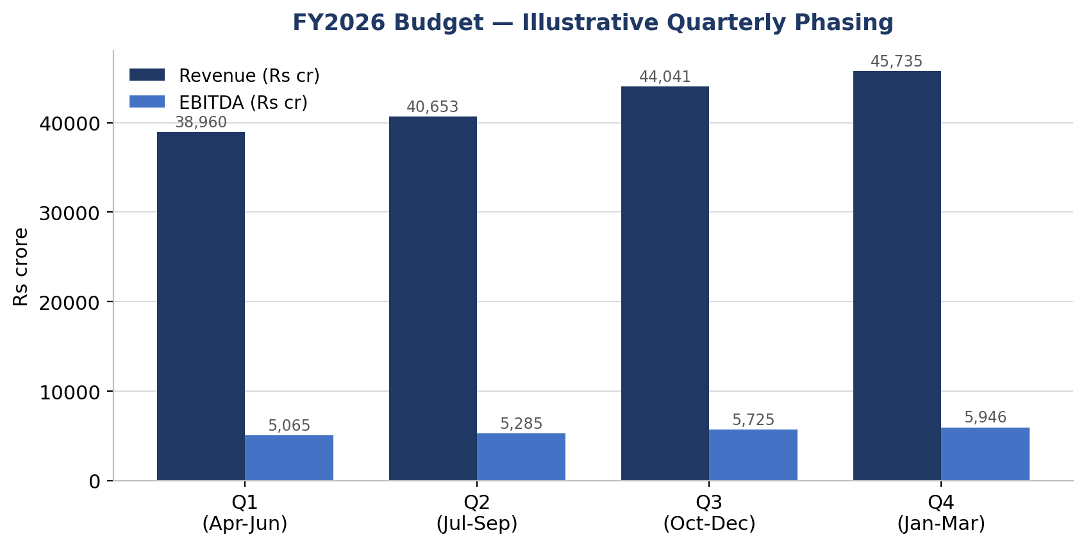
Chart 7.2: Quarterly phasing of Revenue and EBITDA, FY2026 budget
How the FP&A team could use this: by mid-July FY2026, actual Q1 revenue can be compared against the ~23% pace implied here; a material shortfall would be an early warning that the 5.5% volume growth or 5.0% realisation growth assumptions are running too high, well before the full-year numbers would otherwise reveal it. These weights are illustrative — MSIL does not publicly disclose its own internal quarterly budget — and are presented for planning/monitoring purposes only.

8. Cost Budget

8.1 Cost Budget Schedule
Each cost line is driven by its own assumption from the Assumptions tab — no flat, across-the-board growth rate is applied to total costs. This lets the budget show, transparently, exactly where FY2026 margin pressure or relief is expected to come from.
Particulars (Rs crore) | FY2025 Actual | FY2026 Budget
Revenue from Operations | 1,52,913 | 1,69,389
Cost of Materials Consumed (COGS) | 1,07,953 | 1,20,775
Employee Benefit Expense | 6,892 | 7,961
Other Operating Expenses | 17,912 | 18,633
Total Operating Expenses | 1,32,757 | 1,47,369
EBITDA | 20,156 | 22,021
EBITDA Margin % | 13.2% | 13.0%
Depreciation & Amortisation | 5,608 | 6,546
EBIT (Operating Profit) | 14,548 | 15,475
Table 8.1: FY2026 Cost Budget (Rs crore)

8.2 Cost Structure Trend
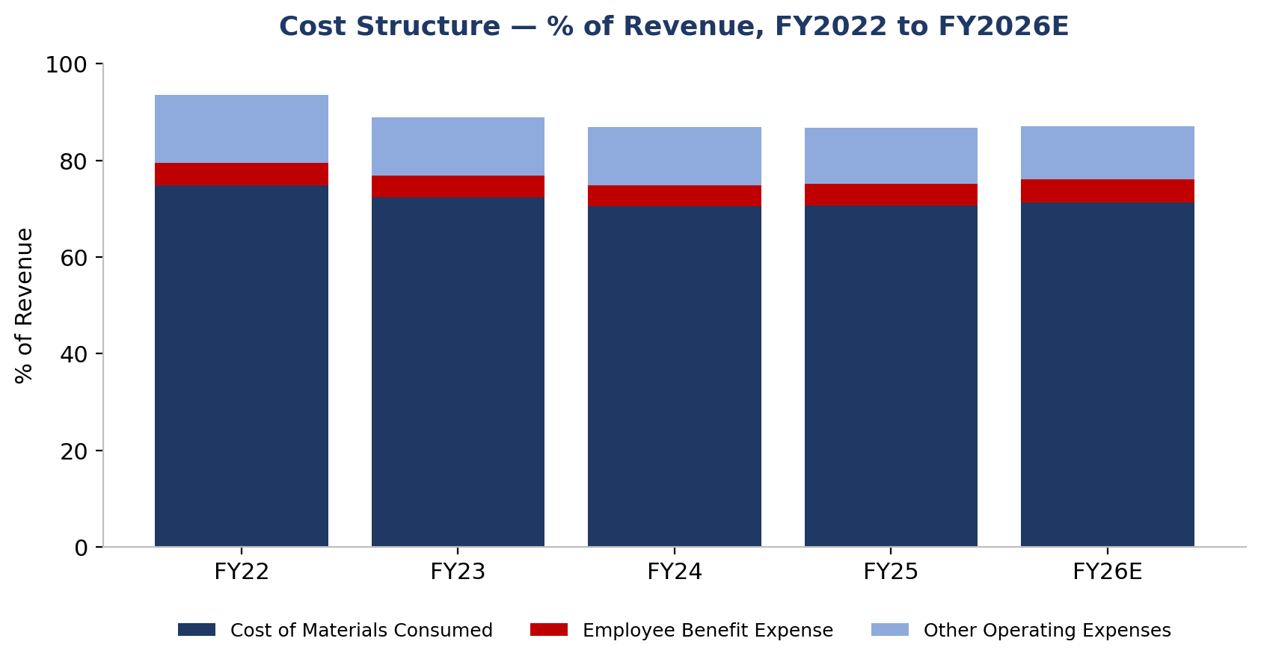
Chart 8.1: Cost structure as % of revenue, FY2022–FY2026E
Reading the chart: the cost stack has been remarkably stable since FY2024 (~87% of revenue), and FY2026’s modest re-widening to 87.0% (from FY25’s 86.8%) is driven entirely by the Cost-of-Materials assumption — Employee Cost and Other Opex actually improve slightly as a share of the growing revenue base.

8.3 EBITDA Bridge
The waterfall below decomposes the FY2025-to-FY2026 EBITDA change into a revenue-growth effect (holding FY2025 cost ratios constant) and three cost-ratio effects, each isolating exactly how much of the change is volume/price-driven versus margin-driven.
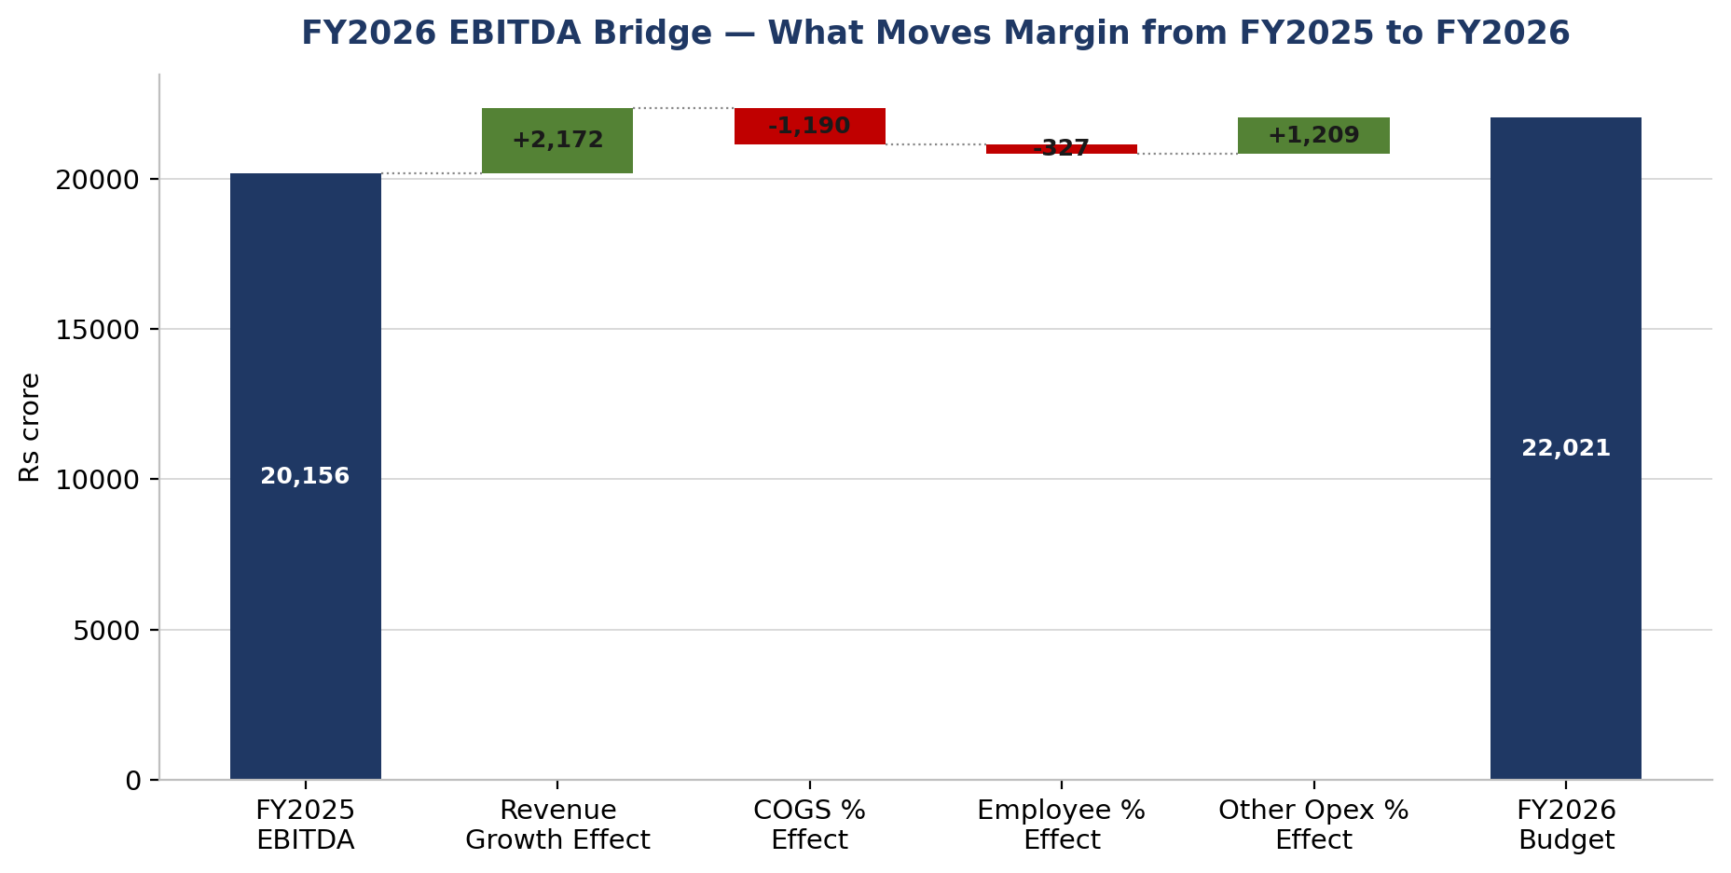
Chart 8.2: FY2026 EBITDA bridge — revenue growth effect vs. cost-ratio effects
Pattern recognised: the Revenue Growth effect alone would add Rs 2,172 crore to EBITDA if cost ratios stayed exactly at FY2025 levels. The three cost-ratio effects roughly net out — COGS deterioration (-Rs 1,190 crore) and Employee-cost deterioration (-Rs 327 crore) are almost fully offset by Other-Opex improvement (+Rs 1,209 crore) — for a combined cost-ratio drag of only -Rs 308 crore. In other words, essentially all of FY2026’s budgeted EBITDA growth (Rs 1,865 crore) comes from the top line, not from margin expansion — a materially different growth quality than FY2023-24, when margin expansion did the heavy lifting (see Section 3.4).

9. Budgeted Profit & Loss Statement

9.1 Full Budgeted P&L
The full Budgeted P&L below is fully linked, on the Budgeted P&L tab of the workbook, to the Revenue Budget, Cost Budget and Assumptions tabs — changing any assumption cell flows through to every line below it.
Particulars (Rs crore) | FY2025 Actual | FY2026 Budget | Growth %
Revenue from Operations | 1,52,913 | 1,69,389 | +10.8%
Less: Cost of Materials Consumed | 1,07,953 | 1,20,775 | +11.9%
Less: Employee Benefit Expense | 6,892 | 7,961 | +15.5%
Less: Other Operating Expenses | 17,912 | 18,633 | +4.0%
Total Operating Expenses | 1,32,757 | 1,47,369 | +11.0%
EBITDA | 20,156 | 22,021 | +9.2%
Less: Depreciation & Amortisation | 5,608 | 6,546 | +16.7%
EBIT (Operating Profit) | 14,548 | 15,475 | +6.4%
Add: Other Income | 5,022 | 4,970 | -1.0%
Less: Finance Cost | 194 | 194 | +0.0%
Add: Share of Profit of Associates | 215 | 226 | +5.0%
Add: Share of Profit of Joint Ventures | 29 | 32 | +10.0%
Profit Before Tax (PBT) | 19,620 | 20,508 | +4.5%
Less: Tax Expense | 5,120 | 5,314 | +3.8%
Profit After Tax (PAT) | 14,500 | 15,194 | +4.8%
EBITDA Margin % | 13.2% | 13.0%
PAT Margin % | 9.5% | 9.0%
Table 9.1: FY2026 Budgeted Profit & Loss (Rs crore)

9.2 Common-Size P&L Comparison
Expressing every line as a % of revenue strips out the scale effect and isolates exactly where margin is gained or lost — a standard analytical check alongside the Rs crore table above.
Particulars, % of Revenue | FY2025 Actual | FY2026 Budget
Cost of Materials Consumed | 70.6% | 71.3%
Employee Benefit Expense | 4.5% | 4.7%
Other Operating Expenses | 11.7% | 11.0%
Total Operating Expenses | 86.8% | 87.0%
EBITDA Margin | 13.2% | 13.0%
Depreciation & Amortisation | 3.7% | 3.9%
EBIT Margin | 9.5% | 9.1%
PBT Margin | 12.8% | 12.1%
PAT Margin | 9.5% | 9.0%
Table 9.2: Common-size P&L, FY2025 Actual vs. FY2026 Budget
Pattern recognised: every cost line except Other Operating Expenses is budgeted to consume a slightly larger share of revenue in FY2026 than in FY2025 — the common-size view makes it visually obvious that FY2026’s margin plateau (Section 9.3) is broad-based across the cost structure, not attributable to any single line.

9.3 Line-by-Line Commentary
- Revenue grows 10.8% to Rs 1,69,389 crore, entirely from the volume × realisation build in Section 7.
- Operating costs grow 11.0%, marginally ahead of revenue, as the rising Cost-of-Materials assumption more than offsets a modest improvement in Employee Cost and Other Opex as a share of revenue.
- EBITDA grows 9.2% to Rs 22,021 crore, but the margin is broadly flat (13.0% vs 13.2%) rather than expanding further, marking a pause in the margin-recovery trend seen through FY2022–FY2025.
- D&A rises 16.7% on the growing capex base (Kharkhoda, Gujarat D-line), a faster growth rate than EBITDA — a normal feature of a capacity-expansion phase.
- Other Income is budgeted essentially flat as MSIL’s investment book grows only modestly and the FY25 base already reflected a step-up.
- The Effective Tax Rate eases slightly to 25.9% from FY25’s elevated 26.1% (which included a one-off deferred-tax charge), providing a small offset to otherwise flat operating margins.
- Net effect: PAT grows just 4.8% to Rs 15,194 crore, with PAT margin easing to 9.0% from 9.5% — the budget explicitly signals a margin plateau, not a re-acceleration, for FY2026.

10. Budgeted Balance Sheet (Stretch Deliverable)
Every asset and liability line except Investments is independently driven from an assumption on the Assumptions tab. Investments is deliberately used as the balancing (plug) line — the same technique used in most driver-based three-statement models — so that it absorbs whatever surplus cash generation (or funding gap) falls out of the independently-driven choices, and the Balance Sheet ties by construction.
Particulars (Rs crore) | FY2025 | FY2026E | Basis
Shareholders' Equity | 96,240 | 1,08,429 | FY25 Equity + FY26 Retained Earnings
Borrowings & Lease Liabilities | 87 | 87 | Held flat YoY
Other Non-Current Liabilities | 5,103 | 5,613 | FY25 × (1+10%)
TOTAL LIABILITIES & EQUITY | 1,01,430 | 1,14,129
Fixed Assets (Net Block + CWIP) | 40,020 | 38,960 | 23.0% of FY26 Revenue
Intangible Assets | 892 | 977 | FY25 × (1+9.5%)
Other Non-Current Assets | 3,608 | 4,258 | FY25 × (1+18%)
Cash and Bank Balances | 553 | 553 | Held flat YoY
Remaining Net Current Assets | (9,908) | (12,704) | -7.5% of FY26 Revenue
Investments (balancing figure) | 66,265 | 82,087 | Plug — see note below
TOTAL ASSETS | 1,01,430 | 1,14,129
Table 10.1: FY2026 Budgeted Balance Sheet (Rs crore)
Balance check: Total Assets equal Total Liabilities & Equity in both FY2025 and FY2026 (the workbook’s Balance Check row reads exactly 0 in both years).

Key Balance Sheet Movements
- Investments grow by Rs 15,821 crore, reflecting both fresh cash deployment and non-cash equity-pickup from the growing Associates/JV investment and OCI — see Section 11 for the cash-vs-non-cash split.
- Fixed Assets fall slightly in Rs crore terms even as gross capex continues, because the Fixed Assets % of Revenue driver (23.0%) is lower than FY25’s realised ratio (26.2%) — i.e. the budget assumes the recent burst of capex intensity moderates as new capacity comes online and is absorbed into higher revenue (consistent with the capex trend in Section 3.5).
- Net Current Assets become more negative (Rs (12,704) crore vs Rs (9,908) crore), consistent with the −7.5% of revenue driver and MSIL’s structurally negative working-capital model — this is a source, not a use, of cash.

11. Budgeted Cash Flow Statement (Stretch Deliverable)
Built using the indirect method, fully derived from the Budgeted P&L and the movement between the FY2025 and FY2026 Budgeted Balance Sheets — no cash-flow figure is independently assumed.
Particulars (Rs crore) | FY2026E | Basis
Cash Flow from Operating Activities
Profit After Tax | 15,194 | Budgeted P&L
Add: Depreciation & Amortisation | 6,546 | Budgeted P&L
Less: Non-cash share of Assoc./JV profit (net) | (258) | Equity-pickup method, non-cash
Add/(Less): Decrease/(Increase) in Net Current Assets | 2,796 | A more negative NCA is a source of cash
Add: Increase in Other Non-Current Liabilities | 510
Net Cash from Operating Activities (A) | 24,789
Cash Flow from Investing Activities
Less: Capital Expenditure | (5,570) | Increase in Fixed+Intangible Assets + D&A
Less: Investments Made (net of non-cash pickup & OCI) | (15,530) | Isolates cash actually deployed
Less: Increase in Other Non-Current Assets | (649)
Net Cash used in Investing Activities (B) | (21,750)
Cash Flow from Financing Activities
Less: Dividend Paid | (3,039) | Budgeted P&L
Add/(Less): Net Change in Borrowings | 0 | Held flat -> nil
Net Cash from/(used in) Financing Activities (C) | (3,039)
Net Increase/(Decrease) in Cash (A+B+C) | 0
Add: Opening Cash & Bank Balance (FY2025) | 553
Closing Cash & Bank Balance (FY2026) | 553 | Ties exactly to the Budgeted Balance Sheet
Table 11.1: FY2026 Budgeted Cash Flow Statement (Rs crore)

Reading the Cash Flow
- Operating cash flow of Rs 24,789 crore comfortably exceeds PAT (Rs 15,194 crore), consistent with the FCF trend already visible in Section 3.5 (D&A add-back and a further build-up of negative working capital both add cash).
- Investing outflow of Rs 21,750 crore is dominated by continued deployment into the Investments book (surplus cash placed in mutual funds/bonds) alongside Rs 5,570 crore of capex for the ongoing capacity expansion.
- Financing outflow of Rs 3,039 crore is entirely the FY2026 dividend payment (20% of PAT); borrowings are held flat.
- Net cash flow is nil by construction — the Cash & Bank Balance is deliberately held flat year-on-year (consistent with MSIL’s practice of sweeping surplus cash into Investments), and the workbook’s cash-flow tie-out check confirms this to the last rupee.

12. Sensitivity Analysis

12.1 Three Key Risk Scenarios
Each scenario below changes exactly one driver on the Assumptions tab — holding everything else at the base case — and reflows through the identical P&L logic used to build the FY2026 budget itself. This isolates the impact of each individual risk rather than conflating them.
Risk Scenario | Revised EBITDA | EBITDA Impact | Revised PAT | PAT Impact
1. Volume/Revenue growth 5pp lower than budgeted | 21,027 | (994) | 14,458 | (736)
2. Raw material cost 10% higher than budgeted | 9,943 | (12,077) | 6,246 | (8,948)
3. Employee cost 8% higher than budgeted | 21,384 | (637) | 14,722 | (472)
Base Case (FY2026 Budget) | 22,021 | — | 15,194 | —
Table 12.1: FY2026 sensitivity — impact on EBITDA and PAT (Rs crore)
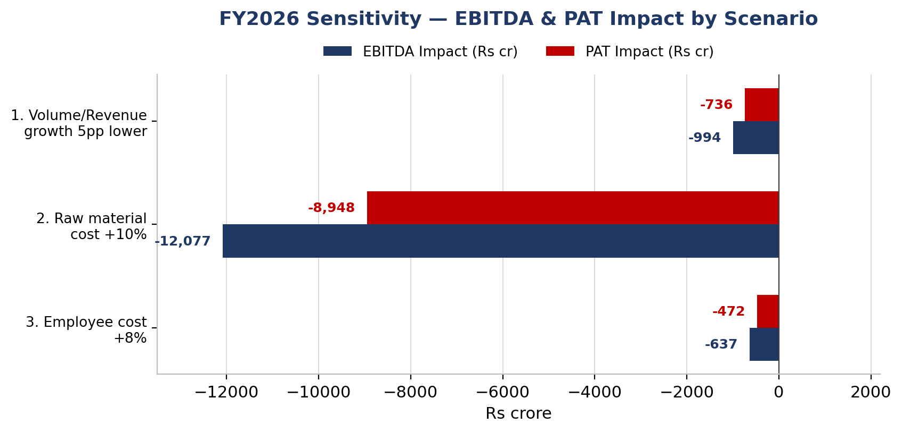
Chart 12.1: EBITDA and PAT impact by scenario, FY2026

Interpreting the Three Risks
- Scenario 1 — Volume/Revenue miss: if industry demand stays near ICRA’s low end and exports fall short of the 20% target, EBITDA falls by Rs 994 crore. Because ~87% of the cost base scales with revenue, the impact is proportionate — a real but moderate risk.
- Scenario 2 — Raw-material cost overrun: this is by far the dominant risk. A 10% adverse move in the Cost-of-Materials assumption (71.3%→78.4% of revenue) cuts EBITDA by Rs 12,077 crore — more than 12× Scenario 1’s impact — because Cost of Materials is ~82% of total operating costs and price hikes cannot instantly re-offset a commodity shock.
- Scenario 3 — Wage/hiring overrun: the smallest of the three (Rs 637 crore EBITDA impact), since Employee Cost is only ~4.7% of revenue — but included because it is the least flexible cost line if Kharkhoda hiring runs ahead of plan.

12.2 Combined Downside & Bull Case
Beyond the SOW’s minimum of 2-3 individual risks, this analysis also tests a combined "perfect storm" downside (all three risks together) and a mirror-image Bull case (all three drivers moving favourably), to bracket the full realistic range of FY2026 outcomes.
Scenario | EBITDA | EBITDA Impact | PAT | PAT Impact
Combined Downside (all three risks together) | 8,886 | (13,134) | 5,463 | (9,731)
Bull Case (all three drivers move favourably) | 36,302 | +14,282 | 25,776 | +10,581
Table 12.2: Combined downside and Bull-case impact on EBITDA and PAT (Rs crore)
A simultaneous "perfect storm" is useful as a stress-test floor for the budget, though the three risks are only partially correlated in practice (e.g. a demand slowdown could coincide with softer commodity prices, partly offsetting rather than compounding). The Bull case is an equally-illustrative ceiling, built from the mirror-image favourable shock to each of the same three drivers.

12.3 Bear / Base / Bull Scenario Range
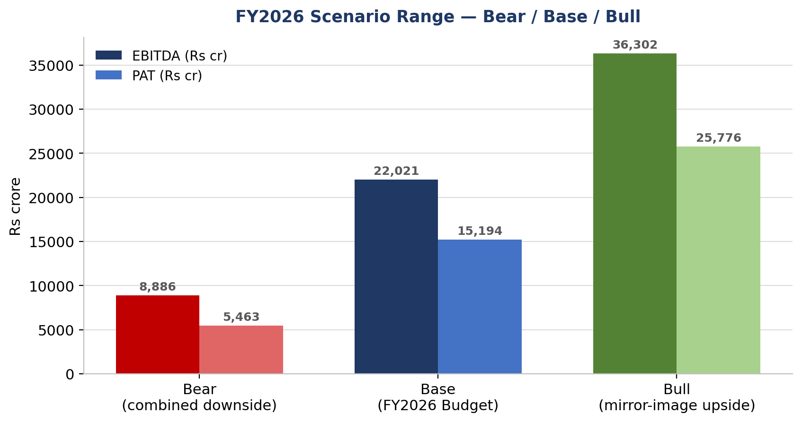
Chart 12.2: FY2026 EBITDA and PAT range — Bear / Base / Bull
The full realistic range for FY2026 PAT spans from roughly Rs 5,463 crore (Bear, 3.2% margin) to Rs 25,776 crore (Bull, 15.2% margin), around the Rs 15,194 crore (9.0% margin) base case. The range is asymmetric: the Bear case is proportionally further from Base than the Bull case is, because costs (COGS in particular) can deteriorate faster than they can improve — commodity cost spikes tend to be sharper than commodity cost relief, a pattern consistent with MSIL’s own FY2022 experience (Section 3.7).

12.4 Break-Even Analysis
Rather than only testing round-number shocks (+10%, +8%, etc.), this section solves algebraically for the exact adverse move in the Cost-of-Materials assumption that would be needed to fully erase FY2026’s budgeted PAT growth over FY2025 — i.e. the point at which the FY2026 budget would deliver zero PAT growth.
Particulars | Value | Note
FY2025 Actual PAT (break-even target) | 14,500 | Rs crore
FY2026 Budgeted PAT (base case) | 15,194 | Rs crore
Budgeted PAT growth over FY2025 | 694 | Rs crore — the growth "at risk"
Break-even relative COGS shock | 0.78% | Solved by iteration (Excel Goal Seek)
Resulting COGS %, of Revenue | 71.86% | vs. 71.3% budgeted — a move of well under 1pp
Table 12.3: Break-even analysis on the Cost-of-Materials assumption
This is the single most important number in this report: a Cost-of-Materials overrun of just +0.8% relative to budget (COGS rising from 71.3% to only ~71.9% of revenue — well under one percentage point) is sufficient, on its own, to erase all of FY2026’s budgeted PAT growth and push PAT back down to FY2025’s actual level. This is a materially smaller shock than the +10% tested in Scenario 2 (Section 12.1) — the margin of safety on MSIL’s single largest cost line is thinner than a round-number stress test alone would suggest. This finding should directly inform how tightly the FP&A team monitors input-commodity costs through the year (see Section 13.4).

12.5 Qualitative Risk Register
The three quantified risks above are deliberately narrow (single-driver shocks to an otherwise fixed budget). The table below broadens the lens to structural and strategic risks that are harder to quantify but still relevant to whether the FY2026 budget is achieved — these are not modelled in the workbook, but are flagged here for completeness and Board-level risk discussion.
Risk | Likelihood | Impact | Mitigant / Context
EV transition pace | Medium | Medium-High | e-Vitara is a first-generation product; if global EV demand (Japan/Europe export markets) softens, export volume growth could fall short of the 20% target embedded in Section 6.
Competitive share loss | Medium | Medium | Mahindra and Tata continue gaining SUV share (Section 2.6); if MSIL’s own SUV launches (Victoris, Fronx) underperform, both volume and mix assumptions are at risk.
Semiconductor / component supply | Low-Medium | Medium | Largely normalised since the FY2022 shortage, but remains a latent industry-wide risk, particularly for EV-specific components.
Regulatory / emissions norms | Low | Medium | Tightening Bharat NCAP safety and emissions norms could raise compliance costs embedded in "Other Opex" beyond the budgeted level.
Geopolitical / tariff risk | Medium | Medium | The April-2025 US tariff episode (Section 5.1) already illustrates how quickly trade policy can move the INR and import costs; a further escalation would pressure the Cost-of-Materials assumption directly.
Kharkhoda ramp-up execution | Low-Medium | Medium | Delays or cost overruns at the new plant would affect both the D&A assumption (Section 6) and the Fixed-Assets-to-Revenue driver (Section 10).
Monsoon / rural demand | Low-Medium | Low-Medium | A weak monsoon disproportionately affects entry-level (Mini/Compact) segment demand, MSIL’s traditional volume base.
Table 12.4: Qualitative risk register (illustrative — likelihood/impact are directional judgements, not modelled outputs)

13. Conclusion & Recommendation

13.1 Overall Assessment
The FY2026 budget presented in this report is internally consistent, driver-based, and fully reconciled: every revenue and cost line traces to a named, sourced assumption; the Budgeted Balance Sheet balances by construction; and the Budgeted Cash Flow Statement ties exactly to the movement in cash implied by the Balance Sheet. The headline picture is one of continued but decelerating growth — Revenue up 10.8%, EBITDA up 9.2%, but PAT up only 4.8% — as a firmer input-cost environment catches up with the margin-expansion story of the last three years. The EBITDA bridge (Section 8.3) shows this is a top-line-driven budget, not a margin-expansion one; the ratio analysis (Section 3.4) shows returns normalising down from a FY2024 peak as the balance sheet absorbs a large capex programme; and the break-even analysis (Section 12.4) shows the entire year’s profit growth rests on well under one percentage point of margin of safety on the single largest cost line.

13.2 Recommendation
Approve the budget as the FY2026 operating plan, with three conditions: (i) treat the Cost-of-Materials assumption (71.3% of revenue) as the single most important number in the entire budget to re-forecast monthly against actual commodity and input-cost data, given the break-even analysis shows a margin of safety of under one percentage point; (ii) revisit the Volume growth assumption (5.5%) at the Q1 FY2026 actuals checkpoint (Section 7.3), since it rests on an export-growth target (20%) that is more ambitious than the subdued domestic industry outlook (1-4%) it is blended with; and (iii) treat the FY2026 Fixed-Assets and D&A assumptions as provisional pending confirmation that the Kharkhoda plant ramp-up stays on its planned schedule and budget.

13.3 KPI Monitoring Dashboard
A single-page reference for the Board/FP&A team, consolidating the base case, the full Bear/Bull range, and the specific trigger points identified throughout this report.
KPI | Bear | Base (Budget) | Bull | Q1 Trigger
EBITDA (Rs cr) | 8,886 | 22,021 | 36,302 | ~Rs 5,065 cr by Q1 (23%)
EBITDA Margin % | 5.2% | 13.0% | 21.4% | Track monthly vs. 13.0%
PAT (Rs cr) | 5,463 | 15,194 | 25,776 | —
PAT Margin % | 3.2% | 9.0% | 15.2% | Track monthly vs. 9.0%
COGS % of Revenue | 78.4% | 71.3% | 64.2% | Break-even at just 71.9%
Revenue Growth % | 5.8% | 10.8% | 15.8% | Compare Q1 actuals vs. 10.8%
Table 13.1: KPI monitoring dashboard — Bear / Base / Bull with Q1 trigger points

13.4 Items for the FP&A Team to Monitor Through FY2026
- Actual vs. budgeted Cost-of-Materials % of revenue, monthly — the single largest swing factor for EBITDA, with a break-even margin of safety of under 1pp (Section 12.4).
- Export volume growth trajectory against the 20% target, given exports carry a disproportionate share of the budgeted volume growth despite being ~15% of total units (Section 7.1).
- Q1 actuals against the ~23% illustrative phasing weight (Section 7.3) as an early read on whether full-year Volume and Realisation assumptions are on track.
- Kharkhoda plant ramp-up costs and timeline — both the Employee Cost and D&A assumptions, and the Fixed-Assets-to-Revenue ratio, are directly tied to this capacity coming online as planned.
- e-Vitara EV launch costs and export traction, since the "Other Opex" assumption embeds a one-off marketing/launch cost that should unwind in later quarters.
- Effective tax rate normalisation — confirm the FY25 one-off (indexation-benefit withdrawal) does not recur, validating the 25.9% FY26 assumption.
- Competitive share trends in the SUV segment (Section 2.6) — a leading indicator for whether the Realisation/mix assumption holds.
This concludes the FY2026 Budgeted P&L, Balance Sheet, Cash Flow Statement, Ratio Analysis and Sensitivity Analysis for Maruti Suzuki India Limited, prepared in accordance with the Financial Planning & Analysis (FP&A) Analyst Live Project Scope of Work.

Appendix A: Sources & Methodology Notes

Primary Financial Data
- Maruti Suzuki India Limited — quarterly and annual consolidated financial results filed with BSE & NSE, and company press releases, FY2022–FY2026 (marutisuzuki.com/corporate/media/press-releases).
- Maruti Suzuki India Limited — monthly and annual vehicle sales press releases (domestic/export volume data).
- Historical cost-structure common-size ratios (Raw Material Cost, Employee Cost, Power & Fuel, Other Manufacturing, Selling & Admin, Other Expenses, each as % of sales) — used only to derive the COGS/Employee/Other-Opex split methodology; the underlying revenue, PBT and PAT totals are the Company’s own reported consolidated figures.

Macroeconomic Sources
- Reserve Bank of India — Monetary Policy Report and MPC resolutions, February and April 2025 (GDP growth, inflation, and repo-rate assumptions).
- Press Information Bureau (PIB), Government of India — RBI policy announcements.
- World Steel Association — India steel demand growth outlook, CY2026.
- ICRA — Indian passenger-vehicle wholesale growth outlook, FY2026 (August 2025).
- Society of Indian Automobile Manufacturers (SIAM) — industry press releases and growth commentary.

Company & Strategy Context
- Maruti Suzuki corporate website (marutisuzuki.com/corporate) — company profile, capacity expansion ("Maruti Suzuki 3.0"), and EV strategy.
- MSIL earnings-call commentary and Reuters coverage — FY2026 capex guidance, export growth target, and price-hike announcement.
- Market-share and competitive positioning: RushLane, Autocar India, CarDekho industry coverage (approximate SIAM-sourced FY2025 figures).

Important Note on Source Authenticity
All historical revenue, profit and balance-sheet figures used in this budget are Maruti Suzuki’s own reported consolidated results — independently cross-checked against reported PBT and PAT in every year (see Section 3). Where a figure required estimation because the underlying source dataset did not carry the necessary granularity (the COGS/Employee/Other-Opex split, implied historical capex, competitor market share, and the illustrative quarterly phasing weights), this is explicitly flagged as an estimate or illustrative construct, not presented as a disclosed company figure — consistent with the Data Accuracy & Traceability standard set out in the Scope of Work.

Appendix B: Glossary of Terms
Term | Definition
ASP | Average Selling Price — used interchangeably with "Realisation" in this report.
COGS | Cost of Goods Sold — here, Cost of Materials Consumed, MSIL’s largest single cost line.
D&A | Depreciation & Amortisation.
EBITDA | Earnings Before Interest, Tax, Depreciation & Amortisation — Revenue minus Total Operating Expenses.
EBIT | Earnings Before Interest & Tax — EBITDA minus D&A.
FCF | Free Cash Flow — here, a simplified proxy (PAT + D&A − Capex), before working-capital movements.
FP&A | Financial Planning & Analysis.
MSIL | Maruti Suzuki India Limited.
NCA / NCWC | Net Current Assets / Net Current Working Capital — receivables + inventory minus payables & other current liabilities; structurally negative for MSIL.
OCI | Other Comprehensive Income — non-P&L items (e.g. fair-value gains) that flow directly to equity.
PAT | Profit After Tax.
PBT | Profit Before Tax.
ROA / ROE / ROCE | Return on Assets / Equity / Capital Employed — see Section 3.4 for exact formulas used.
SIAM | Society of Indian Automobile Manufacturers — the Indian auto industry body.
SMG | Suzuki Motor Gujarat Private Limited — a wholly-owned Suzuki subsidiary manufacturing vehicles for MSIL.
SOW | Scope of Work — the Caplexus Capital Live Project brief this report follows.

