THE OUTLOOK GROUP
Business Analytics Module
Customer Relationship Management — NPS & Customer Lifecycle Analysis
Prepared by: Aishwarya
Outlook Live Project Program — MBA Business Analytics
Survey responses: 133 collected, 123 valid | Overall NPS: 11.4

Executive Summary
This report covers the Customer Relationship Management module. Part 1 answers the six theoretical questions on CRM, the customer life cycle, CLV, and NPS. Part 2 develops a competitor analysis across six magazine segments (India Today, Business Today, Outlook, The Week, Forbes India, and Frontline) covering subscription promotional offers and customer life-cycle behaviour, benchmarked against international subscription models (The Economist, The New York Times). Parts 3 and 4 cover response collection (133 responses, 123 valid after screening) and the resulting NPS and life-cycle analysis.
Headline finding: overall NPS is +11.4 — modestly positive, driven by a near-even split between Promoters (50) and Detractors (36), with a large Passive middle (37) that represents the biggest single opportunity for a well-targeted retention offer. NPS varies sharply by title, from Frontline's +30.8 to Forbes India's -8.0, and — counter to what might be assumed — readers with exposure to international publications report a *lower* NPS for their Indian title (-4.4) than those without (+20.5), suggesting international exposure raises the bar readers judge Indian titles against.

Part 1 — Theoretical Analysis

1. What is CRM?
Customer Relationship Management (CRM) is the strategy, process, and technology a business uses to manage its interactions with current and prospective customers across the entire relationship — not just at the point of sale. In a subscription business like a magazine publisher, CRM covers how a reader is acquired, how their engagement is tracked and nurtured over their subscription lifetime, how renewal and churn risk are managed, and how the relationship is grown through upsells (a second title, a bundle, a higher tier). Modern CRM combines a data layer (a customer database tracking every interaction), a process layer (defined playbooks for onboarding, renewal outreach, win-back), and increasingly an analytics layer (NPS, churn prediction, lifetime value) that turns raw interaction data into decisions.

2. Significance of the customer life cycle — acquisition, retention, development
- Customer acquisition is the process of converting a prospect into a first-time customer — for a magazine, this is the first subscription or the first habitual read. It is usually the most expensive stage per customer (marketing spend, promotional discounts, free trials) and yields no profit on its own; it only pays back if the customer is retained.
- Customer retention is keeping an existing customer subscribed and engaged over time. It is far cheaper than acquisition (no fresh marketing spend needed) and is where most of a subscription business's profit is actually earned, since the sales/marketing cost was already paid in the acquisition stage.
- Customer development is growing the value of an already-retained customer — upgrading them to a bundle, a second title, a premium digital tier, or turning them into a referral source. This is the highest-margin stage, since it monetises trust that already exists rather than building it from scratch.
- The significance of treating these as three distinct stages is that each needs a different strategy, a different cost model, and a different success metric — a business that only measures acquisition (new subscriber count) while ignoring retention and development will keep paying full acquisition cost to replace customers it is quietly losing.

3. What is Customer Lifetime Value (CLV), and what is its general trend across the customer life cycle?
Customer Lifetime Value (CLV) is the total net profit a business expects to earn from a customer across the entire span of their relationship, typically estimated as (average revenue per period x expected relationship length x margin) minus the acquisition cost. It answers the question a single-purchase metric cannot: not 'what did this customer just pay us' but 'what is this customer worth to us in total.'
- At acquisition, CLV is typically negative or near zero — acquisition cost (marketing, discount-driven promotional pricing) usually exceeds first-period revenue.
- Through the early retention period, CLV climbs as the customer renews at (or near) full price with no further acquisition cost — each additional renewal period is close to pure margin.
- In the development stage, CLV accelerates further if the customer is successfully upsold (a bundle, a second title) — average revenue per customer rises without a proportional rise in cost to serve them.
- CLV plateaus or declines if churn risk materialises (the customer lapses) — which is exactly why the churn-consideration and cancellation-reason data in this module's survey matters: it is a leading indicator of where CLV is about to stop growing.

4. What is Net Promoter Score (NPS)?
Net Promoter Score is a single-number measure of customer loyalty, calculated from one question: 'On a scale of 0-10, how likely are you to recommend this [product/brand] to a friend or colleague?' Respondents are grouped into Promoters (9-10), Passives (7-8), and Detractors (0-6), and NPS = %Promoters - %Detractors, giving a score that can range from -100 to +100. Unlike a satisfaction rating, NPS is designed to correlate with actual word-of-mouth referral behaviour and, over time, with revenue growth — the logic being that a customer's willingness to put their own reputation behind a recommendation is a stronger loyalty signal than a satisfaction score.

5. What research questions can be asked to find NPS?
- The core question: 'On a scale of 0 to 10, how likely are you to recommend [this magazine/brand] to a friend or colleague?' — this single question is what NPS is calculated from.
- A mandatory open-ended follow-up: 'What is the main reason for the score you gave?' — this is what turns a number into an actionable diagnostic (this module's survey uses exactly this pairing).
- Segmenting questions asked alongside it — which product/title, how long they've been a customer, which channel acquired them — so NPS can be broken down by segment rather than read only as one aggregate number, exactly as done in this module's 6-title segment comparison.
- A forward-looking question such as 'What one thing would most improve your experience?' — turns the passive/detractor group's dissatisfaction into a prioritised action list rather than just a complaint log.

6. Who are promoters, detractors, and passives?
- Promoters (score 9-10) are loyal enthusiasts who will keep buying and actively refer others, fuelling organic growth at close to zero acquisition cost — the segment a business wants to identify and turn into referral/advocacy programmes.
- Passives (score 7-8) are satisfied but unenthusiastic customers who are vulnerable to competitive offers; they won't complain, but they also won't advocate, and they are the segment most winnable with a well-targeted retention or development offer.
- Detractors (score 0-6) are unhappy customers who can damage the brand through negative word-of-mouth and are at the highest risk of churn; they are the segment a business must either win back with a direct service-recovery effort or, if the cost of doing so exceeds their CLV, consciously accept the loss of.

Part 2 — Competitor Analysis & Survey Design

Subscription promotional offers: Indian print media
- India Today runs an acquisition-led funnel: a 1-month-free trial that auto-continues at Rs 299/month, layered with promo-code discounts (e.g. Rs 500 off a 1-year Print + Digital plan) timed to campaigns like its 'Mood of the Nation' survey issue.
- Business Today (same publisher group) leans on development-stage offers instead — bulk-subscription rebates and academic discounts for schools/libraries — and uses WhatsApp to push new-issue notifications to existing subscribers, a retention-stage engagement tactic.
- Outlook bundles across its own titles (Outlook, Business, Traveller, Money, Hindi) with combo pricing and gift-with-purchase offers (e.g. an Amazon voucher on 1-year print orders), and enforces a rule that print and digital cannot be mixed within a single order — a structural nudge toward one access mode per customer rather than the hybrid access many readers say they want (see Lifecycle - Retention).
The pattern across Indian players: pricing is discount-off-a-flat-annual-rate, largely undifferentiated by customer lifecycle stage — the same kind of offer (a percentage or rupee discount) is used to acquire, retain, and develop, rather than distinct offers purpose-built for each stage.

Subscription promotional offers: international counterparts
- The Economist prices a clear acquisition funnel: first 4 weeks free, then $7.25/week, with a published regular rate of $289/year discounted to $202.30 for new digital subscribers — the gap between offer price and 'regular rate' is the explicit lever used to convert trials.
- The New York Times uses the most aggressive acquisition pricing seen in this research: $1/week for the first year before stepping up to $25 every four weeks ($325/year) — a >20x price step-up at renewal, and is now bundling with The Economist itself in a push toward 15 million subscribers, an explicit customer-development tactic (cross-sell an adjacent masthead to an existing base).
The structural difference: international players price acquisition and retention as two deliberately different numbers (steep discount to convert, full price to retain), which only works if the retention-stage product is strong enough to survive the price step-up. Indian players, by contrast, rarely step price up as sharply — which limits the initial acquisition discount they can afford to offer, and may explain why cancellation-consideration in this survey's data is concentrated more around price increases (see Lifecycle - Retention) than around a sudden shock renewal price.

Survey design and distribution
A 20-question Google Form was built across six sections (screening/demographics, acquisition, retention, development, NPS, international comparison — full design in the accompanying survey documentation), then distributed for response collection. 133 responses were collected; 10 were screened out at Q1 (do not read any Indian news/business magazine) per the survey's own screening logic, leaving 123 valid responses for all magazine-specific and NPS analysis in Parts 3-4.

Part 3 & 4 — Response Analysis: NPS and Customer Lifecycle

Overall NPS
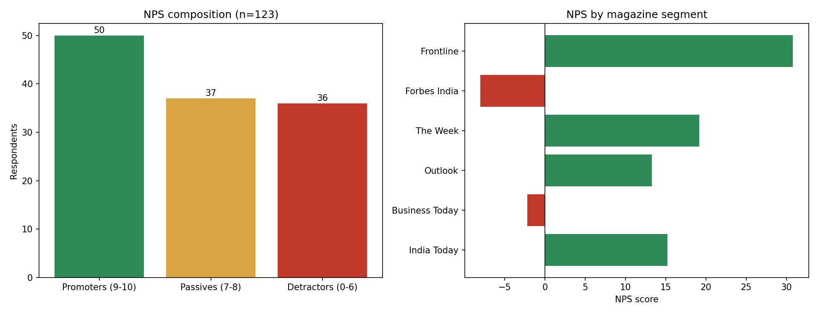
Figure 1. Overall NPS composition and NPS by magazine segment.
Across 123 valid respondents: 50 Promoters, 37 Passives, 36 Detractors, giving an overall NPS of +11.4. A positive-but-modest score with a Passive group nearly as large as the Promoter group means the base is only lightly loyal — satisfied enough not to complain, not enthusiastic enough to actively refer others.

Segment Comparison (Competitor Analysis)
Title | n | NPS | Top acquisition channel | Churn consideration | Top promo preference
India Today | 46 | 15.2 | Family or friend recommendation | 39.1% | Discounted multi-title bundle
Business Today | 45 | -2.2 | Family or friend recommendation | 53.3% | A price-lock guarantee against future increases
Outlook | 30 | 13.3 | Social media | 26.7% | Discounted multi-title bundle
The Week | 26 | 19.2 | Family or friend recommendation | 26.9% | A price-lock guarantee against future increases
Forbes India | 25 | -8 | Family or friend recommendation | 40% | Extra free months on renewal
Frontline | 13 | 30.8 | Newsstand or vendor | 15.4% | A price-lock guarantee against future increases
Table 1. Six-title segment comparison, all figures from the survey response data.
Frontline stands out with the highest NPS (+30.8) and the lowest churn-consideration rate (15.4%) among its (smaller, n=13) reader base, driven mainly by newsstand discovery and long tenure (most over 5 years) — a legacy-loyalty profile. Forbes India and Business Today are the two titles with negative NPS, and both show above-average churn consideration (40% and 53.3% respectively); Business Today's own top promo preference — a price-lock guarantee against future increases — is a direct signal from its own readers about what would address that risk.

Lifecycle: Acquisition
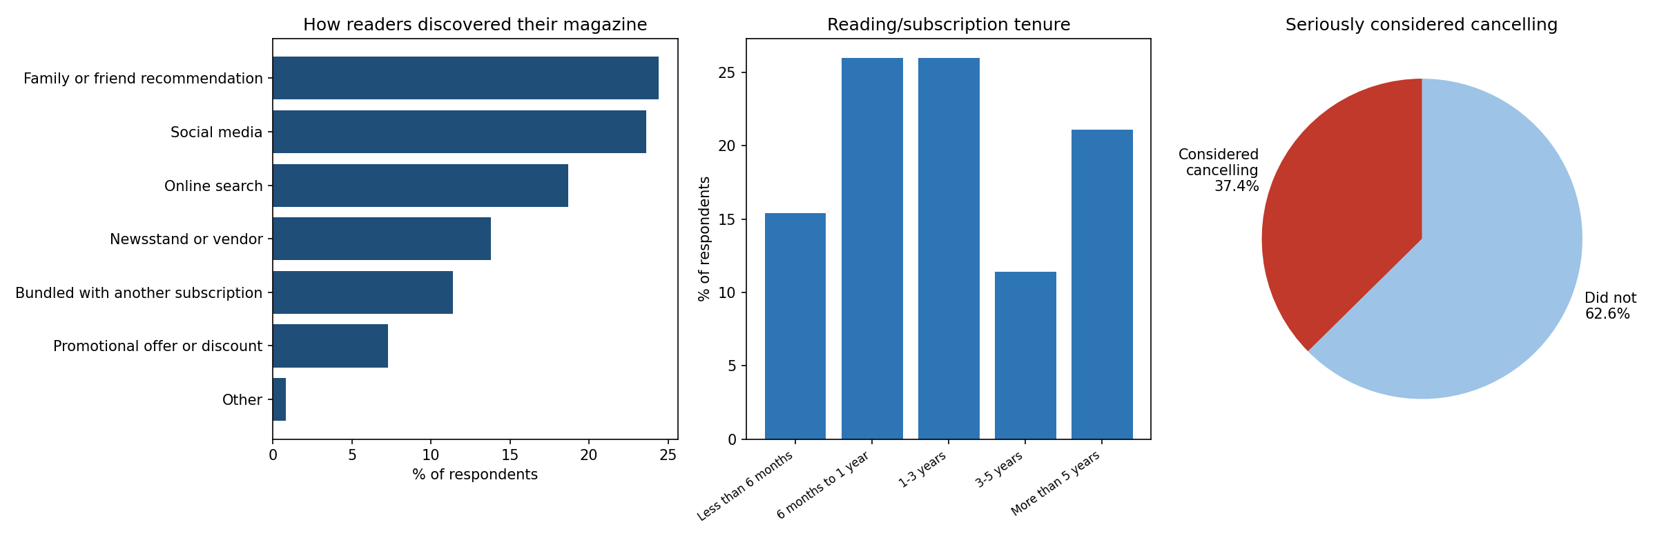
Figure 2. Discovery channel, subscription tenure, and churn consideration.
Family/friend recommendation (24.4%) and social media (23.6%) are the two leading discovery channels, well ahead of paid promotional offers (7.3%) — word-of-mouth and organic digital discovery are doing more acquisition work than discount-led marketing for this reader base, which reinforces the earlier point that Promoters (who drive word-of-mouth) are worth deliberately cultivating rather than only measuring.

Lifecycle: Retention
37.4% of valid respondents have seriously considered cancelling or not renewing — a meaningfully high churn-risk signal. Decline in content quality (34.8%), Price increase (30.4%), Switched to another source (23.9%), Lack of time to read (10.9%) were the reasons cited, among those who considered it.

Lifecycle: Development
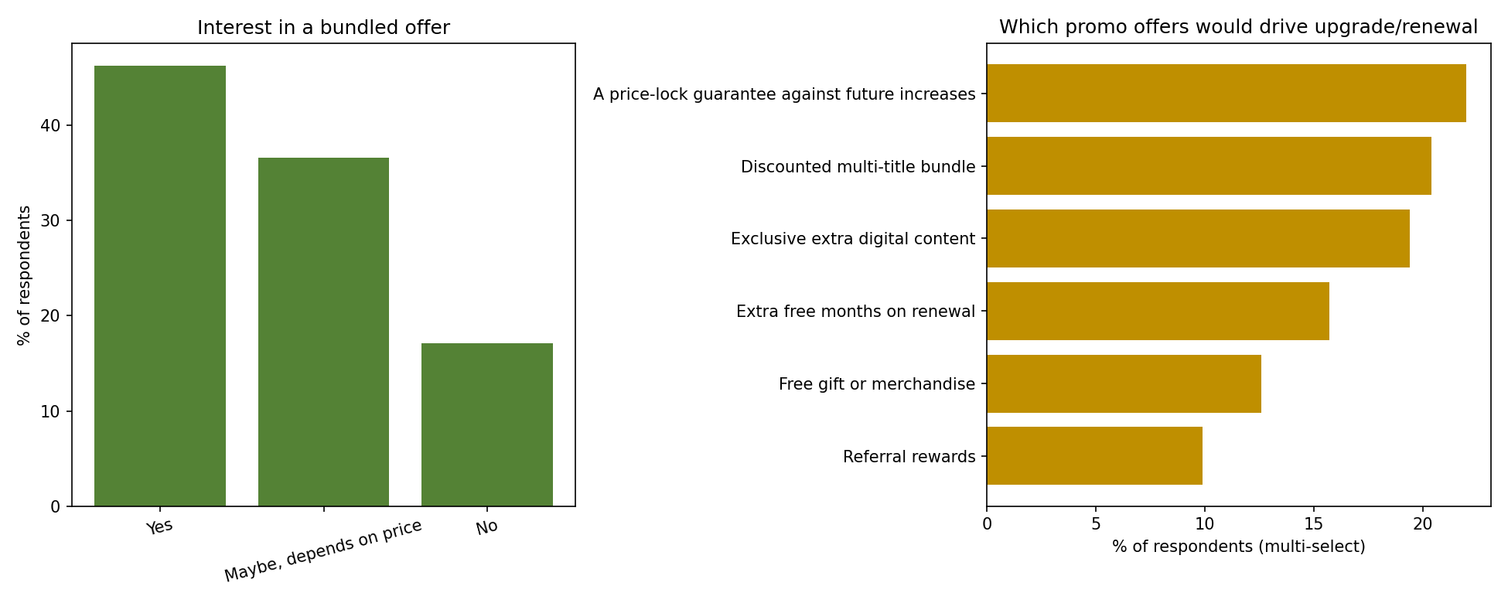
Figure 3. Bundle interest and promotional-offer preference.
Only 22% of respondents already subscribe to more than one title from the same publisher, but 46.3% say they are interested in a bundled offer outright (plus a further 36.6% conditionally interested on price) — a large gap between current multi-title behaviour and stated bundle appetite that represents the clearest single development-stage opportunity in this data. A price-lock guarantee against future increases and a discounted multi-title bundle are the two most-cited offers that would drive upgrade or renewal.

International Comparison
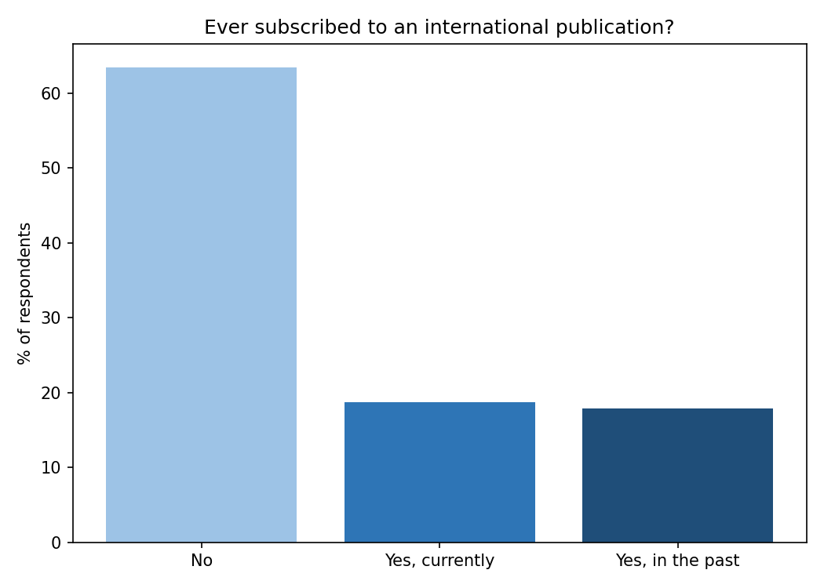
Figure 4. Exposure to international publications.
18.7% currently subscribe to an international publication and a further 17.9% have in the past — over a third of the base has some international exposure. As noted in the Executive Summary, this group reports a lower NPS for their Indian title (-4.4) than readers with no international exposure (+20.5), consistent with the international pricing research in Part 2: international players invest far more deliberately in distinct acquisition/retention pricing and in premium content depth, which may be resetting the bar these readers hold Indian titles to.

Recommendations
- Prioritise the Passive segment (37 respondents, score 7-8) for a low-cost development nudge — a bundle offer or a price-lock guarantee, both already the top-requested offers in this data — since converting Passives to Promoters is cheaper than either replacing a churned Detractor or acquiring a new reader.
- Investigate Business Today and Forbes India's negative NPS directly with a targeted follow-up (their own top cancellation reasons and promo preferences are already visible in Table 1) rather than applying a group-wide fix — their loyalty problems look structurally different from each other.
- Close the bundle gap: 46.3% outright bundle interest against only 22% actual multi-title subscription is the single largest, most concretely actionable development opportunity in this dataset.
- Treat international-exposed readers as a distinct segment for content strategy, not pricing — their lower NPS tracks with content/analysis depth expectations set by international titles, which a price-based offer alone will not fix.

Conclusion
This module carried a CRM analysis through its full arc — from the theory of the customer lifecycle and NPS, through a competitor analysis of Indian and international subscription pricing, to primary survey data collection and its analysis. The consistent thread across all four parts is that acquisition is not where this reader base's loyalty problem sits (word-of-mouth and organic discovery are working reasonably well) — retention and development are where the concrete, data-backed opportunities lie: a large Passive segment ready to be converted, a bundle appetite well ahead of current bundle uptake, and title-specific churn risk that the segment comparison already points toward addressing directly. Full detail, live formulas, and the complete response dataset are in the companion Excel workbook (CRM_Analysis.xlsx).

