THE OUTLOOK GROUP
Business Analytics Module
Cash Flow Analysis
Prepared by: Aishwarya
Outlook Live Project Program — MBA Business Analytics

Executive Summary
This report covers the Cash Flow Analysis module: the theory of cash flow analysis and its three components, a full Cash Flow Statement derived from the provided Balance Sheet and P&L (which contained no cash flow statement), and a secondary-research comparison of cash flow health across FMCG, FMCD, and BFSI companies.
Headline finding: the company's derived cash flow shows a clear stress-then-stabilise pattern. FY2022 was the low point — CFO of Rs -245.9 Cr and Free Cash Flow of Rs -598.1 Cr, both negative, bridged by a Rs 669.9 Cr financing inflow (fresh borrowing). FY2023-24 show recovery to consistent positive CFO (Rs 156.4-147.3 Cr) alongside a return to accounting profitability, though free cash flow remains thin.

Part 1 — Theoretical Analysis

1. What do you mean by cash flow analysis?
Cash flow analysis is the examination of how cash moves into and out of a business over a period, organised into operating, investing, and financing activities, to assess the company's ability to generate cash, fund its operations and growth, and meet its obligations. Unlike profit (which includes non-cash items like depreciation and accrual-based revenue/expense recognition), cash flow analysis looks strictly at actual cash movement — which is why a company can be profitable on paper yet run short of cash, or vice versa.

2. Mention its significance from a company's perspective.
- Liquidity management — ensures the company can meet short-term obligations (salaries, suppliers, loan repayments) without relying on emergency borrowing.
- Investment and growth funding — shows whether internally generated cash can fund capital expenditure and expansion, or whether external financing is required.
- Creditworthiness — lenders and credit-rating agencies weight cash flow (especially CFO and free cash flow) more heavily than accounting profit when assessing default risk.
- Early warning signal — a business can show accounting profit while its cash position deteriorates (e.g. through working-capital build-up), and cash flow analysis is what surfaces that gap before it becomes a crisis.
- Dividend and capital-allocation decisions — a board can only sustainably return cash to shareholders if operating cash generation supports it beyond what accounting profit alone would suggest.

3. What do you mean by Cash Flow from Operations, Cash Flow from Investing, and Cash Flow from Financing?
- Cash Flow from Operations (CFO) — cash generated or used by the company's core, day-to-day business: collections from customers, payments to suppliers and employees, and taxes paid, adjusted for non-cash items (like depreciation) and working-capital movements (inventory, receivables, payables).
- Cash Flow from Investing (CFI) — cash used for or generated from long-term asset decisions: purchasing or selling property/plant/equipment (capex), buying or selling investments, and lending or collecting long-term loans/advances.
- Cash Flow from Financing (CFF) — cash flows between the company and its capital providers: raising or repaying debt, issuing or buying back shares, and paying dividends or interest.

4. What is free cash flow?
Free Cash Flow (FCF) is the cash a business generates from operations after accounting for the capital expenditure needed to maintain or grow its asset base — typically calculated as CFO minus Capex. It represents the cash genuinely available to the company for discretionary use: paying down debt, paying dividends, buybacks, or funding new strategic initiatives, without impairing the existing operating asset base. FCF is widely used in valuation and credit analysis precisely because it strips out both the accounting distortions of profit and the mandatory reinvestment every operating business must make.

5. What do you mean by Positive and Negative cash flow?
Positive cash flow means more cash came into a category (or the business overall) than went out over the period — the company's cash balance in that respect grew. Negative cash flow means the reverse: more cash went out than came in. Context matters enormously in interpreting the sign: negative CFI is often a healthy sign (the company is investing in growth), while negative CFO is a much more serious signal (the core business itself is consuming cash rather than generating it), and negative CFF can simply mean debt is being paid down or dividends distributed from a position of strength.

6. Analyse the statement shared with you in detail. What does it say about the company's financial position?
- The source file contained a Balance Sheet and P&L (FY2020-FY2024) but no Cash Flow Statement, so one was derived using the indirect method (full derivation and methodology notes are in the companion Excel workbook).
- Revenue collapsed from Rs 1,138.8 Cr (FY2020) to Rs 528.1 Cr (FY2021) — a COVID-scale shock — before recovering to Rs 1,418.9 Cr by FY2024, alongside losses in FY2020-FY2022 (worst: -Rs 265.8 Cr in FY2020) turning into a Rs 213.7 Cr profit in FY2023.
- Derived CFO swung from a marginal Rs 10 Cr (FY2021) to a sharply negative Rs -245.9 Cr (FY2022) — the same year Non-Current and Current Investments both roughly doubled on the balance sheet — before recovering to a steadier Rs 156.4 Cr and Rs 147.3 Cr in FY2023-24.
- Free Cash Flow was negative in FY2022 (-Rs 598.1 Cr) and marginally negative in FY2023 (-Rs 20 Cr), meaning operating cash generation alone did not cover capital expenditure in those years — the shortfall was bridged by a large financing inflow in FY2022 (CFF of +Rs 669.9 Cr, i.e. fresh borrowing), which is the clearest financial-stability flag in this dataset.
- Short-term borrowings more than doubled from Rs 421.6 Cr (FY2020) to Rs 1,087.1 Cr (FY2022) before easing to Rs 970.4 Cr by FY2024 — consistent with the FY2022 cash shortfall being plugged by debt rather than internally generated cash.
- Taken together: this is a company that went through a genuine liquidity-stress period around FY2021-22 (collapsed revenue, negative CFO, negative FCF, rising short-term debt), and has since stabilised — FY2023-24 show consistent positive CFO in the Rs 147-156 Cr range and a return to profitability — but has not yet rebuilt a strongly positive free-cash-flow cushion.

Derived Cash Flow Statement — Detail
The source file supplied a Balance Sheet and P&L for FY2020-FY2024 but no Cash Flow Statement. One was derived using the indirect method: starting from Profit Before Tax, adding back non-cash items (depreciation, finance costs) and non-operating income, adjusting for working-capital movements from the Balance Sheet, then separately deriving investing flows (capex approximated from the net change in fixed assets plus depreciation, changes in investments and loans) and financing flows (changes in borrowings, less interest and dividends paid).
Methodology caveat, stated plainly: FY2021's Balance Sheet lumps all fixed assets into a single 'Tangible Assets' line, while every other year splits Tangible/Intangible/CWIP/Other separately — this distorts the capex approximation specifically for FY2021 and FY2022. As a built-in accuracy check, the derived net cash change was reconciled against the actual year-on-year change in the Cash & Cash Equivalents balance: FY2023 reconciles almost exactly (a Rs 0.3 Cr gap), which validates the method; the larger FY2021/FY2022 gaps trace directly to that classification break, not a calculation error.
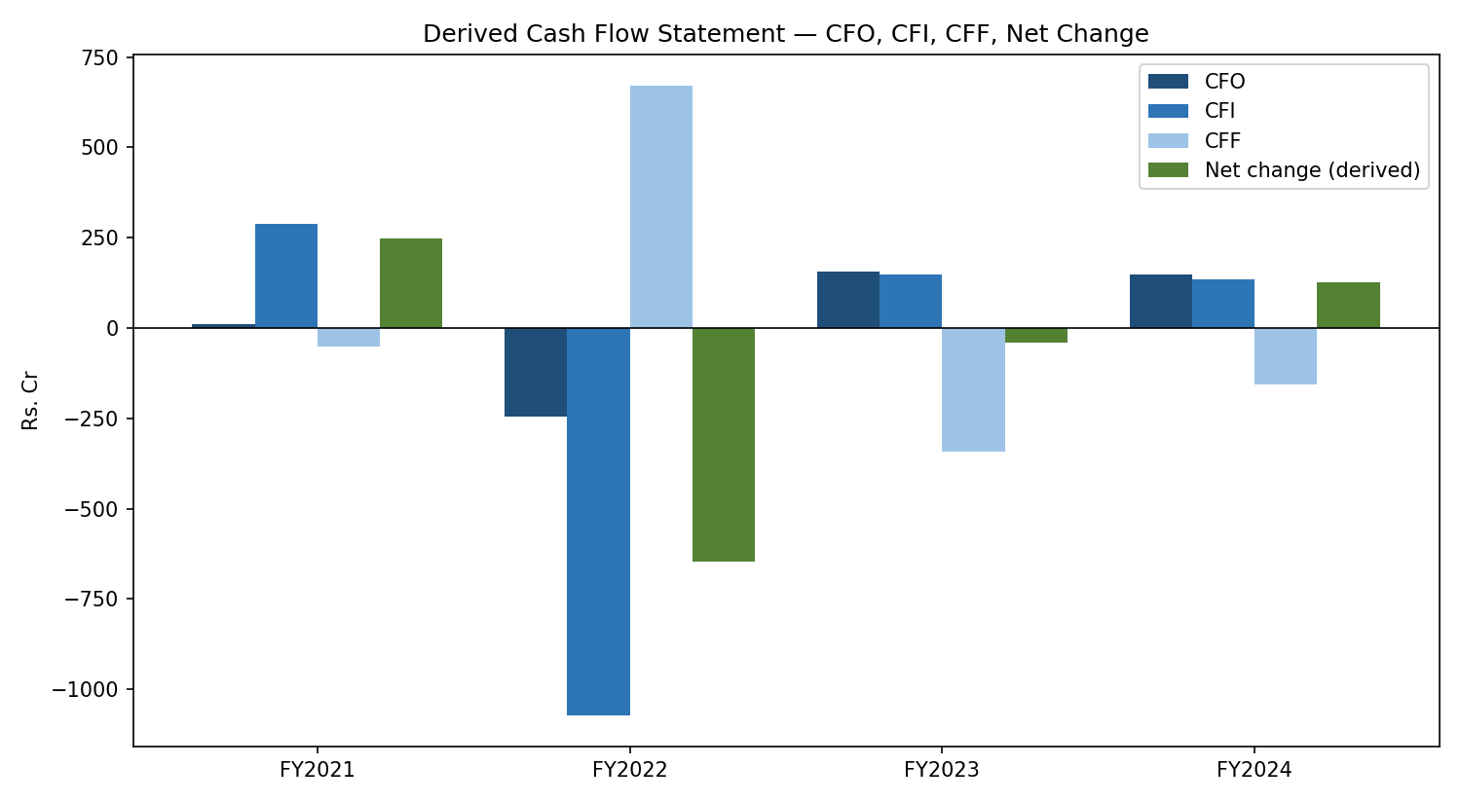
Figure 1. Derived CFO, CFI, CFF and net cash change, FY2021-FY2024.
Rs. Cr | FY2021 | FY2022 | FY2023 | FY2024
CFO | 10 | -245.9 | 156.4 | 147.3
CFI | 288.9 | -1,071.5 | 147 | 135.4
CFF | -50.4 | 669.9 | -343.5 | -157
Free Cash Flow | 224.3 | -598.1 | -20 | 61.9
Reconciliation gap | 249.7 | -721.5 | -0.3 | 140.3
Table 1. Summary derived cash flow statement (full line-by-line build in the Excel workbook).
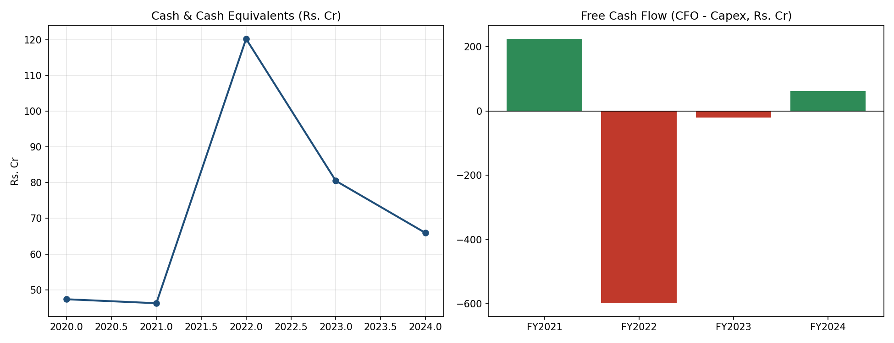
Figure 2. Cash & cash equivalents balance, and Free Cash Flow by year.
Cash on the balance sheet actually peaked in FY2022 (Rs 120.3 Cr) despite that being the worst CFO/FCF year — because the financing inflow (fresh short-term borrowing) more than covered the operating and investing shortfall that year. Cash has declined every year since, down to Rs 65.9 Cr by FY2024, even as CFO turned positive — consistent with the company using stabilising operating cash flow to pay down some of that FY2022 borrowing rather than rebuilding its cash buffer.
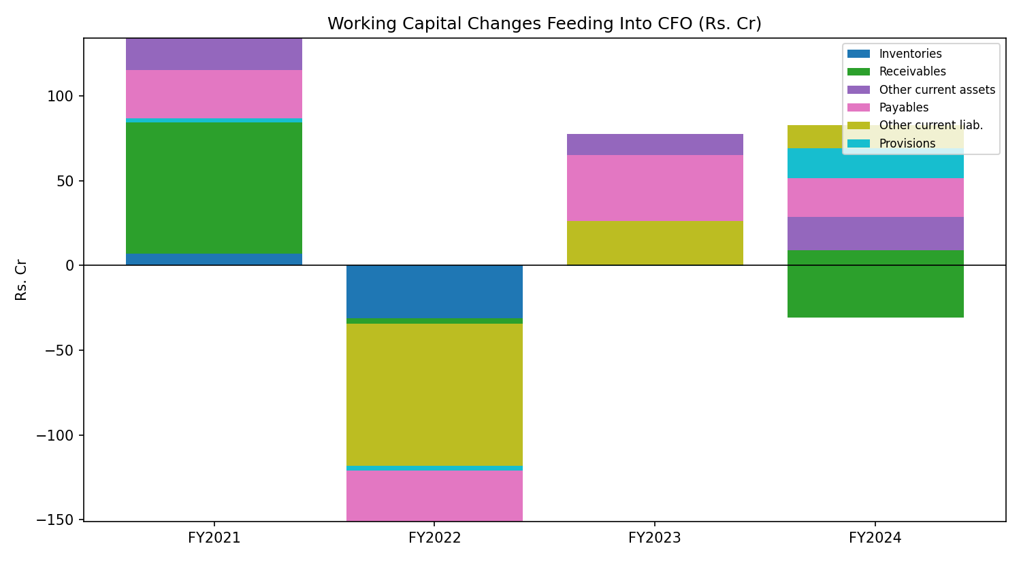
Figure 3. Working-capital components feeding into CFO each year.

Secondary Research — Sector Cash Flow Comparison
Published cash flow figures (most recent available FY) for two companies each in FMCG, FMCD, and BFSI were collected to benchmark cash flow health and financial stability patterns across sectors.
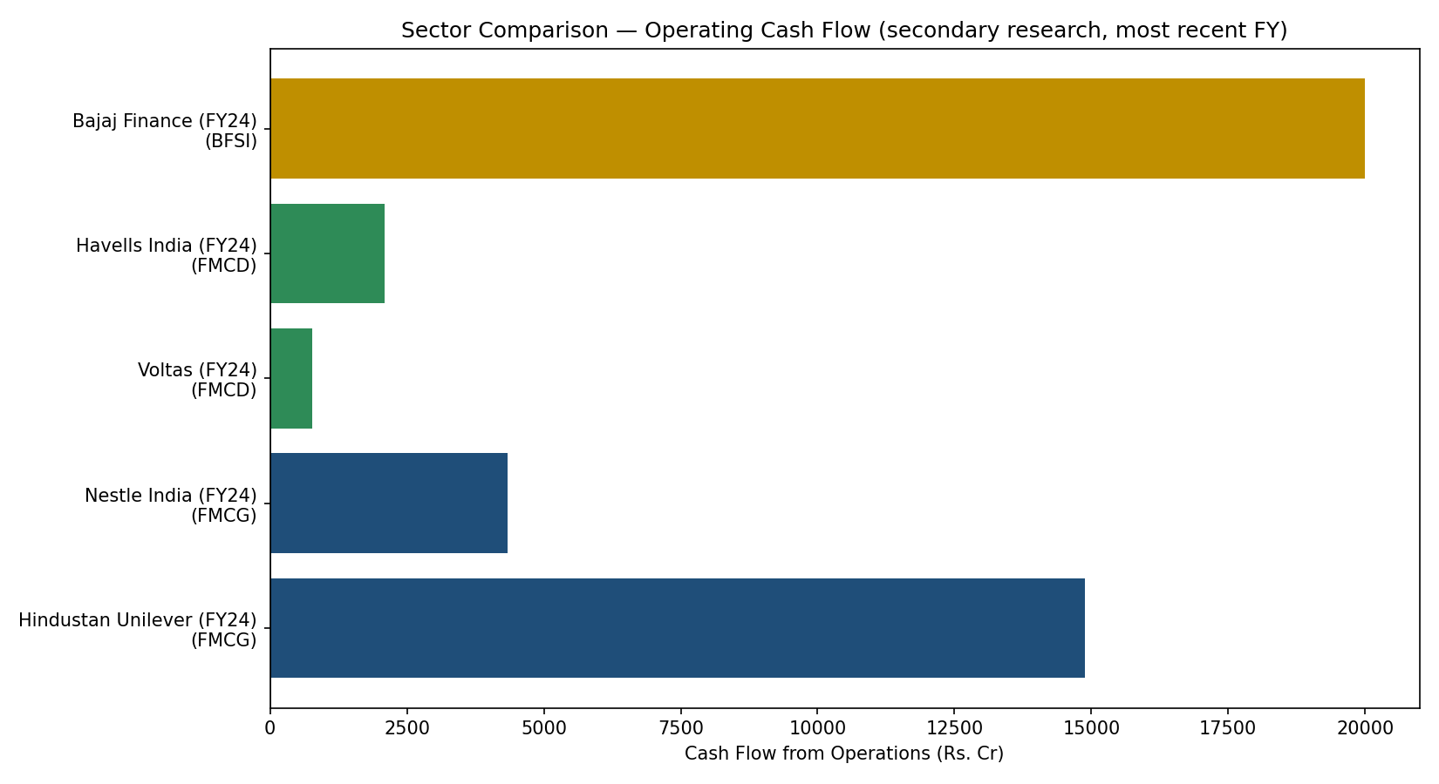
Figure 4. Operating cash flow by company, most recent FY (secondary research).
Company (Sector) | CFO | CFI | CFF | FCF
Hindustan Unilever (FY24) (FMCG) | 14,884 | -5,324 | -10,034 | 13,992
Nestle India (FY24) (FMCG) | 4,340 | -1,404 | -3,133 | 2,458
Voltas (FY24) (FMCD) | 762 | -522 | -116 | 468
Havells India (FY24) (FMCD) | 2,096 | -1,765 | -526 | 1,310
Bajaj Finance (FY24) (BFSI) | 19,992 | -98,282 | 82,415 | 18,954
Table 2. Sector comparison, Rs. Cr, most recent FY per company's own published cash flow statement.

Sector interpretation
- FMCG (Hindustan Unilever, Nestle India): both show strongly positive CFO well in excess of capex, with negative CFI and CFF driven by disciplined reinvestment and consistent dividend payout — the textbook profile of a mature, self-funding, cash-generative sector.
- FMCD (Voltas, Havells India): positive but proportionally thinner CFO than FMCG, with capex-driven negative CFI reflecting ongoing manufacturing capacity investment — capital-intensive but still self-funding.
- BFSI (Bajaj Finance): structurally different from non-financial sectors — loan-book growth is treated as an operating/investing outflow, funded by a large positive financing inflow (fresh borrowing/deposits). A negative CFO or CFI here does not signal distress the way it would for a manufacturer; it reflects balance-sheet growth financed by fresh capital, and should be read against loan-book growth and asset quality rather than free cash flow alone.
Benchmarked against this comparison, the company analysed in this report behaves nothing like the stable FMCG/FMCD peers — its year-to-year CFO swing (from -Rs 245.9 Cr to +Rs 156.4 Cr across just two years) is far more volatile than either sector's pattern, and its FY2022 reliance on financing inflows to cover an operating and investing shortfall is a genuine stability concern that neither FMCG nor FMCD peer shows in their published cash flows.

Recommendations
- Treat FY2022 as the year to investigate directly with management/notes to accounts — the combination of negative CFO, negative FCF, and a large simultaneous jump in investments is the single clearest anomaly in this analysis.
- Monitor the declining cash balance (Rs 120 Cr to Rs 66 Cr, FY2022-FY2024) alongside continued short-term borrowing levels (still ~Rs 970 Cr in FY2024) — positive CFO has not yet translated into a rebuilt cash cushion.
- Benchmark future capex and working-capital discipline against the FMCG/FMCD peers in Table 2, whose consistently positive free cash flow — not just positive CFO — is what ultimately funds dividends and debt reduction without relying on fresh borrowing.

Conclusion
This module carried the cash flow analysis from theory through to a full derived Cash Flow Statement (built from Balance Sheet and P&L data alone, with an honest accounting of the resulting approximations and a built-in reconciliation check) and a sector benchmark grounded in real, externally published figures. The company's own cash flow position shows real financial stress in FY2022 followed by a genuine but still-incomplete recovery through FY2023-24 — a materially different, more volatile pattern than either the FMCG or FMCD peers analysed for comparison. Full line-by-line detail, live formulas, and the sector comparison data are in the companion Excel workbook (CF_Analysis.xlsx).

