THE OUTLOOK GROUP
Business Analytics Module
Data Forecasting & Trendline Analysis
Prepared by: Aishwarya
Outlook Live Project Program — MBA Business Analytics
Dataset: Data_for_sales_forecasting_and_trend_line_analysis.xlsx | 5 titles | 36 months each (2020-2022)

Executive Summary
This report covers the Sales Forecasting & Trendline Analysis module. Part 1 answers the four theoretical questions on data forecasting. Part 2 statistically analyses and forecasts monthly subscription volume for all five Outlook Group titles using a Weighted Moving Average. Part 3 fits and interprets a trendline for each title and for the Group as a whole, forecasts Q1 2023, and comments on The Outlook Group's overall growth.
Method decision: with only 36 monthly data points per title, a machine-learning model was ruled out as overkill and prone to overfitting. Weighted Moving Average (Part 2) and linear trendline regression (Part 3) were used instead — both are transparent, standard techniques for short subscription time series, and both are extended three months forward into Q1 2023 (Jan-Mar).
Headline finding: every title shows the same shape — a dip through 2021 followed by a recovery in 2022 that, for four of the five titles, ends the year above 2020 levels. The Outlook Group's combined monthly volume fell 23.3% from 2020 to 2021, then rebounded 57.3% from 2021 to 2022, a net gain of 20.7% over the three-year window.

Part 1 — Theoretical Analysis

1. What do you mean by Data Forecasting?
Data forecasting is the process of using historical and current data to estimate future values of a metric — sales, subscriptions, footfall, demand — typically by identifying a pattern (trend, seasonality, or cycle) in past observations and projecting it forward. It differs from a simple guess in that it is grounded in a repeatable, quantitative method, which means the forecast can be tested, its error measured, and the method refined as new data arrives. In a subscription business like a magazine group, forecasting is what turns a spreadsheet of past monthly subscription counts into an actionable plan for next quarter's print run, marketing spend, or advertising-rate card.

2. What are the different data forecasting techniques you are aware of?
- Moving Average (MA) — averages the last n periods to smooth out noise; simple and robust, but lags behind real turning points.
- Weighted Moving Average (WMA) — like MA, but gives more weight to the most recent periods, so it reacts faster to genuine momentum shifts.
- Exponential Smoothing (incl. Holt's and Holt-Winters) — a generalisation of WMA with exponentially decaying weights; Holt-Winters additionally models trend and seasonality explicitly.
- Trendline / regression-based forecasting — fits a mathematical curve (linear, polynomial, exponential, logarithmic) through historical data and extends it forward; the R² of the fit indicates how much of the historical variation the trend explains.
- Time-series statistical models (ARIMA, SARIMA) — model the autocorrelation structure of a series explicitly; powerful, but need a reasonably long, stable history to fit reliably.
- Causal / econometric models — forecast a metric as a function of external drivers (e.g. ad spend, price, macroeconomic indicators) rather than its own past values alone.
- Machine-learning models (random forests, gradient boosting, LSTMs) — can capture complex non-linear patterns given enough data and features, at the cost of interpretability and a real risk of overfitting on short series.
- Qualitative methods (Delphi technique, market surveys, sales-force composite) — used when little or no historical data exists, relying on expert or customer judgement instead of statistics.

3. Which of the data forecasting techniques have applications in the print media industry?
Print and magazine publishing is a natural fit for moving-average and trendline methods, because circulation and subscription data are typically monthly or issue-based, moderately noisy, and only a few years deep — exactly the conditions under which simple, transparent methods outperform complex ones.
- Weighted Moving Average / Exponential Smoothing — used for short-term print-run and paper-procurement planning, where recent renewal and churn momentum matters more than the full multi-year history.
- Trendline regression — used for circulation and ad-revenue planning over a full publishing year, and to communicate a growth or decline story to publishers and advertisers in board reporting.
- Seasonal decomposition / Holt-Winters — relevant where a title has a strong seasonal pattern (e.g., a travel magazine peaking around holiday-planning months, or a business magazine dipping in December).
- Sales-force composite / editorial judgement — still widely used alongside statistical methods for launch issues or new verticals with no historical baseline (e.g., a brand-new product-line extension).
This module applies exactly the first two of these — Weighted Moving Average and trendline regression — to The Outlook Group's five titles, for the reasons set out in the methodology section below.

4. What is the significance of Data Forecasting in the current business scenario?
- Resource planning — forecasted subscription volumes drive print-run sizing, paper procurement, and delivery/courier capacity, avoiding both stock-outs and wastage.
- Financial planning — subscription and ad-revenue forecasts feed directly into budgeting, cash-flow planning, and investor/board reporting.
- Early warning — a forecast that the business is falling short of its own trendline (as seen in this module's 2021 dip) is an early signal to investigate before the shortfall shows up in annual results.
- Marketing and pricing decisions — knowing which titles are trending up versus flat lets a publisher allocate acquisition marketing budget and promotional offers where they will have the most effect.
- Competitive and investor confidence — in a media market where digital competitors report growth metrics aggressively, a defensible, data-backed forecast is itself a credibility asset.

Part 2 — Data Preprocessing & Statistical Forecast (Weighted Moving Average)

Preprocessing
The source workbook holds five sheets (one per title), each with three years (2020-2022) of data laid out side by side. Outlook Business, Traveller and Money report monthly; Outlook Hindi reports fortnightly (26 issues/year) and Outlook India reports weekly (52 issues/year). All figures were cleaned of Indian-style comma grouping (e.g. '7,32,234' → 732234) and reshaped from this wide, side-by-side layout into a single long time series per title.
Each sheet carries two fields: Opening Subs and Expiry. Given how sharply these swing period to period (not the slow drift a subscriber-base stock would show), they were interpreted as flow metrics: Opening Subs = new subscriptions opened (sold) in that period, and Expiry = subscriptions that lapsed in that period — i.e., Opening Subs is this business's monthly sales figure, and Expiry is monthly churn volume. Hindi's fortnightly and India's weekly issues were mapped to calendar months (issue i → month = ceil(i × 12 / issues-per-year)) and summed, giving every title a clean, comparable series of 36 monthly sales figures.

Method: Weighted Moving Average
A 3-month Weighted Moving Average (weights 1:2:3, most recent month weighted highest) was fitted to each title's monthly sales series, then rolled forward three months to forecast Jan-Mar 2023. WMA was chosen over a simple moving average because it responds faster to the recent 2022 recovery momentum visible in every title, which a flat simple average would under-weight.
Title | Dec-22 actual | Jan-23 forecast | Feb-23 forecast | Mar-23 forecast
Outlook Business | 978,523 | 767,389 | 807,385 | 822,576
Outlook Hindi | 545,134 | 444,645 | 462,184 | 470,163
Outlook India | 1,855,391 | 1,664,769 | 1,698,997 | 1,713,653
Outlook Money | 621,200 | 617,937 | 618,680 | 618,852
Outlook Traveller | 286,258 | 282,090 | 283,003 | 283,241
Outlook Group (All Titles) | 4,286,506 | 3,776,830 | 3,870,249 | 3,908,485
Table 1. Weighted Moving Average forecast, Q1 2023, all titles (monthly subscriptions opened).

Part 3 — Trendline Analysis & Growth Interpretation
A linear trendline (y = a + b×month) was fitted to each title's 36-month series by least squares; a degree-2 polynomial was fitted alongside it as a check, since a title whose year runs low-dip-high (2021 down, 2022 up) will fit a curved line far better than a straight one. Both R² values are reported below so the honest fit quality is visible rather than assumed.

Outlook Business
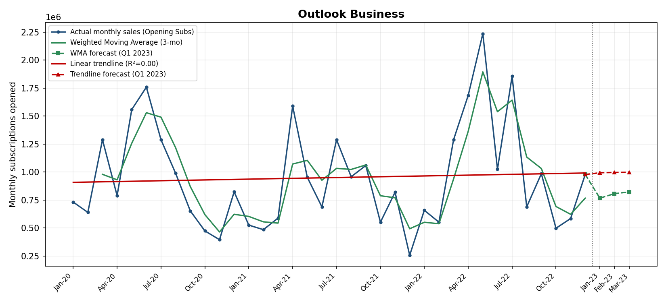
Actual monthly sales, Weighted Moving Average, and linear trendline, with Q1 2023 forecast — Outlook Business.
Yearly average monthly sales: 2020 = 949,637, 2021 = 814,133 (-14.3%), 2022 = 1,086,860 (33.5% vs 2021, 14.4% vs 2020). Linear trendline slope: 2,379 subscriptions/month (R²=0.00); degree-2 polynomial R²=0.01. Average monthly churn (Expiry ÷ Opening Subs): 1.07%.

Outlook Hindi
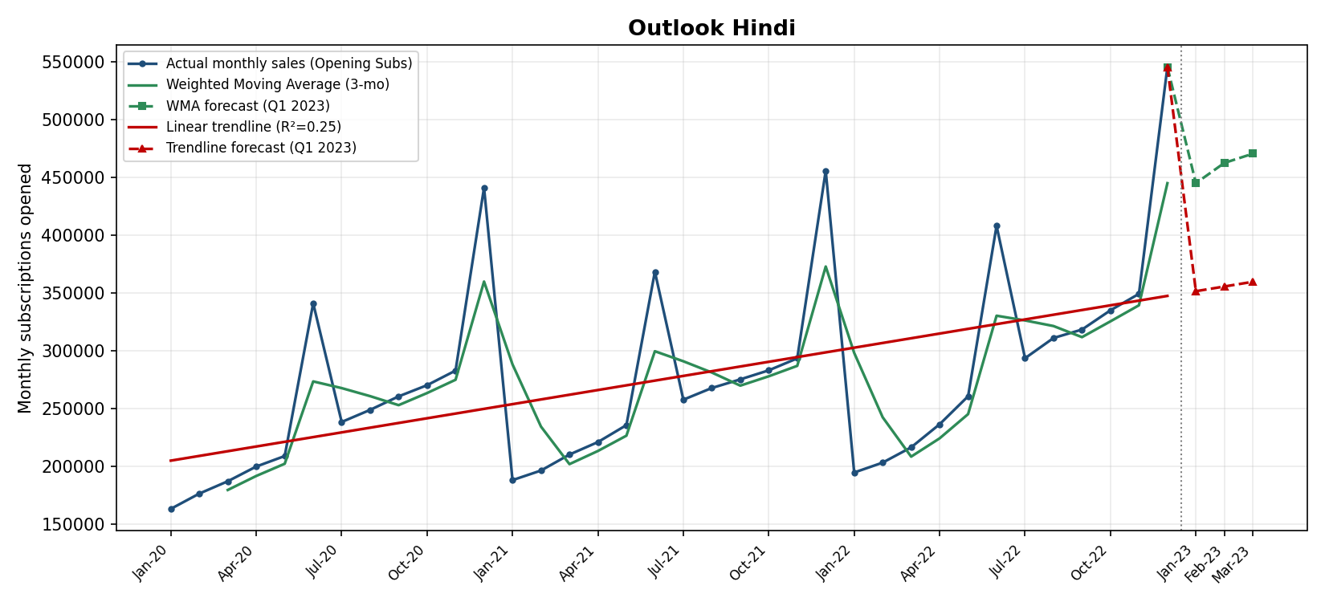
Actual monthly sales, Weighted Moving Average, and linear trendline, with Q1 2023 forecast — Outlook Hindi.
Yearly average monthly sales: 2020 = 251,212, 2021 = 270,732 (7.8%), 2022 = 305,678 (12.9% vs 2021, 21.7% vs 2020). Linear trendline slope: 4,072 subscriptions/month (R²=0.25); degree-2 polynomial R²=0.26. Average monthly churn (Expiry ÷ Opening Subs): 0.66%.

Outlook India
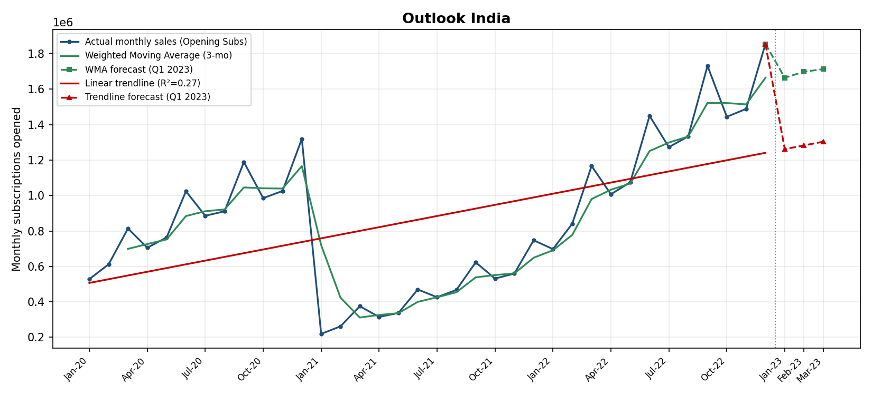
Actual monthly sales, Weighted Moving Average, and linear trendline, with Q1 2023 forecast — Outlook India.
Yearly average monthly sales: 2020 = 896,986, 2021 = 444,398 (-50.5%), 2022 = 1,280,510 (188.1% vs 2021, 42.8% vs 2020). Linear trendline slope: 20,979 subscriptions/month (R²=0.27); degree-2 polynomial R²=0.60. Average monthly churn (Expiry ÷ Opening Subs): 0.72%.

Outlook Money
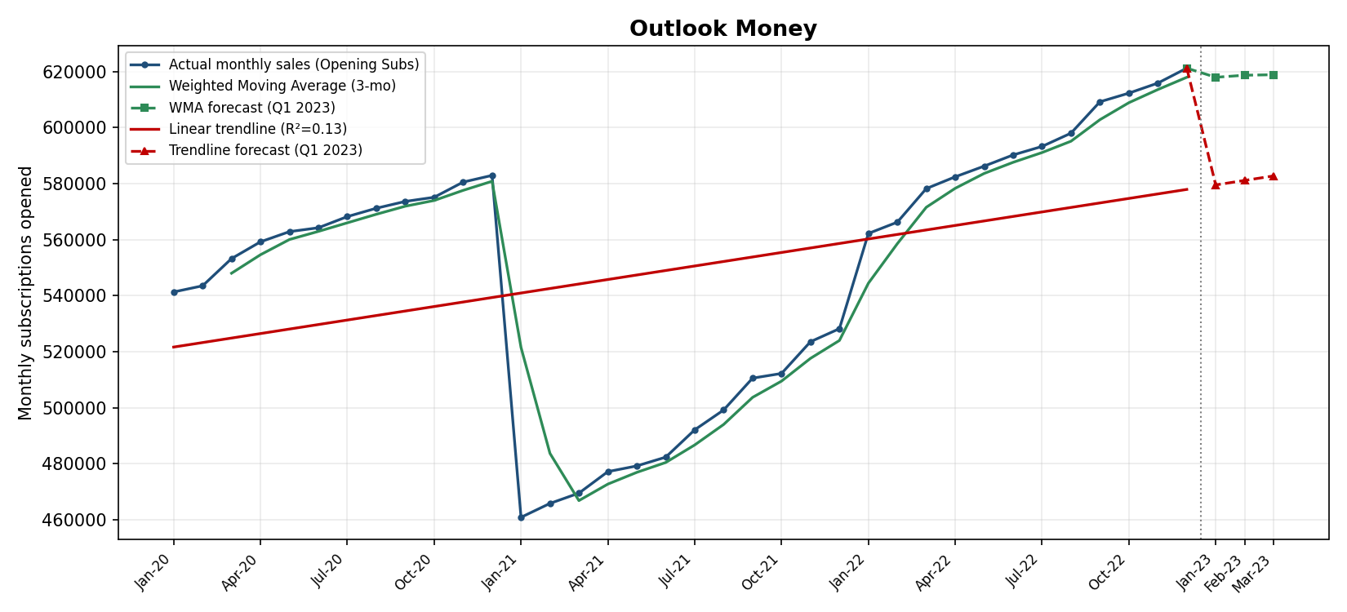
Actual monthly sales, Weighted Moving Average, and linear trendline, with Q1 2023 forecast — Outlook Money.
Yearly average monthly sales: 2020 = 564,669, 2021 = 491,748 (-12.9%), 2022 = 592,944 (20.6% vs 2021, 5.0% vs 2020). Linear trendline slope: 1,607 subscriptions/month (R²=0.13); degree-2 polynomial R²=0.56. Average monthly churn (Expiry ÷ Opening Subs): 0.44%.

Outlook Traveller
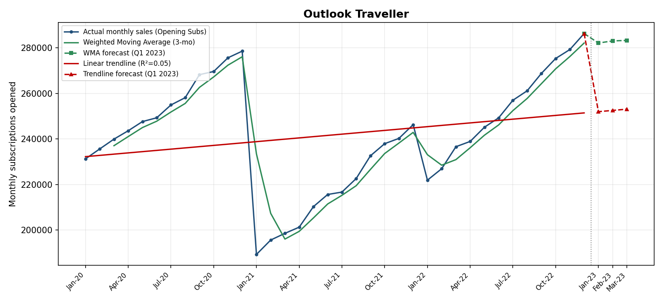
Actual monthly sales, Weighted Moving Average, and linear trendline, with Q1 2023 forecast — Outlook Traveller.
Yearly average monthly sales: 2020 = 254,336, 2021 = 217,218 (-14.6%), 2022 = 253,846 (16.9% vs 2021, -0.2% vs 2020). Linear trendline slope: 548 subscriptions/month (R²=0.05); degree-2 polynomial R²=0.35. Average monthly churn (Expiry ÷ Opening Subs): 0.40%.

Outlook Group (All Titles)
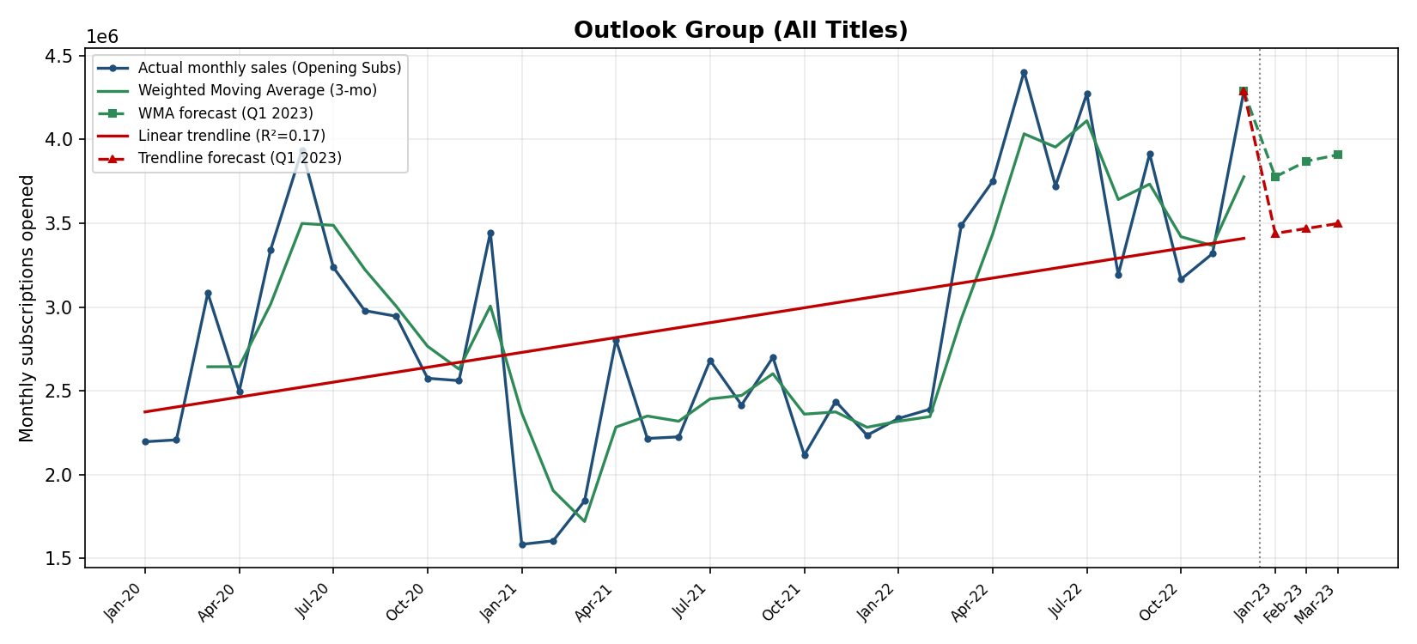
Actual monthly sales, Weighted Moving Average, and linear trendline, with Q1 2023 forecast — Outlook Group (All Titles).
Yearly average monthly sales: 2020 = 2,916,840, 2021 = 2,238,228 (-23.3%), 2022 = 3,519,838 (57.3% vs 2021, 20.7% vs 2020). Linear trendline slope: 29,586 subscriptions/month (R²=0.17); degree-2 polynomial R²=0.38. Average monthly churn (Expiry ÷ Opening Subs): 0.69%.

Growth of The Outlook Group — Consolidated View
Summed across all five titles, The Outlook Group opened an average of 2,916,840 subscriptions a month in 2020. That fell 23.3% to 2,238,228/month in 2021 — a genuine, group-wide dip that shows up in every one of the five titles individually, not just in the aggregate, which is what makes it a credible shared event (most plausibly pandemic-linked disruption to physical distribution and renewals) rather than noise in one title. 2022 then recovered sharply, up 57.3% to 3,519,838/month, finishing the three-year window 20.7% above the 2020 starting level.
The straight-line trendline on the Group total is positive (+29,586 subscriptions/month) but only explains 17% of month-to-month variation (R²=0.17) — the honest reading is that growth has not been a steady monthly climb, it has been a dip followed by a strong recovery, which a single straight line understates. The Weighted Moving Average, being more sensitive to the recent recovery, forecasts continued growth into Q1 2023 (3,776,830 → 3,908,485), while the more conservative trendline forecasts a flatter 3,438,982 → 3,498,155. The truth for planning purposes likely sits between the two: real momentum from H2 2022, but not guaranteed to be a permanent structural shift yet.
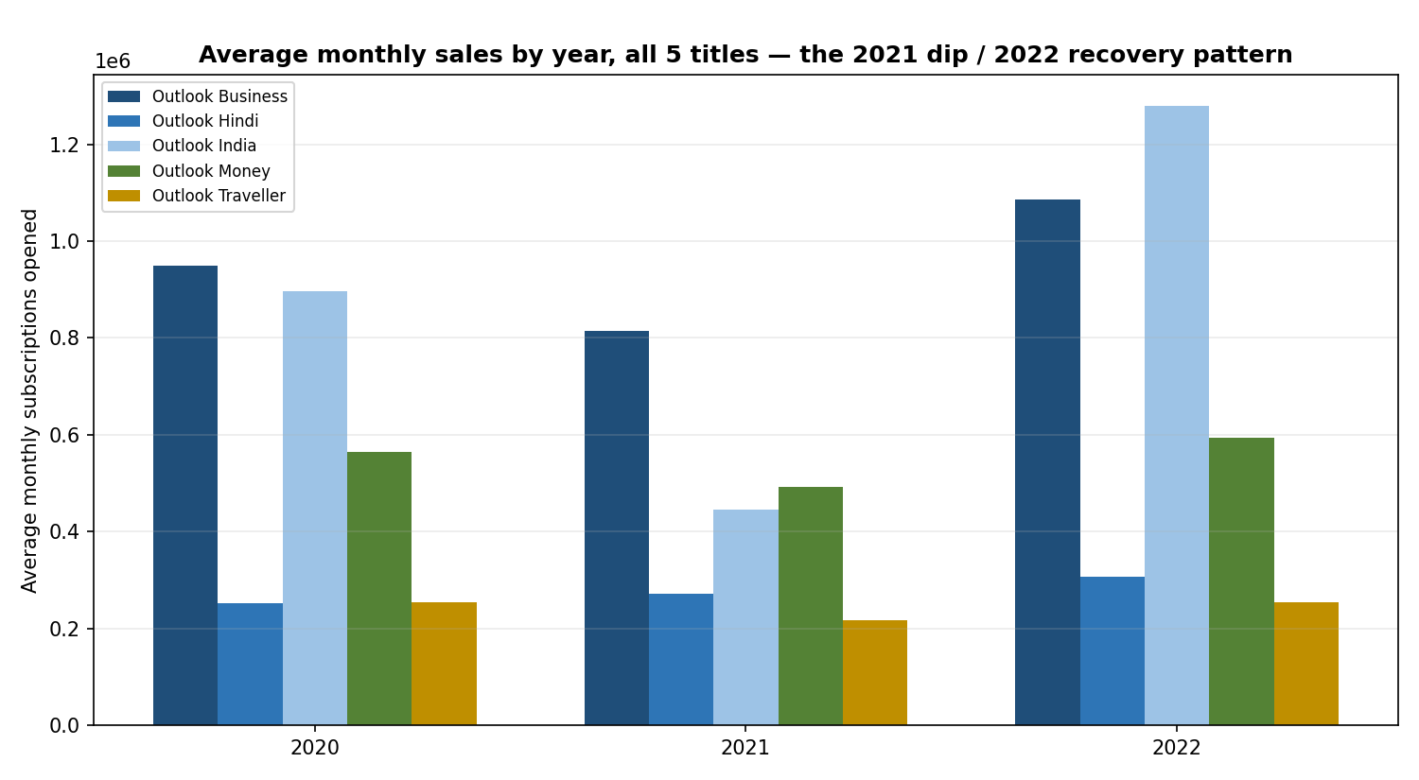
Figure. Average monthly sales by year, all five titles — the shared 2021 dip / 2022 recovery pattern.

Recommendations
- Plan Q1 2023 print runs and paper procurement against the WMA forecast (the more responsive of the two), but budget/revenue-recognition targets against the more conservative trendline forecast, to avoid overcommitting on a recovery that is only one strong year old.
- Investigate the 2021 dip directly with the commercial team rather than assuming a cause — it hit all five titles, which argues for a shared external driver (distribution disruption, macro conditions) rather than a title-specific editorial or pricing problem.
- Outlook India showed by far the sharpest V-shaped recovery and the highest polynomial fit (R²=0.60) — worth a case study into what specifically drove its 2022 rebound, to see if it is replicable in the flatter-recovering titles (Traveller, Money).
- Churn (Expiry ÷ Opening Subs) is low and stable across all titles (0.4%-1.1% monthly), so the growth story here is a demand-side / acquisition story, not a retention problem — marketing and distribution investment is better aimed at new-subscription volume than at churn reduction.

Conclusion
This module forecast monthly subscription sales for five Outlook Group titles using two complementary, appropriately-scaled methods rather than an over-engineered ML model: a Weighted Moving Average for near-term, momentum-sensitive planning, and a trendline regression for a longer-run, board-reportable growth narrative. Both methods point the same direction — genuine, group-wide growth over the three-year window, concentrated in a strong 2022 recovery from a 2021 dip that affected every title. The consolidated Q1 2023 forecast, and the per-title detail behind it, is also available with full live formulas in the companion Excel workbook (Sales_Forecasting_Analysis.xlsx).

