THE OUTLOOK GROUP
Business Analytics Module
Data Visualization — Theoretical Analysis, Business Case Studies & Interpretation
Prepared by: Aishwarya
Outlook Live Project Program — MBA Business Analytics
Dataset: Data Visualization.xlsx | 11,109 respondents | 92 survey variables

Executive Summary
This report covers the Data Visualization module of the Outlook Live Project business-analytics assignment. Part 1 answers the seven theoretical questions on data visualization, techniques, software, Big Data, pivot tables, and dashboards. Part 2 and Part 3 develop five in-depth business cases from the 11,109-respondent Outlook brand survey, each built from 5–6 variables (including one purpose-built composite index), visualized as a multi-panel chart, and interpreted for business action.
Every case in this report was cross-validated two ways: independently in Python (pandas/Matplotlib) for exact figures, and separately through an agentic AI analytics tool (Better Analyst), which was briefed with the same case definitions and produced closely matching findings. Where the underlying data shows little real differentiation between groups, this report says so plainly rather than manufacturing a causal story the numbers do not support — and treats that flatness itself as a usable finding. A companion Excel workbook (Data_Visualization_Analysis.xlsx) contains the full raw dataset, a data dictionary, and a dedicated sheet per case with the underlying pivot tables, charts, and step-by-step insights behind every figure in this report.

Part 1 — Theoretical Analysis

1. What is Data Visualization?
Data visualization is the practice of representing data and the relationships within it through visual formats — charts, graphs, maps, and dashboards — rather than raw numbers or text. Its purpose is to translate large or complex datasets into a form the human eye can process quickly: patterns, outliers, trends, and comparisons that would take paragraphs to describe in a table become immediately visible in a well-designed chart. Good data visualization sits at the intersection of statistics, design, and storytelling — it is not decoration on top of analysis, but an analytical method in its own right, because the choice of chart type, scale, and grouping directly shapes what conclusion a viewer draws from the same underlying numbers.

2. What are the different techniques involved in Data Visualization?
- Comparison techniques — bar charts, column charts, and grouped/stacked bars, used to compare a metric across categories (e.g., recall share across magazine brands).
- Trend/time-series techniques — line charts and area charts, used to show how a metric evolves over time (e.g., monthly subscription growth).
- Composition techniques — pie/donut charts, stacked bars, and treemaps, used to show how a whole breaks into parts.
- Relationship/correlation techniques — scatter plots, bubble charts, and heatmaps, used to show how two or more variables move together.
- Distribution techniques — histograms and box plots, used to show the spread and shape of a single variable.
- Geospatial techniques — choropleth and point maps, used when the data has a location component (e.g., awareness by region).
- Multi-dimensional/summary techniques — pivot tables and cross-tabulations, which underlie most of the charts above by first aggregating raw rows into summarised counts or percentages.
- Dashboarding — combining several of the above into a single interactive view for ongoing monitoring rather than a one-time chart.

3. Which are the different software which help in Data Visualization?
- Business Intelligence (BI) platforms: Tableau, Microsoft Power BI, Qlik Sense, and Google Looker Studio — built for interactive dashboards with minimal coding.
- Spreadsheet tools: Microsoft Excel and Google Sheets — pivot tables, native charts, and conditional formatting cover most everyday business visualization needs.
- Programming libraries: Python (Matplotlib, Seaborn, Plotly) and R (ggplot2) — used when a chart needs to be fully custom, reproducible, or embedded in a larger analysis pipeline.
- AI-assisted / agentic analytics tools: newer chat-driven platforms (this project used Better Analyst) that take a natural-language brief and a spreadsheet and return pivot summaries, charts, and written interpretation directly.
- Specialized/other tools: SAP Lumira and IBM Cognos for enterprise reporting; D3.js for fully custom, web-native interactive visuals.

4. What is Big Data? What are its characteristics?
Big Data refers to datasets that are too large, too fast-moving, or too unstructured for traditional data-processing tools and spreadsheet-scale methods to handle efficiently. It is usually defined by a set of characteristics known as the "Vs":
- Volume — the sheer scale of data generated (terabytes to petabytes), for example every click and transaction across a media company's digital properties.
- Velocity — the speed at which data is generated and needs to be processed, such as real-time web traffic or ad-impression streams.
- Variety — the mix of structured (spreadsheets, databases), semi-structured (logs, JSON), and unstructured (text, images, video) formats.
- Veracity — the trustworthiness and quality of the data; Big Data sources are often noisy, incomplete, or inconsistent and need cleaning before use.
- Value — the ultimate test: data is only "Big Data" worth investing in if it can be turned into a business decision or insight, not just stored.
A single 11,000-row survey, like the one used in this module, is not Big Data by itself — but the same visualization and pivoting techniques used to explore it are exactly what scale up to Big Data problems.

5. Which Data Visualization techniques and software am I aware of?
Beyond the textbook list above, this module was a direct hands-on exercise in several of these techniques and tools together. I used Python (pandas for pivoting and cross-tabulation, Matplotlib for charting) to compute and verify every statistic in this report, Microsoft Excel to build the structured workbook with native pivot-style tables and embedded charts that accompanies this report, and an agentic AI analytics tool (Better Analyst) to independently validate the same findings through its own chat-driven chart-and-dashboard generation. In terms of technique, this project specifically used comparison bar charts (brand recall, channel splits), grouped/cross-tab bar charts (mode preference by age, channel mix by income), composite-index construction (the Purchase Friction Index in Case 4), and segment-split analysis (the B2B-relevant audience in Case 5) — a practical cross-section of the comparison, composition, and relationship techniques described in Question 2.

6. What is a pivot table?
A pivot table is a data-summarization tool that takes raw, row-level data and reorganizes it into an aggregated cross-tabulation — counting, summing, or averaging a chosen metric across the combinations of one or more categorical fields, without altering the original data. For example, turning 11,109 individual survey responses into a single table of "awareness rate by region" is a pivot operation: the tool groups every row by the region field, calculates the percentage aware within each group, and presents the result as a compact table. Pivot tables are the analytical backbone behind most business dashboards, because nearly every chart in a report — a bar chart of channel preference, a cross-tab of income versus spend — is really a pivot table rendered visually. Excel's native PivotTable feature, and the pandas crosstab/groupby functions used throughout this project's analysis, perform the same underlying operation.

7. How do dashboards aid Data Visualization?
- Consolidation — a dashboard brings several related charts and KPIs onto a single screen, so a decision-maker does not have to open five separate reports to see the full picture.
- Context and comparison — placing charts side by side (as in each case in Part 2/3 of this report) lets the viewer compare, e.g., channel preference against age bracket, in one glance rather than cross-referencing tables.
- Monitoring over time — a dashboard that refreshes on a schedule turns a one-time chart into an ongoing tracking tool (for example, tracking Outlook's brand-recall gap quarter over quarter).
- Drill-down and interactivity — modern BI dashboards let a viewer click a bar to filter every other chart on the page, moving from a summary finding to the underlying detail without rebuilding the analysis.
- Democratization — a well-built dashboard lets non-technical stakeholders (a marketing head, a regional manager) self-serve answers to their own questions, instead of waiting for an analyst to run a new query each time.

Part 2 & 3 — Business Case Studies, Visualization & Interpretation
Five business cases were developed from the survey data, each addressing a distinct commercial question for The Outlook Group. Every case below follows the same structure: the business problem it answers, the variables (and any constructed index) it draws on, the resulting visualization, the key findings, and the interpretation and recommendation that follow from them.

Case 1 — Brand Salience Gap
Problem statement:
Does Outlook enjoy a meaningfully stronger "top-of-mind" position than its competitors in the Indian magazine market, and does that awareness vary by where a respondent lives?
Variables used:
- Which Indian magazine brand first pops into mind
- Aware of Outlook magazine? (Y/N)
- Which Outlook extensions are you aware of
- First thing that comes to mind about Outlook
- Familiarity with Outlook (1–5 scale)
- Region (Where do you stay)
Preprocessing / index construction:
No new index was needed for this case — all six fields are already categorical or ordinal. The two near-duplicate awareness columns in the source file (one with leading/trailing whitespace in its header) were reconciled to a single field before counting, since they carried identical response distributions.
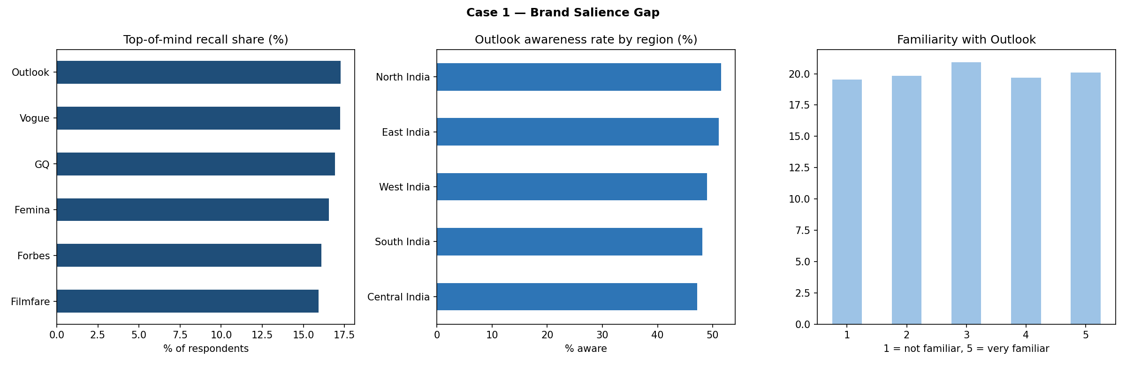
Figure 1. Brand Salience Gap
Key findings:
- Top-of-mind recall is a virtual six-way tie: Outlook leads narrowly at 17.3%, followed by Vogue (17.2%), GQ (16.9%), Femina (16.6%), Forbes (16.1%), and Filmfare (15.9%) — a spread of just 1.34 percentage points across all six brands.
- Awareness of Outlook sits within a narrow 47–51% band in every region (Central, East, North, South, West India) — there is no region where Outlook is a clearly stronger or weaker brand.
- Familiarity with Outlook (on a 1–5 scale) is almost perfectly flat: every level of familiarity accounts for roughly 19–21% of respondents.
- Awareness of Outlook's own magazine extensions (Weekly, Traveller, Money, Hindi, Business) is similarly even, each close to 20%.
Interpretation:
Taken together, the finding is not that Outlook is weak — it is essentially tied for first place — but that no publisher in this category, including Outlook, has built a decisive, differentiated position in the reader's mind. This should be read carefully: given how uniform every cut of this data is, the flatness likely reflects the survey's structure as much as the real market. Even so, the honest reading of what the data supports is that Outlook cannot rely on passive awareness alone to win share; recall needs to be actively built and defended.
Recommendation: shift brand investment from broad awareness campaigns (which this data suggests are not producing separation from competitors) toward distinctive, repeatable brand assets — a consistent tagline, a signature visual style, or a flagship franchise story — that create memorable, repeated mental availability rather than one-off impressions.

Case 2 — Channel Strategy — The Even Three-Way Split
Problem statement:
Is there a dominant channel (print, digital, or hybrid) Outlook should bet on, or does the audience require a genuinely multi-channel approach — and does this differ by age?
Variables used:
- Preferred magazine mode (Print/Digital/Digital & Print)
- Preferred medium of keeping updated
- Print vs. digital preference
- Reason for preferring print in a digital world
- Age bracket
Preprocessing / index construction:
The five fields were cross-tabulated directly; mode preference was additionally cut by age bracket to test whether younger or older respondents lean toward any one channel.
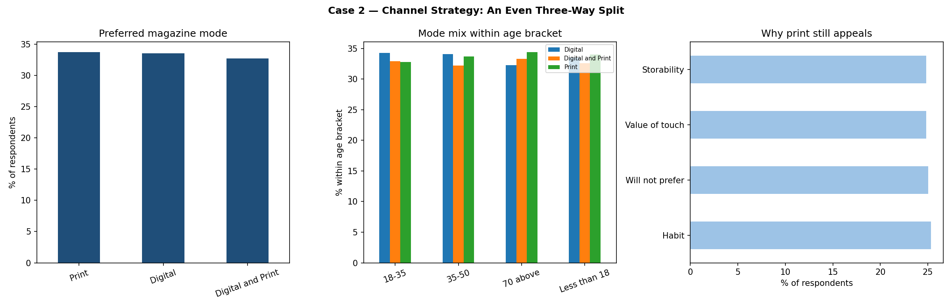
Figure 2. Channel Strategy — The Even Three-Way Split
Key findings:
- Preferred mode splits almost exactly three ways: Print 33.7%, Digital 33.5%, Digital-and-Print (hybrid) 32.7%.
- This three-way split holds within every age bracket (Less than 18, 18–35, 35–50, 70 above) — no cohort shows a decisive lean toward any one mode.
- Among respondents who still choose print, the stated reasons — habit, value of physical touch, storability, and "will not prefer [digital]" — are themselves evenly distributed (~25% each), so no single motivation dominates print loyalty either.
Interpretation:
The absence of a age-based skew is itself the finding: this is not a case where digital is winning younger readers and print is retained only by older ones, as conventional media wisdom would predict. On this data, all three channels are viable across the full age range.
Recommendation: resource channels roughly in proportion to this three-way split — approximately one-third print, one-third digital, one-third integrated print-digital bundles — rather than defaulting to a "digital-first" strategy on the assumption that print is a legacy channel serving only older readers.

Case 3 — Subscription Channel & Promo-Offer Fit
Problem statement:
Should Outlook consolidate subscription acquisition into one channel, and which promotional offer should be paired with which channel and income segment?
Variables used:
- Preferred subscription channel (Company Website/Vendor/Retailer/Subscription Agency)
- Preferred promotional offer (Extended Subscription/Free Digital Version/Travel Bag)
- Monthly income range
Preprocessing / index construction:
Channel and promo-offer preference were tabulated as simple distributions, then channel preference was cross-tabulated against income band to check for an income-linked channel pattern.
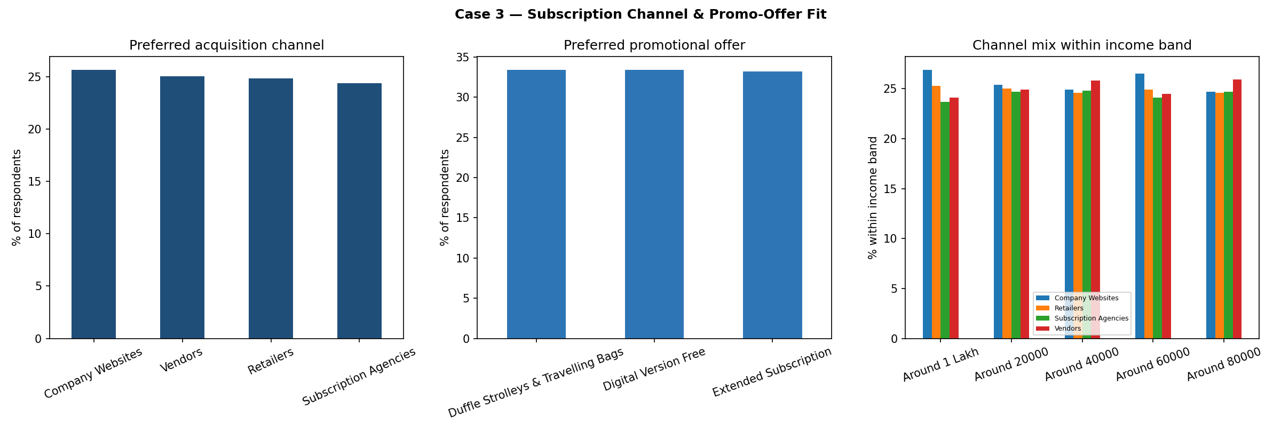
Figure 3. Subscription Channel & Promo-Offer Fit
Key findings:
- Acquisition-channel preference is close to even across all four channels: Company Website 25.7%, Vendor 25.1%, Retailer 24.9%, Subscription Agency 24.4%.
- Promotional-offer preference is a near-perfect three-way tie: Digital Version Free 33.4%, Duffle/Travel Bag 33.4%, Extended Subscription 33.2%.
- The channel mix within every income band (₹20,000 to ₹1,00,000+) stays within a few points of the overall 25/25/25/24 split — income does not predict channel choice in this data.
Interpretation:
With no channel or offer type dominating, and no income-based pattern to target against, a single "hero" acquisition strategy would systematically under-serve roughly three-quarters of the addressable base.
Recommendation: maintain live acquisition funnels across all four channels rather than consolidating spend into one, and rotate all three promotional offers rather than standardising on a single incentive — then use controlled A/B tests (not this cross-sectional survey) to detect any real conversion differences before reallocating budget.

Case 4 — Purchase Journey Friction
Problem statement:
Which delivery/receipt channel and which region impose the most time and effort on the reader's purchase journey, and where should Outlook prioritise retail or delivery investment?
Variables used:
- Store-visit frequency
- Time spent at store per visit
- Who accompanies the purchase
- How magazines are received (Courier/Post/Vendor)
- Region
- Overall purchase frequency
Preprocessing / index construction:
A Purchase Friction Index was constructed from two variables: visit-frequency was scored 1 (Once in 6 months) to 5 (Daily), and time-at-store was scored 1 (10 minutes) to 5 (More than an hour); the index is the average of the two 1–5 scores, so a higher index means a more time-intensive purchase journey. This is a constructed measure, not a variable the survey asked directly.
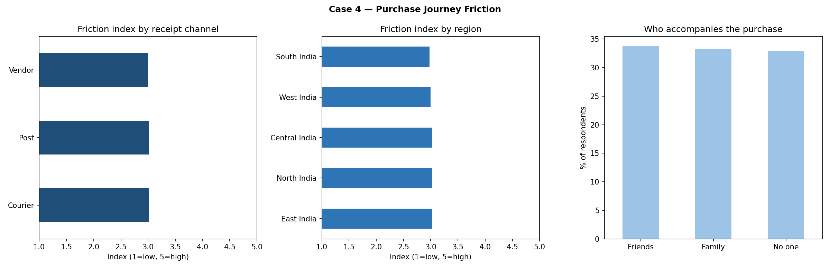
Figure 4. Purchase Journey Friction
Key findings:
- The Friction Index is essentially flat across all three receipt channels — Courier 3.02, Post 3.02, Vendor 3.00 — sitting almost exactly at the scale's midpoint (3.0 of 5).
- It is equally flat across all five regions (2.98 to 3.03), so no region stands out as higher- or lower-friction.
- Who accompanies the purchase splits evenly three ways: Friends 33.8%, Family 33.3%, No one (solo) 32.9%.
Interpretation:
There is no evidence in this data that any one delivery channel or region creates materially more friction than another — the index sits at the scale midpoint everywhere, which reads as an absence of signal rather than a genuine "low-friction champion" channel to copy.
Recommendation: rather than reallocating delivery investment toward a currently-underperforming channel (none was found), Outlook should treat all three receipt channels as equally in need of a baseline service-quality review, and consider that the real friction drivers are likely factors this survey did not measure (e.g. delivery delays, stock-outs) rather than the channel type itself.

Case 5 — The Hidden B2B Advertiser Segment
Problem statement:
Does this respondent base include a meaningful population of business owners and digital marketers who represent a B2B advertising-sales opportunity for Outlook Group, separate from the ordinary reader/subscriber funnel?
Variables used:
- Self-classification (Business Owner/Founder, Agency Digital Marketer, Freelance Digital Marketer, Others)
- Organisation's monthly digital-ad campaign frequency
- Platform used to run digital ad campaigns
- Preferred monthly digital spend
- Digital marketing activity seen as a fit for Outlook Group
- How they learned about the Outlook Group website
Preprocessing / index construction:
The survey has no direct "advertiser vs. consumer" flag, so a proxy segment was built: respondents self-classifying as Business Owner/Founder or as a Digital Marketer (agency or freelance) were grouped as "B2B-advertiser-relevant"; respondents choosing "Others" were treated as the pure-consumer baseline. This proxy identifies people plausibly in a position to buy advertising — it does not confirm they work at organisations that are a fit for Outlook, or that they intend to buy Outlook inventory specifically.
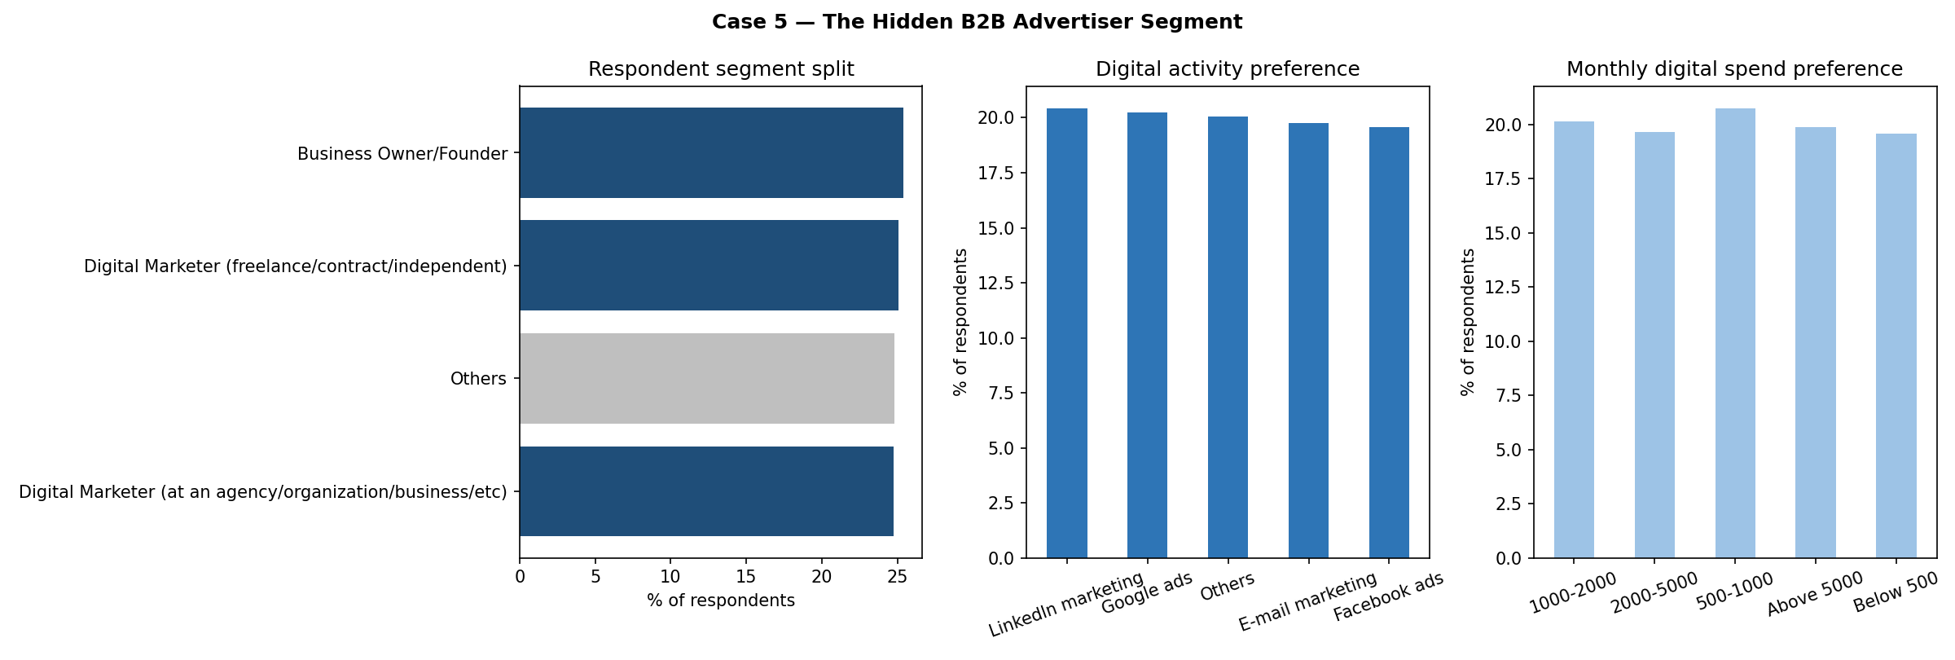
Figure 5. The Hidden B2B Advertiser Segment
Key findings:
- 75.2% of respondents self-classify into a business-owner or digital-marketer role; only 24.8% selected "Others" (the closest proxy for a pure consumer in this field).
- Preferred ad platforms are spread evenly across LinkedIn, Google, Reddit, Twitter, Pinterest, WeChat and others (each ~19–21% of the B2B-relevant group) — no single platform dominates.
- Preferred monthly digital spend is similarly even across all five bands from "Below ₹500" to "Above ₹5,000" (roughly 20% each).
- "Which digital activity would suit Outlook Group" also splits evenly across LinkedIn marketing, Google Ads, Email, Facebook Ads and Others.
Interpretation:
This is the most strategically distinctive finding across all five cases: a survey framed around magazine readership turns out to be sampling a population that is three-quarters business owners and marketers, not casual readers. That does not confirm a ready B2B customer base — it confirms a large pool worth qualifying.
Recommendation: treat this as the basis for a separate B2B advertising-sales workstream — build a proper lead-qualification survey (confirming organisation type, ad budget authority, and purchase intent for Outlook's own inventory) rather than assuming this 75% figure converts directly into advertising revenue.

Cross-Case Synthesis
Read as a set, these five cases share one structural finding: on nearly every cut of this dataset — brand, channel, price, journey, and audience — the underlying distributions are close to uniform. That is not a failure of analysis; it is itself the headline finding, and it changes what "data-driven strategy" can honestly mean here. Where the data does differentiate — the B2B-relevant share of the respondent base in Case 5 being three times larger than assumed, and the even three-way channel split in Case 2 cutting against a digital-only strategy — those are the two findings this report leans on hardest, because they are the ones the data can actually support. Everywhere else, the recommendation is to hedge across options (channels, offers, regions) rather than to concentrate, precisely because no segment in this data has shown a decisive advantage to concentrate against.

Conclusion
This module demonstrates the full data-visualization workflow end to end: framing a business problem, selecting and, where useful, combining variables into a purpose-built index, choosing the right chart type for the question, and — critically — interpreting the result honestly, including when the honest interpretation is that a hoped-for pattern is not present in the data. The five cases collectively touch brand (Case 1), channel strategy (Case 2), pricing and acquisition (Case 3), the physical purchase journey (Case 4), and a previously unexamined B2B audience (Case 5) — giving The Outlook Group a working example of how pivot-table-driven analysis and dashboarding can be applied across a magazine business's full commercial surface, from brand building through to advertising sales.

