STEM Challenge Hub User Flow
  - Simple user flows and essential requirements
Prepared by: Kinjal Bhatt | October 29, 2026 · Updated November 3, 2026 to match the current Figma design
Teachers post short K–12 STEM challenges. Students join a class, open a challenge, answer it, and get feedback. Teachers view class progress and read short answers.

1 Teacher flow
Start with a teacher account. Teachers land on My classes. Create a class and share its join code, then create a challenge for that class and save it as a draft or publish it.
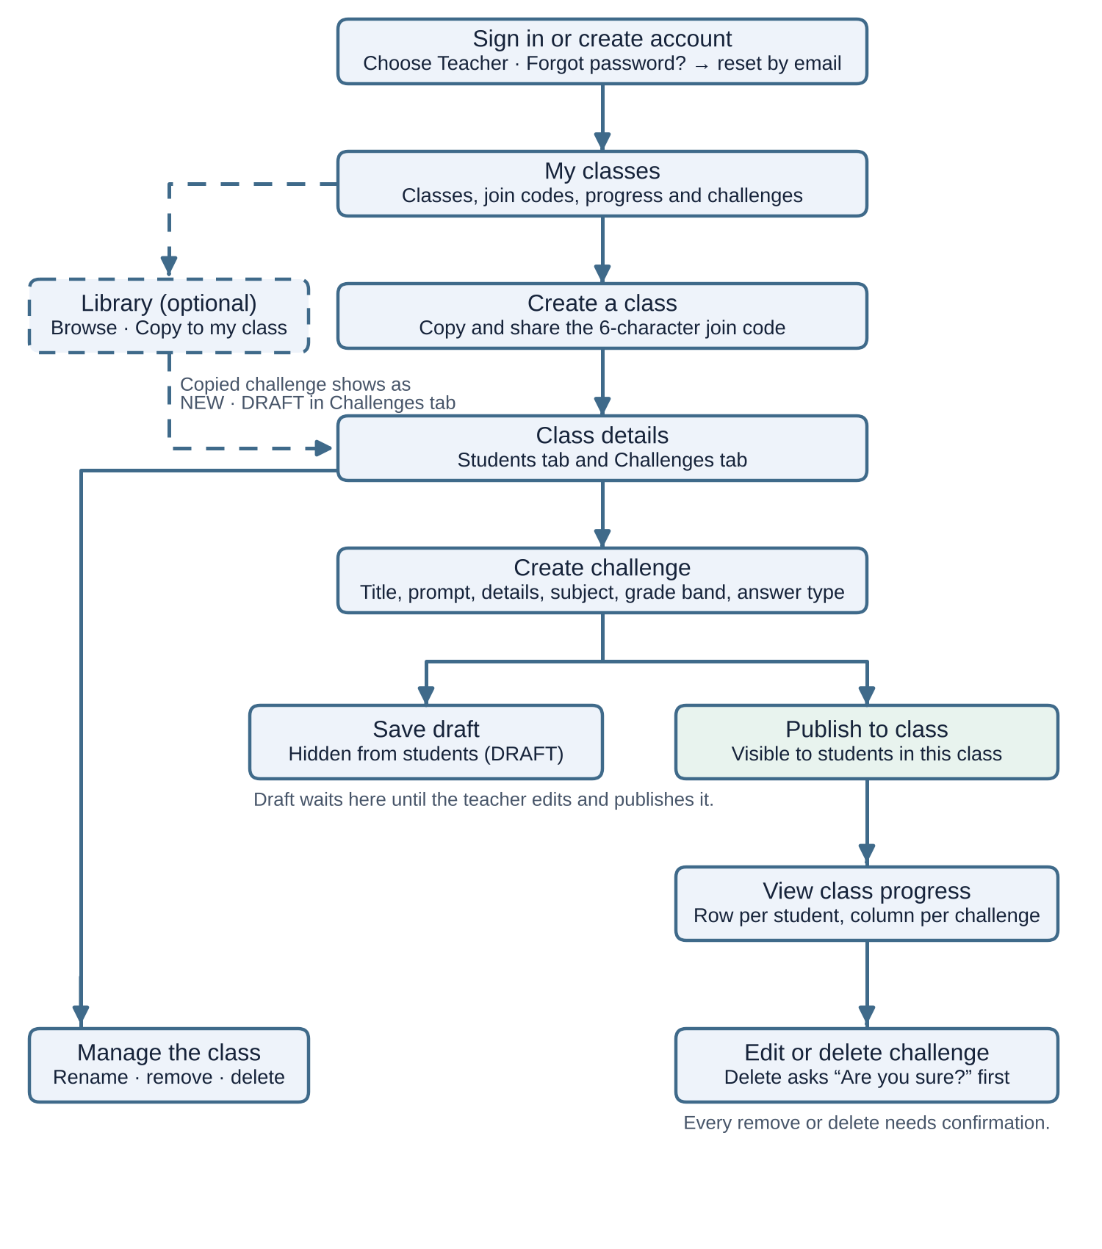
Class management: on Class details, teachers can rename a class, remove a student, and delete a class. From Class details or Class progress they can edit or delete a challenge. Every removal or deletion asks for confirmation first.
Optional: teachers can browse the Challenge library (48 real classroom activities, filtered by subject and grade band) and click Copy to my class. The copy appears in the class’s Challenges tab as NEW · DRAFT, so the teacher can edit it before publishing.

2 Student flow
A student needs an account and a teacher’s class code. New students go to Join class after signing up. Students already in a class land directly on My challenges.
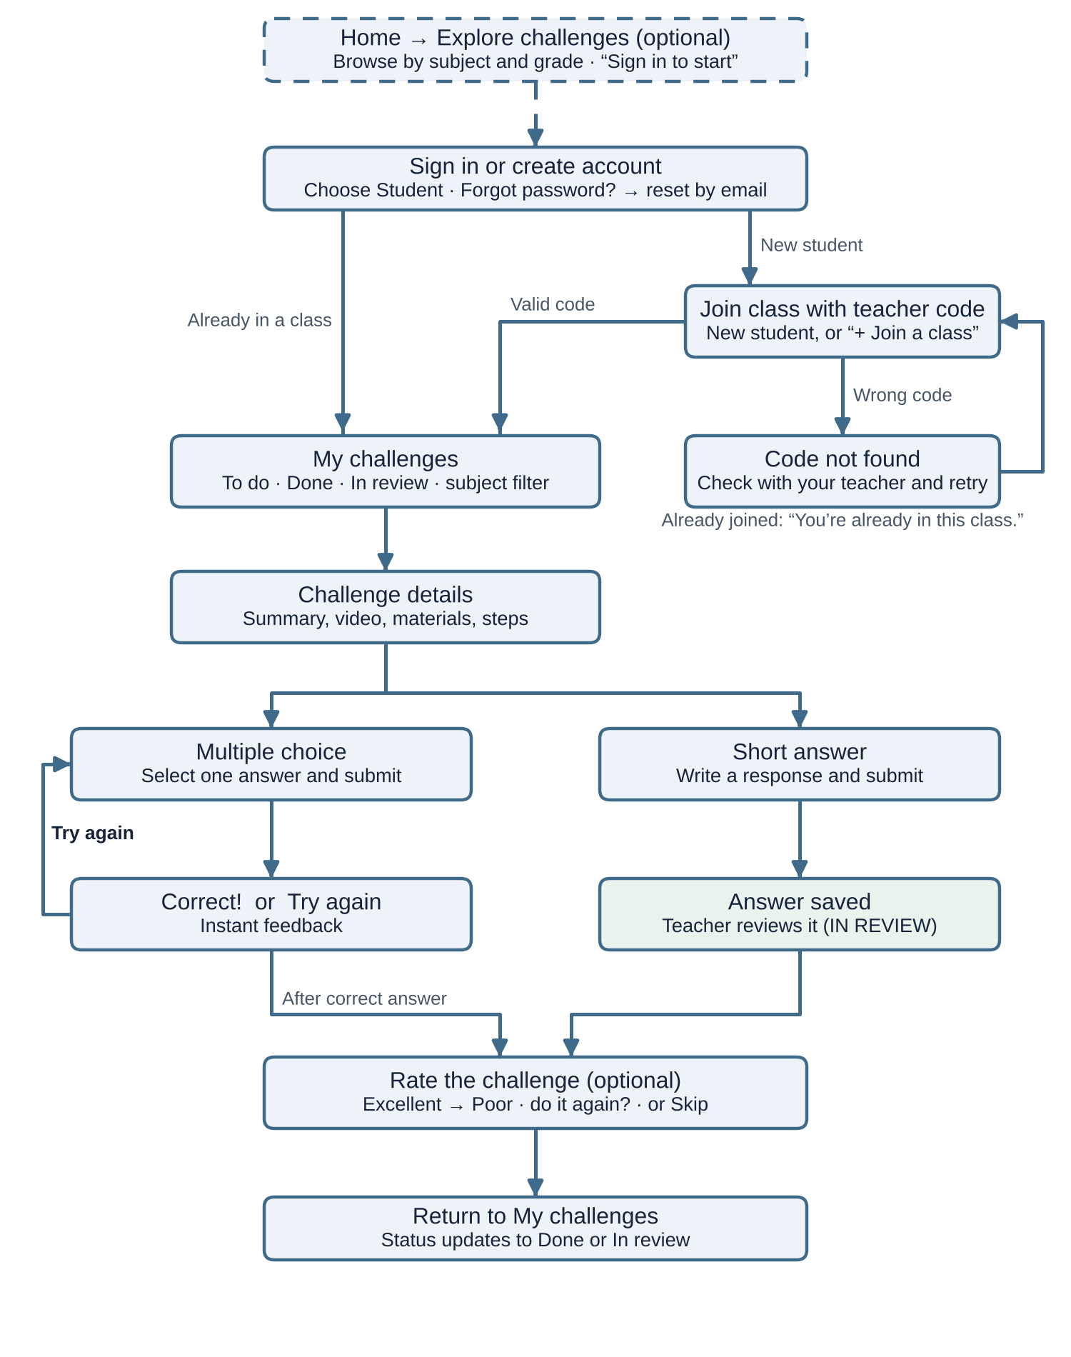
My challenges shows each challenge with a status: To do, Done · Correct answer (COMPLETED badge) or Done · Waiting for teacher review (IN REVIEW badge). Students can filter by subject and switch between the To do and Done tabs.
Challenge details (opened with Start) shows a summary (active time, total time, difficulty, materials, answer type, due date), an optional how-to video, an introduction, a materials list, step-by-step instructions and a safety tip.
Short answers are saved for teacher review and are not graded automatically. Multiple-choice feedback lets students try again; attempt limits are still to be decided. After answering, students can rate the challenge or skip.
Wrong code: show “Code not found. Check the code with your teacher and try again.” and let the student retry. Already joined: show “You’re already in this class.” without creating another membership.

3 Sign-in, access and error states
- Two roles: teachers land on My classes; students land on My challenges.
- Wrong password: show “Email or password is incorrect. Please try again.” and keep the user on the sign-in page.
- Forgot password: enter email → “Check your email” (same message whether or not the account exists; the link works for 1 hour) → set a new password → sign in with a “Password updated” message.
- Teacher pages: a student who opens a teacher page sees “Teachers only – You don’t have access to this page.”
- Other class’s challenge: a student who opens a challenge from another class sees “Challenge not available.”

4 Essential requirements
Use this checklist for the team handoff. These describe expected application behavior; a Figma prototype only demonstrates the experience.
- Accounts: sign up, sign in, choose Teacher or Student, forgot password, and sign out.
- Classes: teacher creates a class and shares its six-character join code; student joins once.
- Challenge form: title, prompt, subject (Science, Technology, Engineering, Math), grade band (K-2, 3-5, 6-8, 9-12) and answer type. Activity details (introduction, materials, steps, active time, video link) are optional.
- Multiple choice: 2–6 options with one correct answer marked. Short answer: text response.
- Visibility: drafts stay hidden from students; published challenges appear only in the intended class.
- Answers: show “Correct!” or “Try again” for multiple choice; save short answers for teacher review.
- Progress: a table with one row per student and one column per challenge (Not started, Completed, Correct or Incorrect); teachers can open submitted short answers.
- Access and safety: students cannot open teacher-only or other-class content; confirm destructive actions.
- Usability: keep forms, errors, navigation and controls readable on laptop, tablet and phone (Chrome and Safari), with WCAG AA color contrast.

Decisions needed before development
- How many retries are allowed, and when does a challenge count as Done?
- How is the progress percentage calculated?
- How are due dates set, and how is an existing draft published?
- What happens to answers after removal, deletion, or editing a published challenge?
- Video links: are YouTube links allowed if some schools block YouTube?
- Ratings: are student ratings stored, and who can see them?

Optional features (beyond the must-haves)
These are designed in Figma but are not core requirements. Confirm each with the PM before building; they are also listed in the “Scope notes” box at the top of the Color Mockups page.
- Public Home page and Explore challenges page (browse by subject and grade without signing in)
- Challenge library with combined subject + grade band filters and “Copy to my class”
- Challenge details page with summary, materials, steps and how-to video
- Feedback screen with star rating and “Would you do it again?”
- Status pills and COMPLETED / IN REVIEW badges on challenge cards
Removed from the design: remembering the subject picked on the Home page after sign-in. Students always land on My challenges and can filter there.

Prototype flows to test
Flow in Figma (Play) | What it covers
Laptop / Tablet / Phone prototype (Teacher + Student) | Full teacher and student journeys, starting at Home
Edge case: student opens a teacher page | “Teachers only” screen
Edge case: challenge from another class | “Challenge not available” screen
Wireframe – Laptop / Wireframe – Phone | Clickable low-detail wireframes

Design references
Research and design rationale
Wireframes and screen structure
Color Mockups and clickable prototype
Style Guide (colors and WCAG contrast)
Developer files: tokens.css (design tokens, matching the Figma “Design tokens” variables) and the real challenge source list (48 activities with source links).
Research uses secondary reviews and fictional personas. Usability test results are not yet recorded. This summary explains the intended journeys; it does not confirm a working application.

