STEM Challenge Hub User Flow
  - Simple user flows and essential requirements
Prepared by: Kinjal Bhatt | October 29, 2026
Teachers post short K–12 STEM challenges. Students join a class, answer challenges, and receive feedback. Teachers view class progress and read short answers.

1 Teacher flow
Start with a teacher account. Create a class and share its code, then create a challenge for that class.
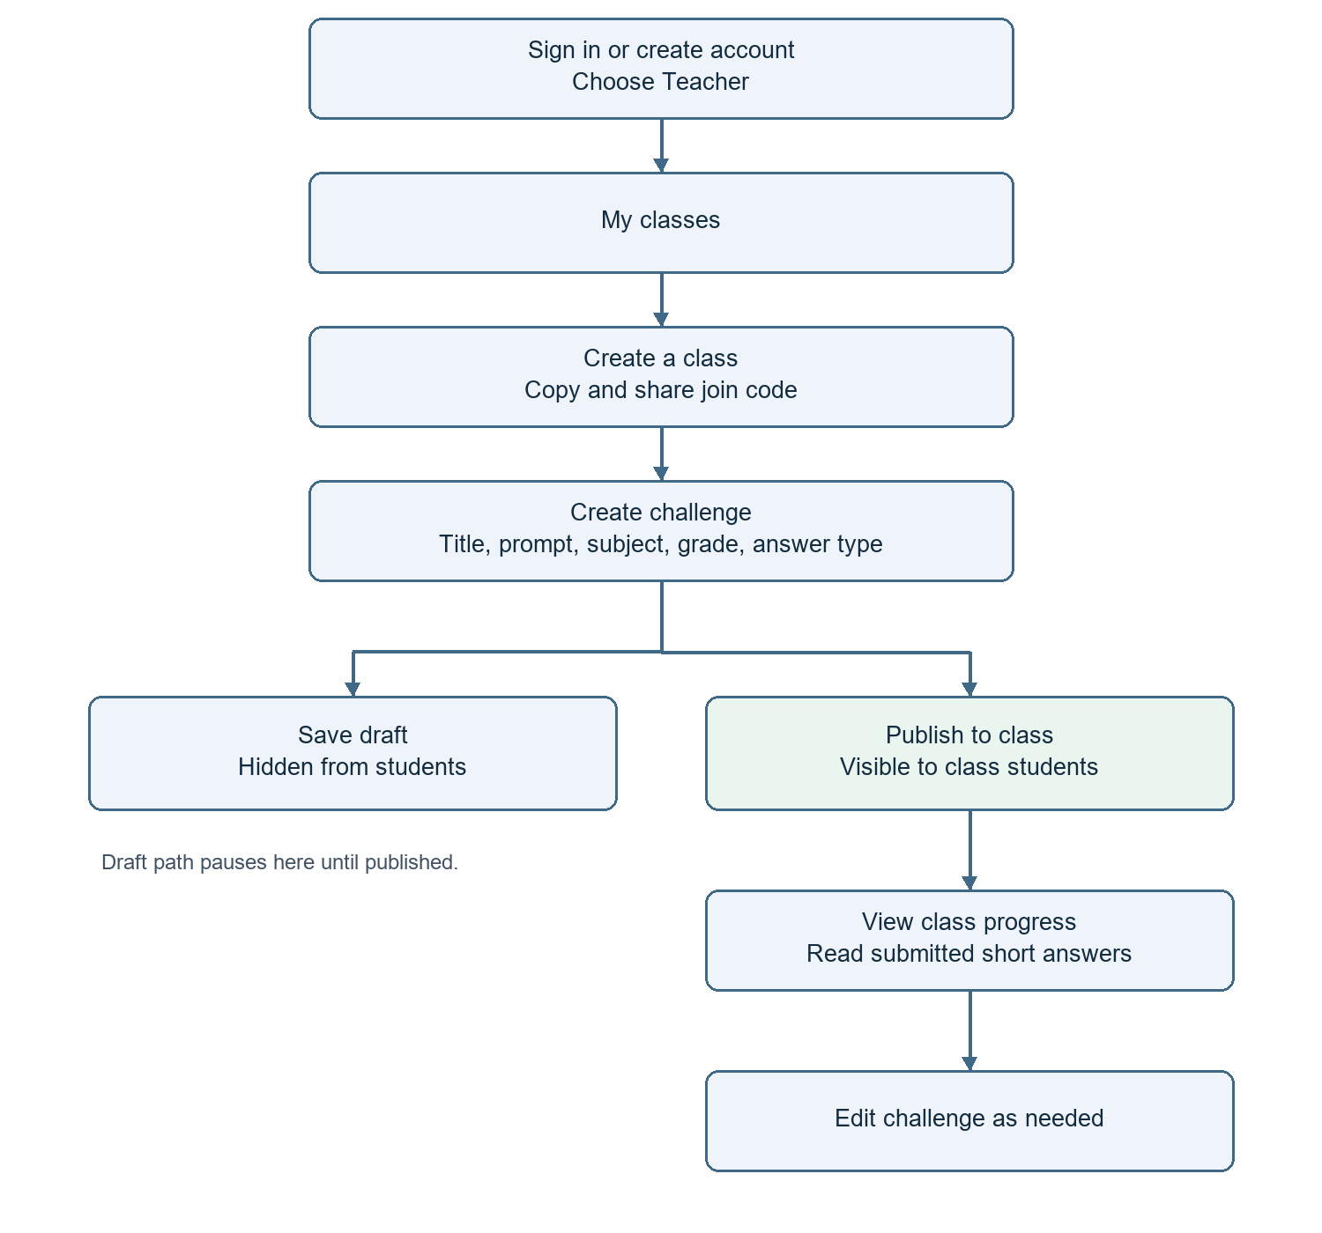
Class management: teachers can rename a class, remove a student, and delete a class or challenge. Removal and deletion require confirmation.

2 Student flow
A student needs an account and a teacher’s class code. Already joined students can go directly to My challenges.
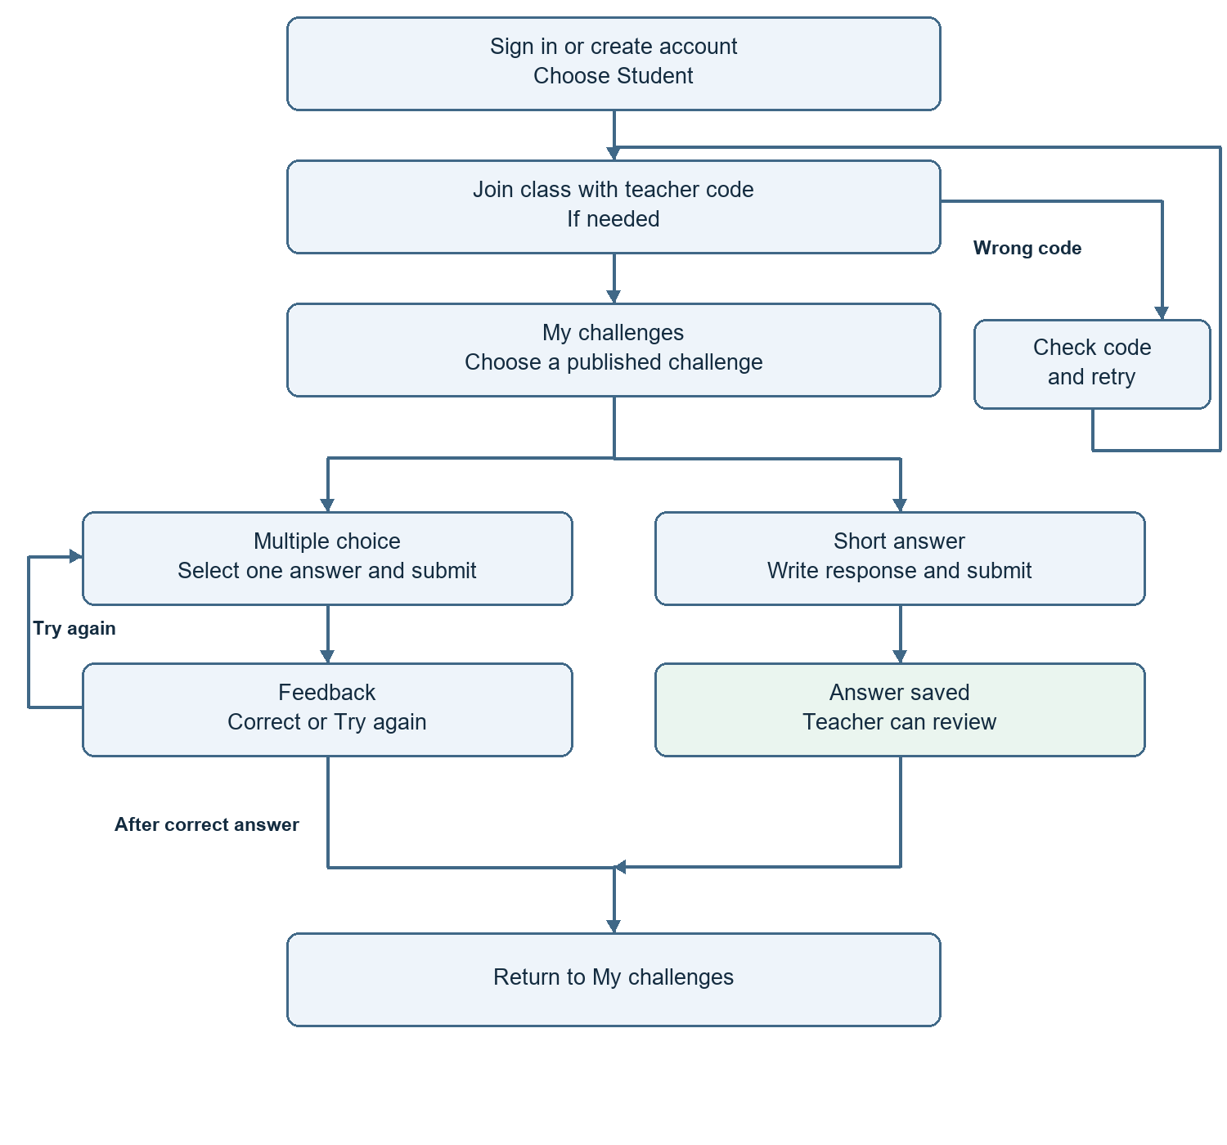
Short answers are saved for teacher review and are not automatically graded. Multiple-choice feedback supports trying again; attempt limits remain to be decided.
Wrong code: show a clear error and let the student retry. Already joined: show a message without creating another membership.

3 Essential requirements
Use this checklist for the team handoff. These describe expected application behavior; a Figma prototype only demonstrates the experience.
- Accounts: sign up, sign in, choose Teacher or Student, and sign out.
- Classes: teacher creates a class and shares its six-character join code; student joins once.
- Challenge form: title, prompt, subject, grade band, and answer type.
- Multiple choice: 2–6 options with a selected correct answer. Short answer: text response.
- Visibility: drafts stay hidden from students; published challenges appear in the intended class.
- Answers: show multiple-choice feedback; save short answers for teacher review.
- Progress: show student completion and multiple-choice results; open submitted short answers.
- Access and safety: students cannot open teacher-only or other-class content; confirm destructive actions.
- Usability: keep forms, errors, navigation, and controls readable on laptop, tablet, and phone.

Decisions needed before development
- How many retries are allowed, and when does a challenge count as Done?
- How is the progress percentage calculated?
- How are due dates set, and how is an existing draft published?
- What happens to answers after removal, deletion, or editing a published challenge?

Optional features
Challenge library and subject filters are marked STRETCH in Figma. The public home page is marked EXTRA. Confirm these separately from the main class and answer flows.

Design references
Research and design rationale
Wireframes and screen structure
Color Mockups and clickable prototype
Research uses secondary reviews and fictional personas. Usability test results are not yet recorded. This summary explains the intended journeys; it does not confirm a working application.

