How to build Detector MPI

DetectorMPI has been developed for RedHat Linux 64 bit. It has not been tested on Windows.
The steps for building and running DetectorMPI are as follows:
- Download and Build QT. Tested w/ QT4.8.
- Download and install QTCreator
- Download and build MPICH version of MPI.
- Download MPI Detector source code and QT project files.
- Configure build environment for MPIDetector in QTCreator.
- Build and Run MPI Detector, for single system.
- For running on multiple computers on a network, configure computers.

Installing QT

Download the free community version of QT from
http://www.qt.io/download-open-source/

The online downloader will download by default to your Downloads folder.
cd Downloads
chmod +x qt-opensource-linux-x64-1.6.0-8-online.run
./qt-opensource-linux-x64-1.6.0-8-online.run

You should get the installation wizard to open:
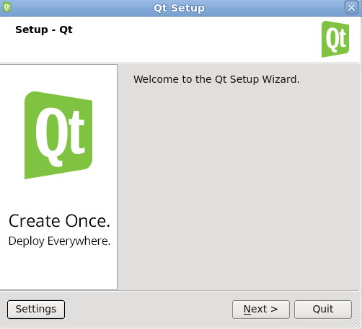

Go through the wizard to install. If you do not have root, it should do a local install.
If there are errors, download source from

http://www.qt.io/download-open-source/#section-2

Recipe for QT4.8.4

detectorMPI was developed on QT 4.8.4. Here is how to build from source on linux.

- Download qt-everywhere-opensource-src-4.8.4.tar.gz from https://download.qt.io/archive/qt/4.8/4.8.4/qt-everywhere-opensource-src-4.8.4.tar.gz
- gunzip qt-everywhere-opensource-src-4.8.4.tar.gz
- tar -xvf qt-everywhere-opensource-src-4.8.4.tar
- cd qt-everywhere-opensource-src-4.8.4
- ./configure --prefix=/local/qt4.8/ \
-release \
-shared \
-no-webkit -no-javascript-jit \
-confirm-license
- gmake
- gmake install

Above puts the install dir into /local/qt4.8. Change –prefix to change the install location.

To install QTCreator:
- Get qt-creator-2.7.1-src.tar from http://sourceforge.net/projects/qtcreator.mirror/files/Qt%20Creator%202.7.1/
- gunzip and tar -xvf the file.
- cd qt-creator-2.7.1-src
- /local/qt4.8/bin/qmake -r
- make
Here we assume qt was installed into /local/qt4.8

Installing MPI

To build you must first install the mpich version of MPI. This can be downloaded from

http://www.mpich.org/downloads/

Get a stable release for platform called mpich. DetectorMPI was first tested with mpich-3.0.4, but should work with later versions. You will be getting a tar.gz file. Expand and untar the file:

gunzip mpichxxxx.tar.gz
tar -xvf mpichxxx.tar

To make the MPI program able to run on multiple systems the MPI library and executable MPI program must be installed on an NFS shared disk. Also, the absolute path to the MPI lib and software should be the same for all systems. That is, if one system sees the software in /mnt/mpidisk/mpisoftware then all the other systems should see the software in that path as well.

master $ tar xzf mpich.tar.gz
Create directory in mounted directory called: mpich-install. For example: /mnt/nfs/mpich-install . Then:
master $ cd /your/unzipped/mpi_libraries
master $ ./configure –prefix=/mnt/nfs/mpich-install 2>&1 | tee c.txt
master $ make 2>&1 | tee m.txt –j8
where -jn means make in n parallel threads. Then install it:
master $ make install 2>&1 | tee mi.txt
After installation, you should able to find mpi library under /mnt/nfs/mpich-install
Then, export the MPI bin path to environment variables, using editor to edit file .bash_profile:
master $ cd ~
master $ gedit .bash_profile
add the following line:
PATH=/mnt/nfs/mpich-install/bin:$PATH
export PATH
to check the environment variable. Restart the terminal, then type:
master $ which mpicc
master $ which mpiexec
The terminal should display mpich-install path.

Setting up MPIDetector Build

There are two important project files

The detectorMPI.pro file is the project setup file that lists all files part of the project and defines which compiler to use. The MPI compiler must be defined in this file as shown below.

#-------------------------------------------------
#
# Project created by QtCreator 2011-12-08T16:30:52
#
#-------------------------------------------------
QMAKE_CXX = mpic++
QMAKE_CXX_RELEASE = $$QMAKE_CXX
QMAKE_CXX_DEBUG = $$QMAKE_CXX
QMAKE_LINK = $$QMAKE_CXX
QMAKE_CC = mpicc

QMAKE_CFLAGS += $$system(mpicc --showme:compile)
QMAKE_LFLAGS += $$system(mpicxx --showme:link)
QMAKE_CXXFLAGS += $$system(mpicxx --showme:compile) -DMPICH_IGNORE_CXX_SEEK -DUSE_MPI
QMAKE_CXXFLAGS_RELEASE += $$system(mpicxx --showme:compile) -DMPICH_IGNORE_CXX_SEEK

The other file is the detectorMPI.pro.user file that is the build configuration. This must be set up as well.

Then in QTCreator configure the build configurations. Once the build configuration is set up, you should be able to Build All from QTCreator. If Build All works, then save a copy of your .user file with
cp detectorMPI.pro.user detectorMPI.pro.userSAVE

You may have to add a compiler that QTCreator knows about. Go to the PROJECTS area in QTCreator, and press Manage Kits. There is an area to add compiler.

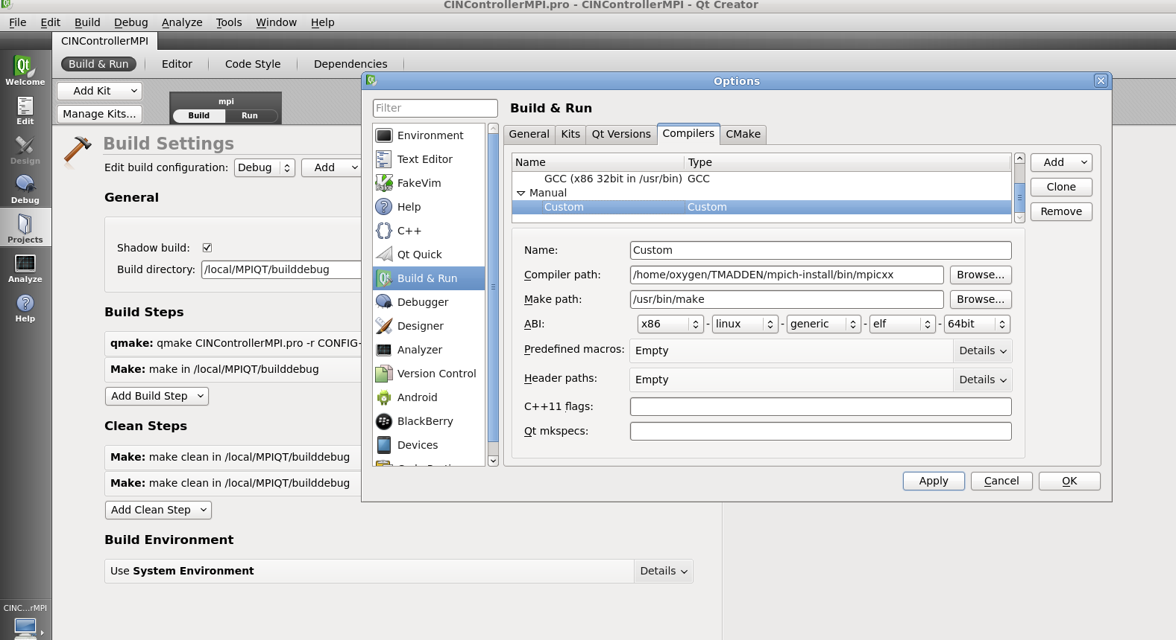

Add the compiler similar to above.

You can add an mpi kit, under add kits, like below:

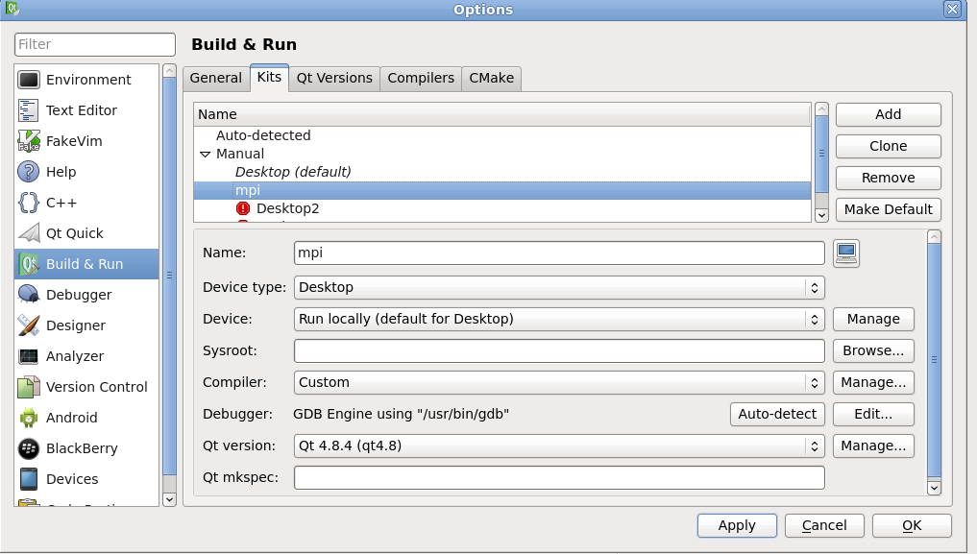

Setting up running the MPI program from QTCreator.

Running the MPI program from command is done this way:

cd build_directory
/local/mpich-install/bin/mpiexec -n 2 xterm -e ./detectorMPI

The above commands are setting pwd to the directory containing the detectorMPI binary. We then use mpiexec to launch the MPI program. -n 2 means we run two copies of the process. If we set -n 4 we would get 4 copies of the process. The xterm -e command forces the detectorMPI processes to run in an xterm, with each process getting an xterm. This allows each process to have its own stdin and stdout. To set this up in QTCreator, set up the RUN configuration as below.

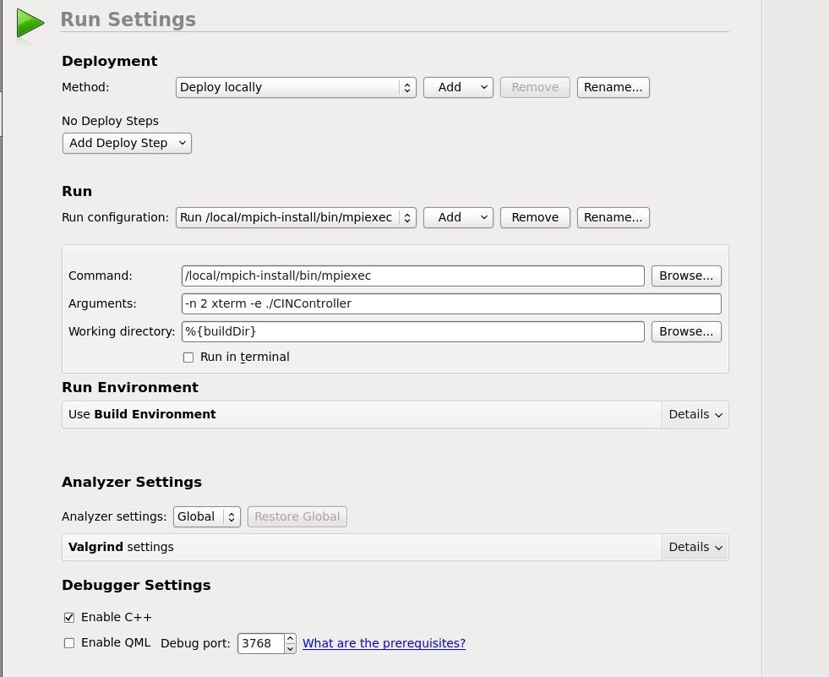

Debugging detectorMPI with QTCreator

The easiest way to debug detectorMPI is to start the program running from the command line or QT Creator. This is not debugging, but just running. Then connect to the running process you wish to debug with QTCreator. To debug several processes, you can start several instances of QTCreator.
The menu on QTCreator is Debug->StartDebugging->Connect to Running Application.

Theory of Operation

detectorMPI is designed in a way so a programmer need not know much about MPI to do parallel processing. It is necessary to understand the basics of C++ and QT.

The model of detector MPI is shown below. We have processes called “ranks” numbered 0 to N-1. Rank 0 is where fresh detector data arrives, and is scattered to all ranks. Rank 1 is the GUI and end of the processing line, where data is stored to disk. Other ranks just process data.

pipeReader
Detector
mpiScatter
Image
Queue

QT signal
Linx
pipe
mpiEngine

Rank 0

MPI messages, scattered iamges

Rank2
Rank3
mpiEngine
mpiEngine

MPI messages, gathered images

mpiGather
Image
queue
pipeWriter
GUI
display
Image
queue

mpiEngine
Linux out pipe
Rank 1

Rank 0 has a pipeReader that can either generate test images, or read images from a detector via a linux pipe. Image data is in a binary format defined in pipebinaryformat.cpp. Change this file to change the format. Images from the pipe are queued on a queue, and stored temporarily. mpiScatter gets the images off the queue, and scatters one image per rank. So if we have 4 ranks, we scatter 4 images. If we have only one image from detector, then only rank 0 gets data to process. mpiScatter then broadcasts a signal to tell all ranks to process their images. When processing is done, a 2nd broadcast is sent out and rank 1 will gather all processed images from all ranks with mpiGather. These images are queued and sent to the pipeWriter, where they can be stored to the linux filesystem. Finally, the images are sent to the GUI for display. For setup of the calculations, the GUI can send messages to all MPI ranks by first sending a message to rank0. Then rank0 broadcasts the settings to all the ranks, assuring all ranks have the same GUI settings. These are the red arrows: GUI sends QT signal to mpiEngine inside mpiGather object. Then mpiEngine translates message to MPI and sends to Rank0. Rank 0 in turn broadcasts the message to all ranks. In this way the GUI sets up all the ranks the same way.

The Public Image

Each instance of mpiEngine in the group of processes has “public images.” Public images are memory spaces in each rank that can be transferred between ranks. When setting up the system, the programmer declares how large the public images are, and how many. Available are ushort images and double images. These are used for all calculations in images that must be shared between processes. If any image must be scattered or gathered, then it should be in public image memory. See code for more information.

How Dark Subtraction is done with Multiple ranks

When doing dark subtraction, each rank has a copy of a back ground image. Data images are scattered to all ranks, and rank subtracts the back ground from its image. mpiGather than gets all computed images and sends to the output pipeWriter.

It is more complicated if we must average many dark images to compute the back ground image. The code comments document this, but the basic steps are:
- Detector spews out a total of N dark images, or more than N.
- mpiScatter scatters images to all ranks, with each rank getting possibly different numbers of images, depending on how fast the detector is. For example, if we wish to average 1000 dark images, rank 0 may get 631 images and rank 1 may get 359 images. The detector may send out more than 1000 dark images. Therefore the system must keep track of this.
- Each rank computes a sum of its collection of images. We call this a partial sum, because each sum is computed on a subset of the dark images.
- When N or more images have been scattered, all ranks send their partial sum of images to rank 1.
- Rank 1 adds up all the partial summed images, and computes average image.
- All ranks get a copy of the final average image, and store in own memory.

An example of this is in the code.

How to do your own MPI calculations

There are three projects released:
detectorMPI.pro, which does only dark subtraction.
XpcsMPI.pro, which does dark subtraction, thresh holding on noise, and simple image compression.
HelloWorld.pro, which does a “photographic negative” of the image. It is the simplest project.

Make a new project based on detectorMPI

If you want dark accumulations, copy the detectorMPI project. If you want a simpler project copy HelloWorld.
cd detectorMPI
cp -r HelloWorld NewProj
cp detectorMPI.pro NewProj.pro
cp detectorMPI.pro.user NewProj.pro.user

nedit newProj.pro
Find:detectorMPI Replace: NewProj

nedit NewProj.pro.user
Find:detectorMPI Replace: NewProj

Update the path and names of the files above in the pro file. Also edit the INCLUDEPATH to not point to DarkSub, but NewProj.

nedit xpcsMPI.pro

Add your new files to any repository to make sure they are saved.

Now you should be able to open the project in QTCreator

Make a GUI

The first thing to do is to design your user interface. This defines what the user inputs to the program, and what is controlled in the MPI calculations. It will help to make a list of all the things detector MPI must do.

Use QTCreator to drop buttons etc. Onto your GUI. The GUI included is a good start. It has a the following tabs:
- Input- where data originates.
- Calcs- what calculations are done on the data in MPI
- Output- where output data is sent after MPI calcs.
- Debug- controls to help debug the program.
- Start- start and stop processing and display of images.

See the QT website for info on how do develop a GUI in QTCreator.
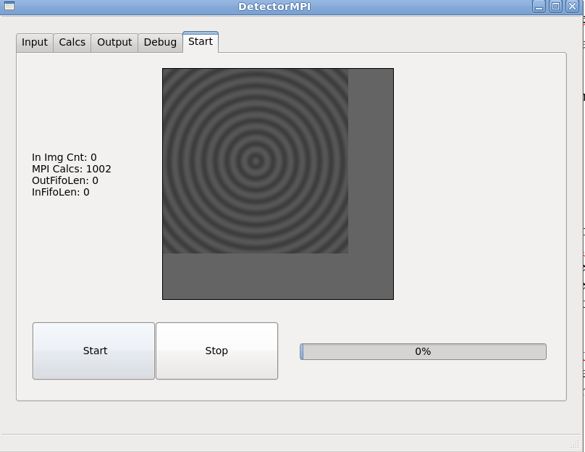
DetectorMPI Gui

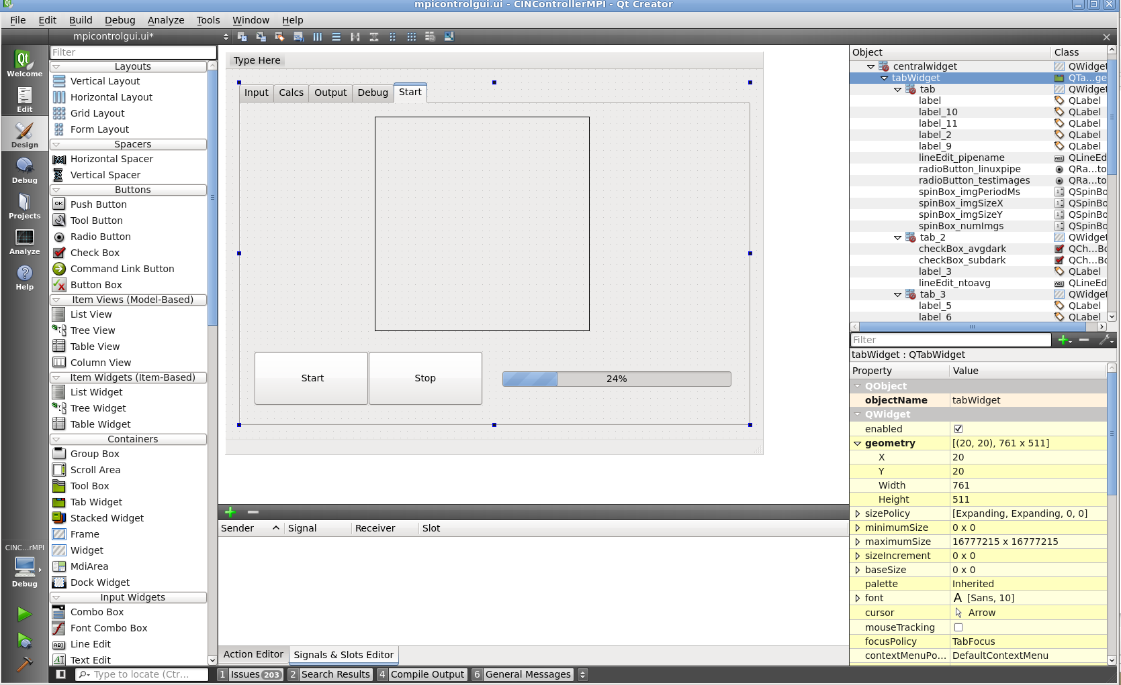
QTCreator gui design.

The C code that correspond to the GUI is in mpiControlGui.cpp. This file has a function that executes for each button that is pressed. These functions are generated by QTCreator for you. See QT website.

Put GUI Settings into a class

Once you figure out the controls on the GUI, edit the file signalmessageUser.h. Edit the class guiMessageFieldsUser to reflect all NEW values you added to the GUI. When you hit a button on the GUI, a value in a guiMessageFieldsUser object should be set. This is done by having a QT slot for each control on the GUI screen. On the GUI screen, right click on the QTCreator design screen, and goto Slot. In the code, set the GUI control value into the guiMessageFieldsUser object.

When you update the GUI, this guiMessageFieldsUser object will be sent as a QT signal to the MPI code, and then sent as MPI message to all MPI processes in the detectorMPI program. In this way, your GUI settings are sent to all processes in the MPI program.

Edit imagequeitem.h

Most of the time, you will not need to edit this file.
The class imageQueueItem defines the image structure. It has fields like size_x, size_y, and a pointer to its data called imgdata. You may wish to change its data type, or add more fields and data to this class. You must also edit imageSpecs class.

The image queues allow the detector and MPI to run at different rates. There are two queues before the MPI calculations: a free queue, with empty images, and a data queue, with fresh images from the detector. Code contained in pipeReader will take items from free queue, fill it in with image data, and place on the data queue. Then pipeReader sends out a signal to mpiScatter, telling it that new images are available for the MPI processing.

Subclass of mpiScatter
The next step is to either edit mpiscatterUser.h, cpp. mpiScatterUser is a class that gets your GUI settings, then tells all MPI processes what your GUI settings are. Also, fresh images from your detector come into mpiScatterUser, and mpiScatterUser sends them to all the MPI processes, then kicks off the MPI concurrent calculations for each set of images.

In this class you will need to make code that is specific to your calculations. You will edit all the functions in mpiscatterUser.cpp.

Functions you need to consider are:
gotMPIGuiSettings- which is called when gui is updated.
onDeFifo, when a new image from detector is taken from the queue an needs to be processed.
beforeDefifo, = called on new image signal, but before we dequeue anything.
afterDefifo- called after we dequeue all the new images, and just before MPI calculations are launched.

Subclass of mpiEngine

To implement your calculations you edit mpiUser.cpp, h. Your calculations will go into the function doImgCalcs(). Also, GUI settings must be dealt with to make sure the MPI calculations are set up based on GUI settings. This is done in beforeFirstCalc(). beforeCalcs() is called by mpiScatter, after images have been scattered to all process, and just before MPI processing is started.

You must also edit signalmessageUser.h to add any fields you need in the following classes:
newImgMessageFiedsUser- a message that means a new image has come in. Image specs etc.
mpiBcastMessageUser- should have a guiMessageFieldsUser in it, so MPI gets the gui settings, also values and fields to control the MPI processing. This message is broadcast to all MPI processes during calculations.

These fields should match the code in your subclass of mpiEngine.

Edit mpiGather

mpiGather is a class that gathers up all the images from all the processes into one place. These images are put into a queue, and a signal is sent to the output code and GUI to save the images and display them. For simple calculations, you will not need to edit mpiGatherUser. For more complex computations you may need to gather several images from each rank, say a raw image, compressed image, and perhaps FFT of image. In this case you must edit or subclass mpiGatherUser.

Altering Linux pipe data format

To alter the data format of images sent over Linux pipes, edit or subclass the file pipebinaryformat.h and cpp. It is basically C file I/O to read and write to pipes. Care should be taken to deal with broken pipes, when the pipe sender process goes away. The code shows an example of this.

Testing the input and output pipes

The file imageStreamTest.cpp is part of the QT project, but it is not compiled with it. It is meant to be compiled as a separate program with gcc. This program runs on the command line and simply dumps images to stdout. Compile the program as shown in the source code comments.

Run detectorMPI, getting input from a named pipe. The name can be anything like /local/madpipe shown in the GUI. You must make this pipe with
mkfifo /local/madpipe
You start the MPI code GUI by hitting start. The code will wait until images show up on the pipe.
Now in anther terminal you run
imgtest 1000 256 200 0> /local/madpipe

imgtest will send 1000 images of size 256x256 to /local/madpipe. The first 200 images will be dark images, and will be type 0. The image type number allows the user to generate different types of images. The MPI software will read the images from the pipe and process.

To test the output pipe you have two options:
- IN another terminal type

  - mkfifo /local/madoutpipe
  - cat </local/madoutpipe > myfile.bin
  - The above will read a pipe called /local/madoutpipe and store it to a file.
  - Run the detectorMPI software with output pointed to a Linux pipe called /local/madoutpipe.

- You can run a SECOND copy of detectorMPI, reading input from /local/madoutpipe.
  - In this case the first detectorMPI write to madoutpipe.
  - The 2nd copy of detectorMPI reads from madoutpipe, and displays the images.

To keep a pipe open, say for sending 1 image at a time from command lines:

sleep 9999999 > /local/madpipe &

Now when detectorMPI reads from that pipe, it will not close the pipe if the sender goes away. So you can do this:
imgtest 1 256 > /local/madpipe
imgtest 1 256 > /local/madpipe
imgtest 1 256 > /local/madpipe

That is, we can send one image at a time from command line. decectorMPI will keep reading.
You will want to kill the sleep process when done debugging.

