AusFarm simulation files

The AusFarm simulation files here are the source for the .sdml files used for Farm4Prophet that are found in the APSIM.Cloud\APSIM.Cloud.Shared\Resources directory.

To generate the .sdml files from these simulation files follow this process from within AusFarm:

- Open the simulation in AusFarm. This may require choosing File | Import.
- Choose File | Export.
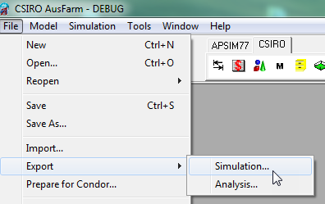

- From the Save Simulation dialog change the file filter to *.sdml. Enter a file name and choose Save.
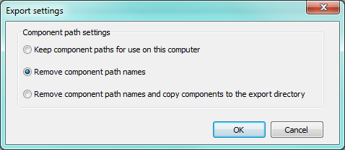
- Then the component paths need to be shortened.

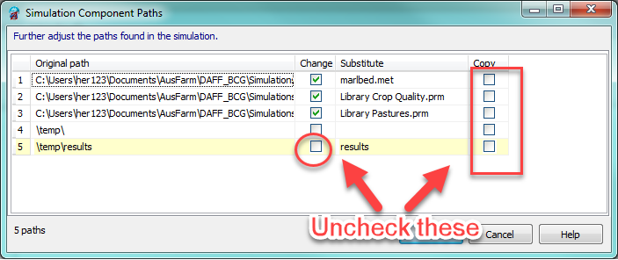
- Further export settings

- Click OK and the .sdml file will be written.

