Soil Temperature

# General description

Simulates soil temperature given minimal input information using a numerical scheme. This implementation is largely based on the method described by Campbell (1985) but has some modifications to make it compatible with APSIM. There are also some updates since the version released in APSIM Classic. Here we add some changes intended to facilitate potential future developments in other APSIM modules.

# Theory

The node/element scheme for the numerical simulation is shown in Figure 1. All heat storage is assumed to occur at the nodes while resistance (or its inverse, conductance) to heat transfer is assumed to take place between nodes. The mapping between soil layers used in other APSIM models and nodes is done internally and is not visible to users.

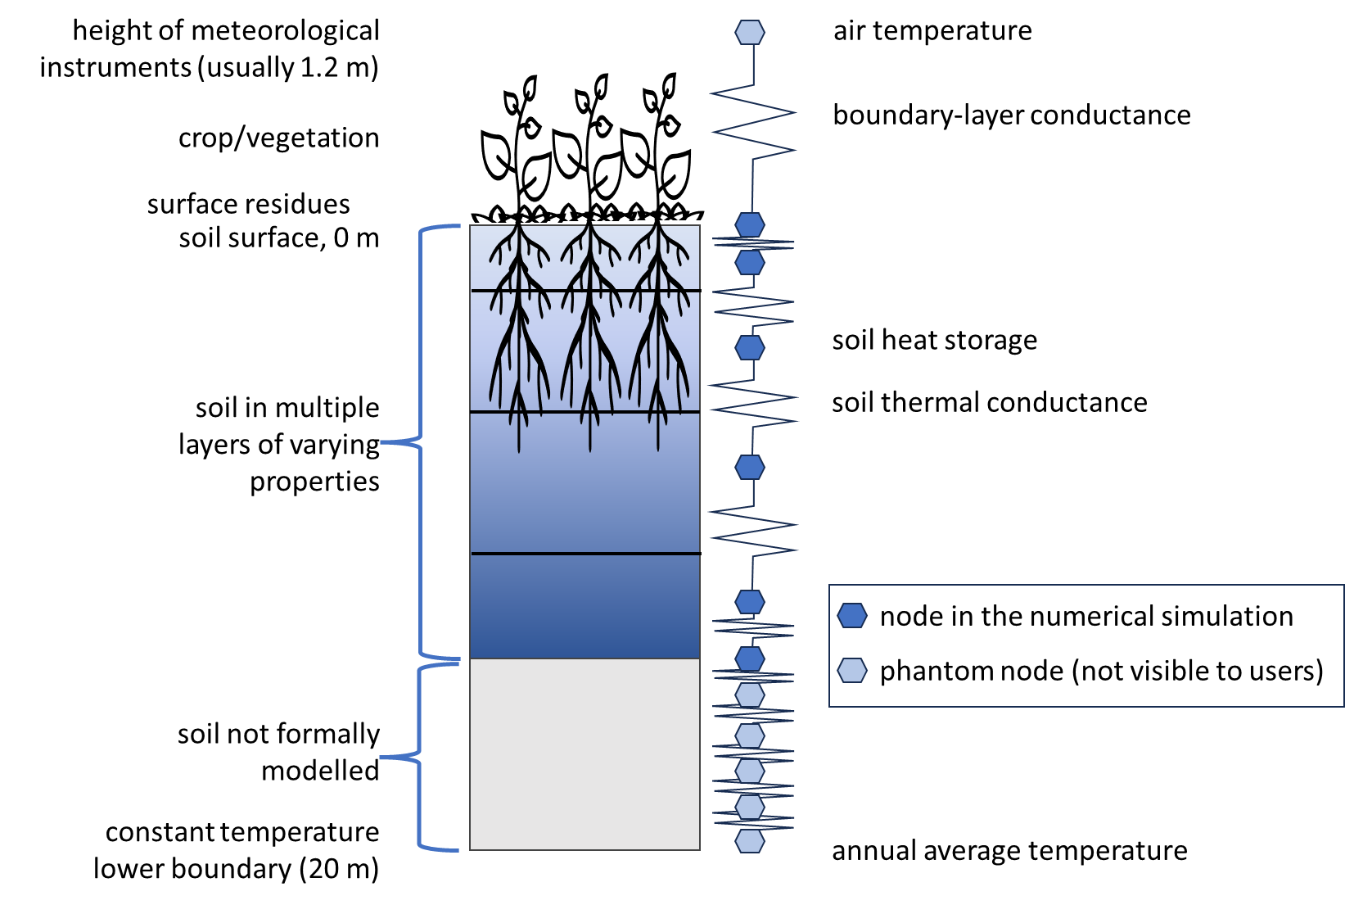

Figure 1. Diagram of the implementation of the numerical simulation of soil temperature into the soil layer orientation of APSIM. The light blue nodes are used in the simulation but are not readily visible to users.

Following Campbell (1985), heat flux density (*h*, the rate of heat movement in the soil; W /m2) is given by:

, [Eq. 1]

where λ is the thermal conductivity (W /m /K), *T* is the soil temperature (C), and *z* is depth in the soil (m). When this equation is combined with the equation for continuity of energy the change in temperature with time emerges as:

[Eq. 2]

where *C* is the volumetric specific heat of the soil (J /m3 /K) and *t* is time (s). This equation is amenable to discretisation and numerical solution when accompanied by air temperatures from the weather file as the upper boundary condition and a constant temperature lower boundary condition placed at an appropriate depth.

Implementation of the numerical solution requires that the thermal properties of the soil (λ and C) are provided and, because the numerical solution requires sub-daily timesteps, some assumptions about the pattern of air temperature during the day. These are documented below.

# Volumetric specific heat of the soil (C)

The volumetric specific heat of the soil is the amount of energy required to raise the temperature of the soil by 1 °C. It is calculated from the soil constituents and includes quantities that change during the simulation. This key soil characteristic is calculated from the weighted sum of the soil constituents as:

[Eq. 3]

where C is the volumetric specific heat of the constituent as given in Table 1, ϕ is the volumetric fraction of the constituent in the whole soil and subscript *i* indicates the soil constituent which has values of rocks, OM (organic matter), sand, silt, clay, water, ice and air. Note that these volumetric fractions are slightly different to those frequently used in APSIM as they need to account for rocks and organic matter in the whole-soil volume.

The calculation method is somewhat complicated by the basis of the soil property inputs in APSIM. For example, the clay percentage is the percentage of clay in the soil fines (i.e., excluding stones) after removal of the organic matter. Given these considerations, the calculations, with their order of calculation, is:

1. ϕrocks = Rocks% / 100
2. ϕOM = Carbon% / 100 * 2.5 * ρb / ρOM
3. ϕsand = (1 - ϕOM – ϕrocks) * Sand% / 100 * ρb / ρs
4. ϕsilt = (1 - ϕOM – ϕrocks) * Silt% / 100 * ρb / ρs
5. ϕclay = (1 - ϕOM – ϕrocks) * Clay% / 100 * ρb / ρs
6. ϕwater = (1 - ϕOM) * θ
7. ϕice = (1 - ϕOM) * θice
8. ϕair = 1 - ϕrocks - ϕOM - ϕsand - ϕsilt - ϕclay - ϕwater - ϕice

where notes on each calculation are as below:

1. Rocks% is the % by volume of stones/rocks in the intact soil layer as entered in APSIM
2. Carbon% is the % by mass of carbon in the soil fine fraction, the factor of 2.5 is to convert from carbon to organic matter by weight, ρb is the soil bulk density as the mass of fine earth in the intact soil volume, and ρOM is the density of organic matter
3. Sand% is the % by volume of sand in the fine earth fraction of the soil as entered in APSIM, and ρs is the particle density of the soil fines
4. Silt% is the % by volume of sand in the fine earth fraction of the soil, as entered in APSIM
5. Clay% is the % by volume of clay in the fine earth fraction of the soil, as entered in APSIM
6. θ is the volumetric soil water content (liquid form only) as simulated by APSIM
7. θice is the volumetric ice content which may be simulated in a future version of APSIM

and

* ρOM is given a value of 1.3 Mg /m3 (Campbell, 1985)
* ρs is throughout APSIM given a value of 2.65 Mg /m3 but there would be more flexibility for a greater range of soils if this was specified in the soil properties rather than being inherently assumed
* ϕOM is often overlooked when calculating soil thermal properties as usually the organic matter content of the soil is sufficiently low that it may be ignored. However explicitly including it will maintain flexibility for soils with high organic matter and particularly for peat soils
* θice is only considered here only for forward compatibility – in the current version it will have a value of 0

Note that the soil surface layers, particularly in perennial systems, can have a high root content. Logically, it would be reasonable to expect that high root contents would affect the thermal properties, but such an effect is not currently included.

# Thermal conductivity of the soil (λ)

The thermal conductivity (λ) of the soil is a quantification of the propensity of the soil to conduct heat from locations of high temperature to those of low temperature. This key soil characteristic can either be determined (see Jury, 1991 for an example) or can be approximated from empirical or regression equations. We have adapted the ‘simplified de Vries’ method from Tian et al. (2016) as this seems suitable for implementation in APSIM. However, Tian et al. (2016) included several features that we do not consider. We do not include the extension of λ to completely dry soils as the soil water models in APSIM do not permit soils to dry below a defined “air dry” water content which is approximately at a suction of 30 bar. Nor do we consider the extension for soil water contents less than 0.09 m3 /m3.

Thermal conductivity is calculated from the weighted sum of the soil constituents as:

[Eq. 4]

where ϕ is the volume fraction as defined above, λ is the constituent thermal conductivity (see Table 1), *k* is a weighting factor by constituent, and the subscript *i* indicates the soil constituent which is as above except that the mineral components are considered together (therefore *i* has values of OM, mineral, water, ice and air). Eq. 4 introduces a weighting factor, *k*, such that:

[Eq. 5]

where *g* is a shape factor which is given by the values and equations in Table 1.

**Table 1.** Specific heat (C), thermal conductance (λ) and shape factor (*g*) of soil constituents. Values from Campbell (1985) unless otherwise noted.

|  |  |  |  |
| --- | --- | --- | --- |
| **Constituent, *i*** | **Ci (MJ /m3 /K)** | **λi (W /m /K)** | **gi (W /m /K)** |
| Rocks1 | 7.702 | 0.1822 | 0.1822 |
| Organic matter | 0.25 | 2.50 | 0.53 |
| Sand | 7.702 | 0.1822 | 0.182 |
| Silt | 2.742 | 2.39 | 0.125 |
| Clay | 2.92 | 1.392 | 0.00775 |
| Minerals | n/a | note 4 | note 5 |
| Water | 0.57 | 4.18 | 1.0 |
| Ice | 2.18 | 1.73 | note 6 |
| Air | 0.025 | 0.0012 | note 7 |
| 1 – rocks or stones were not considered by Tian et al. (2016). We assume that, thermally, they behave similarly to sand | | | |
| 2 – value from Tian et al. (2016) | | | |
| 3 – value from de Vries (1963) but Tian et al. (2016) notes that this value would stand further evaluation | | | |
| 4 – | | | |
| 5 – | | | |
| 6 – | | | |
| 7 – | | | |

# Boundary conditions

Numerical solutions require that the upper and lower boundary conditions be asserted.

For the lower boundary condition we assume, following Campbell (1985), a constant temperature at 20 m deep with the value taken as the annual average temperature of the location from the weather file. Because the depth of soil in most APSIM simulations substantially shallower, typically to a depth of ~2 m only, a number (five by default) of ‘phantom’ soil nodes are added below the specified soil. These nodes are not visible to the use and only serve to facilitate the lower boundary condition. All their properties, static and dynamic, are taken from the lowest soil layer.

The upper boundary condition is taken from the air temperatures as supplied in the weather file. Although other APSIM models will only interact with SoilTemperature on a daily basis, the equations above require a sub-daily timestep to solve reliably. We found a 30-minute fixed time step to be satisfactory and this requires that the air temperature be asserted every 30 minutes. Because the air temperatures are only supplied as a daily minimum and maximum, some assumptions are necessary.

In general we take the air temperature (*T*) at any time during the day to be:

[Eq. 4]

where *t* is the current fractional day (e.g., 30 minutes past midnight is 0.5/24=0.02083), *tmaxt* is the assumed *t* of maximum temperature, and *Tmin*and *Tmax* are the minimum and maximum temperatures from the weather file. The time at which the minimum temperature is reached is assumed to be (*tmaxt* - 0.5) and between midnight and that time, *T* is linearly interpolated from *T* at the end of the previous day and the *Tmin* of the current day. In general this scheme produces realistic curves but there are some anomalies when there are abrupt changes in temperature. Figure 1 shows an example of a 10-day weather record in which there was an abrupt decline in temperature (on the 15th of the month).

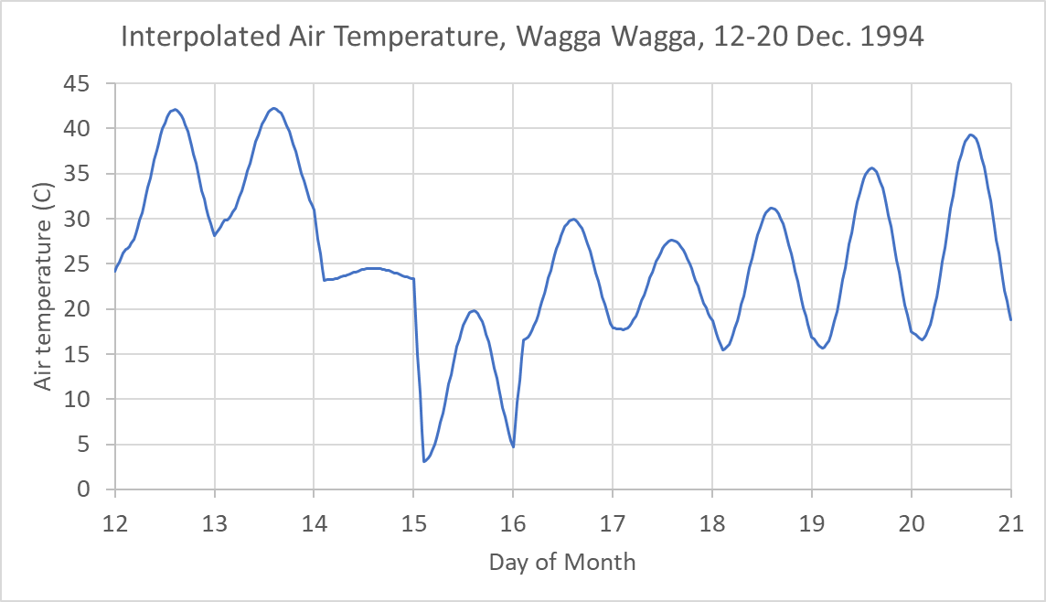

Figure 1. Interpolated air temperature for Wagga Wagga (Australia) from 12 to 20 December 1994.

With the upper boundary being at the hight of the meteorological instruments, it is also necessary to estimate the effective thermal conductance between the instrument height and the soil surface. For this we use the method presented by Campbell (1985, program 12.2, page 140) including the stability corrections which are iterated three times for each internal timestep.

# Initial values

As with most models, SoilTemperature requires initial values. In this case it is the temperature in each soil layer. A scheme has been added to estimate the initial temperature and these are discarded in favour of any user inputs.

# Inputs and Parameters

*Initialisation*

There are two sections required for initialisation of the Soiltemp module; constants and parameters. Where a variable name is followed by “[nz]” the variable is an array and the appropriate number of values must be supplied.

Constants

|  |  |  |  |
| --- | --- | --- | --- |
| Name | Unit | Description | Value |
| nu | - | forward/backward differencing | 0.6 |
| vol_spec_heat_om | J m-3 K-1 | volumetric specific heat of organic matter | 5.00e6 |
| vol_spec_heat_water | J m-3 K-1 | volumetric specific heat of water | 4.18e6 |
| vol_spec_heat_clay | J m-3 K-1 | volumetric specific heat of clay minerals | 2.39e6 |

Parameters

|  |  |  |  |
| --- | --- | --- | --- |
| Name | Unit | Description | Range |
| clay[nz] | - | proportion of clay | 0.0 - 1.0 |
| bound_layer_cond | J s-1 m-2 K-1 | boundary layer conductance | 0.0 - 100.0 |

The higher the value of bound_layer_cond the greater the difference between air and soil surface temperature. If its value is unknown, Campbell (1986) suggests that a value of 20 J s-1 m-2 K-1 is an appropriate initial estimate.

A further, optional, parameter is,

|  |  |  |  |
| --- | --- | --- | --- |
| soil_temp[nz] | °C | initial soil temperature | -100.0 - 100.0 |

which used to initialise soil temperature. If it is not supplied the soil temperature array is initialised to the average annual temperature. Simulations will eventually ‘forget’ the effect of poor initial guesses of soil temperature, but this may take some time. Testing of this module showed that it took approximately 40 days for the temperature at 1.5 m deep to converge to within 0.5 °C of the analytical solution when the initial temperature difference was 7 °C. The discrepancy will be greatest deeper in the soil profile, and where *C* is high or λ is low. In general, where soil temperature is only important in the soil surface layers the convergence will occur within the first 10 days or so.

Where the time taken to ‘forget’ the initial conditions might cause significant error, there are two strategies for overcoming this problem. The first is to run a dummy simulation prior to the start of the real simulation to estimate the starting soil temperature. The second option is to estimate the initial soil temperatures from an analytical solution. A solution for the heat flow equation assuming a sinusoidal upper boundary condition. which might for example be the annual cycle in air temperature, is (Carslaw and Jaeger, 1959),

, [19]

where

, [20]

Tave is the average annual temperature (°C), Tamp is the annual amplitude in temperature (°C), and ω is the angular frequency (radians). Thermal conductivity and heat capacity can be estimated, using soil profile averages, from equations 3, 5, and 6.

*Time step inputs from other modules*

Soiltemp must be accompanied by the input module and a soil water module in order that other inputs are supplied. These inputs are.

Campbell, G.S., 1985. Soil Physics with BASIC. Transport Models for Soil - Plant Systems. Elsevier, Amsterdam.

de Vries, D.A., 1963. Thermal properties of soils, in: van Wijk, W.R. (Ed.) Physics of Plant Environment. North-Holland Publishing Corporation, Amsterdam, pp. 210–235.

Jury, W.A.G., W.R;, Gardner, W.H., 1991. Soil Physics, 5th Ed. . Wiley, New York.

Tian, Z., Lu, Y., Horton, R., Ren, T., 2016. A simplified de Vries‐based model to estimate thermal conductivity of unfrozen and frozen soil. Eur. J. Soil Science. 67(5), 564-572. <https://doi.org/10.1111/ejss.12366>.