# Viluco stress window simulation specifications.

Simulations were carried out near Viluco Chile (latitude -33.912, longitude -70.763) in a silt loam soil with plant-available water in the upper 1.35 m of approximately 216 mm m-1 starting with a full profile. Fertiliser non-limiting.

Pioneer 3394 was sown at 9 plants m-2 at 50mm depth with 760mm row spacing.

2001 season was sown on 7th November and 2002 season sown 10th October.

Weather

|  |  |  |  |  |  |  |
| --- | --- | --- | --- | --- | --- | --- |
| Season | MaxTemp | MinTemp | Rain | Radiation | DaysToFlower | DaysToMaturity |
| 2001 | 33.8 | 4.7 | 11.8 | 3894.4 | 76 | 156 |
| 2002 | 35.5 | 4.4 | 8.1 | 4005 | 83 | 152 |

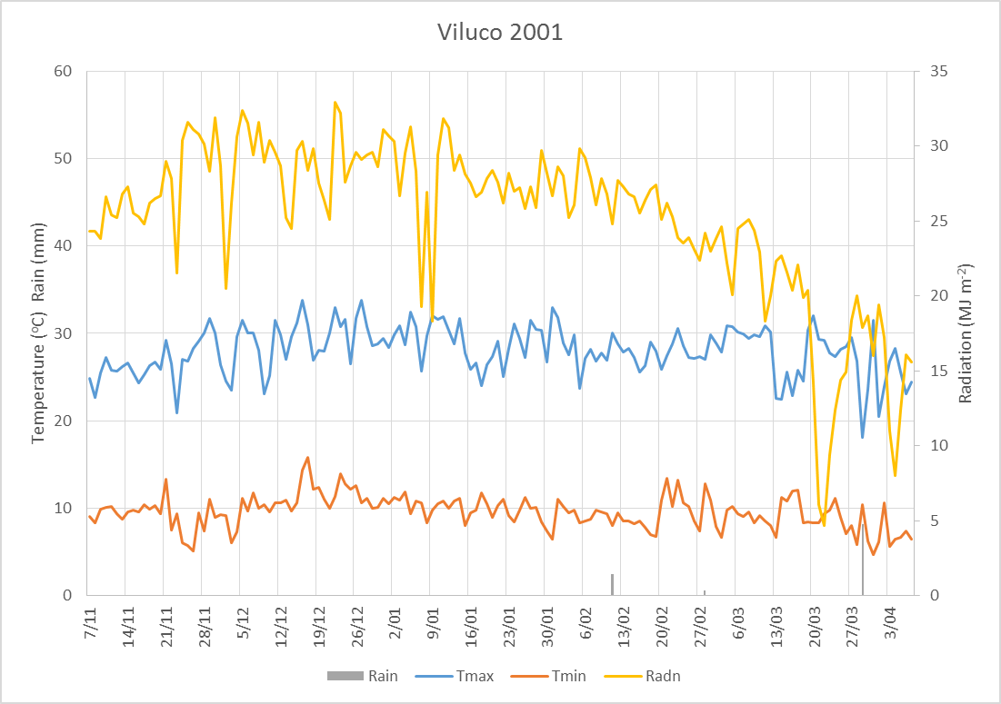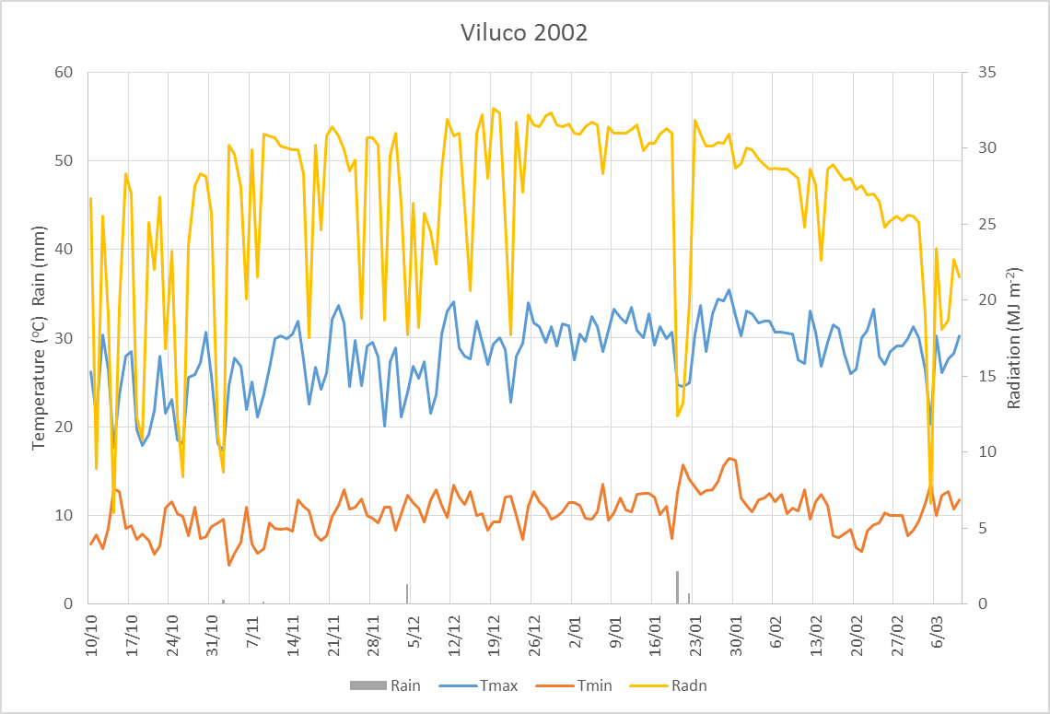

Irrigation Schedule

|  |  |  |  |  |  |  |  |
| --- | --- | --- | --- | --- | --- | --- | --- |
| 2001 | Irrigation(mm) |  |  |  |  |  |  |
| Date | Days after sowing | Full | S1 | S2 | S3 | S4 | S5 |
| 8/11/2001 | 2 | 6.8 | 6.8 | 6.8 | 6.8 | 6.8 | 6.8 |
| 12/11/2001 | 6 | 6.8 | 6.8 | 6.8 | 6.8 | 6.8 | 6.8 |
| 16/11/2001 | 10 | 10.2 | 10.2 | 10.2 | 10.2 | 10.2 | 10.2 |
| 17/11/2001 | 11 | 6.8 | 6.8 | 6.8 | 6.8 | 6.8 | 6.8 |
| 20/11/2001 | 14 | 13.5 | 13.5 | 13.5 | 13.5 | 13.5 | 13.5 |
| 23/11/2001 | 17 | 10.2 | 10.2 | 10.2 | 10.2 | 10.2 | 10.2 |
| 26/11/2001 | 20 | 13.5 | 13.5 | 13.5 | 13.5 | 13.5 | 13.5 |
| 30/11/2001 | 24 | 20.3 | 20.3 | 20.3 | 20.3 | 20.3 | 20.3 |
| 4/12/2001 | 28 | 27.1 | 27.1 | 27.1 | 27.1 | 27.1 | 27.1 |
| 7/12/2001 | 31 | 16.6 | 50.0 | 16.6 | 16.6 | 16.6 | 16.6 |
| 8/12/2001 | 32 | 20.3 |  | 20.3 | 20.3 | 20.3 | 20.3 |
| 12/12/2001 | 36 | 27.1 |  | 27.1 | 27.1 | 27.1 | 27.1 |
| 16/12/2001 | 40 | 28.4 |  | 28.4 | 28.4 | 28.4 | 28.4 |
| 20/12/2001 | 44 | 30.5 |  |  | 30.5 | 30.5 | 30.5 |
| 24/12/2001 | 48 | 28.4 |  |  | 28.4 | 28.4 | 28.4 |
| 28/12/2001 | 52 | 37.2 |  |  |  | 37.2 | 37.2 |
| 1/01/2002 | 56 | 20.3 |  |  |  | 20.3 | 20.3 |
| 5/01/2002 | 60 | 30.5 |  |  |  | 30.5 | 30.5 |
| 9/01/2002 | 64 | 37.2 |  |  |  |  | 37.2 |
| 13/01/2002 | 68 | 30.5 |  |  |  |  | 30.5 |
| 17/01/2002 | 72 | 44.0 |  |  |  |  | 44.0 |
| 25/01/2002 | 80 | 81.2 |  |  |  |  | 81.2 |
| 29/01/2002 | 84 | 33.9 | 33.9 |  |  |  |  |
| 30/01/2002 | 85 | 0.0 | 33.9 |  |  |  |  |
| 2/02/2002 | 88 | 30.5 | 30.5 |  |  |  |  |
| 6/02/2002 | 92 | 37.2 | 37.2 |  |  |  |  |
| 7/02/2002 | 93 |  |  | 67.7 |  |  |  |
| 10/02/2002 | 96 | 27.1 | 27.1 | 27.1 |  |  |  |
| 14/02/2002 | 100 | 30.5 | 30.5 | 30.5 |  |  |  |
| 18/02/2002 | 104 | 54.2 | 54.2 | 54.2 | 54.2 |  |  |
| 22/02/2002 | 108 | 30.5 | 30.5 | 30.5 | 30.5 |  |  |
| 26/02/2002 | 112 | 33.9 | 33.9 | 33.9 | 33.9 |  |  |
| 2/03/2002 | 116 | 16.9 | 16.9 | 16.9 | 16.9 |  |  |
| 6/03/2002 | 120 | 23.7 | 23.7 | 23.7 | 23.7 | 23.7 |  |
| 10/03/2002 | 124 | 30.5 | 30.5 | 30.5 | 30.5 | 30.5 |  |
| 14/03/2002 | 128 | 23.7 | 23.7 | 23.7 | 23.7 | 23.7 |  |
| 18/03/2002 | 132 | 13.5 | 13.5 | 13.5 | 13.5 | 13.5 |  |
| 21/03/2002 | 135 | 10.2 | 10.2 | 10.2 | 10.2 | 10.2 |  |
| 25/03/2002 | 139 | 23.7 | 23.7 | 23.7 | 23.7 | 23.7 |  |
| 28/03/2002 | 142 | 14.9 | 14.9 | 14.9 | 14.9 | 14.9 |  |
| 1/04/2002 | 146 | 5.4 | 5.4 | 5.4 | 5.4 | 5.4 |  |
| Total |  | 987.4 | 639.0 | 613.7 | 547.4 | 500.0 | 547.4 |

|  |  |  |  |  |  |  |  |
| --- | --- | --- | --- | --- | --- | --- | --- |
| 2002 | Irrigation(mm) | |  |  |  |  |  |
| Date | Days after sowing | Full | S1 | S2 | S3 | S4 | S5 |
| 10/10/2002 | 1 | 9 | 9 | 9 | 9 | 9 | 9 |
| 15/10/2002 | 6 | 5.5 | 5.5 | 5.5 | 5.5 | 5.5 | 5.5 |
| 20/10/2002 | 11 | 7.5 | 7.5 | 7.5 | 7.5 | 7.5 | 7.5 |
| 25/10/2002 | 16 | 9 | 9 | 9 | 9 | 9 | 9 |
| 30/10/2002 | 21 | 9.6 | 9.6 | 9.6 | 9.6 | 9.6 | 9.6 |
| 4/11/2002 | 26 | 10.9 | 10.9 | 10.9 | 10.9 | 10.9 | 10.9 |
| 9/11/2002 | 31 | 15.9 | 15.9 | 15.9 | 15.9 | 15.9 | 15.9 |
| 14/11/2002 | 36 | 23.1 | 23.1 | 23.1 | 23.1 | 23.1 | 23.1 |
| 19/11/2002 | 41 | 22.4 |  | 22.4 | 22.4 | 22.4 | 22.4 |
| 24/11/2002 | 46 | 29 |  | 29 | 29 | 29 | 29 |
| 29/11/2002 | 51 | 27.1 |  |  | 27.1 | 27.1 | 27.1 |
| 4/12/2002 | 56 | 26.3 |  |  | 26.3 | 26.3 | 26.3 |
| 9/12/2002 | 61 | 23.7 |  |  | 23.7 | 23.7 | 23.7 |
| 14/12/2002 | 66 | 36.3 |  |  |  | 36.3 | 36.3 |
| 19/12/2002 | 71 | 36.7 |  |  |  | 36.7 | 36.7 |
| 24/12/2002 | 76 | 38 |  |  |  | 38 | 38 |
| 29/12/2002 | 81 | 45.5 |  |  |  |  | 45.5 |
| 3/01/2003 | 86 | 44.1 |  |  |  |  | 44.1 |
| 8/01/2003 | 91 | 41.1 |  |  |  |  | 41.1 |
| 13/01/2003 | 96 | 40.7 |  |  |  |  | 40.7 |
| 18/01/2003 | 101 | 36.7 | 36.7 |  |  |  |  |
| 23/01/2003 | 106 | 23.1 | 23.1 |  |  |  |  |
| 28/01/2003 | 111 | 33.2 | 33.2 | 33.2 |  |  |  |
| 2/02/2003 | 116 | 31 | 31 | 31 | 60 |  |  |
| 7/02/2003 | 121 | 27.7 | 27.7 | 27.7 | 27.7 |  |  |
| 12/02/2003 | 126 | 23.7 | 23.7 | 23.7 | 23.7 | 60 |  |
| 17/02/2003 | 131 | 21.8 | 21.8 | 21.8 | 21.8 | 21.8 |  |
| 22/02/2003 | 136 | 22 | 22 | 22 | 22 | 22 |  |
| 27/02/2003 | 141 | 19.6 | 19.6 | 19.6 | 19.6 | 19.6 |  |
| 4/03/2003 | 146 | 18.3 | 18.3 | 18.3 | 18.3 | 18.3 |  |
| 9/03/2003 | 151 | 10.4 | 10.4 | 10.4 | 10.4 | 10.4 |  |
| Total |  | 768.9 | 358 | 349.6 | 422.5 | 482.1 | 501.4 |