Return type

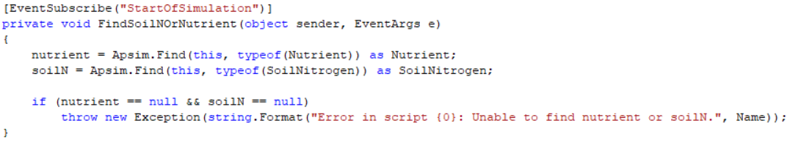

Arguments of method

Name of method