Return type
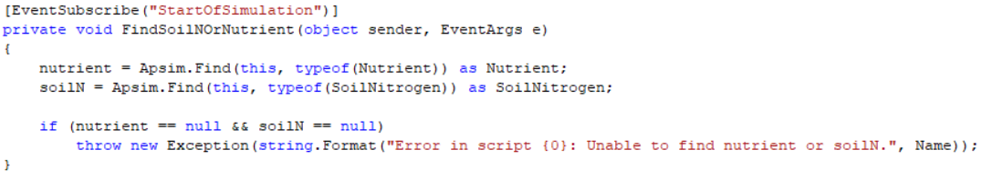
Arguments of method
Name of method

