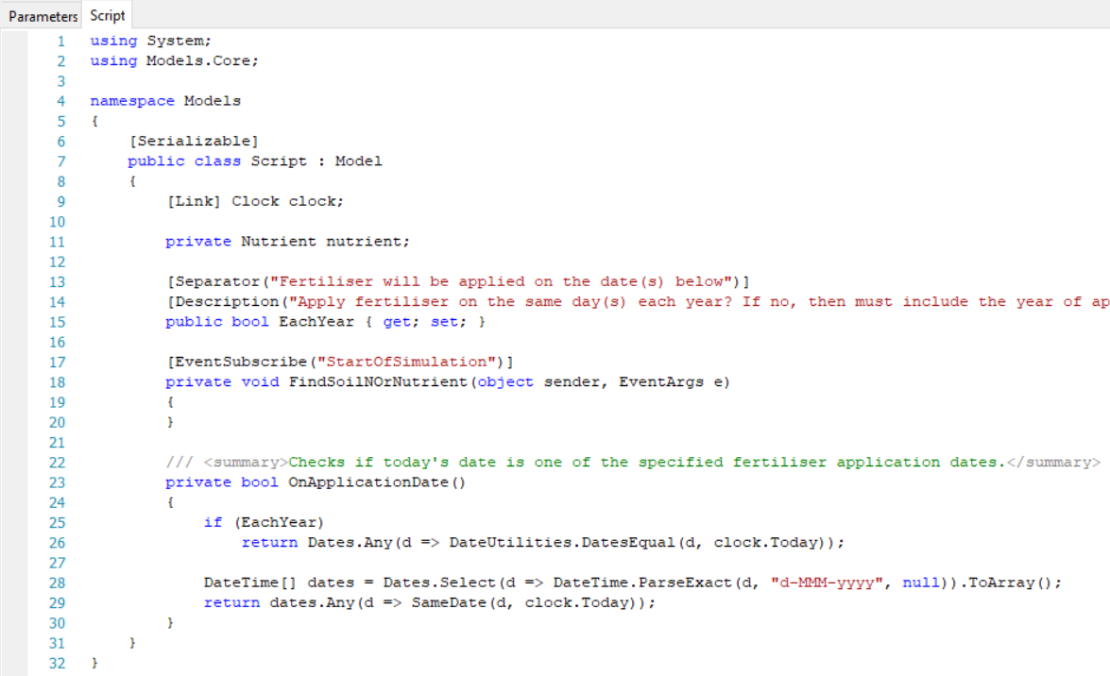

methods
used namespaces
nd

properties
fields
links
namespace
class

