GRAZPLAN Pasture Model

Progress Notes:

Sensibility tests
Hamilton met file: Hamilton.txt
Canberra met file: cbr_70014.met

Test | Type | Climate file | AusFarm simulation | APSIM simulation | Data | Notes
1 | Single species ryegrass | cbr_70014.txt | just_pasture_ryegrass.afs | pasture_test_1.apsimx | ausfarm_test_ryegrass.xlsx
2 | Single species clover | Hamilton.txt | just_pasture_clover_1.afs | pasture_test_2.apsimx | ausfarm_test_clover.xlsx
3 | Clover and Ryegrass | Hamilton.txt | just_pasture_clover_rye.afs | pasture_test_3.apsimx | ausfarm_test_clover_ryegrass.xlsx | ungrazed_hamilton.ggfl  pasture_report.ggrp
4 | Single species ryegrass (same as (1)) Irrigation x ApplyN | cbr_70014.met | just_pasture_ryegrass_applyN_irrig.afs | pasture_test_4.apsimx | ausfarm_test_ryegrass_irrig.xlsx | Irrigate 18 Nov  Apply N 1 Sep

26 Feb 2024
Issues:

- N fixation in clover simulation is not happening in APSIM.

In the single species – Test 2
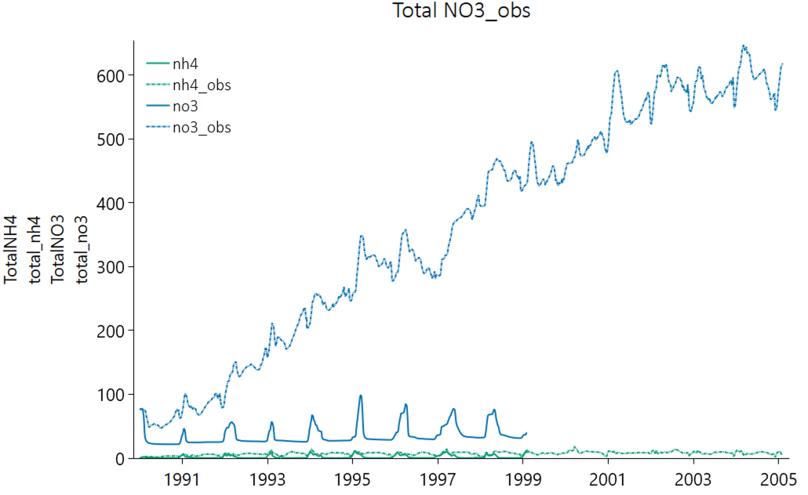

Also in the clover-ryegrass mix – Test 3
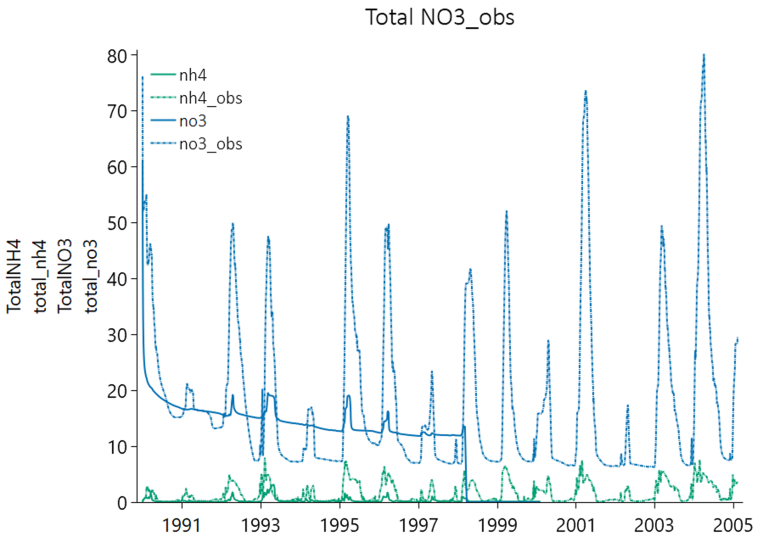

- Litter amount 1 day out of sync. – Test 2

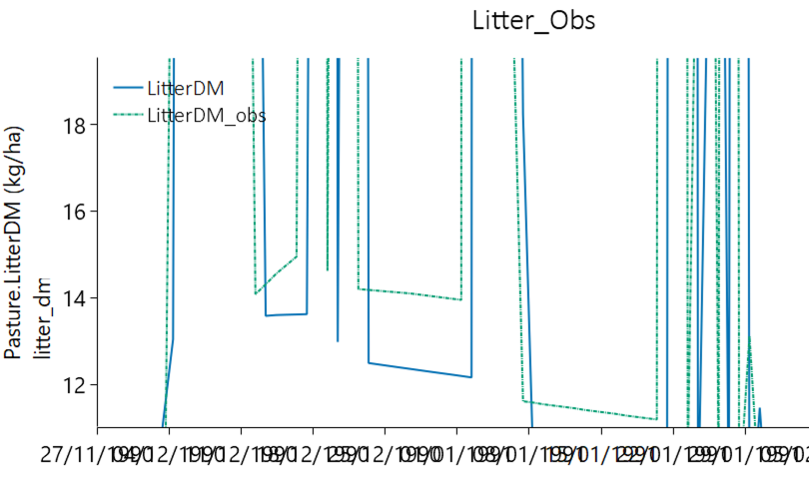

- Litter amount in Test 1 could be causing differences in soil water (due to evap) during dormant time and hence affecting growth after germination – although the litter amounts seem to match quite well.

