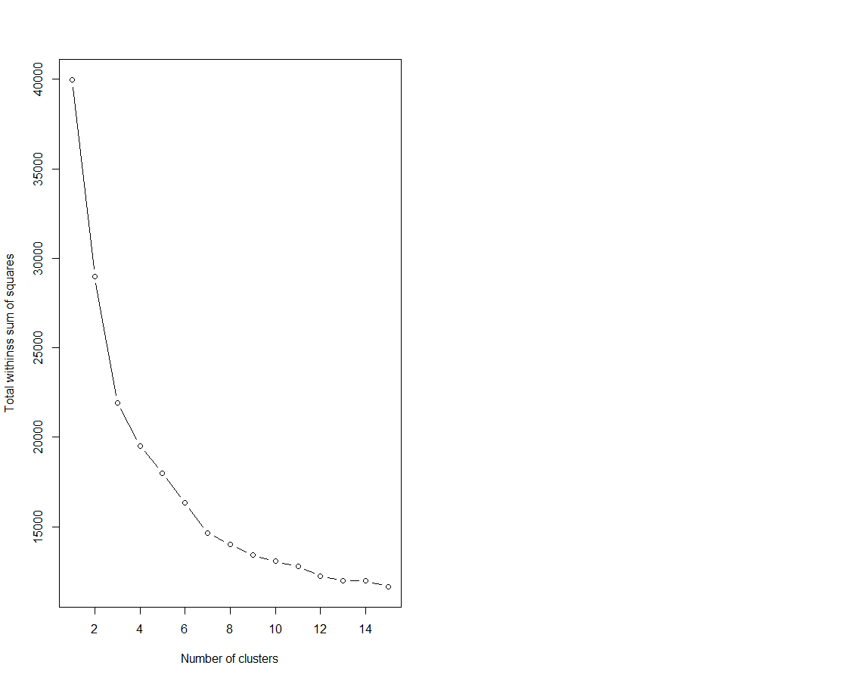

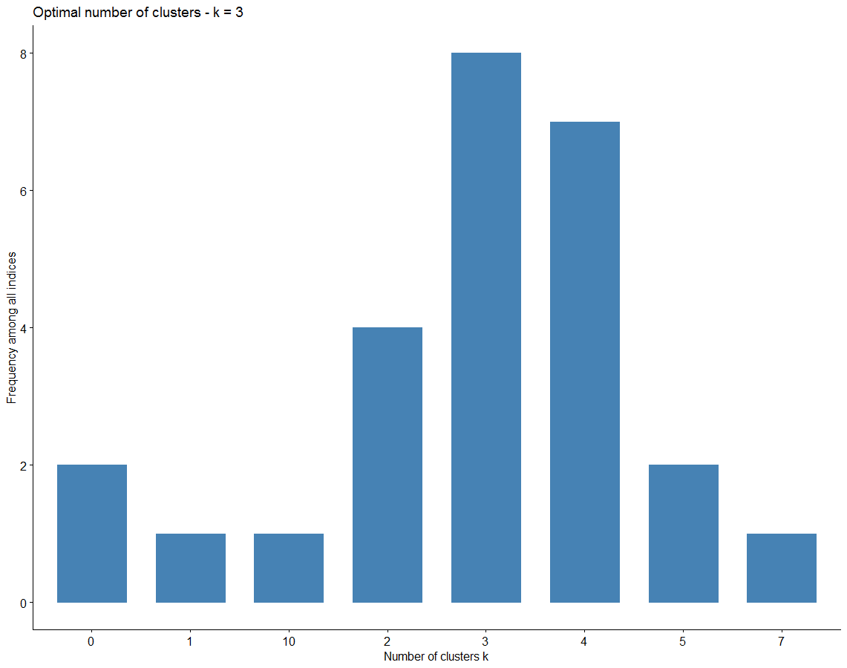

Among all indices:

===================

* 2 proposed 0 as the best number of clusters

* 1 proposed 1 as the best number of clusters

* 4 proposed 2 as the best number of clusters

* 8 proposed 3 as the best number of clusters

* 7 proposed 4 as the best number of clusters

* 2 proposed 5 as the best number of clusters

* 1 proposed 7 as the best number of clusters

* 1 proposed 10 as the best number of clusters

Conclusion

=========================

* According to the majority rule, the best number of clusters is 3 .

Results after aggregation:

|  |  |  |  |  |  |  |  |  |  |  |  |  |  |  |  |  |
| --- | --- | --- | --- | --- | --- | --- | --- | --- | --- | --- | --- | --- | --- | --- | --- | --- |
| Student age | Parents status | Mother education | Father education | traveltime | studytime | failures | family relation | free time | go out | liqure in weekdays | liqure on weekend | health | absences | Grade 1 | Grade 2 | final grade |
| 16.75494 | 0.893281 | 2.193676 | 2.043478 | 1.715415 | 1.750988 | 0.383399 | 3.893281 | 3.268775 | 3.225296 | 1.561265 | 2.411067 | 3.743083 | 2.150198 | 9.355731 | 9.387352 | 9.525692 |
| 16.54452 | 0.886986 | 2.832192 | 2.541096 | 1.441781 | 2.157534 | 0.017123 | 4.027397 | 3.119863 | 3.044521 | 1.273973 | 1.965753 | 3.359589 | 2 | 13.62671 | 13.92808 | 14.40753 |
| 17.27885 | 0.807692 | 2.403846 | 2.288462 | 1.567308 | 1.730769 | 0.403846 | 3.75 | 3.134615 | 3.480769 | 2 | 2.846154 | 3.528846 | 11.99039 | 10.11539 | 10.25962 | 10.67308 |

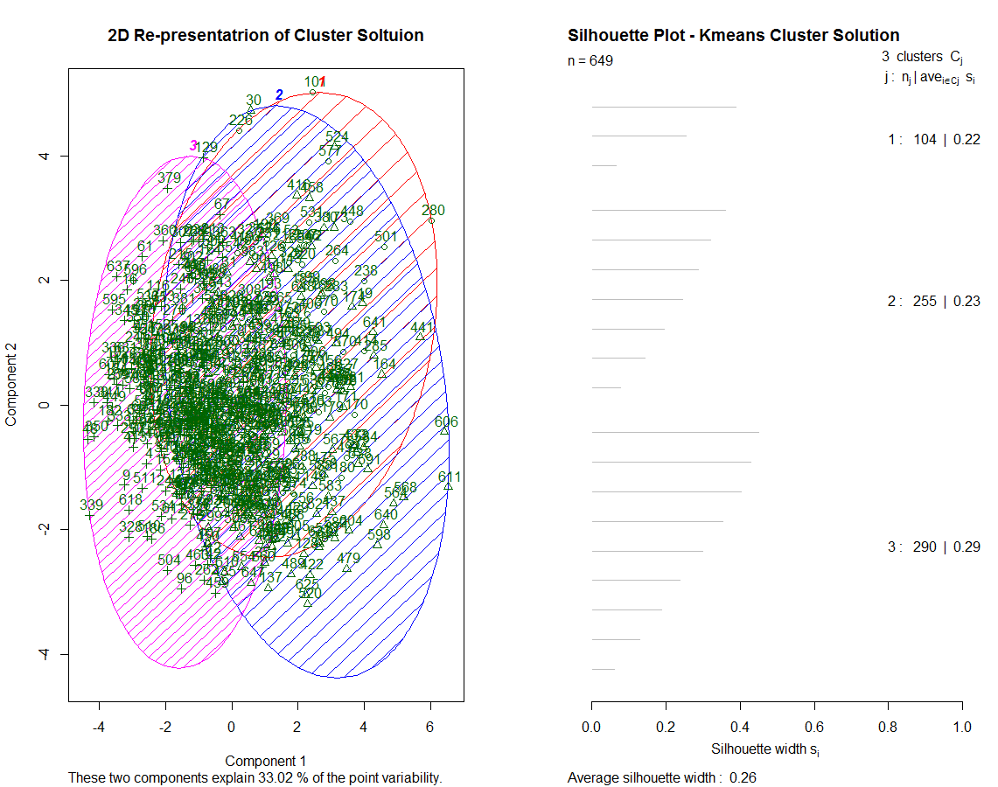

**Linear Regression:**

References:

<https://rstudio-pubs-static.s3.amazonaws.com/390751_f6b763e827b24c9cb4406cd43129c8a9.html>